**Review of the Northern Ireland Weighted Capitation Formula for Allocating Primary Care Prescribing Resources to LCGs and GP Practices**

**Final Report for Public Consultation**

**March 2016**

**Project Support Analysis Branch**

**DHSSPS (NI)**

**CONTENTS**

**IPA Management Group Membership 3**

**Glossary of Terms 4**

1. **Background to Weighted Capitation Formula for GP Prescribing 10**
2. **Background to GP Prescribing Formula Review 2015 13**
3. **Current GP Prescribing Weighted Capitation Formula 16**
4. **Population Base & Trends 18**
5. **Age-Gender Adjustment 23**
6. **Development of STAR-PU 39**
7. **Care Home Adjustment 43**
8. **Data for Modelling Additional Need 54**
9. **Replication of the Current Needs Index with New Data 63**
10. **Additional Need Modelling Strategy 66**
11. **Results of Additional Need Modelling & Preferred Model 73**
12. **Application of the Additional Needs Index at LCG Level 90**
13. **Application of the Full Formula at LCG Level 95**
14. **Sensitivity of the Formula to Targeting Deprivation 98**
15. **Application of the Formula at GP Practice Level 104**
16. **Equality Impact Assessment 111**
17. **Conclusions & Recommendations 117**

**Appendices:**

**Appendix A: List Discrepancy 121**

**Appendix B: Population Base Constraining Procedure 122**

**Appendix C: English Relative Cost Weights (ASTRO-PU) 125**

**Appendix D: STAR-PU Weightings for the Leading 10 Therapeutic Groups 131**

**Appendix E: Supplementary STAR-PU Analysis 141**

**Appendix F: Attribution Process 149**

**Appendix G: Description of Datasets & Summary Statistics 150**

**Appendix H: Disease Prevalence Profiles used for QOF Age Standardisation 176**

**Appendix I: Summary Statistics of the Dependent Variables 180**

**Appendix J: Statistical Tests for Endogeneity 187**

**Appendix K: Consistency of Regression Models (2-Stage versus 1-Stage Stratified) 189**

**Appendix L: Simplified Models of the Preferred 2-Stage Additive Base Model 192**

**Appendix M: Equality Group Data Definitions and Sources 193**

**Appendix N: Alternative Method to Constrain GP Registered List to Match the MYE 194**

**Indicative Prescribing Amounts (IPA) Management Group Membership**

Kathryn Turner (Chair) Pharmacy & Medicines Management, HSCB

Beverley Martin Pharmacy & Medicines Management, HSCB

Brendan Doherty Pharmacy & Medicines Management, HSCB

Emma Quinn Pharmacy & Medicines Management, HSCB

Debbie McGivern Pharmacy & Medicines Management, HSCB

Dr James Bissett General Practitioner, South Eastern LCG

Dr Joe Kuricose General Practitioner, Northern LCG

Paul Cavanagh Assistant Director of Commissioning, Western LCG

Dr Michael Steele Prescribing Lead & General Practitioner, South Eastern LCG

Dean Robertson Finance, HSCB

Penny Murray Statistician, Information & Analysis, DHSSPS

Jacqueline Sheridan Business Services Organisation

**Glossary of Terms**

**Additional Needs:** Needs for health care over and above those pertaining to age and gender.

**Additional Needs Weighting:** Two populations of the same size and structure can have different need for services due to a differing underlying morbidity, such as that caused by deprivation levels. A statistical model is used to calculate the additional needs weighting, which is then combined with an age-gender weighting to produce a single composite weighted population share.

**Antibiotics/antibacterials:** the British National Formulary (BNF) chapter 5 covers drugs used for infections. Chapter 5 includes antibacterial drugs, antifungal drugs, antiviral drugs, antiprotozoal drugs for treating single cell organisms and anti-parasite drugs. Antibacterials are agents which kill and stop growth of bacteria; antibiotics kill and stop growth of bacteria but also fungi. All antibacterials are antibiotics but all antibiotics are not antibacterials. Antibacterial is one of the class of antibiotics. Note the British National Formulary (BNF) definition is given later in this glossary.

**ASTRO-PU:** Age, Sex and Temporary Resident Prescribing Unit; a set of weights in England, developed by the Health & Social Care Information Centre, designed to weight individual GP practice populations for age, sex and temporary residents. These are equivalent to NI-PU in Northern Ireland (although the full NI-PU also includes the additional need weighting but when quoted without the additional need component equates to ASTRO-PU).

**Adjusted R2:** This is a modification of the R2 statistic and is used to determine the quality of fit of a model (see R2 in this glossary). The addition within the adjusted R2 is that it takes into account the number of variables included within the model when evaluating the quality of fit.

**Attribution:** This is a mathematical method that assumes that each individual on a GP practice list is randomly selected from the area (Super Output Area) in which they live. The characteristics of the area to which the person belongs are then attributed to the individual, for example each individual on the GP practice list takes on the unemployment rate for their area (SOA) of residency. Attribution is necessary where modelling is to take place at the GP practice level but the data is only available at area/SOA level.

**Attribution Error (and ecological fallacy):** The main principle behind the attribution process as described above is that each person on a GP practice list is given the value of the score of the super output area in which they reside. This is an approximation and raises the issue of ecological fallacy, that is, service users may not be typical of the area in which they live. The extent to which they are not typical is known as attribution error. Research has shown that the accuracy of attribution increases with population size.

**Backward, forward, stepwise and general-to-specific selection procedures:** Statistical procedures for identifying a subset of variables that are significantly correlated with the dependent variable in the regression model.

**British National Formulary (BNF):** The BNF is published in updated book form twice a year and details all medicines that are generally prescribed in the UK. It contains information on: (i) guidance on the drug management of common conditions; (ii) details of medicines with information on indications and dosages, contraindications, cautions, side effects and relative costs and (iii) guidance on prescribing, monitoring, dispensing and administering medicines.

**Business Services Organisation (BSO):** The BSO was established in April 2009 after the Review of Public Administration in Northern Ireland. The BSO provides a broad range of regional business support functions and specialist professional services to the health and social care sector in Northern Ireland. The legacy organisation was the Central Services Agency; this was dissolved and the majority of services and functions became the responsibility of the new organisation, the BSO.

**Centroid:** The geometric centre of a 2-dimensional area which is the average position of all the points in the area. In terms of SMOSS modelling, which is based on centroids, this refers to the median population weighted centroid of each census output area. See below for a definition of SMOSS.

**COMPASS:** This is a prescribing information system developed to provide GP practices with feedback on their prescribing and how they compare to their peers, both locally and regionally. The practice specific feedback reports provide in-depth analysis including the identification of potentially high cost areas, encourage generic prescribing and discourage over-prescribing of certain medications. COMPASS reports are supplemented with therapeutic notes which provide evidence based advice on the use of medicines to GPs and pharmacists.

**Confidence Intervals:** Confidence intervals can be used to indicate the reliability of an estimate. Instead of estimating a parameter by a single value, a confidence interval gives an estimated range of values which is likely to include a known population parameter. The smaller the interval, the more reliable the estimate will be. In terms of resource allocation, this provides a means of assessing how accurate an area/GP practice’s allocation will be.

**Counter intuitive/Intuitive:** These phrases are used to describe the effect of a coefficient on a specific variable within a model. Counter intuitive signs refers to variables that have coefficients with unexpected signs or magnitude in the regression model, e.g. we might expect areas with higher employment deprivation to have higher prescribing costs when in fact they may have lower costs; this relationship seems to be the opposite to what would generally be believed.

**Department of Health, Social Services & Public Safety (DHSSPS):** The DHSSPS was established by the Departments (NI) Order 1999. The Department administers the business of: (i) health and personal social services, which includes policy and legislation for hospitals, community health and personal social services and family practitioner services; (ii) public health, which covers responsibility for policy and legislation to promote and protect the health and wellbeing of the population of Northern Ireland and (iii) public safety, which encompasses responsibility for the policy and legislation for the Fire Authority, food safety and emergency planning.

**Differential Need:** Different populations may have different need for health and social care services due to need-related factors. This can be due to factors such as deprivation, morbidity and socio-economic circumstances.

**Endogenous/exogenous:** Socio-economic circumstances give rise to healthcare needs which in turn give rise to demand for services. Need is not affected by supply and demand, it is exogenous (that is, originates outside the healthcare system). However, supply can influence demand for services but demand and therefore utilisation can affect the future supply of healthcare. This feedback loop from supply to demand/utilisation means that demand/utilisation and supply can be created within the healthcare system; supply is therefore endogenous. A statistical technique such as two-stage least squares regression is required to solve the problem of endogeneity. See later in this glossary for a definition of two-stage least squares.

**Equality Legislation:** Under Section 75 of the Northern Ireland Act 1998, public authorities in Northern Ireland are required, when carrying out their functions, to have regard to the need to promote equality of opportunity between persons of different religious beliefs, political opinion, racial group, age, marital status, gender orientation, men and women in general, persons with and without a disability and persons with and without dependants. A public authority is also required to have regard to the desirability of promoting good relations between persons of different religious beliefs, political opinion or racial group.

**Face validity:** Whether or not a variable or model reflects what it purports to measure.

**Fair Share:** The aim of a weighed capitation formula is to determine each GP practice and local commissioning group’s fair share of the available resources. This is based on the population size, the age-gender structure and additional needs profile of each population relative to each other.

**Forcing variables into a model:** This refers to adding variables to a model when they were not selected into the model by the usual selection procedures.

**Functional Form:** This refers to the algebraic form of the relationship between a dependent variable and the explanatory variables. The simplest functional form is linear, where the relationship is graphically represented by a straight line. Other functional forms include transformation of the dependent variable and/or explanatory variables using the natural logarithm transformation.

**Health & Social Care Board (HSCB):** On the 1st April 2009, following the Review of Public Administration in Northern Ireland, a single Health and Social Care Board replaced the existing 4 Health and Social Services Boards (HSSBs). The HSCB has a focus on commissioning, resource management, performance management and improvement. The HSCB identifies and meets the needs of the local population through its 5 Local Commissioning Groups (LCGs) that cover the same geographical area as the Health and Social Care Trusts.

**Heteroscedasticity:** In statistical analysis, the condition of non-constant variance; usually an undesirable property in modelling. **Homoscedasticity:** in statistical analysis, this describes a situation where there is constant variance; this is desirable in ordinary least squares regression modelling. Homoscedasticity describes a situation where the error term (“noise” between the independent variables and dependent variable) is the same across all values of the independent variables. Where the error term differs across values of the independent variable, heteroscedasticity is present and observations with larger disturbances have more “pull” or weight than other observations. Statistical techniques allow these observations to be down-weighted.

**Indicative Prescribing Amount (IPA):** This refers to the allocation set at the start of the financial year, for either a GP Practice or an LCG, to cover the costs incurred in prescribing drugs to their population.

**Local Commissioning Group (LCG):** The 5 Local Commissioning Groups are committees of the HSCB and each is co-terminus (same boundary) with their respective Health and Social Care Trust. LCGs have responsibility for assessing health and social care needs, planning health and social care to meet current and emerging needs and securing the delivery of health and social care to meet assessed needs.

**Mid-Year Estimate (MYE):** Population estimates for Northern Ireland are published annually and approximately one year in arrears. Population estimates are based on the 2011 Census of population. Each year, the population is ‘*aged-on*’ by one year - the number of births in the year is added, the number of deaths in the year is subtracted and an adjustment is made for migration. Subsequent mid-year population estimates then use the previous year’s figures as the base.

**National Health Application & Infrastructure Services (NHAIS):** Commonly known as the Exeter System; this records all patients registered on GP practice lists in Northern Ireland.

**Needs Indicator:** Refers to variables that should affect the use of health services; in this case the use of prescribing resources.

**NI-PU (Northern Ireland Prescribing Unit):** These are weights designed to weight individual practice/organisation (e.g. LCG) populations for age and gender and additional need, to allow better comparisons of prescribing patterns. Comparisons can therefore take account of the greater need of elderly people and those living in deprived areas or whose socio-economic circumstances mean they have higher than NI average need for prescribing resources. Note that without the incorporation of the additional need element, NI-PU are equivalent to the English ASTRO-PU (see definition).

**Non-needs Indicator:** Refers to variables that should not affect the use of health services.

**Northern Ireland Statistics & Research Agency (NISRA):** NISRA is an Agency of the Department of Finance and Personnel. NISRA is the principal source of official statistics and social research on Northern Ireland. These statistics and research inform public policy and associated debate in the wider society. A considerable amount of the data used to develop capitation formulae are sourced from NISRA, e.g. census data, registrar general data on births and deaths and population data.

**One-Stage Approach:** A variant of the utilisation approach that accounts for age related needs and additional needs in a single stage.

**Parsimonious Model:** A regression model that contains relatively few independent variables and does not contain variables which add little to the explanatory power of the model.

**QOF:** Quality and Outcomes Framework. This is the annual reward and incentive programme detailing GP practice achievement results. QOF was introduced as part of the new GP Contract in April 2004. QOF awards practices for (i) managing some of the most chronic conditions; (ii) implementing preventative measures; (iii) providing extra services such as cervical screening and contraception services and (iv) the quality and productivity of the service.

**R2:** The coefficient of determination, this is the statistic which can be used to determine the quality of the fit of a model to the data being modelled. It refers to the proportion of the variability of the dependent variable in a regression model that is explained by the independent variables; it ranges in value from 0 to 1.0. A value of R2 = 1.0 indicates that the fit is perfect.

**RESET:** Regression Specification Error Test; a general specification test sometimes used as a criterion model selection in linear regression models. It tests whether or not non-linear combinations of the estimated values help explain the dependent variable. The intuition behind the test is that if non-linear combinations of the explanatory variables have any power in explaining the dependent variable, then the model is mis-specified.

**SMOSS (Simplified Modelling of Spatial Systems):** This is a spatial analytical tool designed by Lancaster University, originally to develop a rurality adjustment within the Northern Ireland regional capitation formula. Using the road network, distances and access times can be calculated using postcodes of facilities and centroids of census output areas; SMOSS incorporates average speeds on different classes of road.

**SMR:** Standardised Mortality Ratio. A measure of how much more or less likely a person is to die in a geographic area compared with the Northern Ireland average, having taken account of the area’s age and gender profile. The calculation of SMR involves indirect standardisation; that is calculating the ratio of observed deaths to expected deaths (the distribution of deaths if total number of deaths had occurred with the same age and gender distribution as in the population).

**Standardisation:** A method used to remove, as far as possible, the effects of differences in age and gender (or some other confounding variable) when comparing two or more populations; the method may be direct or indirect.

**STAR-PU (Specific Therapeutic Group Age-Gender-Related Prescribing Unit):** STAR-PU allows more accurate and meaningful comparisons of prescribing patterns within a specific therapeutic group, by taking into account the types of people who will be receiving that medication. There are differences in the age and gender of patients for whom drugs in specific therapeutic groups are usually prescribed, for example, drugs for dementia are generally prescribed for older people. These weights allow more accurate comparisons for specific categories of drugs as the methodology is based on costs within the therapeutic group.

**Sterilisation:** A method in which variables that should not affect the allocation of resources are removed so that they do not affect allocations either directly or indirectly via their relationship with other variables.

**Super Output Areas (SOAs):** Northern Ireland is geographically split into 890 SOAs, each with a population size of between 1,300 and 2,800. The SOA unit was revised by NISRA for the 2011 census and is used in statistical analysis on a wide range of government and academic studies.

**Supply Variable:** A variable that measures the availability of, access to and/or costs of using health care services in an area. Also refers to characteristics of GP practices, e.g. number of GPs per practice or the generic dispensing rate of the practice.

**Top-slicing:** In this context, top-slicing refers to an amount of money being removed from the overall allocation pot to be held centrally by the Health and Social Care Board to fund high cost medicines/ patients, non-medical prescribing, non-practice employed nurses and out-of-hours prescribing.

**Two-Stage Approach:** A variant of the utilisation approach that accounts for age related needs and additional needs in two separate stages.

**Two-Stage Least Squares:** Two-Stage least squares (2SLS) regression analysis is a statistical technique that is used in the analysis of structural equations. This technique is the extension of the ordinary least squares method (commonly known as linear regression, simple or multiple depending on the number of explanatory variables). In this context 2SLS is required to resolve endogeneity of supply (see definition of endogenous earlier in this glossary).

**Utilisation Approach:** An approach in allocating resources based on the assumption that the use of health care in different areas contains information on the relative needs.

**Variables:** Within this modelling, a variable is a measureable characteristic or feature that will vary from one GP practice or area to the next, allowing differences between each to be analysed.

**Weighted Capitation:** Rather than allocate resources on a per head or per capita basis, weighted capitation formulae are a method of allocating resources having weighted the population and then calculating the relative need of an area’s (or GP practice in this instance) population. This is also known as the fair shares formula. The formula starts with population and then weights this population as appropriate for the need for health care related to age, then adjusts for the need for health care over and above that due to age (usually due to deprivation, morbidity and socio-economic factors) and some formulae then adjust for unavoidable costs such as rurality and market forces.

**Well-specified Model:** In this context, this refers to a model that passes the RESET test.

***Minister’s current reform proposals may mean that some organisations referred to in this document could cease to exist in the near future, with other organisations assuming responsibilities.***

1. **Background to Weighted Capitation Formula for GP Prescribing**

1.1 Expenditureon general practitioner (GP) prescribing covers the costs incurred by GPs in prescribing medication to their patients. In 2014, there were 39.7 million items dispensed in the community, with a gross ingredient cost of £420m.

1.2 Until 1998/99, the mechanism for allocating primary care prescribing resources to both GP practices and the then Health and Social Services Boards (HSSBs) was historic, whereby the out-turn of each HSS Board and ultimately of each GP practice was uplifted by a standard amount, decided by the Department of Health, Social Services & Public safety (DHSSPS) following negotiation with the Department of Finance and Personnel.

1.3 A weighted capitation concept, to distribute resources on the basis of the needs of the population, was first introduced in Northern Ireland in 1998/99. This first step to introduce weighted capitation involved adopting Scottish age-gender prescribing units (SCOT-PU) to adjust for the demographic profile of GP practices and the then HSS Boards. These age-gender weights also accounted for the additional cost of prescribing medication for temporary residents. The next task was to find measures that reflected differences in morbidity and deprivation between GP practices (and between HSS Boards) that statistically explained a large proportion of the variation in prescribing costs per head (basically development of an additional needs index/adjustment). Research was embarked upon during 1998/99 to develop an NI-specific additional needs index. For the 1999/00 allocation round, the SCOT-PU age-gender weights were used in conjunction with an NI-specific additional needs index. During 1999/00, a research project was undertaken to develop NI-specific age-gender weights. For the 2000/01 allocation round, NI-specific indices were applied for both age-gender and additional need. For the following 2 years, projects were carried out to update the age-gender weights.

1.4 In 2003, the formula was subjected to an equality impact assessment, public consultation and external peer review. A full formula review was carried out in 2009/10; this included a new methodology for devising the age-gender weights and full re-modelling of additional need. The formula was again subjected to an equality impact assessment and public consultation. External peer review took place as a collaborative process throughout the full review. This new formula was implemented with Ministerial approval for the 2010/11 allocation round, with the final report published in June 2010.

1.5 The current formula in operation is still that from the 2010 Review, with an additional adjustment to take account of the relative costs of those patients residing in care homes. In 2012, a research project was carried out to examine the relative prescribing costs of those in care homes compared to those living in their own homes. This work was presented to the IPA (Indicative Prescribing Amounts) Management Group, who endorsed the research and agreed to implementation of the care home adjustment within allocations from 2013/14.

1.6 During the initial years after introduction of the weighted capitation approach, given the use of Scottish age weights and the introduction of such a radical new methodology, the formula was implemented at 37.5%; that is, 37.5% of the allocation to each HSSB was based on the formula with the remaining 62.5% based on the previous year’s historic spend. Once a full NI formula was available for the 2000/01 allocations, the capitation level was increased to 62.5%. The allocation method at that time consisted of calculating HSSB indicative prescribing amounts using the HSSB model which used the constrained GP registered population as the population base. The GP practice model then determined practice indices for age-gender and additional need. GP practices then received their relative share of their HSSB’s already determined allocation from the HSSB model; this meant list discrepancy had been dealt with at HSSB level by averaging the discrepancy across HSSBs. The formula cannot take account of list discrepancy at GP practice level but this methodology at least ensured equity between HSSBs. HSSBs were able to use their discretion with regard to the capitation level applied at GP practice; only one HSSB diverged from retaining the level in line with that at HSSB level and implemented the GP practice model at 100% capitation. Method and capitation level remained as such until 2003/04.

1.7 Over the course of the next 6 years, various strategies were implemented in an attempt to reduce the escalating overspend on the community drugs bill. In 2003/04 a “distance from target” strategy was introduced at GP practice level; this was to be a method to move GP practices closer to their “fair share” by comparing their % growth in historic spend from the previous year with their % share based on the formula. The allocation method was unchanged at HSSB level (HSSB model ran using constrained registered populations to take account of list discrepancy). In 2004/05 this strategy was taken a step further by moving to a budget-baseline allocation (that is, using the previous year’s allocation as the starting point) rather than a historic spend baseline at both HSSB and GP practice level. HSSB IPAs were arrived at by simply applying a % growth uplift to their previous year’s allocation; GP practices continued with the “distance to target” strategy.

1.8 From 2005/06 until 2008/09, the escalating drugs bill was tackled by the removal upfront of efficiency savings. A budget-baseline approach was retained with a % growth uplift applied to HSSB allocations after the deduction of efficiency savings. The “distance to target” strategy was retained at GP practice level. In 2009/10, the decision was taken to return to the original methodology pending development of a new formula. April 2009 also brought the dissolution of the 4 legacy HSSBs and replacement with the regional Health and Social Care Board (HSCB) and the creation of 5 Local Commissioning Groups (LCGs). This saw a return to a top-level model, that is, implemented at LCG level with list discrepancy averaged across the 5 LCGs and GP practices then receiving their relative share of their LCG’s already determined allocation from the top-level constraining model (rather than a bottom-up approach starting with GP practice allocations and aggregation to LCG allocations). The capitation level at both LCG and GP practice was set at 62.5% in 2009/10 with an increase to 70% in 2010/11 (note this was also the year that the new formula was implemented) and then 100% from 2011/12.

1.9 Up until 2015/16, allocations have continued on a budget-baseline approach, at 100% capitation at both LCG and GP practice level, with top-slicing arrangements for high cost drugs, out-of-hours and non-medical prescribing. Top-slicing is done on the basis of each LCG’s previous year’s spend on high cost drugs. GP practice allocations are top-sliced accordingly, in line with their LCG’s high cost spend; practices are therefore relieved of the financial responsibility of dealing with low numbers of very high cost patients and are therefore in a better position to manage their indicative prescribing amount for the financial year.

1.10 In a further attempt to exercise budgetary control, the HSCB has also introduced a capping mechanism. GP practices with an under spend at year end of greater than £150k have their allocations capped at either the previous year’s budget or their formula share for the coming year, whichever is the lower of the 2 figures.

1.11 A Prescribing Incentive Scheme came into operation in Northern Ireland in 1997; this was simply a monetary focussed scheme rewarding GP practices for coming in under budget. The savings were partly retained by the individual GP practices allowing them to spend the savings on reinvestment in their practice according to an agreed set of criteria. The remaining proportion of the savings was retained by the legacy HSSBs to fund prescribing advisers. As the scheme started to fail to provide incentive to GP practices, it was reviewed and in 2006/07, a quality based indicator was introduced. This scheme was replaced in 2010/11 with the Medicines Management Resource Scheme which was developed by the HSCB in conjunction with GPC and local medical committees; however, this only ran for 1 year and there is currently no prescribing incentive scheme in operation in Northern Ireland.

1. **Background to GP Prescribing Formula Review 2015**

2.1 Review of the NI Prescribing Formula falls under the responsibility of the DHSSPS as owner of the formula, its development and enhancement. As the budget holder, the HSCB is the other main party on behalf of which the work is being taken forward. The project was led by statisticians in Project Support Analysis Branch, DHSSPS on behalf of the DHSSPS and HSCB. It was agreed that the formal forum for taking forward the work would be the IPA Management Group, chaired by the HSCB; this Group would provide final sign-off of the work and draft report. Membership of the IPA Management Group is detailed on page 3.

2.2 A peer reviewer was engaged (Mr Michael Stevenson, Queen’s University Belfast) and management of this process was undertaken by the statisticians. The peer reviewer was engaged on a collaborative and interactive basis throughout development of the formula. It is good practice to subject any research to independent critical evaluation; identification of weaknesses and opportunities for improvement may be more obvious to those coming fresh to the work and with expertise in the area. A peer reviewer can consider the relative quality and merit of our new research and particularly important here is to gain a seal of approval and that the formula can be declared “fit for purpose”.

2.3 There are a number of reasons why the weighted capitation formula for GP prescribing resources requires updating and why it is appropriate to undertake this full formula review now:

* All resource allocation formulae should be reviewed regularly to ensure that the applied weightings are up-to-date and as accurate as possible in terms of reflecting current population needs. The formula was last reviewed in 2010 and so is now due for review under our normal review process. Since 2011 prescribing costs in Northern Ireland have been decreasing due to a number of factors and it is therefore important that the formula used to allocate GP practice and Local Commissioning Group (LCG) resources is based on up-to-date cost information. Factors which have contributed to decrease prescribing costs include (i) implementation of the Pharmaceutical Clinical Effectiveness programme, (ii) the influence of GP prescribing incentive schemes, (iii) increased generic prescribing and dispensing rates, (iv) the influencing role of Medicines Management Advisors and (v) the introduction of a Northern Ireland Formulary.
* NI went through a Review of Public Administration, commencing in 2002. In 2005 the Review concluded that reform was required for the administrative structures of health and social services. In April 2009, reform included a re-configuration of the 4 legacy Health Boards into the regional Health and Social Care Board (HSCB) and the establishment of new commissioning arrangements under local commissioning groups (LCGs). It is important that the formula is robust and up-to-date under these new commissioning arrangements, particularly given the scrutiny that LCGs come under with regard to reducing prescribing spend and enabling effective prescribing. In a time of financial pressure, it is vital that the formula is as robust as possible.
* The need to further develop the method used to derive the age weightings. The current age cost curve is derived from dispensing data for April 2008 only, as development was immediately after the introduction of EPES (Electronic Prescribing and Eligibility System). It is now feasible to use a full financial year of data relating to 2013-14. In the interim, we had tested 2009/10 data, but as the weights had changed little, a decision was taken to review again as part of a full formula review.
* The need to devise updated age weights for specific therapeutic groups (STAR-PU). STAR-PU has only been developed once in NI and these have proven to be a very useful tool in comparative analysis within therapeutic groups. As well as being a useful prescribing measure/tool, STAR-PUs will allow us to build additional need models for separate therapeutic groups and may lead to a more robust model, in that different specified preferred models may result depending on the therapeutic group in question. Robustness of this work during the last review was questionable, given that only one month’s dispensing data was available; the full financial year of data now makes this analysis feasible.
* The need to revisit the analysis behind the care home adjustment. A care home adjustment was only developed in 2012 and has been incorporated into the formula since 2013/14; although endorsed by the IPA Process Management Group, this will be the opportunity for wider scrutiny of this work and the opportunity for public consultation on the issue.
* Further modelling was recommended when new data sources would become available; for example, data from the NI Census 2011 is now available and it would be timely to use it now before it too becomes out-dated.
* Enhanced electronic prescribing data will allow us to consider model specifications not possible in previous reviews. For example, prescribing data now allows us to model at area level (SOA), as patient postcode is now available for each dispensed item, and to develop 1-stage stratified models, again as patient details are attached to each item. Analysis at area level may give a more direct link between population characteristics and prescribing expenditure. Practice level averages of the characteristics of heterogeneous populations can lead to a shallower needs index. SOA level analysis also removes the need for attribution and therefore the problems associated with attribution error.
* During the 2010 Formula Review, although the majority of the peer reviewer’s comments and feedback were taken on board at that time, there were data restraints that prevented some of the preferred modelling. The peer reviewer advocated that the preferred additional needs model should be a 1-stage stratified model, where the dependent cost variable is cost-weighted activity per head in each separate age-gender group. Again, one month’s EPES data would not have been robust for such analysis. The enhanced prescribing dataset now allows all preferred modelling to be explored; the cost dependent variable can be constructed as required for this model and a full financial year of data should be robust for such purposes.
* The need to continue to monitor differential list discrepancy across local commissioning groups.
* The need to monitor equality impacts with more up-to-date data sources. Publication of Census 2011 results allows more up-to-date equality impacts to be assessed.

1. **Current GP Prescribing Weighted Capitation Formula**

3.1 The weighted capitation formula currently in operation to allocate primary care prescribing resources was introduced for the 2010/11 allocation round, with the addition of an adjustment for care home patients introduced from 2013/14. The components of the current formula are outlined below. Note that the weighted capitation formula is not concerned with the absolute level of prescribing resources for Northern Ireland; rather the formula is concerned with equitably sharing out an already determined pot of resources across LCGs and in turn GP practices. The major determinant in resource allocation is the relative size of the population being served; the principle of weighted capitation then adjusts an area or practice’s share, based on relativity of need due to age/gender structure and additional need arising from deprivation, morbidity and other socio-economic factors.

***Population Base***

3.2 The population base is the constrained GP registered list. This is sourced from the National Health Applications and Infrastructure Services (NHAIS) System, maintained by the Business Services Organisation (BSO) and records all patients registered on GP practice lists. This list is then constrained to the mid-year estimate of population produced by the Northern Ireland Statistics and Research Agency (NISRA), plus a count of cross-border workers as maintained by BSO. This constraining procedure is described in detail at Appendix A.

***Age-Gender Weights***

3.3 The age-gender relative weights in Table 3.1 are applied to the population to account for needs arising from having a population age and/or gender structure which is different from the Northern Ireland average. The weights were developed using cost weighted dispensing data from April 2008. Development of these current weights and their update, including enhancement to the methodology, will be discussed in detail in section 5. These relative cost weightings are commonly referred to as Northern Ireland Prescribing Units (NI-PU); those from the 2010 Review being called NI-PU 2010.

**Table 3.1 Relative Cost Weights – NI-PU 2010**

|  |  |  |
| --- | --- | --- |
| **Age Group** | **Males** | **Females** |
| **0-4** | 1.49 | 1.25 |
| **5-15** | 1.23 | 1.00 |
| **16-24** | 1.11 | 1.52 |
| **25-44** | 2.28 | 3.02 |
| **45-59** | 5.56 | 6.49 |
| **60-64** | 9.91 | 10.10 |
| **65-74** | 13.04 | 12.71 |
| **75+** | 16.72 | 16.39 |

3.4 Note that the 2010 Formula Review saw the removal of an adjustment for temporary residents, which had previously been incorporated within the relative cost weights. Since introduction of the new GMS Contract in April 2004, claims are no longer made by GP practices for these patients and therefore no data source exists to either update the adjustment or provide a base population on which to apply the weighting. Up to 2010, the temporary resident weighting developed using data from 1999/00 to 2003/04 had been retained.

***Care Home Adjustment***

3.5 For the 2013/14 allocation round, a weighting was incorporated within NI-PU 2010 to account for the relative higher prescribing costs of those patients residing in care homes compared to patients living in the community in their own homes. Research was carried out and endorsed by the IPA Management Group; this concluded that the NI-PU weights for patients in care homes be 2.5 times the value of the corresponding patients living in the community. Development of this adjustment and its update for this full formula review is described in detail in section 7.

***Additional Needs Index***

3.6 The aim of this adjustment is to take account of needs for prescribing resources over and above that demanded by population size and age-gender structure. These tend to be needs arising from differing levels of deprivation, morbidity and socio-economic circumstances. Modelling was carried out in-house by Project Support Analysis Branch (PSAB) in DHSSPS to investigate the relationship between prescribing utilisation, needs indicators and the supply of health services. The work was subjected to a collaborative peer review process, with sign off by the peer reviewer that the adjustment was fit for purpose.

3.7 Of the variables tested during this modelling, the following were found to be significant and the best at explaining variation in prescribing utilisation over and above age and gender. The final model explained 50.5% of the variation in prescribing expenditure across GP practices.

* + The proportion of the GP registered list population who are babies, defined as under 1 year old (+ve association, increased proportions of babies are associated with increased prescribing costs).
  + The proportion of dependent children (aged 0-17) in lone parent households (+ve association, increased proportions of children in lone parent households are associated with increased prescribing costs).
  + NI Index of Multiple Deprivation Education Domain, which comprises a range of indicators that measure low educational attainment (+ve association, increased levels of low educational attainment are associated with increased prescribing costs).
  + Proportion of persons aged 16-74 who are full-time students (-ve association, increased levels of students are associated with decreased prescribing costs).

1. **Population Base & Trends**

***Population Base & Data Sources***

4.1 Central to any capitation based allocation mechanism is an accurate count of the population to which the resources are being allocated. The main determinant of the level of health and social care need, and in this case prescribing need, in an LCG or GP practice, is the size of the population for which it is responsible. Differential changes in population can and should have a marked impact on the allocation of resources across Northern Ireland. As population dynamics change, so should the flow of resources to meet these changing demands.

4.2 As GP prescribing allocations are intended to cover the costs incurred by GP practices in prescribing drugs to their patients, it is important that practices receive an allocation for the relative proportion of patients registered with them. This means that the starting population point for allocations must be to count patients registered with GP practices and in turn attribute these patients to the LCG that manages the GP practice, irrespective of whether the patient is resident in that particular LCG.

4.3 The NHAIS System is the successor to the Exeter System and records the age and gender of each patient, their GP practice of registration and their postcode of residency which allows for the capture of patients registered in one LCG who are resident in a different LCG. At April 2015, 5.88% of patients were registered with a GP practice outside the LCG in which they live. In terms of cross boundary flow, 13.70% of patients are registered with GP practices outside the local government district in which they live.

4.4 The NHAIS system also includes registration of cross border workers who are entitled to medical treatment whilst in Northern Ireland, on the same basis as residents. Although such workers live in another jurisdiction, due to working in Northern Ireland they are entitled to receive a medical card in the same manner as NI residents. At April 2015, there were 1,921 cross border workers (9 in Belfast LCG, 1 in Northern LCG, 3 in South Eastern LCG, 449 in Southern LCG and 1,456 in Western LCG).

***List Discrepancy***

4.5 There exists a population discrepancy between the NHAIS system and the official mid-year estimate of population (produced by NISRA). The mid-year estimate is based on latest census figures rolled forward one year at a time by adding births, subtracting deaths and adjusting for migration. The discrepancy is due in part to delays in removing patients from practice lists who no longer avail of services, e.g. due to death or moving away. There can also be delays in registering babies with practices. The issue in Northern Ireland is further compounded by users from the Republic of Ireland using addresses of convenience to access not only GP services free of charge, but subsequently being able to access secondary care services due to their registration with a GP practice.

4.6 List discrepancy stands at 3.00% at Northern Ireland level, but differs in size by age and geographical area (see Appendix A for list discrepancy at local government district level and by age). At LCG level, list discrepancy ranges from 1.03% in Northern LCG to 4.86% in Southern LCG. These figures for list discrepancy refer to a comparison of GP registered lists at January 2013 and the 2013 mid-year estimate. Note that at January 2013, there were 22,430 (1.17% of all NHAIS records) patient records on NHAIS that did not have a postcode and therefore could not be assigned to an LGD or LCG of residency. It is therefore accepted that registered populations are not suitable for resource allocation purposes, if used as the sole population base. It is possible to carry out a controlling procedure to adjust for list discrepancy, resulting in the population base for allocations to LCGs being the constrained registered list population. The constraining methodology takes the registered GP population as its start point and scales it back to match the resident population for an area. The constraining method does not eliminate list discrepancy entirely, but rather averages it across the area at which it is being absorbed. List discrepancy within the formula is currently absorbed at LCG level, but the constraining method takes place at LGD level. The constraining methodology plus a worked illustration are provided at Appendix B. Appendix B also outlines the rationale and historical ministerial approval that led to the decision to use the constrained registered list as the population base.

***Population Base – Constrained Registered Population***

4.7 Table 4.1 details the constrained registered list population of each LCG at April 2015, after constraining the GP registered list population at April 2015 to match the 2013 mid-year estimate adjusted for the number of cross border workers at April 2015. These are the base population shares for the allocation process and will appear throughout the report as the other formula components are presented and demonstrate the effect on population shares of applying the age-gender and additional need adjustments.

**Table 4.1 LCG Constrained Registered Population and % Shares at April 2015**

|  |  |  |
| --- | --- | --- |
| **LCG** | **Constrained Registered Population** | **Population % Shares** |
| **Belfast** | 409,044 | 22.33% |
| **Northern** | 443,717 | 24.23% |
| **South Eastern** | 309,434 | 16.89% |
| **Southern** | 370,370 | 20.22% |
| **Western** | 299,075 | 16.33% |
| **Northern Ireland** | 1,831,641 | 100.00% |

4.8 Note that in setting allocations, it is necessary to use the most up-to-date GP registered population as the base, as GP practices should receive an allocation for each of their registered patients; for the 2015/16 allocations, this was GP registrations on NHAIS as at 1st April 2015. Unfortunately, the mid-year estimate population to which this registered population has to be constrained always has a time delay. At the time of setting the 2015/16 allocations, the latest available MYE was June 2013. It would be more desirable to have the 2 population bases more closely aligned but this is not feasible. At Northern Ireland level, the misalignment of the 2 population bases increases list discrepancy by approximately 1.5%.

4.9 The following section on population trends therefore details the population bases as used for the 2014/15 and 2015/16 allocation rounds. For the 2015/16 allocations, the GP registered list at April 2015 was constrained to the 2013 MYE (plus cross border workers as at April 2015). For the 2014/15 allocations, the GP registered list at January 2014 was constrained to the 2012 MYE (plus cross border workers as at January 2014).

**Population Trends**

***GP Registered List Population***

* 1. Table 4.2 shows the change in GP registered lists between January 2014 and April 2015; an overall increase of 0.95%. All LCGs show an increase in their GP registered lists, the largest increase being in Southern LCG of +1.55% (+6,158 patients), which accounted for almost 34% of the overall growth in NI lists. The smallest increase was in Western LCG, with an increase of 0.50% (+1,617 patients) accounting for nearly 9% of the overall NI growth in GP registered lists.

**Table 4.2 GP Registered List Populations at January 2014 and April 2015**

|  |  |  |  |  |  |  |  |
| --- | --- | --- | --- | --- | --- | --- | --- |
| **LCG** | **GP List Population at January 2014** | **% Shares** | **GP List Population at April 2015** | **% Shares** | **Change in Population** | **%**  **Change in Population** | **% of Total Growth** |
| Belfast | 430,820 | 22.42% | 434,071 | 22.38% | 3,251 | 0.75% | 17.83% |
| Northern | 453,711 | 23.62% | 457,999 | 23.61% | 4,288 | 0.95% | 23.52% |
| S. Eastern | 316,637 | 16.48% | 319,557 | 16.48% | 2,920 | 0.92% | 16.01% |
| Southern | 396,763 | 20.65% | 402,921 | 20.78% | 6,158 | 1.55% | 33.77% |
| Western | 323,284 | 16.83% | 324,901 | 16.75% | 1,617 | 0.50% | 8.87% |
| **N Ireland** | **1,921,215** | **100.00%** | **1,939,449** | **100.00%** | **18,234** | **0.95%** | **100.00%** |

***Mid-Year Estimate Population***

* 1. Table 4.3 shows the change in mid-year estimate (plus cross border workers as recorded on NHAIS) between 2012 and 2013. The Northern Ireland estimate has increased by +0.54% (+9,851 people) between the 2012 MYE and 2013 MYE. South Eastern LCG area had the largest increase (+0.94%, +3,259 people), accounting for just over 33% of total growth in NI. Western LCG area saw the smallest increase (+0.13%, +382 people), accounting for nearly 4% of overall NI growth.

**Table 4.3 Resident Population Mid-Year Estimates at June 2012 and June 2013**

|  |  |  |  |  |  |  |  |
| --- | --- | --- | --- | --- | --- | --- | --- |
| **LCG** | **2012 MYE + CBW** | **% Shares** | **2013 MYE + CBW** | **% Shares** | **Change in Population** | **%**  **Change in Population** | **% of Total Growth** |
| Belfast | 348,231 | 19.11% | 349,627 | 19.09% | 1,396 | 0.40% | 14.17% |
| Northern | 464,534 | 25.50% | 466,725 | 25.48% | 2,191 | 0.47% | 22.24% |
| S. Eastern | 347,532 | 19.08% | 350,791 | 19.15% | 3,259 | 0.94% | 33.08% |
| Southern | 363,537 | 19.95% | 366,160 | 19.99% | 2,623 | 0.72% | 26.63% |
| Western | 297,956 | 16.36% | 298,338 | 16.29% | 382 | 0.13% | 3.88% |
| **N Ireland** | **1,821,790** | **100.0%%%** | **1,831,641** | **100.0%%** | **9,851** | **0.54%** | **100.00%** |

4.12 The increase in registered patients of 0.95% was more than the resident population increase of 0.54% (compare Table 4.2 and Table 4.3). All of the LCGs saw increases in both their registered patients and resident population; the percentage increase in registered patients was greater than the percentage increase in resident population in all but the South Eastern LCG (increases of +0.94% and +0.92% in resident and registered populations respectively).

4.13 The GP registered list attributes patients to the LCG that manages the practice, that is, it is based on practice of registration as opposed to where a patient resides. Using the patient postcode, available on NHAIS, we can attribute GP lists according to patient residency; this is more comparable with the MYE. Table 4.4 shows that based on patient residency, all LCGs experienced growth. Southern LCG area had the largest increase (+1.53%, +5,999 people), accounting for 32.9% of the overall growth in Northern Ireland. Western LCG area had the smallest increase (+0.48%, +1,552 people), accounting for 8.51% of overall growth.

**Table 4.4 GP Registered List Population Based on Patient Residency at January 2014 & April 2015**

|  |  |  |  |  |  |  |  |
| --- | --- | --- | --- | --- | --- | --- | --- |
| **LCG** | **GP List at January 2014 (based on residency)** | **% Shares** | **GP List at April 2015 (based on residency)** | **% Shares** | **Population**  **Change** | **%**  **Change in Population** | **% of Total Growth** |
| Belfast | 369,641 | 19.24% | 372,825 | 19.22% | 3,185 | 0.86% | 17.47% |
| Northern | 477,524 | 24.86% | 481,454 | 24.82% | 3,930 | 0.82% | 21.55% |
| S. Eastern | 358,807 | 18.68% | 362,376 | 18.68% | 3,569 | 0.99% | 19.57% |
| Southern | 392,691 | 20.44% | 398,691 | 20.56% | 5,999 | 1.53% | 32.90% |
| Western | 322,552 | 16.79% | 324,103 | 16.71% | 1,552 | 0.48% | 8.51% |
| **N Ireland** | **1,921,215** | **100.0%** | **1,939,449** | **100.0%** | **18,234** | **0.95%** | **100.0%** |

4.14 Table 4.5 shows the constrained registered population for each LCG and % shares after constraining the April 2015 registered list to the 2013 MYE and constraining the January 2014 registered list to the 2012 MYE. MYE figures have been adjusted for cross border workers as recorded on NHAIS at the respective time periods.

**Table 4.5 Constrained Registered Population at January 2014 and April 2015**

|  |  |  |  |  |  |
| --- | --- | --- | --- | --- | --- |
| **LCG** | **Constrained Registered Population at January 2014** | **% Shares** | **Constrained Registered Population at April 2015** | **% Shares** | **Difference in % Shares** |
| Belfast | 407,806 | 22.38% | 409,044 | 22.33% | -0.05% |
| Northern | 441,162 | 24.22% | 443,717 | 24.23% | +0.01% |
| South Eastern | 306,625 | 16.83% | 309,434 | 16.89% | +0.06% |
| Southern | 367,556 | 20.18% | 370,370 | 20.22% | +0.05% |
| Western | 298,641 | 16.39% | 299,075 | 16.33% | -0.06% |
| **N Ireland** | **1,821,790** | **100.0%** | **1,831,641** | **100.0%** | **0.00%** |

4.15 South Eastern LCG saw the largest increase in population base % share between the 2014/15 and 2015/16 allocations, with Western having the largest decrease. Western LCG had experienced the smallest increase in both registered and resident populations and therefore subsequently its relative % share of the constrained registered population has seen the largest decrease.

4.16 During development of the updated formula, discussion arose around an alternative method of constraining to that currently in operation; this alternative method is detailed in Appendix N. Until the alternative method has been subjected to public consultation and agreement reached on its adoption; this report continues to use the constrained registered populations as derived from the current methodology.

**Recommendations:**

**A constrained registered population should be used as the population base for setting Local Commissioning Group (LCG) allocations. Regardless of the constraining method, the base should be the latest available registered list from NHAIS constrained to the latest available mid-year estimate of population adjusted for the latest available number of cross-border workers as recorded on NHAIS.**

**The GP practice registered list is retained as the population base for setting GP practice allocations. This should be the latest available registered list from NHAIS.**

**5. Age-Gender Adjustment**

***Background***

5.1 After population size, the next significant consideration in a resource allocationformula is to account for the needs which arise from having a population age and/or gender structure which is different than the Northern Ireland average. Different age-gender groups place different demands on the health service. It is logical that older age groups will require more prescribing resources than younger age groups and should therefore attract higher weightings within the formula. This section details the development of updated age-gender weightings.

5.2 The Northern Ireland Prescribing Unit (NI-PU) was first introduced in 2000/01 as part of the GP prescribing resource allocation process, to account for differences in demography when distributing resources. As well as an adjustment within the allocation formula, the NI-PU can also be used to make comparisons more valid between GP practices or between areas. The NI-PU also includes an adjustment for additional needs. By using the appropriate denominator, comparisons can take account of the greater need of elderly people and also the greater need of those people living in deprived areas or whose socio-economic circumstances mean they have higher than NI average need for prescribing resources.

5.3 GP practices receive COMPASS reports quarterly and annually containing data and feedback on their prescribing (reports are also produced at LCG and NI level). In these reports, comparisons are made between GP practices and their LCG and NI. LCG reports compare the LCG to NI and the overall NI report compares the 5 LCGs plus compares each LCG with NI. To make these comparisons more valid, the NI-PU weightings are used to standardise for differences in population size, structure and additional needs.

5.4 Prescribing habits change over time as new drugs are introduced, older drugs become less popular, new indications (signalling a valid or necessary reason to use) are licensed for existing drugs, drugs come off patent and generic equivalents become available, and more patients may be treated for existing indications as better evidence for efficacy is demonstrated, for example, increased use of statins in the treatment of coronary heart disease. For this reason, the NI-PU needs to be reviewed regularly.

***Introduction of the Electronic Prescribing & Eligibility System (EPES) & Associated Enhanced Prescribing Database***

5.5 The Electronic Prescribing and Eligibility System (EPES) and the associated enhanced prescribing database, maintained by the Business Services Organisation (BSO), have greatly increased the accuracy of prescribing and dispensing information. Utilisation of the 2-D barcode on the prescription form allows for the capture of data on the patient, prescriber and dispenser. Note that although prescribing information is captured, this is only feasible for scripts which have been cashed-in, that is, presented at a community pharmacy for dispensing. The database therefore captures prescribing, dispensing and patient information for all items dispensed in the community.

***Current NI-PU (usually known as NI-PU 2010)***

5.6 The NI-PU currently in operation was devised as part of the last full formula review in 2009/2010. At the time of the last review, EPES had been rolled out during 2008 and, being a new system and having bedding-in issues associated with scanning and matching of patient health and social care numbers, only April 2008 data was suitable for download and analysis. It was acknowledged that EPES and the data captured from it had limitations, but thorough validation confirmed it represented the best available data source at the time. The previous methodology which involved extraction of data direct from a sample of GP practices would not have been sustainable and EPES and the enhanced prescribing database would inevitably be the solution in the future.

5.7 The age-gender weightings were reviewed in 2012 but, as the weights had changed little and the effect of adopting them would have been so small, it was recommended that the weights would not be updated at that time and instead the NI-PU would be reviewed again as part of the next full formula review.

5.8 The remainder of this section describes the development of NI-PU 2015, that is, updated weights developed as part of this full formula review. The section will also compare NI-PU 2015 with NI-PU 2010; as the interim weights produced in 2012 were not implemented and they were so similar to NI-PU 2010, a comparison of these has not been made.

***Development of Updated Age-Gender Weightings NI-PU 2015***

5.9 Two datasets were acquired from the Business Services Organisation (BSO) to derive the updated weightings: (i) a dispensing dataset (to create the numerator) and (ii) a population dataset of GP registered patients (to create the denominator).

***Dispensing Dataset***

5.10 The dispensing dataset consisted of 34.1m items, extracted by individual item with patient’s age and gender attached to each item (see paragraphs 5.12 for information on exclusions). The age of the patient was determined as at mid-point October 2013. The patient’s GP practice was determined as the practice the patient was registered to when the script was prescribed. The items included were prescribed by GPs and/or nurses within the 351 GP practices in operation during 2013/14 and subsequently presented for dispensing by a community pharmacist, dispensing doctor or appliance contractor. Only items prescribed and subsequently dispensed were included in the dataset; for example, if a patient does not take their script to a pharmacy to be dispensed, then no information about that script can be captured in the BSO enhanced prescribing database. As the formula is concerned with actual costs incurred by GP practices (that is, prescribed and subsequently dispensed), this is therefore the appropriate numerator from which to derive the relative cost weights.

5.11 The gross ingredient cost (cost of drugs before discount and excluding dispensing fees) of the items contained in the dataset was £347.4m. Gross ingredient costs have been analysed as these are consistent with the GP practice monthly prescribing statements and the Prescription Costs Analysis (PCA). Here we are not concerned with the community pharmacy arrangements and therefore we want to analyse costs prior to any discounts that are applied when community pharmacists are reimbursed for the cost of medicines they have purchased and excluding any dispensing fees associated with the dispensing of these medicines.

5.12 During 2013/14, the BSO recorded over 40 million prescription items. The following exclusions applied to the data in order to produce the appropriate dataset for NI-PU derivation. These exclusions resulted in 37.6m items being eligible for analysis. However, 9.3% of these eligible items did not have patient details captured and had to be excluded, resulting in 34.1m items for analysis. Details of these exclusions are given below:

(i) Fees, e.g. multiple dispensing fees, repeat dispensing intervention and non-intervention fees and sexual health fees. These fees are coded within BSO and recorded in a manner that makes them appear as an item; they are fees paid to community pharmacists and not actual prescription items.

(ii) Hospice prescribing and any prescribing other than those attached to GP practices, e.g. out-of-hours centres and scripts issued by general dental practitioners. The formula is only concerned with making allocations to GP practices.

(iii) Stock items which are items commonly required to be on-hand within GP practices for direct administration to patients by GPs and their staff.

(iv) Items on substitute prescribing forms (SP1 and SP2 forms) which involve supervised prescribing of medication as part of treatment for opiate dependence.

(v) Items on the high cost drug list for 2013/14. At GP practice level, one of the many pressures placed on the prescribing budget is high cost items. To relieve practices of the financial responsibilities of dealing with very high cost outlying prescribing (much of which are initiated in secondary care), these items are managed by means of a top-slice budget and are not funded via the weighted capitation formula. Items on the high cost list, funded via the top-slice, needed to be excluded from the analysis. The expensive drug list is determined at the start of the financial year and for 2013/14 this was defined as: “drugs for which the annual cost at daily defined dosage (or average usage if no DDD available) is greater than £2,500 but only where all strengths and types of the drug meet the criteria”. For example, if a drug is produced in 4 strengths and 3 meet the criteria and one does not, then none would have been included on the list.

(vi) Items where the patient’s health and social care number was not captured (due to the barcode on the script being damaged or the script being handwritten) subsequently could not have patient details attached to that particular item. These items were not exclusions as above, but the omission of patient details meant technically that they could not be included.

***Population Dataset (denominator)***

5.13 The appropriate denominator for deriving NI-PU is all patients who “had the potential to be prescribed a medicine or product” and not just those patients who actually received an item during 2013/14. This dataset therefore consisted of all patients registered with GP practices during 2013/14. In terms of patient details (age and GP practice of registration), given that patient details can alter over the course of the year, data at mid-point October 2013 was provided. The dataset was required to capture all registered patients during the 2013-14 year and therefore some patients would have left the NI GP list or joined the list before/after October 2013; the patient details closest to October 2013 were therefore provided in these cases.

5.14 Table 5.1 shows the numerators (ingredient cost before discount) and denominators (registered patients) and the costs per head for each age-gender group. These per capita costs are then standardised around the minimum to produce relative cost weights (see Table 5.2 and Figure 5.1). Analysis was initially carried out by single years of age to examine whether the natural break points in costs per head still aligned with the historic age groupings. The charting of costs per head by single ages confirmed that the age groups were still appropriate. The peer reviewer raised the issue of an ageing population and whether it would be more appropriate to split the 75+ age band into 75-84 and 85+. We revisited the prescribing costs per head splitting the 75+ age band as suggested and creating relative weights for these new age bands; this made no material difference to the weights that would be applied and therefore the age bands have not be revised given the amount of time involved to revise all analysis and application calculations.

**Table 5.1 Prescribing Costs, Registered Patients, Cost per Head & Relative Cost Weights**

|  |  |  |  |  |  |  |  |  |
| --- | --- | --- | --- | --- | --- | --- | --- | --- |
| **Age Group** | **Prescribing Costs**  **Items Paid in 2013/14** | | **Registered Patients**  **During 2013/14** | | **Prescribing Costs per Head** | | **Relative Cost Weights** | |
| **Males** | **Females** | **Males** | **Females** | **Males** | **Females** | **Males** | **Females** |
| **0-4** | £5,211,411 | £4,228,623 | 70,227 | 67,423 | £74.21 | £62.72 | £1.80 | £1.52 |
| **5-15** | £7,313,354 | £5,270,674 | 134,758 | 127,916 | £54.27 | £41.20 | £1.32 | £1.00 |
| **16-24** | £6,208,243 | £7,103,055 | 118,058 | 113,448 | £52.59 | £62.61 | £1.28 | £1.52 |
| **25-44** | £22,547,015 | £30,782,519 | 283,938 | 273,289 | £79.41 | £112.64 | £1.93 | £2.73 |
| **45-59** | £38,665,420 | £44,517,630 | 196,607 | 190,271 | £196.66 | £233.97 | £4.77 | £5.68 |
| **60-64** | £15,914,119 | £16,179,538 | 48,925 | 48,353 | £325.28 | £334.61 | £7.89 | £8.12 |
| **65-74** | £33,049,690 | £33,741,791 | 76,662 | 82,543 | £431.11 | £408.78 | £10.46 | £9.92 |
| **75+** | £30,916,782 | £45,706,893 | 51,966 | 77,861 | £594.94 | £587.03 | £14.44 | £14.25 |

Source: 2013/14 down load of dispensing data from EPES & Registered Patients during 2013/14 sourced

from the National Health Applications & Infrastructure Services (NHAIS) System.

**Table 5.2 NI-PU 2015**

|  |  |  |
| --- | --- | --- |
| **Age Group** | **Males** | **Females** |
| **0-4** | £1.80 | £1.52 |
| **5-15** | £1.32 | £1.00 |
| **16-24** | £1.28 | £1.52 |
| **25-44** | £1.93 | £2.73 |
| **45-59** | £4.77 | £5.68 |
| **60-64** | £7.89 | £8.12 |
| **65-74** | £10.46 | £9.92 |
| **75+** | £14.44 | £14.25 |

Source: Derived from dispensing data (EPES) & GP Registered Lists (NHAIS)

**Figure 5.1 Relative Cost Weights – NI-PU 2015**

***Interpretation of the Relative Cost Weights***

5.15 The interpretation of the relative age-gender weights is that an elderly woman aged 75 and over is expected to cost just over 14 times more than a female aged 5-15. Technically, when we refer to NI-PU, we are also referring to the inclusion of the adjustment for additional needs, which allows for 2 populations of similar size and demographic structure but who, due to morbidity and socio-economic circumstances, have different needs for prescribing resources. Table 5.3 shows the calculation of NI-PU for 2 GP practices which have the same list sizes but whose demographic structure and socio-economic profiles differ.

5.16 Practice A and Practice B have the same number of registered patients (8,488); however, practice A has a more elderly age profile than practice B. Practice A also has need for additional resources higher than the NI average (1.0453), NI being 1.00. Practice B has lower than average additional needs (0.9225). All other things being equal, although the practices have the same list size, having adjusted for age, gender and additional need, we would expect practice A’s prescribing costs to be higher than practice B’s.

**Table 5.3 Worked Example of Applying the NI-PU**

**Example 1 – Practice A**

|  |  |  |  |  |
| --- | --- | --- | --- | --- |
| **Age Group** | **Practice Registered Patients** | | **Relative Cost Weights Applied to Registered Population to Create Prescribing Units (PU)** | |
| **Males** | **Females** | **Male PU** | **Female PU** |
| 0-4 | 258 | 282 | 464 | 429 |
| 5-15 | 624 | 548 | 824 | 548 |
| 16-24 | 578 | 554 | 740 | 842 |
| 25-44 | 1250 | 1217 | 2413 | 3322 |
| 45-59 | 838 | 728 | 3997 | 4135 |
| 60-64 | 217 | 230 | 1712 | 1868 |
| 65-74 | 339 | 331 | 3546 | 3284 |
| 75+ | 216 | 278 | 3119 | 3962 |
| TOTAL | 4320 | 4168 | **16815** | **18389** |
|  |  |  |  |  |
| Needs Index = **1.0453** | | Total NI-PU = (**16815 + 18389**) * **1.0453** = 36,798 | | |

**Example 2 – Practice B**

|  |  |  |  |  |
| --- | --- | --- | --- | --- |
| **Age Group** | **Practice Registered Patients** | | **Relative Cost Weights Applied to Registered Population to Create Prescribing Units** | |
| **Males** | **Females** | **Male PU** | **Female PU** |
| 0-4 | 360 | 311 | 648 | 473 |
| 5-15 | 711 | 657 | 939 | 657 |
| 16-24 | 605 | 595 | 774 | 904 |
| 25-44 | 1296 | 1279 | 2501 | 3492 |
| 45-59 | 779 | 714 | 3716 | 4056 |
| 60-64 | 203 | 184 | 1602 | 1494 |
| 65-74 | 231 | 220 | 2416 | 2182 |
| 75+ | 135 | 208 | 1949 | 2964 |
| TOTAL | 4320 | 4168 | **14545** | **16222** |
|  |  |  |  |  |
| Needs Index = **0.9225** | | Total NI-PU = (**14545 + 16222**) * **0.9225** = 28,383 | | |

***Adjustment for Temporary Residents***

5.17 The original NI-PU, developed in 1999/00 and first implemented in the 2000/01 allocations, also took account of the demands placed on GP practice prescribing resources by temporary residents. Since the introduction of the new GMS Contract for general practitioners in April 2004, there is no longer a central source to count temporary residents, as GP practices no longer make item of service claims in respect of these patients. Instead, this item of service was subsumed into the global sum element of the new Contract funding streams. There is therefore no data source from which to derive an adjustment but also no population base of temporary residents to which this weight would be applied. During the last formula review in 2010, sensitivity testing demonstrated that exclusion of this adjustment had negligible effect on practice allocations overall and it was recommended that the adjustment be removed (at that stage it was being based on very out-of-date, pre-new Contract data). Where such patients do impact on resources, it is in a small number of practices, such as those near holiday resorts. This issue is best dealt with by the Health and Social Care Board taking local knowledge into account and making some form of local adjustment to the GP practice allocation before issuing the practice with a final indicative prescribing amount for the forthcoming year.

***Scan Rates***

5.18 Scan rates have improved substantially since EPES (electronic prescribing) was first introduced; Figure 5.2 shows the improvement in scan rates between the 3 data downloads used to derive NI-PU. The EPES April 2008 download was used to derive NI-PU 2010, the NI-PU still in operation today. The EPES 2009/10 download was used to derive NI-PU 2012 (the interim update which was not subsequently implemented) and the EPES 2013/14 download has been used to derive NI-PU 2015 (the current review).

5.19 In April 2008, 15% of practices had scan rates of less than 40%; by 2009/10, all practices had achieved at least 40% successful scanning rates and by 2013/14, all practices now have scan rates of at least 60%. In April 2008, 71% of practices had scan rates of 75% and above; this increased to 77% of practices in 2009/10 and to 99% of practices in 2013/14. 89% of practices now have successful scanning of 85% and above (compared to 66% of practices in 2009/10 and 58% in April 2008).

5.20 Scripts which are hand written do not hold patient details on the system and the scan rate will also be affected by these. The 2013/14 analysis excluded 9% of items (and Gross Ingredient Cost) due to scanning/hand written scripts, compared with the 2009/10 analysis which excluded 16% (items and GIC) and the April 2008 data which excluded 30% (items and GIC). It is not possible to disaggregate the number of items with no patient details due to the script being handwritten versus an unsuccessful script scan. However, as the scan rates have vastly improved over the years, it is probably a safe assumption that this is primarily due to improved barcode reading and improved scanning as opposed to fluctuations in the number of handwritten scripts.

**Figure 5.2 GP Practice Script Scan Rates – 2008 v 2009/10 v 2013/14**

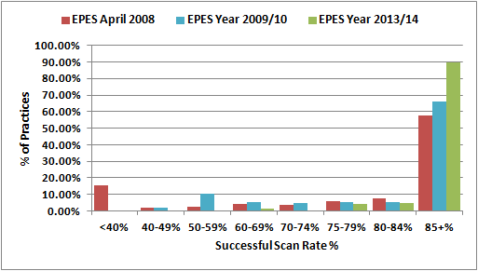

***Comparison between NI-PU 2015 v NI-PU 2010***

5.21 We compared the NI-PU 2010 weights, which have been in operation since the 2010/11 allocation round and are in operation currently, with the NI-PU 2015 weights derived for this full formula review. Figure 5.3 shows that the relative cost weights for both males and females have changed substantially between NI-PU 2010 and NI-PU 2015. The weights have changed little for the age groups 0-4, 5-15 and 16-24 and there are small differences of up to £1 for the age groups 25-44 and 45-59. However, there are reductions of £2 and over in the older age groups (60-64, 65-74 and 75+) moving from NI-PU 2010 to NI-PU 2015.

5.22 Table 5.4 shows the prescribing costs per head for both NI-PU (NI-PU 2010 based on 2009/10 dispensing data and NI-PU 2015 based on 2013/14 dispensing data). Prescribing costs per head have increased in children between 2009/10 and 2013/14; however, costs per head have decreased in each of the age groups from 25-44 upwards. Prescribing costs per head have decreased more in the older age groups (60-74). This is in line with the trend that prescribing costs have been decreasing in recent years. See Table 5.5 for overall NI prescribing costs per GP registered patient, taken from the Prescription Costs Analysis which details all items (and their gross ingredient cost) dispensed in the community in NI. The PCA will include e.g. dental scripts, scripts written in out-of-hours centres, scripts written in other UK countries but dispensed in NI and all other items that were excluded from the NI-PU analysis.

**Figure 5.3 Comparison of NI-PU 2015 & NI-PU 2010**

1. **Male Cost Weights**

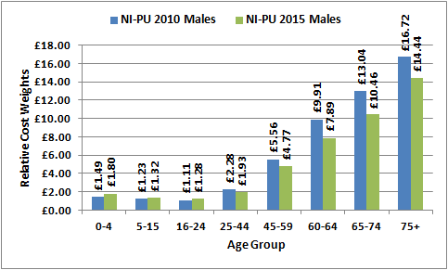

1. **Female Cost Weights**

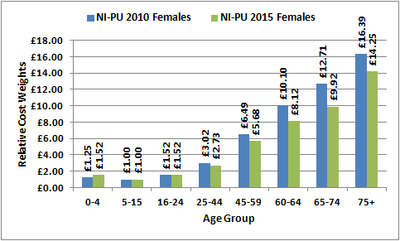

**Table 5.4 Comparison of Prescribing Costs per Head 2010 v 2015**

|  |  |  |  |  |  |  |
| --- | --- | --- | --- | --- | --- | --- |
| **Age Group** | **Prescribing Costs Per Head - Males** | | | **Prescribing Costs per Head - Females** | | |
| **Males 2010** | **Males 2015** | **Difference** | **Females 2010** | **Females 2015** | **Difference** |
| **0-4** | £57.49 | £74.21 | **+£16.72** | £48.44 | £62.72 | **+£14.28** |
| **5-15** | £47.64 | £54.27 | **+£6.63** | £38.67 | £41.20 | **+£2.53** |
| **16-24** | £42.85 | £52.59 | **+£9.74** | £58.67 | £62.61 | **+£3.94** |
| **25-44** | £88.36 | £79.41 | **-£8.95** | £116.72 | £112.64 | **-£4.08** |
| **45-59** | £214.90 | £196.66 | **-£18.24** | £250.98 | £233.97 | **-£17.01** |
| **60-64** | £383.30 | £325.28 | **-£58.02** | £390.68 | £334.61 | **-£56.07** |
| **65-74** | £504.41 | £431.11 | **-£73.30** | £491.63 | £408.78 | **-£82.85** |
| **75+** | £646.60 | £594.94 | **-£51.66** | £633.79 | £587.03 | **-£46.76** |

**Table 5.5 Prescribing Costs per GP Registered Patient, 2008 to 2014**

|  |  |
| --- | --- |
| **Calendar Year** | **Costs per GP Registered Patient** |
| **2008** | £213.67 |
| **2009** | £223.06 |
| **2010** | £233.85 |
| **2011** | £225.62 |
| **2012** | £214.07 |
| **2013** | £213.18 |

Source: Prescription Costs Analysis NI

Notes: PCA reports on a calendar year

Prescription charges were reduced from £6.85 to £3 in January 2009

and charges were abolished in April 2010.

***Trend in Decreased Prescribing Costs in Northern Ireland***

5.23 Despite increasing prescribing volumes, which reflect the impact of a steadily growing older population, costs have been decreasing in Northern Ireland since 2011 and this is due to a number of factors:

* Implementation of the Pharmaceutical Clinical Effectiveness Programme (PCE), a set of medicines management initiatives which was initiated by the DHSSPS in 2005 and continues to be implemented by the Health and Social Care Board (HSCB). Following the introduction of PCE, the rate of growth on prescribing expenditure was reduced and annual efficiency savings have been made as part of the Comprehensive Spending Review.
* The influence of GP Prescribing Incentive Schemes which were budget-focused schemes; savings were shared between the GP practices and their Local Commissioning Group (LCG), with savings reinvested into patient care.
* The role of Medicines Management Advisers (MMAs) who seek to influence the prescribing behaviour of GPs. They monitor prescribing patterns, focusing on safety, effectiveness and efficiency and highlight where savings can be generated.
* The increased rate of generic dispensing from 58% in 2009/10 to 71% in 2013/14. When a branded medicine’s patent expires, the generic equivalents which appear on the market (containing the same active ingredient) are usually cheaper. For many years, the DHSSPS and HSCB have encouraged GPs to prescribe generically, examples of which include (i) the 2006 “Go Generic” Campaign; (ii) Prescribing Incentive Schemes which included targets for generic prescribing and (iii) the HSCB Commissioning Plan includes an Indicator of Performance which monitors both generic prescribing and generic dispensing rates at LCG and NI level on a quarterly basis.
* The introduction of a NI Formulary. The Formulary is a list of medicines that have been shown to be both clinically effective and safe for patients as well as providing value for money. The NI Formulary promotes and ensures that patients receive the most effective and safe medicine. Patients across Northern Ireland are given the same medicines for the medical conditions and doctors working in both hospital and primary care settings will be prescribing medicines in the same way. The Formulary covers the majority of prescribing decisions for non-specialist prescribing. The HSCB Commissioning Plan includes a target and an indicator of performance which monitor compliance with the formulary by BNF Chapter and overall compliance.

***Impact of Updating the NI-PU 2010 to NI-PU 2015***

5.24 In order to assess the impact of updating the age/gender weightings, we looked at the correlation between gross ingredient cost (i.e. ingredient cost before discount) per patient and per prescribing unit (i.e. patients weighted to take account of their age and gender) for both NI-PU 2010 and NI-PU 2015. Table 5.6 shows that the correlation improved slightly with using the updated NI-PU 2015. We also examined the correlation between gross ingredient cost per prescribing unit, using both NI-PU 2010 and NI-PU 2015; the result was a very high association between the 2 prescribing unit measures.

5.25 We also examined the effect on practices of moving from the 2010 NI-PU to the updated 2015 NI-PU; the redistribution at practice level would have been +/-0.281% (which equated to +/-£1.102m in 2013/14 expenditure terms). The change for individual practices ranged from a maximum drop in weighted patient share of -0.013% to a maximum increase in share of +0.015%. Although these redistributive changes at practice level seem quite modest; compared to moving from NI-PU 2010 to NI-PU 2012, these are notable changes. This is to be expected given the change in relative weights resulting from decreased prescribing costs per head in 2013/14.

**Table 5.6 Correlation between NI-PU 2010 & NI-PU 2015**

|  |  |  |  |
| --- | --- | --- | --- |
|  | **Gross Ingredient Cost per Patient** | **Gross Ingredient Cost per PU 2010** | **Redistribution at GP Practice Level** |
| **Gross Ingredient Cost per PU 2010** | 0.7561 | - | - |
| **Gross Ingredient Cost per PU 2015** | 0.7870 | 0.9987 | +/-0.281%  (+/-£1.102m) |

5.26 Figure 5.4 shows the difference in gross ingredient cost per head and gross ingredient cost per head adjusted, having applied the relative cost weights at practice level across NI. The chart simply shows a selection of anonymised NI GP practices. The chart shows how misleading GIC per patient can be and why it is important to take account of the age-gender effect when either allocating resources or making comparisons. Example A shows a practice with a high GIC/patient (£330) but when the age-gender profile of the practice is taken into account, the costs are somewhat lower (£268). Example B shows a practice with a lower GIC/patient (£243) but taking account of age-gender the costs rise to £311. Using cost per head without adjusting for age and gender would clearly hide the high cost of practice B. Likewise practice A’s costs are not as high as would have been implied if examining cost per head without adjusting for age and gender. This demonstrates the importance of the NI-PU weightings and their application in resource allocation and as a prescribing measure.

**Figure 5.4 Gross Ingredient Cost per Head & per Head Adjusted for Age-Gender**

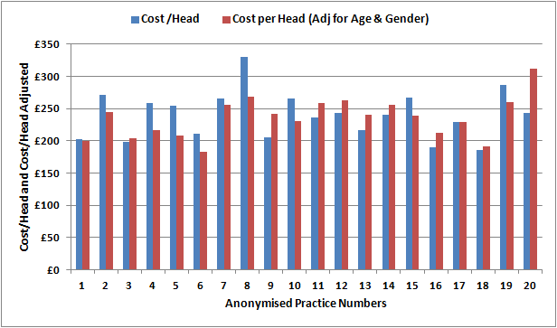

**Practice B**

**Practice A**

**English Relative Cost Weights**

5.27 The Health and Social Care Information Centre (HSCIC) in England produce prescribing relative cost weightings which are used within their resource allocation formula and are also used as a prescribing measure for better comparisons of prescribing patterns. These are referred to as Age, Sex, Temporary Resident Originated Prescribing Units (ASTRO-PU) and were first derived in 1993. There have been a number of reviews of ASTRO-PU, the last being in 2013. Although we could not make direct comparisons between NI-PU and ASTRO-PU due to different age groupings, it was beneficial to examine the ASTRO-PU and in particular the change in ASTRO-PU between their 2009 review and the current ASTRO-PU 2013. This analysis is presented in Appendix C.

**Scottish Prescribing Units**

5.28 Information Services Division, NHS National Services Scotland is responsible for development and maintenance of the Scottish Resource Allocation Formula, which provides funding to NHS Boards for the provision of Hospital & Community Health Services (HCHS) and GP Prescribing. The current Resource Allocation Formula in Scotland was introduced in 2009/10, replacing the Arbuthnott Formula which had been in place since 2001/02 and which was subject to a major review between 2005 and 2007. During this review, all age-gender weights within the formula were reviewed including those used within the GP prescribing component of the formula. The prescribing weights were estimated using a random sample of approximately 12,000 prescription forms per annum, selected from all prescriptions dispensed in the community. At that time, the prescribing warehouse held by ISD did not hold patient level data (like NI this was not a requirement for reimbursing pharmacists). The Central Health Index (CHI) number was not a legal requirement and was not always complete, especially on hand-written scripts (again this mirrors the historic picture in NI). However, since 2004 the CHI number has been routinely captured and stored and various developments have led to improvements in data recording and facilitating patient level analyses (e.g. restructuring of the warehouse, changes to GP IT systems to improve electronic scanning and the ePharmacy Programme which provides electronic prescription data direct from community pharmacies). There is now a high level of CHI completeness on the prescribing warehouse and ISD have moved to using a single year of dispensing data from the whole dataset as opposed to a sample. Scotland is now in the same position as NI with regard to the capture of dispensing data. Again, due to different age groups, we cannot make direct comparisons between NI-PU and SCOT-PU, but it was beneficial to examine them and in particular the change in SCOT-PU between 2012 and 2014. This analysis is presented in Appendix C.

**Application of the NI-PU 2015 Weights at Local Commissioning Group (LCG) Level**

5.29 The weighted capitation formula adjusts for differences in the use of prescribing resources based on the age-gender profile of each LCG’s population (and additional needs), rather than based simply on a per head basis. For example, an LCG with a more elderly population than the NI average will find that its prescribing resources will have to cater for a greater amount of health need than an LCG with a younger population. Table 5.7 shows the age profile of the LCGs based on 1st April 2015 GP registered lists, constrained to the 2013 mid-year estimate, adjusted for cross-border workers at 1st April 2015, as recorded on NHAIS. This illustrates that, for example, Southern and Western LCGs have younger populations whereas South Eastern LCG has the most elderly population.

**Table 5.7 Age Structure of the 5 LCGs at 1st April 2015**

|  |  |  |  |  |  |  |
| --- | --- | --- | --- | --- | --- | --- |
| **Age Group** | **Belfast** | **Northern** | **S Eastern** | **Southern** | **Western** | **N Ireland** |
| **0-15** | 19.29% | 20.73% | 20.14% | 22.73% | 21.80% | 20.89% |
| **16-64** | 66.03% | 63.11% | 62.15% | 63.48% | 64.29% | 63.87% |
| **65+** | 14.68% | 16.15% | 17.71% | 13.79% | 13.91% | 15.24% |
| **Total** | 100.0% | 100.0% | 100.0% | 100.0% | 100.0% | 100.0% |

5.30 Table 5.8 shows the LCG relative population shares resulting from applying NI-PU 2015 to the constrained registered population at 1st April 2015. The weight effects are shown as an index around 1 (Northern Ireland =1.0). LCGs with an index below 1.0 have an age-gender structure which places a less than NI average burden on GP prescribing costs; this is because they have a lower proportion of elderly people in their population. Comparison with the population shares before adjusting for age-gender, South Eastern LCG have gained the largest in population share due to the age-gender adjustment, whereas Southern LCG has seen the largest decrease in population share. These changes in population shares after weighting for age-gender reflect the LCG population structures as shown in Table 5.7. Note the age-gender adjustment presented in this section does not incorporate a weighting for care home patients; at this stage only the age cost curve (NI-PU 2015) has been applied.

**Table 5.8 Age-Gender Index & Age Weighted Population Shares at LCG Level at 1st April 2015**

|  |  |  |  |  |  |
| --- | --- | --- | --- | --- | --- |
|  | **Belfast** | **Northern** | **S Eastern** | **Southern** | **Western** |
| **Constrained Registered Population Shares %** | 22.33% | 24.23% | 16.89% | 20.22% | 16.33% |
| **Age-Gender Index** | 0.9852 | 1.0246 | 1.0703 | 0.9544 | 0.9675 |
| **% Shares After Adjusting for Age-Gender** | 22.00% | 24.82% | 18.08% | 19.30% | 15.80% |
| **Change in % Share due to Age-Gender Weighting** | -0.33% | +0.59% | +1.19% | -0.92% | -0.53% |

5.31 Table 5.9 shows the constrained registered population % shares as at 1st April 2015 and the age-gender index and associated weighted population shares using NI-PU 2010 and then updated using NI-PU 2015. Application of NI-PU 2010 redistributed +/-1.93% of resources, resulting in the age-gender weighted % shares highlighted in blue. Application of the NI-PU 2015 would redistribute +/-1.78% of resources, resulting in the age-gender weighted % shares highlighted in red. The use of the updated NI-PU 2015 is less redistributive between crude population and age-gender weighted population (-0.15%) than the NI-PU 2010, due to the NI-PU 2015 weights being less steep in the older age groups.

**Table 5.9 Impact of Updating NI-PU (Age-gender Element Only) from NI-PU 2010 to NI-PU 2015**

|  |  |  |  |  |  |
| --- | --- | --- | --- | --- | --- |
| **LCG** | **Constrained Registered Population Shares %** | **Age-Gender Index Using NI-PU 2010** | **Weighted Population Shares % Using NI-PU 2010** | **Age-Gender Index Using NI-PU 2015** | **Weighted Population Shares % Using NI-PU 2015** |
| **Belfast** | 22.33% | 0.9822 | **21.94%** | 0.9852 | **22.00%** |
| **Northern** | 24.23% | 1.0266 | **24.87%** | 1.0246 | **24.82%** |
| **S Eastern** | 16.89% | 1.0761 | **18.18%** | 1.0703 | **18.08%** |
| **Southern** | 20.22% | 0.9514 | **19.24%** | 0.9544 | **19.30%** |
| **Western** | 16.33% | 0.9662 | **15.78%** | 0.9675 | **15.80%** |
| **N Ireland** | 100.0% | 1.000 | **100.0%** | 1.000 | **100.0%** |
| **Redistribution** |  |  | **+/- 1.93%** |  | **+/- 1.78%** |

5.32 Table 5.9 shows that Northern and South Eastern LCG will gain in % share due to the age weighting (due to their more elderly age profiles), whether using NI-PU 2010 or the updated NI-PU 2015. Likewise Belfast, Southern and Western LCGs will decrease their % share, whether using NI-PU 2010 or the updated NI-PU 2015. However, Northern and South Eastern LCGs’ age-gender weights % shares decrease under application of the updated NI-PU 2015 (see Table 5.10 which shows the change in index and change in age-gender weighted % shares that result from updating NI-PU 2010 with NI-PU 2015), due to the NI-PU 2015 being less steep in the older age groups (of which they have a higher proportion). LCGs with more elderly age profiles will continue to see a gain in population share with application of the age-gender adjustment, but the gain is slightly reduced with the updated NI-PU 2015. Likewise, the 3 LCGs that see a reduced share after application of the age-gender adjustment will continue to have less relative population shares after age-gender application, but that reduction will be slightly less.

**Table 5.10 Change in Index and Age-gender Weighted % Shares – NI-PU 2010 v NI-PU 2015**

|  |  |  |  |  |  |  |
| --- | --- | --- | --- | --- | --- | --- |
| **LCG** | **Age-Gender Index Using**  **NI-PU 2010** | **Age-Gender Index Using**  **NI-PU 2015** | **Change in Index** | **Age Wgt Popn Shares %**  **Using NI-PU 2010** | **Age Wgt Popn Shares %**  **Using NI-PU 2015** | **Change in % Shares** |
| **Belfast** | 0.9822 | 0.9852 | **+0.003** | 21.94% | 22.00% | **+0.06%** |
| **Northern** | 1.0266 | 1.0246 | **-0.002** | 24.87% | 24.82% | **-0.05%** |
| **S Eastern** | 1.0761 | 1.0703 | **-0.006** | 18.18% | 18.08% | **-0.10%** |
| **Southern** | 0.9514 | 0.9544 | **+0.003** | 19.24% | 19.30% | **+0.06%** |
| **Western** | 0.9662 | 0.9675 | **+0.001** | 15.78% | 15.80% | **+0.02%** |
| **N Ireland** | 1.000 | 1.000 | **-** | 100.0% | 100.0% | **-** |
| **Redistribution** | - | - | **-** | +/- 1.93% | +/- 1.78% | **-0.15%** |

**Recommendations:**

**The updated NI-PU 2015 should be adopted as the age-gender adjustment within the GP Prescribing Formula from 2016/17 allocations. NI-PU 2015 should be adopted from this date within the formula for both LCG and GP practice allocations.**

**As a comparator prescribing measure, the updated NI-PU 2015 should be introduced for COMPASS Reporting from April 2016.**

**6. Development of STAR-PU**

***Background***

6.1 There are differences in the age and gender profiles of patients who are prescribed drugs in specific therapeutic groups. For example, drugs for dementia are generally prescribed for older people. STAR-PU (Specific Therapeutic Group Age-Gender-Related Prescribing Unit) have been developed to allow more accurate and meaningful comparisons within a specific therapeutic group, by taking into account the types of people who will be receiving that medication. These have been developed using the same methodology as that used for NI-PU, but are based on costs within individual therapeutic groups rather than all prescribing. These weightings should be used only for the specific therapeutic area in question; this will be covered in more detail later.

6.2 STAR-PU weightings have been developed in Northern Ireland for the leading 10 therapeutic groups which account for 94% of items dispensed in 2013/14 (and 89% of total gross ingredient cost in 2013/14). STAR-PU has also been developed for a number of specific drugs (specific British National Formulary (BNF) chapters, sections and paragraphs). The 2 datasets acquired from the BSO to create NI-PU were used again to create STAR-PU: (i) a dispensing dataset (to create the numerator) and (ii) a population dataset of GP registered patients (to create the denominator). The dispensing dataset has already been described at paragraphs 5.10 to 5.12 and the population dataset at paragraph 5.13. In addition, the dispensing dataset had the BNF chapter, section and paragraph attached to each item.

***Derivation of STAR-PU***

6.3 The weights have been derived by dividing the total gross ingredient cost in each age-gender group for the specific BNF chapter (or section and/or paragraph if relevant) by the total number of registered patients in each age-gender group. This produces a BNF-specific cost per capita for each age-gender group. The exception is anti-bacterials/antibiotics (BNF Chapter 5) which are item based; as most of these are prescribed as short courses, volume is more appropriate as a prescribing measure. The costs (or items) per capita are not standardised; this is where the methodology diverges from the NI-PU methodology.

6.4 Standardising the weightings potentially introduces a source of variation, with all weightings dependent on the factor by which the true weighting for the minimum cost per head is adjusted to reach a weighting of 1.0. Where prescribing measures are used in resource allocation (as the NI-PU are), they require standardisation; however, where weightings are not primarily used for resource allocation but instead are utilised in monitoring comparative prescribing spend, they do not require standardisation. Unlike standardised weightings, “non-standardised” weightings are real values, that is, the average cost per patient for that specific age-gender group. This methodology is consistent with that employed by the Health and Social Care Information (HSCIC) in England when producing their equivalent STAR-PU. All STAR-PU presented in this report are non-standardised weightings.

6.5 As part of this full formula review, an updated additional needs adjustment within the capitation formula will be developed. This will take the form of regression models to best predict variation in prescribing costs across GP practices. Part of that work will involve the development of specific therapeutic models; in that instance, standardised STAR-PU will need to be used.

6.6 Table 6.1 shows STAR-PU weightings for the leading 10 therapeutic groups and graphical presentation of these 10 STAR-PU weightings are provided in Figures D.1 to D.10 at Appendix D. Not surprisingly, the STAR-PU weightings differ greatly for different therapeutic groups, reflecting the demographics of the population being prescribed certain medicines. As previously mentioned, the top 10 leading therapeutic groups account for 94% of items dispensed in 2013/14 (and 89% of total gross ingredient cost in 2013/14). A check was made against the Prescription Cost Analysis (PCA), which details by BNF classification, the number of items and gross ingredient cost of all items dispensed in the community in Northern Ireland. Whilst the PCA would not have any drug exclusions as in the study’s dataset, a check confirmed the same 10 leading therapeutic groups (accounting for 87% of cost and 94% of items).

6.7 STAR-PU weightings have also been developed for a number of specific drugs (see Table D.1 and Figures D.11 to D.21 at Appendix D).

***Application of STAR-PU***

6.8 STAR-PU weightings should only be applied to the specific group of medicines from which that weighting has been derived. NI-PU has been derived from an analysis of total prescribing and should therefore only be applied when measuring or comparing total prescribing. Applying NI-PU to individual drugs or BNF chapters/sections/paragraphs is not appropriate and is likely to produce spurious information. STAR-PU is the appropriate weighting denominator when a particular medicine or set of drugs is being considered. In the absence of a STAR-PU having been developed for that particular drug or combination of drugs, number of patients (that is, per patient) is the most appropriate measure to use.

6.9 The weighting used must reflect the usage (or cost) of the medicine by the patients, according to their age and sex. The PU weightings are derived by looking at medicine use by costs, by age and gender groups, and then setting the ratios between them. For example, if you were looking at medicine use for a childhood condition, you would want a PU giving greater weight to the young so that when comparing areas, those with a high proportion of children are weighted accordingly.  If you do not have a STAR-PU, and you use the NI-PU in this example, the weightings are the exact opposite of what you want, that is, weighted towards the elderly and this will distort the results. If you were to use patients instead, while not ideal, at least this treats the age-gender groups equally rather than weighting one age-gender group over another. Using NI-PU where no STAR-PU exists is an issue if the profile of medicine use in whatever area you are looking at does not match the profile of the NI-PU. In order to understand this issue more fully, supplementary analysis was carried out; this is presented at Appendix E.

**Recommendation:**

**STAR-PU should be adopted as the prescribing measure when analysing either a particular drug, BNF chapter, section or paragraph. In the absence of an appropriate STAR-PU, the appropriate STAR-PU should either be generated or a “per patient” denominator used.**

**Table 6.1 STAR-PU Weightings for the Leading 10 Therapeutic Groups**

|  |  |  |  |  |  |  |
| --- | --- | --- | --- | --- | --- | --- |
| **Age Group** | **BNF Chapter 1**  **Gastro-intestinal System** | | **BNF Chapter 2**  **Cardiovascular System** | | **BNF Chapter 3**  **Respiratory System** | |
| Males | Females | Males | Females | Males | Females |
| 0-4 | £3.43 | £3.14 | £0.23 | £0.14 | £6.01 | £4.23 |
| 5-15 | £1.57 | £1.47 | £0.29 | £0.26 | £10.64 | £6.84 |
| 16-24 | £2.62 | £3.05 | £0.63 | £1.06 | £8.24 | £7.15 |
| 25-44 | £5.38 | £7.28 | £3.67 | £4.35 | £8.92 | £10.51 |
| 45-59 | £11.49 | £14.66 | £27.20 | £18.84 | £21.15 | £28.44 |
| 60-64 | £16.80 | £20.78 | £64.34 | £45.06 | £41.32 | £49.69 |
| 65-74 | £20.02 | £24.50 | £92.01 | £70.10 | £61.89 | £60.57 |
| 75+ | £27.33 | £30.91 | £105.72 | £92.59 | £77.28 | £55.99 |

|  |  |  |  |  |  |  |
| --- | --- | --- | --- | --- | --- | --- |
| **Age Group** | **BNF Chapter 4**  **Central Nervous System** | | **BNF Chapter 6**  **Endocrine System** | | **BNF Chapter 7**  **Obs, Gynae & UT Disorders** | |
| Males | Females | Males | Females | Males | Females |
| 0-4 | £2.35 | £2.35 | £1.41 | £1.19 | £0.03 | £0.04 |
| 5-15 | £13.65 | £6.18 | £6.52 | £6.02 | £0.12 | £0.43 |
| 16-24 | £15.37 | £14.34 | £6.40 | £6.56 | £0.21 | £9.58 |
| 25-44 | £31.21 | £43.93 | £9.45 | £11.05 | £1.55 | £9.33 |
| 45-59 | £63.10 | £89.69 | £25.97 | £25.43 | £7.49 | £9.45 |
| 60-64 | £76.19 | £100.87 | £45.17 | £37.73 | £15.98 | £12.72 |
| 65-74 | £79.92 | £104.25 | £61.68 | £45.04 | £21.56 | £15.69 |
| 75+ | £103.44 | £156.03 | £67.99 | £44.60 | £26.87 | £17.69 |

|  |  |  |  |  |  |  |
| --- | --- | --- | --- | --- | --- | --- |
| **Age Group** | **BNF Chapter 9**  **Nutrition & Blood** | | **BNF Chapter 10**  **Musculoskeletal & Joint Diseases** | | **BNF Chapter 13**  **Skin Diseases** | |
| Males | Females | Males | Females | Males | Females |
| 0-4 | £33.35 | £28.51 | £0.60 | £0.54 | £7.66 | 36.40 |
| 5-15 | £2.68 | £2.43 | 30.41 | £0.56 | £4.19 | £4.81 |
| 16-24 | £1.92 | £1.82 | £0.63 | £1.12 | £6.28 | £7.74 |
| 25-44 | £2.28 | £2.91 | £2.53 | £3.55 | £5.18 | £6.24 |
| 45-59 | £5.84 | £6.74 | £6.83 | £9.28 | £7.02 | £7.31 |
| 60-64 | £9.77 | £11.38 | £9.12 | £11.84 | £8.92 | £8.61 |
| 65-74 | £16.68 | £18.43 | £9.10 | £11.30 | £10.97 | £10.40 |
| 75+ | £44.80 | £73.51 | £8.58 | £9.59 | £16.50 | £15.69 |

|  |  |  |  |
| --- | --- | --- | --- |
| **Age Group** | **BNF Chapter 5**  **Infections (Item Based)** | |  |
| Males | Females |  |
| 0-4 | 1.02 | 0.99 |  |
| 5-15 | 0.44 | 0.55 |  |
| 16-24 | 0.46 | 0.79 |  |
| 25-44 | 0.38 | 0.86 |  |
| 45-59 | 0.60 | 1.12 |  |
| 60-64 | 0.93 | 1.53 |  |
| 65-74 | 1.24 | 1.88 | Source: Derived from dispensing data (EPES) & |
| 75+ | 1.78 | 2.60 | GP Registered Lists (NHAIS) |

**7. Care Home Adjustment**

7.1 An adjustment has been developed and incorporated within the age-gender weighting to take account of the relative greater prescribing need of patients in care homes compared to patients living in their own homes. The analysis for this adjustment was first carried out in 2012 and presented to the IPA Management Group, who endorsed the work and agreed to introduction of the adjustment for the 2013/14 allocation round. The analysis has now been updated as part of this full formula review; the analysis, results and application of the adjustment are described in this section.

***Definition of a Care Home***

7.2 The following definition of a care home has been used in this analysis:

An establishment is a care home if it provides accommodation, together with nursing and personal care, for any of the following persons: persons who are or have been ill, persons who have or have had a mental disorder, persons who are disabled or infirm, persons who are or have been dependent on alcohol or drugs. An establishment is not a care home if it is a hospital, independent clinic or children’s home. Under the Care Standards Act 2000, the distinction between residential and nursing homes was abolished; regardless of what individual establishments are named, now they are by definition all care homes.

***Datasets for Analysis***

7.3 The 2 datasets acquired from the BSO to create NI-PU/STAR-PU were used again to derive the care home adjustment: (i) a dispensing dataset (to create the numerator) and (ii) a population dataset of GP registered patients (to create the denominator). The dispensing dataset has already been described at paragraphs 5.10 to 5.12 and the population dataset at paragraph 5.13. In addition, the dispensing dataset had a flag attached indicating whether the patient receiving the item was resident in a care home at anytime during 2013/14. Likewise, the population dataset had a flag attached to each person again indicating whether they had been resident in a care home at anytime during 2013/14. It was not possible to determine the exact status of each patient (care home or non-care home) for each particular item, that is, whether they were in a care home when prescribed that particular drug; we only know that they had been in a care home at some point. Note, patients may have moved in and out of care during the year.

7.4 The population dataset allowed us to examine the age-gender breakdown of the patients registered on GP practice lists that were resident in a care home at anytime during 2013/14, compared to the profile of all other patients on the GP registered list. The dispensing dataset allowed a comparison of prescribing costs for care home patients versus non-care home patients. The data allowed examination of the age-gender distribution of both populations, calculation of costs per head for care home patients and all other patients by age-gender group and calculation of the relative age-gender cost profiles for those in care homes and those not.

***Age-Gender Distribution of Care Home & Community Populations***

7.5 This initial analysis has used the same age bands as those for NI-PU to allow direct comparison of the resulting age-gender curves for patients residing in a care home and those residing in the community with the overall NI-PU age cost curve. Single age bands were charted to allow natural break points to be identified and this largely followed the NI-PU bandings.

7.6 The following tables and figures (7.1 a & b) show the age and gender distribution of care home patients compared to those living in the community. When interpreting Table 7.1a and Figure 7.1, it should be noted that percentages within each category (males, females or persons) sum to 100%. Likewise, to compare the gender split of the 2 populations in Table 7.1b, percentages sum to 100% for the 2 categories of population (that is, residing in care homes versus living in the community). The age distribution of each group, males or females in care home or non-care home, is based on each individual population. For example, of the total number of males who live in care homes, 64.42% are in the 75+ age band. It should be noted especially when interpreting Figure 7.1 that, while percentages sum to 100% across all ages of either the care home or non-care home population, the care home population denominator is very small (11,147 residents) compared to the community population (over 1.9m people).

7.7 As expected, patients in care homes were found to be predominantly elderly (77.46% of those in care homes are aged over 75), with 83.89% of females who are in care homes being over 75 compared to 64.42% of males (Table 7.1a). The gender split of those living in the community is approximately 50:50, whereas over 66% of care home residents are female and 33.01% are male (Table 7.1b). 6.08% of those living in the community are aged over 75, with 7.16% of females living in the community being over 75 compared to 5.00% of males.

7.8 This distribution of age and gender for care home patients would be expected to have a large impact on volume, types of medication prescribed and subsequently prescribing costs.

**Table 7.1(a)** **Age Distribution of Care Home & Non-Care Home Populations 2013/14$**

|  |  |  |  |  |  |  |  |  |
| --- | --- | --- | --- | --- | --- | --- | --- | --- |
| ***Care Home Age Distribution*** | | | | | | | | |
|  | 0-4 | 5-15 | 16-24 | 25-44 | 45-59 | 60-64 | 65-74 | 75+ |
| Males | 0.18% | 0.14% | 0.74% | 3.91% | 9.78% | 4.65% | 16.17% | 64.42% |
| Females | 0.01% | 0.05% | 0.23% | 1.52% | 3.84% | 1.90% | 8.57% | 83.89% |
| Persons | 0.07% | 0.08% | 0.40% | 2.31% | 5.80% | 2.81% | 11.08% | 77.46% |
| ***Non-Care Home Age Distribution*** | | | | | | | | |
|  | 0-4 | 5-15 | 16-24 | 25-44 | 45-59 | 60-64 | 65-74 | 75+ |
| Males | 7.19% | 13.80% | 12.09% | 29.06% | 20.09% | 4.99% | 7.77% | 5.00% |
| Females | 6.94% | 13.17% | 11.68% | 28.12% | 19.55% | 4.96% | 8.41% | 7.16% |
| Persons | 7.07% | 13.49% | 11.88% | 28.60% | 19.82% | 4.97% | 8.09% | 6.08% |

**Table 7.1(b) Gender Distribution of Care Home & Non-Care Home Populations 2013/14$**

|  |  |  |
| --- | --- | --- |
|  | **% of Care Home Population** | **% of population living in Community (Non-Care Home)** |
| **Males** | 33.01% | 50.13% |
| **Females** | 66.99% | 49.87% |
| **Persons** | 100.00% | 100.00% |

$ The population relates to patients registered at any time during 2013/14 and will include patients no longer on the list due to death or having moved outside NI. Note, patients may also have moved in and out of care during the period.

**Figure 7.1(a)**

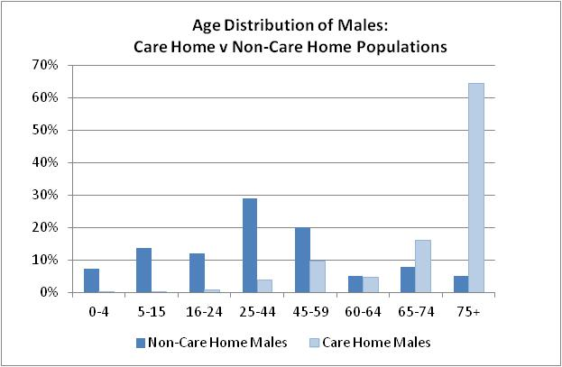

**Figure 7.1(b)**

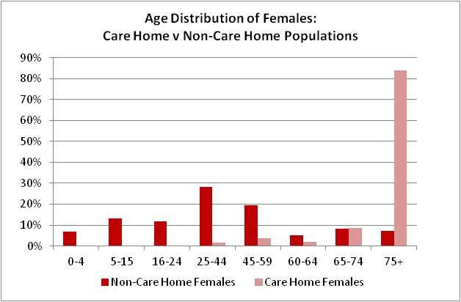

***Relative Prescribing Costs***

7.9 The next part of the analysis looked at prescribing costs per capita for a set of age-gender groups and then standardisation of these costs to produce relative prescribing costs (i.e. same principle as the calculation of NI-PUs). Prescribing costs for those living in the community were isolated from those residing in care homes to provide numerators based on ingredient cost before discount for both groups. These costs were divided by the relevant population denominator, that is, registered patients living in the community and registered patients residing in care homes respectively. This produced costs per head per age-gender group and, once standardised, resulted in the relative prescribing costs shown in Figures 7.2(a) and 7.2(b).

**Figure 7.2(a)**

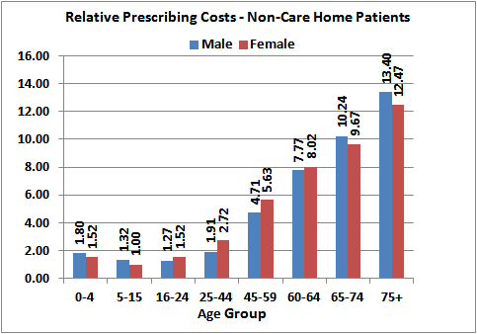

**Figure 7.2(b)**

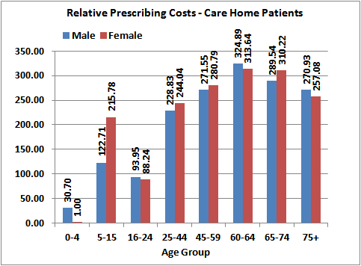

7.10 The profile of the relative prescribing costs for those living in the community is very similar to the NI-PU 2015 age cost curve (compare Figure 7.2(a) with Figure 7.3). In both cases, costs increase with age, females tend to be more expensive than males from age 16-64, with the costs being more similar for both males and females in the older age groups. The profile for those living in the community is slightly less steep than the NI-PU 2015; this is because the NI-PU 2015 is based on total prescribing for all patients and therefore includes care home patients which, as already demonstrated, are more expensive and this pushes the relative costs up in the age groups from 60+.

**Figure 7.3**

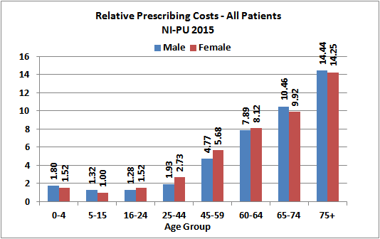

* 1. Interestingly, the profile of the relative prescribing costs of those in care homes does not follow

the same age distribution; there is much less association with age. From age group 25-44, the costs tend to plateau rather than increase and females are not in general more expensive than males. This suggests that the age-gender profile of the population is less important than the fact that the patient is resident in a care home. It is also important to note that the relative costs of those in care homes are much higher overall in each age-gender group than those living in the community; this provides further evidence that these care home patients need higher weightings within the NI-PU system because of their greater need. Note that the ratio of cost between patients in care homes and other patients decreases with age; that is, the difference between the cost associated with care home patients compared to those in their own homes is greater in the younger age groups. For example, a male aged 25-44 in a care home is 120 times more expensive than a male of the same age living in their own home; whereas a male aged 75+ in a care home is only 20 times more expensive than the equivalent male living in their own home.

* 1. The previous use of age bands that correspond to NI-PU age bands was to allow direct comparison of the age cost curves for care home and non-care home with overall prescribing patterns. In case of masking any variation due to the smaller number of age-gender groups, the analysis was repeated using 5-year age bands, the resulting graphs for which can be seen in Figures 7.4(a) and 7.4(b). While the distribution of the relative prescribing costs for non-care home patients was similar, the use of the larger age bands masked how much higher the relative prescribing costs for 11-15 year old females in care homes are, the extent of which was not as apparent in Figure 7.2(b). Closer inspection of the data revealed that use of the larger age bands had masked this due to a greater number of patients, a lower cost per capita and a smaller relative cost weight. These findings therefore support the use of the 5-year age bands for the next stage of analysis.

**Figure 7.4(a)**

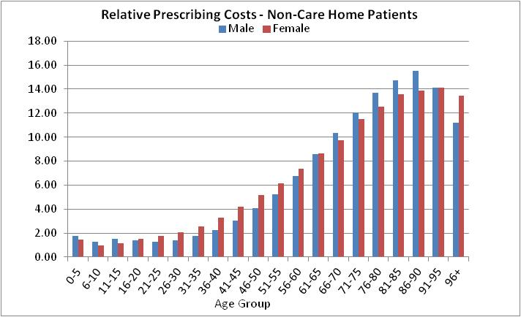

**Figure 7.4(b)**

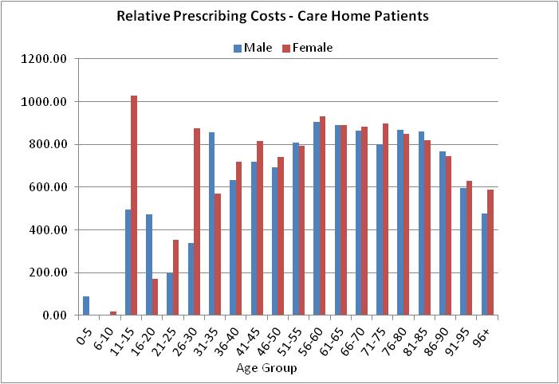

* 1. The use of 5-year age bands provides more accurate analysis and does not create any difficulties with application of a care home adjustment within the prescribing formula allocation calculation. The ultimate output of this analysis is to arrive at a single weighting for care home patients which can be applied regardless of the age bands being used. The allocation calculation will actually use the NI-PU age bands so that NI-PU can be applied, with the additional weighting being applied to care home residents.
  2. Of note are the different scales in Figures 7.2(b) and 7.4(b). The use of smaller age bands resulted in a smaller minimum cost per capita for care home patients and therefore much larger relative cost weights. This was due to how many patients were in each age band and the total cost of prescriptions.

***Ratio of Cost per Prescribing Unit***

7.15 The next stage of the analysis was to apply the NI-PU 2015 weightings to practice registered lists, having isolated those patients in care homes from all other patients. The NI-PUs were applied to practice lists broken down by age-gender groups, resulting in a number of prescribing units for each practice for both care home patients and other patients. The prescribing costs for each practice were derived separately for care home patients and non-care home patients. We then calculated the cost per PU for the care home patients and the other patients in each practice and took a ratio of the 2 values. The cost per PU for patients in care homes was £97.62, while the cost for the remaining patients was £39.91, leading to a ratio of 2.45. Individually, however, practices had ratios that varied considerably, from a maximum cost ratio of 6.97 to a minimum of 0.19. Figure 7.5 shows the distribution of the ratio between cost per NI-PU for patients in care homes compared with the rest of the patients in the practice. **Given the distribution of the ratios, we would recommend that the weights for patients in care homes be 2.5 times the value of the corresponding patients living in their own homes. The adjustment introduced in 2013/14 was also a 2.5 weighting for care home patients and therefore we are recommending this continues to be incorporated within the age-gender adjustment.**

**Figure 7.5**

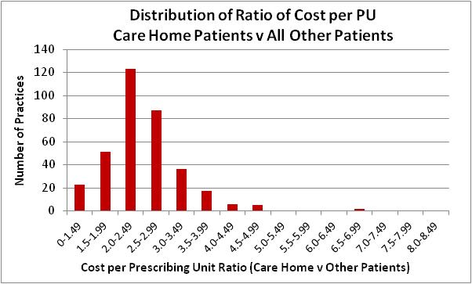

***Prescribing Measures in England***

7.16 Note that in a study carried out in 1997 by the Prescribing Support Unit1 and documented in the NHS Information Centre, Prescribing Support Unit “Prescribing Measures and their Application”, 6th Edition, October 2009, it was recommended that the prescribing units for residential home patients be doubled and those for nursing home patients be tripled. The document also noted that, given the new classification of care homes in which it would be difficult to separate nursing and residential homes, a weighting of 2.5 should be used. Our findings and recommendation are therefore in line with English evidence. Note that the care home weighting is not used by the Department of Health in calculating PCT allocations, as the requisite data is not available centrally; in Northern Ireland, we have the necessary population data to be able to apply the weighting in both LCG and GP practice allocations.

***Application of NI-PU Weightings for Patients in Care Homes***

7.17 To allow for care home weightings in budget allocations for practices and LCGs, it is recommended that the following procedure is followed:

**Calculate the number of NI-PUs for the patients in the care home and then multiply this number by 2.5 before adding to the remaining NI-PUs for the practice (i.e. NI-PUs for the non-care home patients).**

7.18 The care home adjustment had been introduced for the 2013/14 allocation round and has continued to be applied as described above in all subsequent years. The weighting was set at 2.5 and this updated analysis has reaffirmed that weighting.

* 1. We have applied the updated NI-PU 2015 weightings to the care home populations of each practice at April 2015 (broken down by 16 age-gender groups) to create prescribing units per practice. We have then multiplied these “care home” prescribing units by 2.5 to account for the additional weighting recommended for care home patients. We have then applied the NI-PUs to the remaining patients on the lists by the 16 age-gender groups, ensuring the number in care homes have been deducted from these registered list populations. This creates “non-care home” prescribing units, which are added to the “care home” prescribing units to arrive at total prescribing units per practice.

**Impact of the Care Home Adjustment within the Prescribing Formula at GP Practice Level**

7.20 The distribution of the age-gender index is more redistributive when the care home weighting is included. The range of the index with the care home weighting is larger and has greater variability (see Table 7.2). Application of the age/gender index without the care home weighting redistributes +/-4.11% of prescribing resources (this equates to +/-£16.45m of the total 2015/16 £400m budget) compared to the un-weighted registered practice lists % shares. Inclusion of the care home weighting redistributes +/-4.35% of prescribing resources (this equates to +/-£17.40m of the total 2015/16 £400m budget) compared to the un-weighted registered practice lists % shares. (Note that inclusion of the care home adjustment is equivalent to redistributing an additional +/-0.54% or +/-£2.1m of the 2015/16 budget).

**Table 7.2 Summary Statistics for the Age-Gender Index, With & Without a Weighting for Care Homes**

|  |  |  |
| --- | --- | --- |
|  | Age/Gender Index  Without Care Home Weighting | Age/Gender Index  With Care Home Weighting |
| Minimum | 0.4942 | 0.4826 |
| Maximum | 1.2699 | 1.2877 |
| Range | 0.7757 | 0.8052 |
| 5th Percentile | 0.8435 | 0.8306 |
| 25th Percentile | 0.9331 | 0.9312 |
| Mean | 1.0034 | 1.0034 |
| Median | 1.0040 | 0.9982 |
| 75th Percentile | 1.0790 | 1.0824 |
| 95th Percentile | 1.1878 | 1.1942 |
| Standard Deviation | 0.1068 | 0.1125 |

7.21 44% of practices would gain weighted patients and 56% of practices would lose weighted patients as a result of applying the care home adjustment. The change in weighted patients would range from -2.43% to +7.11%. 50% of practices would have a change in weighted patients between -1.08% and +0.81%. 75% of practices would have a change in weighted patients between -1.55% and +1.45%. The bottom 25% of practices that lose weighted patients with application of the adjustment see only small changes up to a maximum of -2.43%. Of the top 25% of practices that gain weighted patients through application of the adjustment, 87.4% of these top 25% gain up to +2.83%, leaving only 3% of practices in total that gain over +3.0%. The small % changes in weighted patients across the majority of practices allow resources to be redistributed to the small number of practices that have relatively higher number of patients in care homes.

**Impact of the Care Home Adjustment within the Prescribing Formula at LCG Level**

7.22 The annual calculations require a download from the Exeter System in BSO, which records all patient registrations with GPs. BSO currently supply annually each patient’s age, gender, postcode and practice of registration; an additional field is also provided which indicates whether the patient is resident in a care home or not and this allows the creation of separate population bases. The same method of calculating prescribing units for care home patients and multiplying by 2.5 before adding to the remaining prescribing units is applied; at LCG level this involves summing together the practice populations (care home and non-care home separately) for those practices geographically located/managed within each LCG. Table 7.3 demonstrates the impact of incorporating the care home adjustment within the capitation formula when setting LCG allocations.

7.23 The following should be noted when interpreting Table 7.3. The constrained registered population shares are at April 2015. The age index either with or without the care home adjustment refers to the application of the new NI-PU 2015. The additional needs index in the table refers to the current index in operation and not that which will be developed as part of this 2015 formula review. The age and needs indices are applied simultaneously to the LCG constrained registered population, producing a weighted population. The application of the indices produces a notional population which differs from the actual population; these weighted populations are adjusted through a process of normalisation (or rebasing) so as to total the constrained registered population. Each LCG then receives their share of the overall rebased weighted population. The care home index is not used in the allocation calculation, the care home adjustment is part of the overall age-gender adjustment; this is simply to demonstrate the impact of the adjustment on each LCG. The care home index is the ratio of the age index with the care home adjustment to the age index without incorporating the care home adjustment. South Eastern LCG experiences the largest positive gain from application of the adjustment; this is expected given South Eastern LCG’s more elderly age structure. Southern and Western LCGs have care home indices less than 1.0 indicating that their age weighted population share reduces with incorporation of the care home adjustment into the age-gender adjustment.

**Table 7.3 Impact of Incorporating the Care Home Adjustment within the Weighted Capitation GP Prescribing Formula at LCG Level**

|  |  |  |  |  |  |
| --- | --- | --- | --- | --- | --- |
|  | **Belfast** | **S Eastern** | **Northern** | **Southern** | **Western** |
| Constrained Registered Population % Shares# | 22.33% | 16.89% | 24.23% | 20.22% | 16.33% |
| Age Index **Without** CH Adj | 0.9852 | 1.0703 | 1.0246 | 0.9544 | 0.9675 |
| Age Index **With** CH Adj | 0.9856 | 1.0766 | 1.0247 | 0.9522 | 0.9630 |
| Age Wgt Popn Shares  (Without Care Home Adj) | 22.00% | 18.08% | 24.82% | 19.30% | 15.80% |
| Age Wgt Popn Shares  (With Care Home Adj) | 22.01% | 18.19% | 24.82% | 19.25% | 15.72% |
| Additional Needs Index at LCG$ | 1.1029 | 0.9590 | 0.9746 | 0.9640 | 1.0095 |
| Total Index (Without Care Home Adj) Total % Shares | 1.0829  24.18% | 1.0229  17.28% | 0.9951  24.11% | 0.9168  18.54% | 0.9733  15.89% |
| Total Index (With Care Home Adj)  Total % Shares | 1.0668  23.82% | 1.0357  17.50% | 1.0001  24.23% | 0.9186  18.57% | 0.9723  15.88% |
| **CARE HOME INDEX** | **1.0005** | **1.0058** | **1.0001** | **0.9977** | **0.9953** |

# The population base for care home patients is the registered list; these are not constrained as there would be no official populations to scale them back to. There is unlikely to be list discrepancy in this sub-population but also it is more appropriate here not to constrain so the practice adjustment for care homes is based on all those care home patients registered with each practice.

$ Note the needs index is applied according to the patient’s residency LCG (i.e. based on the patient’s postcode) and not the LCG of the practice at which the patient is registered.

Note the population shares are based on the GP registered populations (constrained to match the official mid-year estimate of population) whereas the needs index is based on patient residency. Therefore direct multiplication of the indices in the table above to the population shares will not result in the total index or total shares shown.

**Recommendation:**

**The care home adjustment should be incorporated within the age-gender weighting and implemented in setting both LCG and GP practice allocations.**

**8. Data for Modelling Additional Need**

***Background***

8.1 After adjusting for the age and/or gender structure of the population, including the relative higher prescribing costs of those in care homes, the next weighted capitation adjustment is that required to reflect the relative need for prescribing resources over and above those due to population size and age/gender structure. This adjustment allows for 2 populations (either GP practices or SOAs) of similar size and demographic structure but who, due to morbidity and socio-economic reasons; have additional need for prescribing resources.

8.2 The aim of the additional needs modelling is to relate prescribing utilisation to population needs. Population needs are measured using a range of morbidity, deprivation and socio-economic factors, whilst prescribing utilisation is measured in the form of costs per capita adjusted for age. The dataset can be partitioned into costs, needs and supply.

***Unit of Analysis***

8.3 Historically when developing the GP prescribing weighted capitation formula, analysis could only be carried out at GP practice level, as the prescribing cost utilisation data to create the dependent variable was only available at GP practice level. The Electronic Prescribing and Eligibility System (EPES) and associated enhanced prescribing database, which stores all prescription data, now makes it possible to analyse prescribing costs by area. Due to the 2-D barcode on the prescription form, information is now captured on the patient, including their postcode. By assigning geographically referenced information to the patient based on their postcode, we can produce costs by Super Output Area (SOA). The modelling strategy and advantages and disadvantages of area-based modelling versus GP practice level modelling will be dealt with in separate sections and the results of both presented separately. There is, however, much overlap in terms of the datasets required to be assembled for analysis at either level and therefore the descriptions of the datasets and the construction of the variables are detailed jointly in this section. The GP practice and SOA datasets had potentially 351 units (351 GP practices) and 890 units (890 SOAs) respectively.

***Costs – Dependent Variable***

8.4 Cost data relate to the financial year 2013/14 and represent ingredient cost before discount of prescriptions issued and subsequently dispensed. The 2 datasets acquired from the BSO to create NI-PU were used again to create the dependent variables: (i) a dispensing dataset (to create the numerator) and (ii) a population dataset of GP registered patients (to create the denominator). The dispensing dataset has already been described, including items that were excluded, at paragraphs 5.10 to 5.12 and the population dataset at paragraph 5.13. Depending on the functional form of the model, the cost utilisation dependent variable will take different forms, for example, for some functional forms the costs are stratified by age-gender groups; in other functional forms the costs will be age standardised before being employed in the model. Details of the construction of the dependent variables are included in the modelling strategy (see section 10).

8.5 An important exclusion from the datasets is items on the high cost drug list. Currently within the allocation process, high cost drugs are dealt with by “top-slicing” GP practice allocations and allowing the Health and Social Care Board (HSCB) to retain a proportion of the overall NI allocation to enable these drugs and/or patients to be managed out of a central pot. GP practices are therefore relieved of the financial responsibilities of dealing with low numbers of very high cost patients, which would be difficult to control within their budget. As these high cost drugs are dealt with off-formula, they have accordingly been excluded from all analysis.

8.6 A criticism from the peer reviewer during the last GP Prescribing Formula Review in 2010 was that the cost numerator and population denominator were not commensurate (costs were for a full financial year whereas the population was a mid-year snapshot). Likewise, the age cost curve (NI-PU 2010) was derived from cost utilisation data relating to a different period than the cost utilisation data for modelling additional need. Both these issues have been rectified for this review; data, both cost utilisation and the population base, are consistent throughout all elements of formula development. The numerator refers to all items dispensed during 2013/14 and the population relates to all patients registered during the same period.

8.7 In principle, it would have been preferable to use generic-equivalent prices to minimise rewarding GP practices who prescribe higher rates of branded medicines. This was raised by the peer reviewer during the last review but was not feasible. BSO have indicated that this would continue to pose problems for them in terms of generating the data. A supply variable for the proportion of monthly generic items will be included in the GP practice level models.

***Health Care Need***

8.8 A comprehensive set of needs variables was constructed at both GP practice and SOA level. There is no evidence that these “needs drivers” are in fact measures of health care needs. This is recognised as a limitation with any resource allocation model based on relative needs; however, as “needs” are not directly observable, it is difficult to overcome this problem. Pragmatically, this modelling assumes that needs are an aggregate of decisions made by healthcare professionals in assessing relative needs depending on morbidity, deprivation and socio-economic factors.

8.9 The needs variables can be categorised into a number of themes as below. All needs variables, with the exception of disease prevalence indicators, were available at Super Output Area (SOA) level. A number of variables were age standardised where it was believed that the variable would be concentrated in particular age groups. For the SOA dataset, the variables were used as constructed; however, for the GP practice dataset it was necessary to attribute the variables from SOA to GP practice level. An explanation of this attribution process is provided at Appendix F. Disease prevalence rates are sourced from the Quality and Outcomes Framework (a funding stream within the GMS Contract for general practitioners); this data was only available at GP practice level and it was therefore necessary to attribute these data from GP practice to SOA level for inclusion in the SOA dataset.

**Health and unpaid care**: this includes self reported health and unpaid care from the 2011 Census, childhood immunisation rates, standardised admission rates and emergency admissions, dental treatments, proportion of babies and low birth-weight babies.

**Vital Statistics**: this includes mortality, birth and fertility variables sourced from NISRA.

**Qualifications**: this includes a range of variables relating to different levels of educational attainment from the 2011 Census.

**Housing, Accommodation & Living Arrangements**: this includes car ownership, housing tenure, household amenities, marital status and living arrangements. All these variables were derived from 2011 census data.

**Ethnicity, Identity & Religion**: this includes country of birth, ethnic group and religion derived from 2011 Census data.

**Labour Market, Employment & Socio-Economic Classification**: this includes unemployment, full and part-time employees, long-term sick, students and the National Statistics Socio-Economic Classifications. These variables were derived from 2011 Census data.

**Social Security Income Related Variables**: this includes the proportion of claimants in receipt of a range of social security benefits as sourced from live administrative systems maintained by the Department of Social Development.

**Index of Multiple Deprivation**: this includes the overall score for the Northern Ireland Multiple Deprivation Measure plus scores from each of the domains from which it is comprised. These measures are sourced from the NISRA Multiple Deprivation Measure 2010.

**Rurality Indicators**: this includes population density and agricultural employment from the 2011 Census plus the NISRA rural-urban classification 2010.

**Disease Prevalence**: this includes age standardised prevalence rates per 1,000 population for 10 chronic conditions; coronary heart disease, stroke and TIA, diabetes, epilepsy, hypertension, asthma, chronic kidney disease, chronic obstructive pulmonary disease, cancer and mental health.

8.10 Definitions of the needs variables with summary statistics are provided at Appendix G. Correlations with the dependent variables are also provided at Appendix G. Note these statistics are only presented for the reduced dataset that is after dealing with co-linearity of variables.

***Health Care Supply***

8.11 Utilisation of health care resources does not depend only on patient need and demand. The availability or supply of resources also has an influence. Techniques for measuring supply have been developed so that variations in supply between GP practices or areas can be controlled for in the modelling. Area supply conditions were used to pick up access measures for health care services. These access measures take 2 forms: (i) weighted average distances to nearest facilities and (ii) distances specific to each individual patient recorded on NHAIS.

***(i) Weighted Average Distances to Nearest Facility***

* Average distance to nearest Accident & Emergency Department (A&E)
  + Average distance to nearest Minor Injuries Unit (MIU)
  + Average distance to nearest A&E or MIU
  + Average distance to nearest GP Practice
  1. These variables were constructed using Simplified Modelling of Spatial Systems (SMOSS)

software. SMOSS allowed us to create a matrix of distances from the centroid of each census output area (COA) to the centroid of the COA in which the facility (A&E, MIU or nearest GP practice) in question is located. Identification of minimum distances between each COA and each facility are then aggregated up to SOA level and weighted by SOA populations to create weighted average distances to nearest facility. As these variables are constructed at SOA level, it was necessary to then attribute them to GP practice level for inclusion in the GP practice dataset.

***(ii) Patient-Specific Distances***

* + Average distance to GP Practice of registration
  + Proportion of patients living less than 3 miles from their practice of registration
  + Proportion of patients living 3 or more miles from their practice of registration
  + Proportion of patients living 5 or more miles from their practice of registration
  + Proportion of patients living 8 or more miles from their practice of registration
  + Proportion of patients living 10 or more miles from their practice of registration

8.13 These variables were again constructed using SMOSS software. This time a matrix of distances was constructed from the centroid of each COA to every other COA. All patients on NHAIS could then be assigned a COA of residency and a COA for their practice of registration, allowing us to attach a distance to each patient based on the distance from their residency COA to registration COA. Once distances were attached to each patient, we were able to create average distance to practice of registration and the proportion of patients living certain distances from their practice of registration. It was possible to derive these variables at both SOA and GP practice level for inclusion in the respective datasets without the need for attribution.

8.14 Practice supply characteristics were available directly at GP practice level; the following variables were included as additional supply variables within the GP practice level dataset:

* Number of GPs
* Number of GPs per 1,000 list population
* Number of patients per GP
* Whether the practice was a training or dispensing practice
* The average number of monthly prescription items by GP practice
* The proportion of monthly generic items by GP practice
* The electronic prescription scan rate of the GP practice
* The proportion of the GP practice list residing in a care home
* Whether the GP Practice was classified as rural as denoted by its postcode.
  1. Definitions of all the supply variables with summary statistics are provided at Appendix G.

Correlations with the dependent variables are also provided at Appendix G.

***Local Commissioning Group Effects***

8.16 It can be reasonably assumed that Local Commissioning Groups (LCGs) may operate in different ways when providing health care services to their respective populations. These may impact on utilisation patterns and/or the needs of the population. Differences between areas created by policy decisions can be controlled for in regression models through the use of dummy variables. Binary dummy variables were created for each LCG, practices belonging to a particular LCG received the value 1 and all other practices were coded 0. The Northern LCG being the largest in terms of population was used as the comparator. The LCG dummies are not used in calculating allocations; allocations should not be based on different historical utilisation levels which may in part be due to different policies in each LCG.

***List Discrepancy Effect***

8.17 It is recognised that list discrepancy is correlated with GP practice characteristics, which in turn could be correlated with need. Historically within the modelling, the approach had been to control for differential list discrepancy at GP practice level whilst estimating the needs coefficients. During the last review in 2010, there was much debate and peer review advice on the most appropriate method to deal with the list discrepancy effect. It was agreed that, given the nature of list discrepancy in Northern Ireland, the use of either a dummy control variable or directly adjusting the cost utilisation dependent variable would be too blunt.

8.18 Although there will be “ghost patients” due to mobile populations, migrations and delays in removing those who have died or moved away from Northern Ireland, a certain amount of list discrepancy in Northern Ireland will be due to un-entitled users from the Republic of Ireland who use addresses of convenience in NI to avail of health services. Therefore in NI some of these “ghosts” are actual GP registrations and subsequently make demands on a GP practice’s prescribing resources. Controlling list discrepancy as described in paragraph 8.15 would remove all apparent “ghosts”, including these ROI users and this would subsequently penalise GP practices in border areas that would have the largest numbers of un-entitled users.

8.19 Our approach instead comes from the view that some causes of list discrepancy may be correlated with needs. We want to model the non-need component of list discrepancy and then use a predicted list discrepancy variable which is uncontaminated by needs effects to control for list discrepancy. The benefit of this approach is that any needs component of list discrepancy is netted out, that is, we are left with an estimate of list discrepancy having removed needs effects.

8.20 The method involves firstly deriving an estimate of list discrepancy for each GP practice by attributing the level of list discrepancy at Local Government District (LGD) level to practice level. It was possible to construct list discrepancy at SOA level directly without attribution by comparing NHAIS GP registered populations based on SOA of residency with NISRA mid-year population estimates at SOA level. This variable is then regressed against the preferred set of needs variables from the preferred model plus variables that we suspect affect list discrepancy. Variables that we suspect of being list discrepancy indicators include: students, births, deaths and migration. Given the Northern Ireland issue of un-entitled users, who are availing of services, a “distance to the border” variable is included as a needs indicator rather than a non-needs component. Based on the regression coefficients for the list discrepancy indicators only, we can construct a predicted list discrepancy indicator. This allows identification of the difference between the 2 list estimates that are due to the list discrepancy indicators and not the genuine needs drivers. The preferred model is then re-run including the predicted list discrepancy variables rather than using the list discrepancy variable itself directly.

***Quality & Outcomes Framework (QOF) Prevalence Data***

8.21 The Quality and Outcomes Framework (QOF) is a funding stream within the GMS Contract introduced in April 2004. The QOF rewards GP practices on the basis of the quality of care delivered to their patients through a framework of indicators. A feature of the QOF is the requirement to maintain registers of patients who currently have or in some cases have ever had particular chronic conditions. One of the main difficulties in using QOF register data for resource allocation modelling purposes is that the data is only reported as total counts for each GP practice. Crude prevalence rates can be calculated by dividing the register count by the GP practice list size, but ideally for modelling purposes we require the data to be age standardised to take account of variations in age and gender where it was believed that the variable would be concentrated in specific age groups.

***Prescribing Formula Review 2010 & Testing QOF Data***

8.22 During the 2010 Review,we explored the use of QOF registers as a robust source of morbidity data to include within the additional needs modelling. At that time, 7 of the QOF disease registers had remained consistent in terms of definition across the 5 years of QOF (2004/05 to 2008/09). We used a number of published sources to compile UK or NI prevalence rates to use as age standardisation. Indirect standardisation was used, that is the rates are applied to the age-gender composition of the GP practice list to arrive at an expected number of people with the specific condition. The indicator is the ratio of the actual QOF register count to the expected value. Our main concerns during the last review were whether QOF registers and prevalence are a robust and accurate source of epidemiological data on morbidity and whether the type of morbidity measured is appropriate for allocating prescribing resources. QOF registers are more concerned with identifying people who need symptom management or review in primary care, than measuring prevalence per se. This issue is also relevant in terms of whether the data sources used for age standardisation are suitable for use in indirect age standardisation and again whether these sources are more likely to measure prevalence as opposed to symptom management and review.

8.23 During the 2010 Review, we tested the validity of our age standardised prevalence rates with common measures of morbidity and deprivation (the overall NI Index of Multiple Deprivation, the Health Domain of the IMD and SMR u75). The results are shown in Table 8.1. COPD was the only register to exhibit a strong positive correlation (and significant at the 0.05 level). Otherwise, there was no consistent pattern, with a number of registers exhibiting negative associations. Given these results and bearing in mind our concerns, QOF variables were not included in the main modelling work but were subjected to sensitivity testing. This sensitivity testing proved to add nothing to the preferred model; none of the QOF variables exhibited significant coefficients, the R2 remained unchanged and the needs variables remained significant with their expected relationship with prescribing variation.

**Table 8.1 Correlations between QOF Registers & Morbidity/Deprivation Measures**

**GP Prescribing Formula Review 2010**

|  |  |  |  |
| --- | --- | --- | --- |
| **Disease Register** | **NI Index of Multiple Deprivation** | **NI IMD Health Domain** | **SMR u75** |
| **Coronary Heart Disease** | 0.334* | 0.297* | 0.330* |
| **Stroke & TIA** | 0.142* | 0.178* | 0.201* |
| **Hypertension** | 0.064 | -0.018 | -0.005 |
| **Hypothyroidism** | -0.270* | -0.242* | -0.238* |
| **Chronic Obstructive Pulmonary Disease** | 0.668* | 0.597* | 0.615* |
| **Asthma** | 0.038 | 0.070 | 0.071 |
| **Cancer** | 0.020 | -0.007 | 0.012 |

**\* p<0.05**

***Testing QOF Data for Inclusion in Additional Needs Modelling - Prescribing Formula Review 2015***

8.24 During this 2015 Review, 10 QOF registers have remained consistent for the last 5 years (2009/10 to 2013/14) and we were able to source prevalence rates from other data sources for these diseases. The data sources and the disease profiles used for age standardisation are provided at Appendix H. We have again tested validity of our age standardised prevalence rates with common measures of morbidity and deprivation (the overall NI Index of Multiple Deprivation, the Health Domain of the IMD and SMR u75). The results are shown in Table 8.2. For those QOF registers covered in the 2010 Review, we can compare the correlations using updated QOF data and having used different data sources for the age standardisation. CHD, stroke and COPD have stronger associations with the morbidity and deprivation measures. Hypertension and asthma have stronger correlations but are also now significant. Cancer continues to show no correlation with these morbidity/deprivation measures and continues to be non-significant. Of the additional registers now covered, diabetes, epilepsy and mental health have moderate correlations and all are significant. Chronic kidney disease shows no correlation with these morbidity/deprivation measures.

**Table 8.2 Correlations between QOF Registers & Morbidity/Deprivation Measures**

**GP Prescribing Formula Review 2015**

|  |  |  |  |
| --- | --- | --- | --- |
| **Disease Register** | **NI Index of Multiple Deprivation** | **NI IMD Health Domain** | **SMR u75** |
| **Coronary Heart Disease** | 0.554* | 0.589* | 0.523* |
| **Stroke & TIA** | 0.387* | 0.399* | 0.403* |
| **Diabetes** | 0.380* | 0.365* | 0.372* |
| **Epilepsy** | 0.525* | 0.521* | 0.521* |
| **Hypertension** | 0.290* | 0.339* | 0.139* |
| **Chronic Kidney Disease** | -0.049 | 0.005 | -0.152* |
| **Chronic Obstructive Pulmonary Disease** | 0.735* | 0.694* | 0.683* |
| **Asthma** | 0.289* | 0.274* | 0.245* |
| **Mental Health** | 0.370* | 0.391* | 0.436* |
| **Cancer** | -0.016 | 0.037 | -0.088 |

**\* p<0.05**

8.25 We have considered the correlation between the age standardised QOF registers and the dependent variable for the 2010 Review and the equivalent dependent variable in the 2015 Review, cost per prescribing unit, that is costs per head at GP practice level having adjusted for age and gender. These correlations are shown in Table 8.3. Again, the correlations have improved and hypertension is now significant. Cancer continues to have no association with prescribing costs. Of the new registers, with the exception of CKD which shows no correlation, the others have moderate correlation with prescribing costs and are significant. Given these results, this time we have included the QOF variables in the main modelling exercise.

**Table 8.3 Correlations between QOF Registers & Dependent Variables**

|  |  |  |
| --- | --- | --- |
| **Disease Register** | **Cost per PU 2010** | **Cost per PU 2015** |
| **Coronary Heart Disease** | 0.334* | 0.536* |
| **Stroke & TIA** | 0.167* | 0.321* |
| **Diabetes** | - | 0.398* |
| **Epilepsy** | - | 0.438* |
| **Hypertension** | 0.101 | 0.196* |
| **Hypothyroidism** | 0.083 | - |
| **Chronic Kidney Disease** | - | 0.048 |
| **Chronic Obstructive Pulmonary Disease** | 0.365* | 0.386* |
| **Asthma** | 0.161* | 0.227* |
| **Mental Health** | - | 0.269* |
| **Cancer** | -0.028 | 0.021 |

**\* p<0.05**

**9. Replication of the Current GP Prescribing Formula Additional Needs Index**

9.1 In this section, we aim to replicate the current GP prescribing formula additional needs index using new data assembled during this current review. The dependent variable in the current model was based on cost weighted prescribing activity for the financial year 2007/08. This was indirectly standardised using the age cost curve (NI-PU 2010) to account for variations in the age and gender distribution of each practice. The preferred model which was subsequently implemented was a 2-stage additive model, where, at the first stage, age-related needs are calculated by estimating average levels of use for different age-gender groups (known as the age cost curve). At the second stage, additional needs are estimated by regressing cost weighted activity against a set of needs indicators but at this stage the utilisation data are standardised using the age cost curve to control for the effects of age and gender. The dependent variable is therefore cost per head standardised for age and gender.

9.2 We have replicated the dependent variable using cost weighted prescribing activity for the financial year 2013/14. This has been indirectly standardised using the new age cost curve devised during this current review (NI-PU 2015).

9.3 The supply and needs variables used in the current formula additional needs index are shown in Table 9.1. We were able to replicate all the variables using updated data. The original and updated data sources are shown in the table. The unit of analysis in both cases is GP practice. Comparison of the replicated model with the original model is shown in Table 9.2.

**Table 9.1 Indicators in Current Additional Needs Index**

|  |  |  |
| --- | --- | --- |
| **Indicators in Current Formula** | **Original Data Source** | **Updated Data Source** |
| ***Supply Variables*** |  |  |
| Single-handed GP | BSO data at January 2008 | BSO data at April 2014 |
| Number of GPs in practice | BSO data at January 2008 | BSO data at April 2014 |
| Patients per GP | BSO data at January 2008 | BSO data at April 2014 |
| Average monthly items | BSO data at January 2008 | BSO data at April 2014 |
| Generic prescribing rate | BSO data at January 2008 | BSO data at April 2014 |
|  |  |  |
| % List Discrepancy | NHAIS July 2007 & MYE 2007 | NHAIS 2013/14 & MYE 2013 |
|  |  |  |
| ***Needs Variables*** |  |  |
| % of babies on practice list | NHAIS January 2008 | NHAIS 2013/14 |
| Children in Lone Parent Households | Census 2001 | Census 2011 |
| Index Multiple Deprivation: Education | NISRA: NI Multiple Deprivation Measure 2005 | NISRA: NI Multiple Deprivation Measure 2010 |
| Full-time Students | Census 2001 | Census 2011 |

**Table 9.2 Replication of Current Additional Needs Index with Updated Data**

|  |  |  |  |  |  |  |  |
| --- | --- | --- | --- | --- | --- | --- | --- |
|  | | **Current Additional Needs Index** | | | **Replicated Additional Needs Index** | | |
| **Variable** | | **Co-efficient** | **t-value** | **Significance** | **Co-efficient** | **t-value** | **Significance** |
| Number of GPs | | -0.786 | -6.979 | <0.001 | -0.702 | -6.126 | <0.001 |
| Patients per GP | | -0.241 | -3.895 | <0.001 | -0.295 | -4.005 | <0.001 |
| Single-handed Practice | | 0.089 | 1.839 | 0.067 | 0.124 | 2.243 | 0.026 |
| Average Monthly Items | | 0.931 | 8.476 | <0.001 | 0.667 | 6.222 | <0.001 |
| Generic Prescribing Rate | | -0.321 | -7.769 | <0.001 | -0.068 | -1.385 | 0.167 |
|  | |  |  |  |  |  |  |
| List Discrepancy | | 0.010 | 0.157 | 0.875 | -0.214 | -3.875 | <0.001 |
|  | |  |  |  |  |  |  |
| Children in Lone Parent Households | | 0.318 | 3.709 | <0.001 | 0.049 | 0.396 | 0.693 |
| Index of Multiple Deprivation: Education | | 0.235 | 3.164 | 0.002 | 0.397 | 3.687 | <0.001 |
| % of babies on list | | 0.096 | 2.403 | 0.017 | 0.064 | 1.152 | 0.250 |
| Full-time Students | | -0.119 | -2.571 | 0.011 | -0.005 | -0.072 | 0.943 |
| Regional Indicators | | HSS Boards | | | Legacy HSS Boards | | |
|  | | | | | | | |
| Observations | 354 | | | | 351 | | |
| R2 | 50.5% | | | | 36.2% | | |
| RESET Test | -1.615 p = 0.107 | | | | -0.158 p = 0.875 | | |
|  | | | | | | | |
| **Distribution of Additional Needs Index Across Practices** | | | | | | | |
| 5th Percentile | 0.9461 | | | | 0.9044 | | |
| 25th Percentile | 0.9706 | | | | 0.9669 | | |
| Mean | 1.0036 | | | | 1.0106 | | |
| Median | 0.9918 | | | | 1.0061 | | |
| 75th Percentile | 1.0233 | | | | 1.0539 | | |
| 95th Percentile | 1.1134 | | | | 1.1591 | | |
| Standard Deviation | 0.0511 | | | | 0.1054 | | |

9.4 The regression analysis using updated data explains a lower proportion of variation in cost weighted activity than in the original model (36.2% compared to 50.5%). With respect to the supply variables, the coefficients in the replication model exhibit the same sign as in the original model; however, generic prescribing rate is now no longer significant. Using new data, the coefficient on generic prescribing rate is less than half the size of the coefficient in the current model.

9.5 In terms of the needs variables, 3 of the 4 needs variables are no longer significant when the model is replicated using updated utilisation data and updated needs variables. The magnitude of the coefficients on the variables changes when using new utilisation and needs data. The coefficients using new data are not as strong and are in line with the fact that these are no longer significant.

9.6 Table 9.2 also includes the distribution of the additional needs indices resulting from the current model and replication model with new data. Although the distribution is wider under the replication model, this is now irrelevant to the analysis given that the variables are not significant. The variable definitions are consistent between the 2 models and therefore the change in coefficients and significance suggests that the relationship between activity and the current needs indicators have changed. These needs indicators no longer reflect current levels of need. Replicating the old model with new data results in an approximately 1.5 fold increase in the range of the needs adjustments across GP practices but this increase is associated with a 2-fold increase in the standard deviation. Consequently the replication model has only around 70% of the explanatory power of the original model. Continuing to use the current model will lead to allocations which do not reflect current need and which would lead to inaccurate practice and LCG allocations. This analysis gives a strong case for a full formula review.

**10. Additional Needs Modelling Strategy**

***Background to Model Approaches***

10.1 The aim of this utilisation-based modelling is to determine the need for prescribing resources after allowing for population size and the age-gender structure of the population (GP practice or SOA). Before embarking on this modelling, we need to consider the preferred functional form of the model components, the different models available, and their underlying differences, especially in terms of the way age-gender related needs and additional needs are combined. This allows us to identify a preferred model type on a theoretical basis, before considering the output they produce. Table 10.1 shows our starting point in thinking through the model types.

**Table 10.1 Model Approaches & Functional Form**

|  |  |  |  |
| --- | --- | --- | --- |
| **Model Type** | **Age-Gender Component** | **Additional Needs Component** | **Combination of Age-Gender & Additional Needs** |
| **1-stage additive** | Additive | Additive | Additive |
| **1-stage multiplicative** | Multiplicative | Multiplicative | Multiplicative |
| **1-stage stratified** | Additive | Additive | Additive |
| **2-stage additive** | Additive | Additive | Multiplicative |
| **2-stage multiplicative** | Additive | Multiplicative | Multiplicative |

***Background to Level of Analysis***

10.2 Previously in the development of the GP prescribing formula, analysis had to be undertaken at GP practice level, as prescribing cost to create the dependent variable was only available at this level. The Electronic Prescribing and Eligibility System (EPES) and associated enhanced prescribing database maintained by the BSO, which stores all prescription data, now make it possible to analyse prescribing costs by area. Information on the patient, including their postcode, is now captured and by assigning geographically referenced information to the patient based on their postcode of residency, we can produce costs by super output area (SOA). We will consider the advantages and disadvantages of both levels of analysis. GP practice level analysis will be carried out first using 1-stage stratified models and a 2-stage additive model. BNF models will also be tested at GP practice level. SOA/area based model will then be tested; again only 1-stage stratified and 2-stage additive models will be tested. This section describes the rationale and theoretical basis for the choice of models being tested.

***Advantages of GP Practice Level Modelling***

10.3 GP practice characteristics (practice supply variables) could be included in the modelling. It is widely accepted that the local supply of health services can influence the demand for healthcare and, in turn, demand influences utilisation. This is important because, in the absence of a direct measure of need for resources, we are using a utilisation-based approach.

10.4 Prescribing takes place at GP practice level and therefore analysis of the variation in prescribing costs across GP practices may be the more appropriate measurement. Allocations for GP practices have to be calculated directly at GP practice level and therefore there would be consistency in model development and formula application at the GP practice level.

***Disadvantages of GP Practice Level Modelling***

10.5 The majority of supply and needs variables have to be attributed from area level to GP practice and this introduces the issue of attribution error. However, attribution cannot be avoided in implementation of the formula, regardless of whether the needs index has been developed as a GP practice or SOA model; in order to calculate GP practice level allocations, the needs variables that comprise the preferred model have to be attributed.

10.6 It is possible that practice level averages of the characteristics of heterogeneous populations (patients within a GP practice may be less homogeneous than residents within an SOA) could lead to a shallower needs index, which would be less redistributive in terms of shifting resources to those areas most in need.

***Advantages of Area Level Modelling***

10.7 Analysis at SOA level removes the need for attribution of the supply variables and the majority of the needs variables (the exception being the QOF registers, which are only available at GP practice level and therefore would have to be attributed from GP practice to SOA) and therefore removes the issue of attribution error.

10.8 Analysis at SOA level may give a more direct link between population characteristics and prescribing expenditure.

10.9 Allocations for LCGs are built-up from SOAs and so there would be consistency in model development and formula application for LCG budgets.

***Disadvantages of Area Level Modelling***

10.10 GP practice characteristics (practice supply variables) would be omitted from the modelling. We have already noted that it is widely accepted that the local supply of health services can influence the demand for healthcare, which in turn influences utilisation. This is important because in the absence of a direct measure of need for resources, we are using a utilisation-based approach.

10.11 Disease prevalence variables from QOF would have to be attributed from GP practice level to SOA.

***Models Ruled Out from the Outset of Modelling***

***Individual Level Models***

10.12 Ideally, the effects of population characteristics on utilisation would be estimated using individual level data, which tracked the use of health services by individuals over time. The potential problem with basing analysis on GP practices (or areas) is that important differences in population characteristics between sub-groups of the population are diluted in GP practice/area level data. The dependent variable in individual level analysis would be cost-weighted activity per person. Although the enhanced prescribing database now makes it feasible to produce individual level prescribing data and we could therefore compute annual prescribing costs for each individual, including those with zero costs, this is not linked to diagnostic information, socio-economic factors, morbidity, deprivation or disease prevalence. Small area data would therefore have to be applied anyway, on the basis of the patient’s residency, to run individual level models and therefore little is gained in modelling terms.

***1-Stage Additive Models***

10.13 The 1-stage additive approach assumes that the effects of age and additional needs are added together. It assumes that the absolute effects of the additional needs variables are constant across all age-gender groups, that is, the effect of a one unit change in costed weighted activity (the dependent variable) is the same for all age groups. We believe that it would be unrealistic to think the effects of need would be the same in all GP practices/areas irrespective of their level of age-related needs. We acknowledge that the 1-stage additive approach does allow age/need interactions to be captured, but the proportional relationship between needs and age was considered more important in model choice. We have therefore rejected the 1-stage additive type of model.

***Multiplicative Models***

10.14 Linear regression modelling assumes that the contribution of the different independent variables to the prediction of the dependent variable is additive. That is, an absolute change in the dependent variable is proportional to the absolute change in the needs and supply variables. The estimated coefficients attached to the needs variables represent the additional amount of spend resulting from a one unit increase in the needs variables.

10.15 The alternative functional form is multiplicative, that is, a percentage change in prescribing costs per head is proportional to the absolute change in need. It is usual to estimate multiplicative models in log form, by taking the natural logarithm of both sides and estimating the equivalent linear additive model. When using a log model, it is necessary to transform from the predicted log of cost-weighted activity to the predicted level of cost-weighted activity. Although multiplicative models allow interactions between age and additional needs to be captured, issues with transformation make these models less desirable. We have therefore rejected the use of multiplicative models.

***Preferred Model – Stratified 1-Stage***

10.16 Preference would be for a model that allows interactions between age and supply and needs variables to be captured. In a stratified 1-stage approach, there are interactions between each of the age categories and each of the supply and additional need indicators. The model basically involves stratifying the data by age group (or age-gender group). Theoretically, the stratified 1-stage approach is preferred because: (i) it allows the effects of additional needs to vary with age but without the restriction that the effects increase in proportion to the age cost curve; (ii) age, supply and need are still free to interact and (iii) there are no overlaps between age/gender and additional needs effects- both are accounted for simultaneously.

10.17 Although the stratified 1-stage model is the theoretical preference, the models will be assessed in terms of how much value they bring in predicting variation in prescribing costs across the 16 age-gender groups. Although theoretically strong, this approach is less transparent and also significantly more resource intensive, not only in terms of having to produce 16 age-gender based regressions, but also because one-stage stratified models are more complicated when being implemented in terms of how the spreadsheet calculations need to be set up. Other recent resource allocation work in Northern Ireland tested the 1-stage stratified model, but it proved to add little value as there were no differences between the age groups and the same needs indicators resulted regardless of the age group in question. On balance, the over complicated allocation calculations were over-ruled in favour of implementing a simpler but equally well specified 2-stage additive model. It may be that prescribing will produce different models across the age groups and therefore it will be of value to adopt and implement the 1-stage stratified model; if that is not the case, however, it may prove pragmatic to implement a simpler model, but only if not at the expense of capturing needs as fully as possible and if the robustness and specification of the model does not suffer. We may find that the statistical fits for the stratified 1-stage equations are relatively weak for certain age groups, particularly for very young or old age groups where there are less data. The value of adopting the 1-stage stratified model will depend on the relative importance of the theoretical basis, statistical performance and transparency.

10.18 To carry out a stratified 1-stage model, a dependent variable has to be created for each individual age-gender group. Therefore, at either GP practice or SOA level, we would create 16 dependent variables (using the same 16 age-gender groups as the age cost curve). The numerator would be the ingredient cost before discount (2013/14) for the specific age-gender group and the denominator would be the GP registered population (2013/14) for the same age-gender group. For GP practice level modelling, the population would be based on practice of registration; at SOA level, the population would be based on SOA residency of the patient. The dependent variables are not age standardised and age dummies are not required; age is accounted for due to the separate models for each age group.

***Second Choice Model – 2-Stage Additive Model***

10.19 In the absence of being able to develop a stratified 1-stage model or that it proves of little value in terms of implementation, a 2-stage additive model would be the next preferred choice. The 2-stage additive model results in a multiplicative relationship between age and need, when the age and needs are combined. This imposes the assumption that the impact of additional need is the same across all age groups. The 2-stage approach adjusts first for differences in the age-gender structure of the population using the age cost curve, then for remaining additional needs. The same set of needs indicators is assumed to be relevant for all groups. The 2-stage additive model does not have any retransformation issues associated with multiplicative/logged models. The disadvantage of the 2-stage additive model over the stratified 1-stage model is that it imposes the restriction that the additional needs effects increase in proportion to age, whereas the stratified 1-stage model allows needs to vary with age but without the proportional restriction. The other limitation with a 2-stage additive model is that age is accounted for in the additional needs model, but additional needs are not accounted for in the age cost curve. Because age related needs and additional needs are not estimated in a single stage, interactions between the 2 are not fully captured. Despite the limitations, we consider the 2-stage additive the best alternative to the stratified 1-stage model.

***Selection of Supply Variables***

10.20 The choice of supply variables under all types of model and under the various functional forms was determined by whether they exhibited a statistically significant relationship with prescribing expenditure and whether this relationship was intuitive. Selection of supply variables was undertaken whilst conditioning on LCG dummy variables.

***Selection of Additional Needs Indicators***

10.21 All models (1-stage stratified and 2-stage additive) were conditioned on supply variables and LCG dummy variables (used to capture perceived policy influence on prescribing behaviour). An estimate of list discrepancy was also included in controlling for list discrepancy. At a later stage, this estimate will be replaced with a predicted list discrepancy indicator which is uncontaminated by needs effects and the preferred model at that time will be re-run.

10.22 We are interested in finding as parsimonious a model as possible, that is, a model with the least number of variables, which sensibly captures variations in supply-adjusted utilisation. A model may have a large number of significant factors explaining variation, but many of these factors may be only just significant and have little influence in predicting appropriate shares of prescribing resources. To simplify the model and make it more easily understood and more manageable, we take out factors with little influence; however, it is important to ensure that the overall impact on results is not too large. For transparency, however, the model needs to be intuitively plausible. That is, any model put forward should contain needs variables with coefficients exhibiting the relationship with prescribing expenditure that we would expect. For example, we would expect that increases in disability living allowance would be related to increased utilisation and therefore increased prescribing expenditure and should in turn exhibit a positive relationship with prescribing expenditure. An observed negative coefficient on this variable would indicate that it may be working in tandem with another variable with which it is highly correlated, for example another income variable.

10.23 We were faced with a list of 170 potential variables, selected initially on the basis of informed judgement and face validity. First, we needed to detect and deal with collinearity, to reduce the dataset to a more manageable size. An initial run of bi-correlations between all the independent variables indicated a number of variables with high correlation (+/-0.8 or above), which were essentially measuring the same factor, such as the proportion of households who are owner-occupied and the proportion of households where the property is owned outright. However, as well as similarly constructed variables, many socio-economic indicators are highly correlated and it is not uncommon to observe 2 variables operating in tandem with one off-setting the effects of the other. Often when one variable is removed, the other variable also becomes non-significant. To ensure that as parsimonious and transparent model as possible is found, a sensible selection procedure needs to be adopted.

10.24 Therefore, as well as testing forward, backward and stepwise variable selections, a “general-to-specific” scheme was also tested. This included fitting the full set of potential needs variables (after dealing with collinearity) and then removing them from the model based on the following criteria in order of sequence. Only one variable was removed at a time, allowing all variables an equal opportunity in the selection procedure.

* Remove if counter-intuitive and coefficient is significant;
* Remove if counter-intuitive and coefficient is not significant;
* Remove if not significant.

10.25 In seeking to infer a regional average model of utilisation, it is important that undue weight is not given to patterns of utilisation in smaller GP practices; we suspect that prescribing cost weighted activity is more variable for GP practices with small list sizes. When cases that are high on some attribute show more variability than cases that are low on the same attribute, ordinary least squares (OLS) regression does not provide optimal model estimates. Although the average GP practice list in NI is 5,500, lists range from 1,250 to nearly 15,000. We know from previous modelling that weighting each observation by list size produced models and parameter coefficients which did not make sense and list size appears to be the problem. On examining the residuals, we detected heteroscedasticity; there was variation in the residuals for small practices. The size of the error varied across values of the independent variable. A scatter-plot of the residuals against the predicted values of the dependent variable showed the classic cone-shaped pattern of heteroscedasticity. We will therefore use weighted least squares regression to ensure that observations with less variability are given greater weight in determining the coefficients. The differences in variability of cost per head or cost per prescribing unit can be predicted from list size. Weight estimation allows us to account for the effect of list sizes on the dependent variable. A scatter-plot of list size versus the standardised residuals shows that the spread of the residuals decreases as list size increases; this suggests that list size could be used for generating weights. This approach allows us to take account of list size without violating the assumptions of OLS. In the SOA models, observations will be weighted by population.

***Specification Tests***

10.26 The RESET is a general specification test for linear regression models. It tests whether or not non-linear combinations of the estimated values help explain the dependent variable. The intuition behind the test is that if non-linear combinations of the explanatory variables have any power in explaining the dependent variable, then the model is mis-specified. One advantage of the RESET is that it is easy to apply because it does not require the researcher to specify what the alternative model is; however, that can also be a disadvantage, as knowing a model is mis-specified does not necessarily help in choosing a better alternative. The RESET was included as criteria in the model selection, but attention will also be paid to face validity and plausibility of the models irrespective of passing the RESET.

***Testing Models for Therapeutic Groups***

10.27 We plan to explore testing models derived for separate therapeutic groups of medicines as opposed to models which consider total prescribing. The approach of developing separate models by therapeutic group was first seen in the 1999 Scottish Resource Allocation Formula “Fair Shares for All” and the current formula in Scotland still disaggregates the prescribing component into the top 5 British National Formulary (BNF) chapters. The “Fair Shares for All” formula development showed that very different needs indicators resulted depending on the therapeutic group being analysed. This is what we are interested to test in NI.

10.28 Models will be tested for the top 6 BNF chapters, based on ingredient cost before discount: gastro-intestinal, cardiovascular, respiratory, central nervous system, endocrine system and nutrition and blood. It would not be feasible to construct BNF models in conjunction with 1-stage stratified models. This would require dependent variables to be created for each age-gender group for each BNF chapter separately; disaggregation of the dispensing data to this level would not be robust for analysis and such models would be overly complicated and not transparent. BNF models will therefore only be tested as 2-stage additive models.

10.29 If the specific therapeutic models prove to be similar in terms of the needs indicators that result as predictors, there may be no value in implementing BNF models. Again, a balance will be required between statistical performance, transparency and preventing implementation of overly complicated models. A decision may be required on choosing to implement 6 therapeutic group models based on 2-stage additive models or 16 age stratified models which are based on total prescribing.

1. **Results of Additional Need Modelling & Preferred Model**

11.1 Summary statisticsfor prescribing activity are presented at Appendix I. Table I.1 shows descriptive statistics for expenditure per head having standardised the costs using NI-PU 2015 (i.e. Cost per PU). Cost per PU is the dependent variable in the 2-stage additive model. Table I.2 shows descriptive statistics for costs per head (un-standardised) for each of the age-gender groups, the dependent variables in the 1-stage stratified models. Table I.3 shows summary statistics for costs per head having standardised by STAR-PU 2015, that is, age-gender weights for specific therapeutic groups (i.e. Cost per STAR-PU); these are the dependent variables in the 2-stage additive models for 6 BNF chapters or therapeutic group models. Summary statistics at LCG level are given in Tables I.4 to I.6. Note, all statistics are weighted by practice list.

**Results of the 2-Stage Additive Model**

11.2 In developing a preferred 2-stage additive model, the following selection routines were tested: backward (which produced no plausible models), stepwise and forward (which produced the same models) and the general-to-specific routine. All models passed the RESET specification test and, in terms of explanatory power and statistical robustness, there was little to choose between the models. Seven needs variables were consistent across the models and a preferred model was chosen based on face validity and plausibility. The preferred model using a stepwise selection routine is outlined in Table 11.1.

11.3 The percentage of variation in prescribing costs after standardising for age and gender and list size explained by the 2-stage additive model was 68.0% and the model was well specified.

11.4 The supply/practice characteristics that exhibited a statistically significant relationship with prescribing expenditure and were intuitive (whilst conditioning on LCG dummy variables) were:

* Number of GPs
* GPs per 1,000 list
* Average number of monthly items
* % of generic items
* Practice scan rate (%)

11.5 An increase in the number of GPs in the practice and an increase in generic prescribing rates are both associated with a decrease in standardised prescribing costs. The other supply variables have positive coefficients, indicating that an increase in these variables is associated with increased prescribing costs.

11.6 Seven of the 9 needs variables in the model have a positive association with prescribing costs, that is, an increase in the variable is associated with an increase in costs. Higher prevalence of long-term conditions, higher rates of low birth-weight babies, being unemployed aged 16-24 and higher admission rates to hospital have higher prescribing costs. The % of children immunised against MMR and being married has negative relationships with prescribing costs; an increase in either is associated with decreased prescribing costs.

**Table 11.1 2-Stage Additive Model**

|  |  |  |
| --- | --- | --- |
|  | **Co-efficient** | **t-value** |
| ***Supply***  Number of GPs  GPs per 1,000 List  Average Monthly Items  % Generic Items  Practice Scan rate (%)  *List Discrepancy*  ***Needs***  Children Immunised Against MMR (%)  % of Low Birth-weight Babies  Married, not living in a couple, aged 16+ (%)  % Unemployed, who are aged 16-24  Admission Rates - All  Coronary Heart Disease – Prevalence per 1,000 Population  Diabetes – Prevalence per 1,000 Population  Epilepsy – Prevalence per 1,000 Population  Mental Health – Prevalence per 1,000 Population  **Local Commissioning Groups**  Belfast  South Eastern  Northern (excluded as comparator)  Southern  Western | -0.810  0.321  0.780  -0.248  0.501  0.010  -0.119  0.079  -0.107  0.083  0.115  0.204  0.181  0.119  0.143  -0.145  -0.029  -  -0.178  -0.236 | -8.801  6.324  9.139  -6.976  13.986  0.249  -2.355  2.055  -2.655  2.019  2.465  5.126  4.943  3.011  3.887  -2.561  -0.623  -  -2.845  -5.033 |
| **Observations**  **R2 Adjusted**  **RESET TEST**  **F-Statistic**  **p-value** | 344  68.0%  0.219  0.827 | |
| **Selection Routine** | Stepwise | |

11.7 Demand for healthcare is a complex process; socio-economic characteristics give rise to healthcare needs which in turn give rise to demand for services. Need is not affected by supply and demand. However, supply can influence demand for services but demand and therefore utilisation can affect the future supply of healthcare. This feedback loop from supply to demand/utilisation means that demand/utilisation and supply are created within the healthcare system. This is termed endogeneity of supply; if it exists, the use of ordinary least squares regression is inappropriate and further statistical methods such as 2-stage least squares regression are required to resolve the problem. The first stage is to detect whether endogeneity is indeed a problem. The appropriate statistical testing is outlined at Appendix J. All supply variables under the stepwise selection are exogenous (note one variable under the general-to-specific selection would have been endogenous and this therefore contributed to our choice of model) and we can proceed with the preferred stepwise 2-stage additive model.

11.8 In order to more accurately take account of list discrepancy in our model, we have produced a predicted list discrepancy indicator, uncontaminated by those causes of list discrepancy which are correlated with needs. Having first estimated list discrepancy at GP practice level by attributing from Local Government District, this variable was then regressed against the preferred needs indicators plus non-needs indicators which we suspect cause list discrepancy (births, deaths, students and migration). A “distance to border” variable was created as a proxy measure of potential un-entitled users from the Republic of Ireland; this variable was included as an actual needs variable due to the fact that these users are not ghosts but may actually be availing of services. We created a predicted list discrepancy variable and substituted our original list discrepancy variable with it. The results of this substitution are shown in Table 11.2.

**Table 11.2 2-Stage Additive Model (Stepwise) + Inclusion of Predicted List Discrepancy**

|  |  |  |
| --- | --- | --- |
|  | **Co-efficient** | **t-value** |
| ***Supply***  Number of GPs  GPs per 1,000 List  Average Monthly Items  % Generic Items  Practice Scan rate (%)  *Predicted List Discrepancy*  ***Needs***  Children Immunised Against MMR (%)  % of Low Birth-weight Babies  Married, not living in a couple, aged 16+ (%)  % Unemployed, who are aged 16-24  Admission Rates - All  Coronary Heart Disease – Prevalence per 1,000 Population  Diabetes – Prevalence per 1,000 Population  Epilepsy – Prevalence per 1,000 Population  Mental Health – Prevalence per 1,000 Population  **Local Commissioning Groups**  Belfast  South Eastern  Northern (excluded as comparator)  Southern  Western | -0.798  0.314  0.771  -0.246  0.498  -0.041  -0.118  0.084  -0.107  0.090  0.121  0.206  0.178  0.123  0.153  -0.124  -0.026  -  -0.137  -0.220 | -8.538  6.060  8.923  -6.966  14.142  -0.672  -2.395  2.147  -2.670  2.128  2.614  5.170  4.867  3.078  3.885  -2.219  -0.558  -  -1.827  -4.230 |
| **Observations**  **R2 Adjusted**  **RESET TEST**  **F-Statistic**  **p-value** | 344  68.0%  0.260  0.795 | |
| **Selection Routine** | Stepwise | |

11.9 With substitution of the predicted list discrepancy variable for our original measure, all the coefficients on the needs variables exhibit the same signs and there is little difference in the magnitude of the coefficients. The explanatory power of the model remains 68.0% and the model continues to be well specified. Note that the coefficient sign for list discrepancy has changed from positive to negative; the original positive sign was counter-intuitive and so this model now more accurately takes account of list discrepancy, as the relationship with prescribing costs is now intuitive. The model in Table 11.2 is now the preferred 2-stage additive model should we choose to adopt this type of model. A decision on that can only be made once we have developed 1-stage stratified models and specific-therapeutic group (BNF) models.

**Results of the 1-Stage Stratified Models**

11.10In developing preferred 1-stage stratified models for each age-gender group, the following selection routines were tested: backward (which produced no plausible models), stepwise and forward and the general-to-specific routine. The dependent variable in each model is the cost per head (un-standardised) for the specific age-gender group being modelled. The supply/ practice characteristics were again selected whilst conditioning on LCG dummy variables. Sixteen preferred models are presented in Tables 11.3 and 11.4; models were chosen based on a combination of considering robustness, explanatory power, face validity and plausibility. All supply variables in these preferred models were tested for endogeneity and where an endogenous supply variable was detected, the method of 2-stage least squares was employed. The presented models also include the substitution of the original list discrepancy variables with a predicted list discrepancy variable. On a number of occasions, this substituted list discrepancy variable resulted in changing the model in terms of significant needs variables. All models were subjected to specification tests again after dealing with endogeneity and having used predicted list discrepancy; all models passed the RESET test. Given the number of models, we have only presented the 16 final models which have gone through all stages of testing and modelling.

11.11The endogeneity tests indicated that 2-stage least squares (2SLS) regression was appropriate to correct for *practice scan rate* in the male 75+ model and *average monthly items* and *number of GPs* in the female 5-15 model. After employing 2SLS and substituting list discrepancy with its predicted value, the explanatory power of the models ranges from 9.4% (Females 0-4) to 62.5% (Females 45-59). Appendix K details the explanatory power of the models before and after these stages. Appendix K also examines the consistency of the needs variables that occur in the 1-stage stratified models with the 2-stage additive model. With the exception of 1 variable (married, not living in a couple, aged 16+), all other needs variables in the 2-stage additive model occur in at least 1 stratified model. Four needs variables in the 2-stage model occur in multiple 1-stage models, for example, the prevalence of epilepsy per 1,000 population occurs in 3 female models and 4 male models. Also, coronary heart disease, mental health and diabetes prevalence each occur across 5 stratified models.

**Results of the BNF Specific 2-Stage Additive Models**

11.12 In further testing the 2-stage additive model, we have produced models for specific therapeutic groups of drugs based on British National Formulary (BNF) classification. For each model, the dependent variable is the prescribing costs for the specific BNF chapter, age standardised using the appropriate STAR-PU weighting. In developing these 2-stage additive models, the following selection routines were again tested: backward (which produced no plausible models), stepwise and forward (which produced the same models) and the general-to-specific routine. Only 1 model failed to pass the RESET specification test; we were unable to produce a specified model for BNF 3 respiratory system and therefore we have not presented a model for that therapeutic group. Five BNF models have been presented (Table 11.5); in terms of explanatory power and statistical robustness, there was little to choose between the different models resulting from different selection routines. A preferred model for each BNF Chapter has again been chosen based on a combination of robustness, explanatory power, face validity and plausibility.

11.13 All supply variables in these preferred models were tested for endogeneity and testing did not detect any endogenous supply variables. The models again use a predicted list discrepancy to account for differential list discrepancy across GP practices. Appendix K details the explanatory power of the models before and after these stages; the explanatory power ranges from 29% for BNF 9 nutrition and blood to 61.9% for BNF 4 central nervous system. Appendix K also examines the consistency of the needs variables that occur in the BNF-specific models with the 2-stage additive model. There is less consistency in needs variables between the BNF models and 2-stage additive model compared to what we observed between the 1-stage stratified models and the 2-stage additive model. Four needs variables in the 2-stage additive model do not occur in any of the BNF specific models. Two of the remaining 5 variables only occur in 1 BNF model, with the other 3 occurring in 2 BNF models.

|  |  |  |  |  |  |  |  |  |  |
| --- | --- | --- | --- | --- | --- | --- | --- | --- | --- |
| **Table 11.3 1-Stage Stratified Models for Males** | | **Males 0-4** | | **Males 5-15** | | **Males 16-24** | | **Males 25-44** | |
| **Co-efficient** | **t-value** | **Co-efficient** | **t-value** | **Co-efficient** | **t-value** | **Co-efficient** | **t-value** |
| ***Supply*** | Practice Scan Rate (%) | 0.205 | 3.977 | 0.161 | 3.655 | 0.157 | 3.019 | 0.262 | 6.096 |
|  | Number of GPs |  |  | -0.184 | -2.449 |  |  | -0.582 | -5.189 |
|  | GPs per 1,000 List |  |  |  |  |  |  | 0.211 | 3.143 |
|  | Average Monthly Items |  |  | 0.169 | 2.227 | 0.222 | 4.396 | 0.493 | 4.856 |
|  | % Generic Items |  |  |  |  |  |  |  |  |
|  | % Living 3 or more miles from practice of registration |  |  | 0.067 | 1.349 |  |  |  |  |
|  | Average distance to nearest GP practice (km) |  |  |  |  |  |  | -0.020 | -0.294 |
| ***Predicted List Discrepancy*** | | 0.033 | 0.349 | -0.062 | -0.735 | -0.214 | -2.946 | -0.007 | -0.093 |
| ***Needs*** | Stroke – Prevalence per 1,000 population | 0.117 | 1.984 |  |  |  |  |  |  |
|  | Epilepsy – Prevalence per 1,000 population |  |  |  |  |  |  | 0.166 | 3.170 |
|  | Diabetes – Prevalence per 1,000 population |  |  | 0.139 | 3.034 |  |  | 0.117 | 2.459 |
|  | Coronary Heart Disease – Prevalence per 1,000 popn |  |  |  |  |  |  |  |  |
|  | Mental Health – Prevalence per 1,000 population |  |  | 0.143 | 2.749 |  |  | 0.131 | 2.542 |
|  | Hypertension – Prevalence per 1,000 population |  |  |  |  | 0.137 | 2.649 |  |  |
|  | % Low Birth-Weight Babies |  |  | 0.207 | 3.753 |  |  |  |  |
|  | Rented from private landlord/letting agency (%) |  |  | -0.148 | -2.761 |  |  |  |  |
|  | Emergency Admissions – Total | 0.179 | 2.485 |  |  |  |  |  |  |
|  | Country of Birth : UK |  |  |  |  |  |  | 0.277 | 5.032 |
|  | Students - full-time, aged 16-74 (%) |  |  |  |  |  |  |  |  |
|  | Other Religions (%) |  |  |  |  |  |  |  |  |
|  | Three or more dependent children in households |  |  |  |  |  |  | -0.272 | -4.061 |
|  | Retired, aged 16-74 |  |  |  |  |  |  |  |  |
|  | % Unemployed, who are aged 16-24 |  |  |  |  |  |  |  |  |
|  | Provides 1-19 hours unpaid care per week |  |  |  |  |  |  |  |  |
|  | **Includes LCG Indicators** | Yes | | Yes | | Yes | | Yes | |
| **Observations** | 345 | | 349 | | 349 | | 347 | |
| **R2 Adjusted** | 14.30% | | 39.00% | | 16.50% | | 42.50% | |
| **RESET TEST F-Statistic** | 0.047 | | 0.889 | | 0.193 | | -0.622 | |
| **p-value** | 0.963 | | 0.374 | | 0.847 | | 0.534 | |
|  | **Selection Routine** | Stepwise | | Stepwise | | Stepwise | | Stepwise | |

|  |  |  |  |  |  |  |  |  |  |
| --- | --- | --- | --- | --- | --- | --- | --- | --- | --- |
| **Table 11.3 1-Stage Stratified Models for Males** | | **Males 45-59** | | **Males 60-64** | | **Males 65-74** | | **Males 75+** | |
| **Co-efficient** | **t-value** | **Co-efficient** | **t-value** | **Co-efficient** | **t-value** | **Co-efficient** | **t-value** |
| ***Supply*** | Practice Scan Rate (%) | 0.328 | 8.238 | 0.227 | 4.875 | 0.438 | 10.244 | 0.100 | 1.887 |
|  | Number of GPs | -0.331 | -2.963 | -0.190 | -2.345 | -0.386 | -3.317 | -0.140 | -1.541 |
|  | GPs per 1,000 List | 0.107 | 1.699 |  |  | 0.059 | 0.908 |  |  |
|  | Average Monthly Items | 0.379 | 3.674 | 0.274 | 3.340 | 0.336 | 3.091 | 0.134 | 1.458 |
|  | % Generic Items |  |  |  |  | -0.201 | -4.195 | -0.143 | -2.559 |
|  | % Living 3 or more miles from practice of registration |  |  |  |  |  |  |  |  |
|  | Average distance to nearest GP practice (km) | -0.117 | -1.888 |  |  |  |  |  |  |
| ***Predicted List Discrepancy*** | | -0.124 | -1.100 | 0.255 | 3.741 | 0.248 | 3.777 | 0.407 | 4.274 |
| ***Needs*** | Stroke – Prevalence per 1,000 population |  |  |  |  |  |  |  |  |
|  | Epilepsy – Prevalence per 1,000 population | 0.186 | 3.743 | 0.195 | 3.604 | 0.109 | 2.138 |  |  |
|  | Diabetes – Prevalence per 1,000 population | 0.123 | 2.788 | 0.275 | 5.540 | 0.188 | 3.908 |  |  |
|  | Coronary Heart Disease – Prevalence per 1,000 popn | 0.176 | 3.584 |  |  | 0.244 | 4.778 | 0.195 | 3.327 |
|  | Mental Health – Prevalence per 1,000 population | 0.169 | 3.280 |  |  |  |  |  |  |
|  | Hypertension – Prevalence per 1,000 population |  |  |  |  |  |  |  |  |
|  | % Low Birth-Weight Babies |  |  | 0.139 | 2.675 |  |  |  |  |
|  | Rented from private landlord/letting agency (%) |  |  |  |  |  |  |  |  |
|  | Emergency Admissions – Total |  |  |  |  |  |  |  |  |
|  | Country of Birth : UK |  |  |  |  |  |  |  |  |
|  | Students - full-time, aged 16-74 (%) |  |  |  |  |  |  | -0.278 | -4.115 |
|  | Other Religions (%) |  |  |  |  |  |  | -0.186 | -3.404 |
|  | Three or more dependent children in households |  |  |  |  |  |  |  |  |
|  | Retired, aged 16-74 | 0.205 | 2.351 |  |  |  |  |  |  |
|  | % Unemployed, who are aged 16-24 | 0.190 | 3.597 |  |  |  |  |  |  |
|  | Provides 1-19 hours unpaid care per week | -0.240 | -3.757 |  |  |  |  |  |  |
|  | **Includes LCG Indicators** | Yes | | Yes | | Yes | | Yes | |
| **Observations** | 348 | | 342 | | 350 | | 348 | |
| **R2 Adjusted** | 50.80% | | 33.50% | | 42.60% | | 17.50% | |
| **RESET TEST F-Statistic** | -1.128 | | 0.012 | | 0.066 | | 0.574 | |
| **p-value** | 0.260 | | 0.990 | | 0.947 | | 0.567 | |
|  | **Selection Routine** | Stepwise | | Gen-to-Spec | | Stepwise/Gen-to-Spec | | Stepwise | |

|  |  |  |  |  |  |  |  |  |  |
| --- | --- | --- | --- | --- | --- | --- | --- | --- | --- |
| **Table 11.4 1-Stage Stratified Models for Females** | | **Females 0-4** | | **Females 5-15** | | **Females 16-24** | | **Females 25-44** | |
| **Co-efficient** | **t-value** | **Co-efficient** | **t-value** | **Co-efficient** | **t-value** | **Co-efficient** | **t-value** |
| ***Supply*** | Practice Scan Rate (%) | 0.178 | 3.368 | 0.130 | 2.448 | 0.240 | 4.762 | 0.286 | 7.057 |
|  | Number of GPs |  |  | -0.040 | -0.743 | -0.199 | -2.370 | -0.557 | -4.783 |
|  | GPs per 1,000 List |  |  |  |  |  |  | 0.248 | 3.652 |
|  | Patient per GP | 0.126 | 2.438 |  |  |  |  |  |  |
|  | Average Monthly Items |  |  | 0.020 | 0.372 | 0.288 | 3.379 | 0.584 | 5.624 |
|  | % Generic Items |  |  |  |  | -0.175 | -3.354 | -0.259 | -5.727 |
|  | Average distance to GP practice of registration (miles) |  |  |  |  |  |  | -0.074 | -1.813 |
|  | Rural Classification |  |  |  |  |  |  |  |  |
|  | Care home residents (%) |  |  |  |  |  |  |  |  |
|  | Training Practice |  |  |  |  |  |  |  |  |
| ***Predicted List Discrepancy*** | | 0.151 | 1.630 | -0.080 | -0.747 | -0.319 | -4.345 | -0.334 | -5.415 |
| ***Needs*** | Asthma – Prevalence per 1,000 population |  |  | 0.149 | 2.551 |  |  |  |  |
|  | Epilepsy – Prevalence per 1,000 population |  |  |  |  |  |  | 0.117 | 2.415 |
|  | Coronary Heart Disease – Prevalence per 1,000 popn |  |  |  |  |  |  |  |  |
|  | COPD – Prevalence per 1,000 population |  |  |  |  |  |  |  |  |
|  | Mental Health – Prevalence per 1,000 population |  |  |  |  |  |  | 0.171 | 3.610 |
|  | Hypertension – Prevalence per 1,000 population |  |  |  |  | 0.130 | 2.487 |  |  |
|  | Emergency Admissions – Total | 0.215 | 2.955 |  |  |  |  |  |  |
|  | Country of Birth : UK |  |  |  |  |  |  |  |  |
|  | Country of Birth : Other Europe | -0.198 | -3.085 |  |  |  |  | -0.283 | -5.692 |
|  | Country of Birth : Republic of Ireland |  |  |  |  |  |  | -0.324 | -6.099 |
|  | Highest Qualification Level 2 – aged 16+ |  |  | 0.215 | 2.334 |  |  |  |  |
|  | Children Immunised Against MMR (%) |  |  |  |  |  |  | -0.207 | -3.469 |
|  | Routine Occupations, aged 16-74 (%) |  |  |  |  |  |  | 0.337 | 5.481 |
|  | Index of Multiple Deprivation – Education Domain |  |  |  |  |  |  |  |  |
|  | Age Standardised Long-term Limiting Illness |  |  |  |  |  |  |  |  |
|  | Ethnic Group - White |  |  |  |  |  |  |  |  |
|  | Admission rates - All |  |  |  |  |  |  |  |  |
|  | X-rays per patient |  |  |  |  |  |  |  |  |
|  | **Includes LCG Indicators** | Yes | | Yes | | Yes | | Yes | |
| **Observations** | 351 | | 347 | | 347 | | 347 | |
| **R2 Adjusted** | 9.40% | | 10.80% | | 21.80% | | 51.50% | |
| **RESET TEST F-Statistic** | -1.179 | | 0.054 | | 1.38 | | 0.48 | |
| **p-value** | 0.239 | | 0.957 | | 0.168 | | 0.632 | |
|  | **Selection Routine** | Gen-to-Spec & Stepwise | | Stepwise | | Gen-to-Spec | | Stepwise | |

|  |  |  |  |  |  |  |  |  |  |
| --- | --- | --- | --- | --- | --- | --- | --- | --- | --- |
| **Table 11.4 1-Stage Stratified Models for Females** | | **Females 45-59** | | **Females 60-64** | | **Females 65-74** | | **Females 75+** | |
| **Co-efficient** | **t-value** | **Co-efficient** | **t-value** | **Co-efficient** | **t-value** | **Co-efficient** | **t-value** |
| ***Supply*** | Practice Scan Rate (%) | 0.308 | 8.785 | 0.343 | 8.585 | 0.407 | 9.600 | 0.439 | 9.792 |
|  | Number of GPs | -0.534 | -5.484 | -0.404 | -3.674 | -0.553 | -4.555 | -0.260 | -3.238 |
|  | GPs per 1,000 List | 0.220 | 4.009 | 0.206 | 3.232 | 0.246 | 3.749 |  |  |
|  | Patient per GP |  |  |  |  |  |  |  |  |
|  | Average Monthly Items | 0.548 | 6.313 | 0.410 | 4.146 | 0.523 | 4.653 | 0.311 | 3.791 |
|  | % Generic Items |  |  |  |  | -0.231 | -5.222 | -0.168 | -3.538 |
|  | Average distance to GP practice of registration (miles) |  |  |  |  |  |  |  |  |
|  | Rural Classification | -0.057 | -1.436 |  |  |  |  |  |  |
|  | Care Home Residents (%) |  |  |  |  |  |  | 0.188 | 3.770 |
|  | Training Practice |  |  |  |  |  |  | -0.089 | -1.864 |
| ***Predicted List Discrepancy*** | | -0.133 | -1.947 | -0.012 | -0.156 | -0.192 | -1.699 | -0.027 | -0.288 |
| ***Needs*** | Asthma – Prevalence per 1,000 population |  |  |  |  |  |  |  |  |
|  | Epilepsy – Prevalence per 1,000 population | 0.139 | 3.321 | 0.116 | 2.382 |  |  |  |  |
|  | Coronary Heart Disease – Prevalence per 1,000 popn | 0.119 | 2.541 |  |  | 0.162 | 2.829 | 0.175 | 3.057 |
|  | COPD – Prevalence per 1,000 population |  |  | 0.153 | 2.611 |  |  |  |  |
|  | Mental Health – Prevalence per 1,000 population | 0.170 | 3.991 |  |  |  |  |  |  |
|  | Hypertension – Prevalence per 1,000 population |  |  |  |  |  |  |  |  |
|  | Emergency Admissions – Total |  |  |  |  |  |  |  |  |
|  | Country of Birth : UK |  |  |  |  | 0.211 | 3.164 |  |  |
|  | Country of Birth : Other Europe |  |  |  |  |  |  |  |  |
|  | Country of Birth : Republic of Ireland | -0.193 | -3.874 | -0.147 | -2.855 |  |  |  |  |
|  | Highest Qualification Level 2 – aged 16+ |  |  |  |  |  |  |  |  |
|  | Children Immunised Against MMR (%) |  |  |  |  |  |  | -0.226 | -3.273 |
|  | Routine Occupations, aged 16-74 (%) |  |  |  |  |  |  |  |  |
|  | Index of Multiple Deprivation – Education Domain | 0.433 | 5.917 | 0.272 | 3.102 |  |  |  |  |
|  | Age Standardised Long-term Limiting Illness |  |  |  |  | 0.491 | 4.980 |  |  |
|  | Ethnic Group - White (%) |  |  |  |  | -0.386 | -4.482 |  |  |
|  | Admission rates - All |  |  | 0.181 | 2.931 |  |  | 0.181 | 2.892 |
|  | X-rays per patient |  |  |  |  |  |  | 0.116 | 2.098 |
|  | **Includes LCG Indicators** | Yes | | Yes | | Yes | | Yes | |
| **Observations** | 345 | | 349 | | 343 | | 347 | |
| **R2 Adjusted** | 62.50% | | 50.70% | | 45.60% | | 36.80% | |
| **RESET TEST F-Statistic** | 0.585 | | -1.646 | | 0.036 | | -0.354 | |
| **p-value** | 0.559 | | 0.101 | | 0.971 | | 0.724 | |
|  | **Selection Routine** | Stepwise | | Stepwise | | Stepwise | | Stepwise | |

|  |  |  |  |  |  |  |  |  |  |  |  |
| --- | --- | --- | --- | --- | --- | --- | --- | --- | --- | --- | --- |
| **Table 11.5 BNF 2-Stage Additive Models** | | **BNF 1** | | **BNF 2** | | **BNF 4** | | **BNF 6** | | **BNF 9** | |
| Co-efficient | t-value | Co-efficient | t-value | Co-efficient | t-value | Co-efficient | t-value | Co-efficient | t-value |
| ***Supply*** | Practice Scan rate (%) | 0.432 | 9.629 | 0.526 | 13.593 | 0.341 | 9.611 | 0.379 | 9.434 | 0.382 | 7.817 |
|  | Number of GPs | -0.681 | -5.633 | -0.198 | -2.907 | -0.671 | -6.403 | -0.156 | -2.302 | -0.287 | -3.378 |
|  | GPs per 1,000 List | 0.323 | 4.774 |  |  | 0.283 | 4.786 |  |  |  |  |
|  | Average Monthly Items | 0.751 | 6.637 | 0.298 | 4.309 | 0.644 | 6.877 | 0.167 | 2.430 | 0.255 | 2.956 |
|  | % of Generic Items | -0.156 | -3.232 | -0.240 | -5.824 | -0.227 | -6.110 |  |  |  |  |
|  | Average distance to nearest GP Practice (km) |  |  | 0.135 | 2.251 |  |  |  |  |  |  |
|  | Rural Classification |  |  |  |  | -0.064 | -1.441 |  |  | -0.056 | -1.063 |
|  | Care Home Residents (%) |  |  |  |  |  |  |  |  | 0.265 | 4.933 |
| ***Predicted List Discrepancy*** | | 0.220 | 3.274 | 0.225 | 2.526 | -0.099 | -1.067 | 0.058 | 0.486 | -0.261 | -2.123 |
| ***Needs*** | Epilepsy - Prevalence per 1,000 Population | 0.197 | 4.139 |  |  | 0.195 | 4.695 |  |  |  |  |
|  | Diabetes - Prevalence per 1,000 Population |  |  | 0.191 | 4.278 |  |  | 0.403 | 9.366 |  |  |
|  | Coronary Heart Disease - Prevalence per 1,000 Population |  |  | 0.263 | 5.734 | 0.206 | 4.740 |  |  |  |  |
|  | Mental Health - Prevalence per 1,000 Population |  |  |  |  | 0.194 | 4.563 |  |  |  |  |
|  | Hypertension - Prevalence per 1,000 Population |  |  | 0.101 | 2.327 |  |  |  |  |  |  |
|  | Stroke - Prevalence per 1,000 Population |  |  |  |  |  |  | 0.113 | 2.693 |  |  |
|  | Country of Birth : UK | 0.229 | 4.422 |  |  |  |  | 0.221 | 4.547 |  |  |
|  | Children Immunised Against MMR (%) |  |  | -0.123 | -2.087 |  |  |  |  |  |  |
|  | Age Standardised General Health - Good |  |  |  |  |  |  | 0.346 | 3.310 |  |  |
|  | Semi-routine Occupations, aged 16-74 (%) |  |  |  |  | 0.179 | 3.621 |  |  |  |  |
|  | Index of Multiple Deprivation - Health Domain |  |  |  |  |  |  |  |  | 0.503 | 4.968 |
|  | x-rays per registered patient |  |  |  |  |  |  |  |  | 0.201 | 3.678 |
|  | Fillings per registered patient |  |  |  |  |  |  |  |  |  |  |
|  | Economically Inactive - Retired, aged 16-74 (%) |  |  | 0.336 | 5.105 |  |  |  |  |  |  |
|  | % Unemployed, who are aged 50-74 |  |  | -0.157 | -2.250 |  |  |  |  |  |  |
|  | Married aged 16+ |  |  |  |  | -0.158 | -4.039 |  |  |  |  |
|  | One Person Households aged 65+(%) |  |  |  |  | -0.153 | -2.341 |  |  |  |  |
|  | **Local Commissioning Groups** |  |  |  |  |  |  |  |  |  |  |
|  | Belfast | -0.140 | -2.130 | -0.160 | -2.284 | 0.049 | 0.834 | 0.001 | 0.014 | -0.075 | -1.086 |
|  | South Eastern | -0.037 | -0.720 | -0.181 | -3.334 | 0.141 | 3.345 | 0.060 | 1.299 | 0.005 | 0.092 |
|  | Southern | -0.112 | -1.556 | -0.226 | -3.141 | 0.019 | 0.230 | 0.109 | 1.552 | -0.043 | -0.555 |
|  | Western | -0.017 | -0.276 | -0.081 | -1.665 | -0.196 | -3.695 | 0.029 | 0.479 | 0.106 | 1.644 |
|  | **Observations** | 343 | | 344 | | 346 | | 345 | | 340 | |
|  | **R2 Adjusted** | 38.60% | | 54.10% | | 61.90% | | 50.80% | | 29.00% | |
|  | **RESET TEST F-statistic** | -1.488 | | 1.060 | | -0.271 | | 1.298 | | -0.972 | |
|  | **p-value** | 0.138 | | 0.290 | | 0.786 | | 0.195 | | 0.332 | |
|  | **Selection Routine** | Stepwise | | General-to-Specific | | Stepwise | | General-to-Specific/Stepwise | | Stepwise | |

**Preferred Model for Implementation**

11.14Before proceeding with sensitivity testing and assessing the application of the new formula in terms of its re-distributional effect, a decision has been made on the preferred model for implementation; the preferred model is the 2-stage additive model. The rationale for this is as follows:

(i) The 2-stage additive model is much easier to implement within the full formula allocation process compared to the 1-stage stratified models or BNF stratified models.

(ii) The 2-stage additive model is more easily understood and more transparent. The simplicity of the 2-stage additive model versus the complexity of the stratified models makes it more preferable. The benefit of this simpler model is that it will be easily understood by the wider healthcare sector including those accountable for prescribing activity and costs within LCGs and general practices.

(iii) The 1-stage stratified models, while plausible and well-specified, have different explanatory variables in consecutive age groups. The lack of consistency across the age groups makes this model set less desirable.

(iv) The 2-stage additive model has very good explanatory power with an adjusted R2 of 68.0%. Although 7 of the 16 stratified models have explanatory power of over 40%, for some of the age-gender groups, the adjusted R2 is as low as 10%. The standard error of the estimate for the 2-stage additive model is no higher than that seen in the 1-stage stratified models, again giving us a valid reason to adopt the 2-stage additive model. Although we cannot combine the 16 stratified models and produce one measure of explanatory power to compare with the 2-stage model, the less robust models will inevitably impact on the overall application of the additional needs index.

(v) The 1-stage models have confirmed that the needs indicators in the 2-stage model appear consistently across different age-gender groups, however, the other needs indicators that occur in the stratified models appear so infrequently that they add little value to the additional needs adjustment.

(v) There are no outstanding reasons for or advantages in implementing the 1-stage stratified models or BNF models over the simpler 2-stage additive model. An aim of utilisation based modelling is in general to find as parsimonious a model as possible; that is, a model with the least number of variables which sensibly captures variations in cost utilisation. The 2-stage model achieves this without the complication of applying 16 separate models.

**Sensitivity Testing**

11.15 Tables 11.6 (a) and (b) present the results of the sensitivity analysis on the preferred 2-stage additive model. The following sensitivity tests have been carried out:

1. Exclusion of practices with list sizes smaller than 1,500 are omitted.
2. Exclusion of practices with list sizes smaller than 1,750 are omitted.
3. Exclusion of practices with list sizes smaller than 2,000 are omitted.
4. Inclusion of 2 dummy variables representing medium sized practices (5,000 to 8,000 list size) and large practices (list sizes of 8,000+).
5. Exclusion of dispensing GP practices.
6. Inclusion of a dummy variable to represent student populations; rather than use a dummy variable to represent student practices (of which there are only 2 in Northern Ireland) a dummy has been created based on the percentage of the GP practice list aged 18-24.
7. Exclusion of the 4 dummy variables that represent Local Commissioning Group (LCG) policy effects.
8. Exclusion of the 4 dummy variables that represent Local Commissioning Group (LCG) policy effects and exclusion of the practice supply variables.
9. Inclusion of all practice supply characteristics present in the dataset irrespective of significance or expected relationship with prescribing expenditure.
10. Inclusion of all practice supply characteristics and area supply variables present in the dataset irrespective of significance or expected relationship with prescribing expenditure.

11.16 During the last prescribing formula review, sensitivity analysis also considered rurality indicators and disease prevalence using QOF registers; these variables were included in the main modelling exercise this time.

11.17 When practices with list sizes of less than 1,500 and 1,750 were excluded, percentage of low birth-weight babies became non-significant; all other coefficients on the needs indicators remained statistically significant and the sign of the coefficient remained as it was in the base model. When practices with list sizes of less than 2,000 were excluded, a further variable (percentage of unemployed aged 16-24) became non-significant. There was little change in the explanatory power of the models. Inclusion of dummy variables to represent medium and large practices also saw percentage of low birth-weight babies becoming non-significant but with little or no change to the coefficients on the other needs variables and again no change in the adjusted R2. Exclusion of the 5 dispensing practices did little to alter the base model in terms of either the magnitude of the coefficients or the explanatory power. Likewise, inclusion of a dummy variable to represent student populations did not alter the base model.

**Table 11.6(a) Sensitivity Analysis of the Preferred 2-Stage Additive Model – Model 1 to 5**

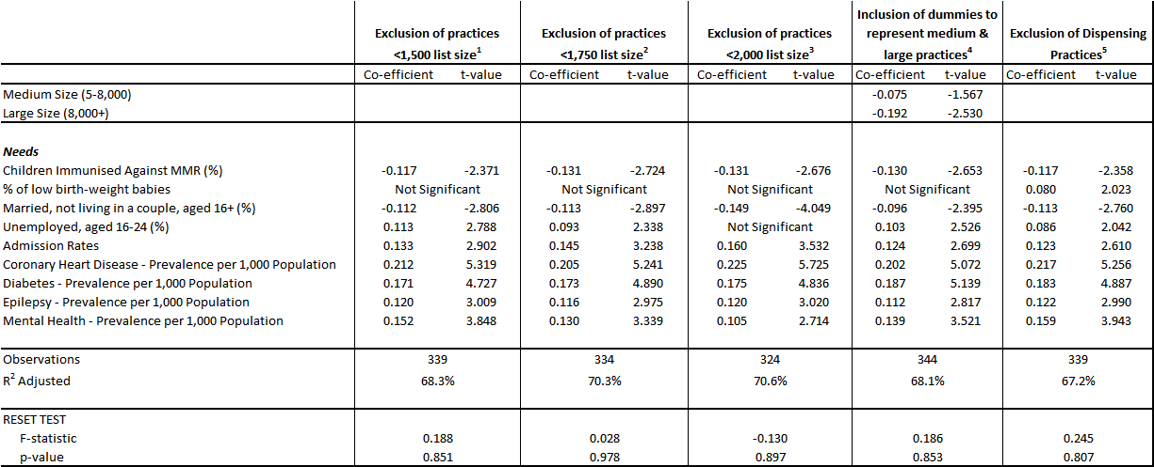

**Footnotes:**

1. Exclusion of practices adopts a cut-off of 1,500; practices with list sizes smaller than this are omitted from this sensitivity analysis.
2. Exclusion of practices adopts a cut-off of 1,750; practices with list sizes smaller than this are omitted from this sensitivity analysis.
3. Exclusion of practices adopts a cut-off of 2,000; practices with list sizes smaller than this are omitted from this sensitivity analysis.
4. The model includes 2 dummy variables representing medium sized practices (5,000 to 8,000 list size) and large practices (list sizes of 8,000+).
5. Exclusion of dispensing GP practices.

**Table 11.6(b) Sensitivity Analysis of the Preferred 2-Stage Additive Model – Models 6 to 10**

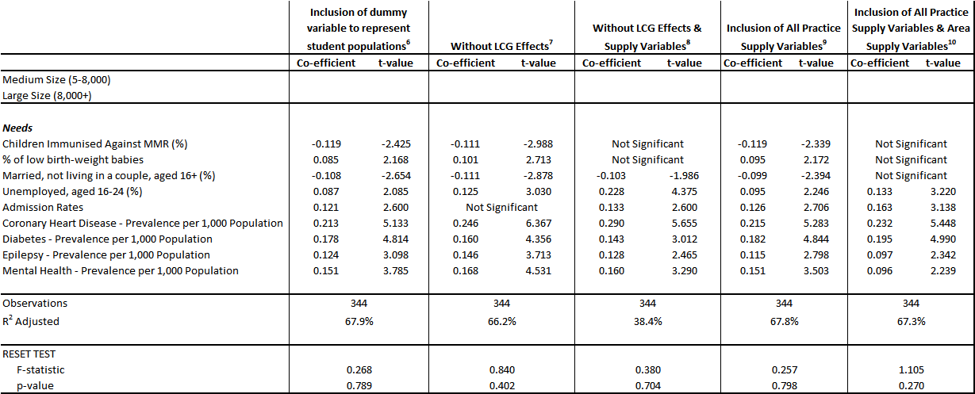

**Footnotes:**

1. Inclusion of a dummy variable to represent student populations; rather than use a dummy variable to represent student practices (of which there are only 2 in Northern Ireland) a dummy has been created based on percentage of the GP practice list aged 18-24.
2. Exclusion of the 4 dummy variables that represent Local Commissioning Group (LCG) policy effects.
3. Exclusion of the 4 dummy variables that represent Local Commissioning Group (LCG) policy effects and exclusion of the practice supply variables.
4. Inclusion of all practice supply characteristics present in the dataset irrespective of significance or expected relationship with prescribing expenditure.
5. Inclusion of all practice supply characteristics and area supply variables present in the dataset irrespective of significance or expected relationship with prescribing expenditure.

11.18 When we dropped the practice characteristics/supply variables, the R2 fell to 38.4%; this suggests that the needs indicators have considerable explanatory power in explaining variation in prescribing costs across practices. When we included all practice supply variables (as opposed to only those that were significant in our model), there is little change to the base model in terms of the magnitude of the coefficients or the explanatory power. Inclusion of all area supply variables along with all practice supply variables sees 3 needs variables becoming non-significant (percentage of children immunised against MMR, percentage of low birth-weight babies and percentage of those aged 16+ married but not living as a couple) and significantly changes the coefficients on the other needs variables. The R2 does not change from the base model; this suggests that these non-significant variables are contributing very little to the overall model.

11.19 When the LCG indicators were dropped, the R2 dropped from 68% to 66.2% and admission rates became non-significant. There were also slight changes to the coefficients on the other needs variables. ***The peer reviewer has flagged that the Western LCG dummy is juxtaposed or in other words working side-by-side with admission rates. He points out that sensitivity test 7 is the evidence for this by the very fact that admission rates become non-significant when LCG dummies are excluded. The peer reviewer questioned the rationale for including LCG dummies given that Northern Ireland has one single regional Health and Social Care Board and he would have advocated dropping the LCG dummies and in turn that would exclude admission rates. However, it is known that on the ground there remain differences in policy and practice across the LCGs and therefore a case remains for retaining LCG dummy variables. Retention of the LCG dummies dictates that we have to deal with the admission rate juxtaposition issue by another means.***

11.20 The results of the sensitivity testing led us to question and reconsider our preferred base model. Given the number of times that certain indicators become non-significant across the sensitivity models, without dramatically altering either coefficients or explanatory power, led us to question the value of retaining these variables in the preferred model. We therefore tested omission of each of these variables in turn; the results of this modelling are presented in Table L.1, Appendix L. As one of our aims is to find as parsimonious a model as possible, which sensibly captures variations in supply-adjusted utilisation, then there is rationale for dropping indicators which have little influence as long as doing so does not dramatically alter the preferred model.

11.21 Needs variables that appeared to be unstable under the sensitivity analysis were omitted in various combinations and the 7 models resulting from the sensitivity analysis were assessed against the preferred base model. Under each of the simplified models 1 to 6, the coefficients on the supply variables change little. Percentage of low birth-weight babies proved to be a very unstable variable under all sensitivity testing and it is therefore recommended that this variable is definitely omitted. Exclusion of *married, not living in a couple, aged 16+* and *unemployed aged 16-24* along with *percentage of low birth-weight babies* leads to *children immunised against MMR* becoming non-significant; therefore all 4 needs variables have to be excluded, however, this model leads to quite dramatic changes in the coefficients on the remaining needs indicators. On assessment and balance, model 3 (see Table L.1, Appendix L) was initially considered the preferred simplified model. This omits 3 unstable needs variables that contributed less to the overall model, demonstrated by the R2 dropping by only 1.3% from 68.0% to 66.7%. The coefficients on the remaining needs variables increase slightly with the exception of *mental health prevalence* which decreases slightly; the coefficient on *unemployed aged 16-24* does increase more so than the other variables but this is still less of a change than resulting from the other simplified models. However, to deal with juxtaposition of the LCG dummies and admission rates; having decided that the LCG dummies must be retained, admission rates were also excluded. This leads to model 7 (see Table L.1, Appendix L) which is basically the preferred model 3 with admission rates excluded. The resulting model is now very similar in terms of the standardised coefficients and the explanatory power to sensitivity test 7 (that is, the base model without LCG dummies). This indicates that we can deal with the juxtaposition issue by excluding admission rates but still retaining LCG dummies which is more appropriate. The final simplified preferred model is presented in Table 11.7. The model continues to be well specified and passes the RESET test.

**Table 11.7 Simplified 2-Stage Additive Model (Stepwise) - Final Simplified Preferred Model**

|  |  |  |
| --- | --- | --- |
|  | **Co-efficient** | **t-value** |
| ***Supply***  Number of GPs  GPs per 1,000 List  Average Monthly Items  % Generic Items  Practice Scan rate (%)  *Predicted List Discrepancy*  ***Needs***  % Unemployed, who are aged 16-24  Coronary Heart Disease – Prevalence per 1,000 Population  Diabetes – Prevalence per 1,000 Population  Epilepsy – Prevalence per 1,000 Population  Mental Health – Prevalence per 1,000 Population  **Local Commissioning Groups**  Belfast  South Eastern  Northern  Southern  Western | -0.852  0.347  0.829  -0.258  0.489  0.020  0.145  0.246  0.201  0.143  0.147  -0.084  0.032  -  -0.098  -0.196 | -9.077  6.719  9.553  -7.178  14.516  0.331  3.790  6.351  5.425  3.594  3.699  -1.721  0.824  -  -1.490  -4.103 |
| **Observations**  **R2 Adjusted**  **RESET TEST**  **F-Statistic**  **p-value** | 344  66.1%  0.080  0.936 | |
| **Selection Routine** | Stepwise | |

**Treatment of Supply in the Preferred Model**

11.22 The issue here is the role that measures of and/or proxies for supply should have in allocating resources according to the formula developed through the estimation procedures. There are 3 possible scenarios for treating supply variables at the stage of allocating resources:

(i) Leave the supply variables in and allow them to affect the predicted value in each small area and therefore the allocations at an area level:

(ii) Leave the supply variables in but, for the purposes of allocation, fix (or “sterilise”) them at the average value for Northern Ireland;

(iii) Omit the supply variables and re-estimate.

11.23 There have been different schools of thought over the years from analysts working on weighted capitation and resource allocation. However, there is universal agreement that the first approach above is contrary to the whole purpose of trying to abstract from the effects of supply. This approach would treat the supply variables as equivalent to the other needs variables and allow them to have an effect on costed utilisation on the same level as the needs variables. Rather, we want to explain utilisation that is a response to need and not utilisation which has been created due to extra supply. We want to isolate the effect of the legitimate needs drivers and allocate resources on the basis of legitimate need only. Previous debates centred round whether approach 2 or 3 best met this aim.

11.24 Previous allocation formula in Northern Ireland, including the current prescribing formula and regional capitation formulae for the programmes of care, adopted approach 3. The rationale had been that the coefficients on the needs variables picked up the direct effect of need on utilisation but also the indirect effects of need which arise because supply is in part determined by need. In England, approach 2 has been adopted for a number of years and our thinking in Northern Ireland would now support that method for treating supply within the allocation process. Approach 2 assumes that the relationship between supply and need variables is mutually independent.

11.24The mental health programme of care within the Northern Ireland regional capitation formula has recently been reviewed and the treatment of supply in allocating resources has adopted approach 2. As other programmes of care within the regional formula are reviewed, these will also adopt approach 2 to ensure consistency across all the regional formulae.

**Recommendation:**

**The preferred simplified 2-stage additive stepwise model as presented in Table 11.7 should be adopted as the additional needs adjustment and implemented when setting both LCG and GP practice allocations. The supply variables should be retained but sterilised, that is, fixed at the average value for Northern Ireland.**

**12. Application of the Additional Needs Index at Local Commissioning Group (LCG) Level**

12.1 Table 12.1 shows the LCG relative population shares resulting from applying the additional needs regression model to the constrained registered population at 1st April 2015. The weight effects are shown as an index around 1.0 (Northern Ireland = 1.0). LCGs with a value greater than 1.0 have need for prescribing resources (over and above that due to age-gender) greater than the Northern Ireland average, whilst values less than 1.0 indicate less need than the NI average. Belfast LCG has the highest additional needs index (1.0443) followed by Western LCG (1.0060); the other 3 LCGs have indices less than 1.0.

**Table 12.1 New Additional Needs Index 2015 & Need Weighted Population Shares at LCG Level**

**at 1st April 2015**

|  |  |  |  |  |  |
| --- | --- | --- | --- | --- | --- |
|  | **Belfast** | **Northern** | **S Eastern** | **Southern** | **Western** |
| **Constrained Registered Population Shares %** | 22.33% | 24.23% | 16.89% | 20.22% | 16.33% |
| **New Additional Needs Index** | 1.0443 | 0.9983 | 0.9699 | 0.9832 | 1.0060 |
| **% Shares After Adjusting for Additional Need** | 23.28% | 24.14% | 16.35% | 19.84% | 16.39% |
| **Change in % Share due to Additional Need Weighting** | +0.94% | -0.09% | -0.54% | -0.38% | +0.07% |

12.2 Initially considering the needs index at LCG level, the Southern LCG index may seem counter-intuitive. Historically, we expect Southern, Western and Belfast areas to have additional needs greater than the NI average, that is, higher than 1.0. Likewise, we expect Northern and South Eastern areas to be less than the NI average. However, during development of the current prescribing formula in 2010, Southern LCG also resulted in having an additional needs index of less than 1.0 (see Table 12.2); analysis of the individual indicators explained the resulting overall index. We will carry out this analysis again for the 2015 additional needs index to explain the resulting indices and ranking of the LCGs.

12.3 Table 12.2 compares the new additional needs index being developed in 2015 with the old additional needs index from 2010. The comparison in Table 12.2 is made using the same population base, that is, the GP registered list at April 2015 constrained to the 2013 MYE. The update of the additional needs index sees Belfast and Western LCGs continuing to have indices greater than the NI average of 1.0 and the other 3 LCGs continuing to have indices below 1.0. As expected, South Eastern LCG again has the lowest needs index. The range of the needs index at LCG level is now narrower using the updated needs index (a range of 0.0744 between Belfast LCG and South Eastern LCG) compared with the old needs index (a range of 0.1439 between Belfast LCG and South Eastern LCG). The new needs index is less redistributive; this new index redistributes +/-1.01% of resources compared to constrained registered population shares, whereas the old index redistributed +/-2.28% of resources after weighting for additional need. Table 12.3 details the impact of the old additional needs index 2010 on needs weighted % shares (for comparison with Table 12.1).

**Table 12.2 Comparison of New Additional Needs Index 2015 with Current Additional Needs Index 2010**

|  |  |  |  |  |  |
| --- | --- | --- | --- | --- | --- |
|  | **Belfast** | **Northern** | **S Eastern** | **Southern** | **Western** |
| **Old Additional Needs Index** | 1.1029 | 0.9746 | 0.9590 | 0.9640 | 1.0095 |
| **New Additional Needs Index** | 1.0443 | 0.9983 | 0.9699 | 0.9832 | 1.0060 |

**Table 12.3 Old Additional Needs Index 2010 & Need Weighted Population Shares at LCG Level**

**at 1st April 2015**

|  |  |  |  |  |  |
| --- | --- | --- | --- | --- | --- |
|  | **Belfast** | **Northern** | **S Eastern** | **Southern** | **Western** |
| **Constrained Registered Population Shares %** | 22.33% | 24.23% | 16.89% | 20.22% | 16.33% |
| **Old Additional Needs Index** | 1.1029 | 0.9746 | 0.9590 | 0.9640 | 1.0095 |
| **% Shares After Adjusting for Additional Need** | 24.53% | 23.51% | 16.13% | 19.41% | 16.41% |
| **Change in % Share due to Additional Need Weighting** | +2.20% | -0.71% | -0.76% | -0.81% | +0.09% |

12.4 Profiles of the LCGs, in terms of the individual needs indicators, were analysed to explore the plausibility of the resultant LCG overall indices (see Table 12.4). The 4 disease prevalence variables have been age standardised and therefore there are no age effects in the results. Belfast LCG has indices for all 5 needs indicators greater than the NI average of 1.0 and for 4 needs variables, Belfast LCG has the highest index; this is what leads to Belfast LCG having the highest additional needs index overall. Western LCG has indices greater than the NI average for 4 of the 5 needs indicators; only the percentage of unemployed who are aged 16-24 has an index less than 1.0. Western has the highest index for 1 need variable but also has the second highest index for 3 of the other needs variables. Belfast and Western LCGs therefore occupy the top 2 positions in terms of need.

**Table 12.4 LCG Profiles (variables expressed as ratios around the NI Average of 1.0)**

|  |  |  |  |  |  |
| --- | --- | --- | --- | --- | --- |
| **Needs Variable** | **Belfast** | **Northern** | **S Eastern** | **Southern** | **Western** |
| **CHD Prevalence** | **1.0470** | 1.0027 | **0.9340** | 1.0038 | 1.0053 |
| **Diabetes Prevalence** | 1.0256 | 1.0219 | **0.9411** | 0.9713 | **1.0328** |
| **Epilepsy Prevalence** | **1.1238** | **0.9309** | 0.9624 | 0.9320 | 1.0508 |
| **Mental Health Prevalence** | **1.1970** | 0.9160 | **0.8598** | 0.9222 | 1.0873 |
| **% Unemployed Aged 16-24** | **1.0375** | 1.0116 | 1.0266 | 0.9819 | **0.9472** |

12.5 Intuitively, we expected South Eastern LCG to have the lowest additional needs index, as in the current formula and this is indeed the case. With the updated needs index, both South Eastern and Southern LCGs have only one indicator each which is greater than the NI average (for Southern LCG this is coronary heart disease prevalence and for South Eastern LCG this is percentage unemployed aged 16-24); but note that in both cases the index is not much higher than 1.0. South Eastern has the lowest index for 3 of the 5 needs variables; having indices of nearly 1.0 or well below 1.0 for all 5 needs indicators reflects lower than average NI levels of long-term conditions and unemployment of those aged 16-24 in the South Eastern area. Figures 12.1 to 12.5 show thematic maps of the 5 needs indicators at SOA level.

**Figure 12.1 Prevalence of Coronary Heart Disease per 1,000 Population by SOA**

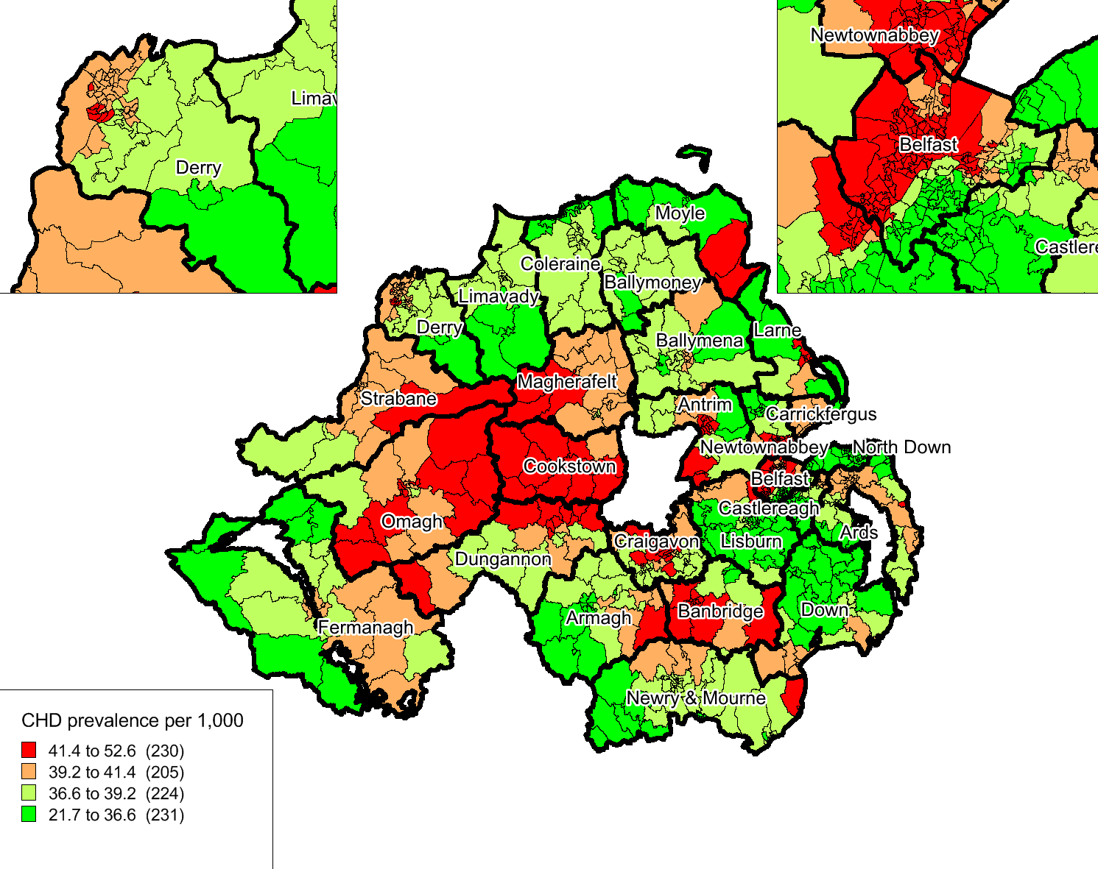

**Figure 12.2 Prevalence of Diabetes per 1,000 Population by SOA**

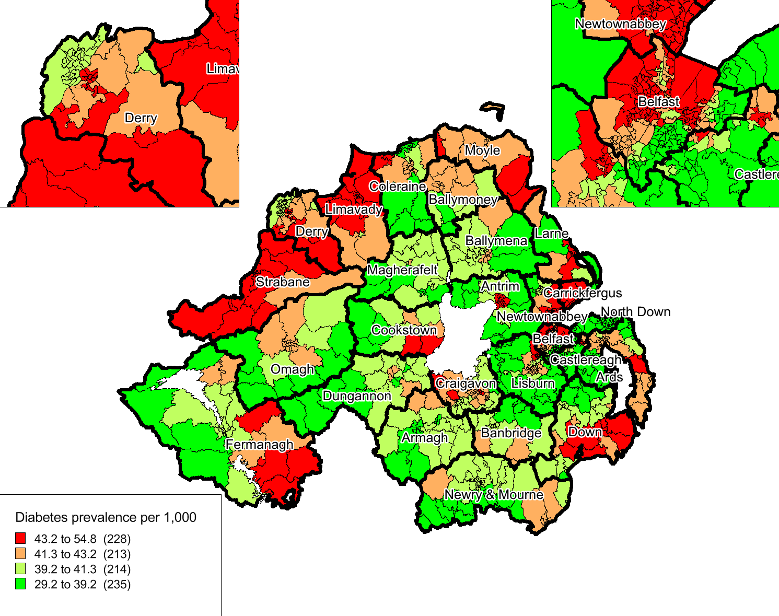

**Figure 12.3 Prevalence of Epilepsy per 1,000 Population by SOA**

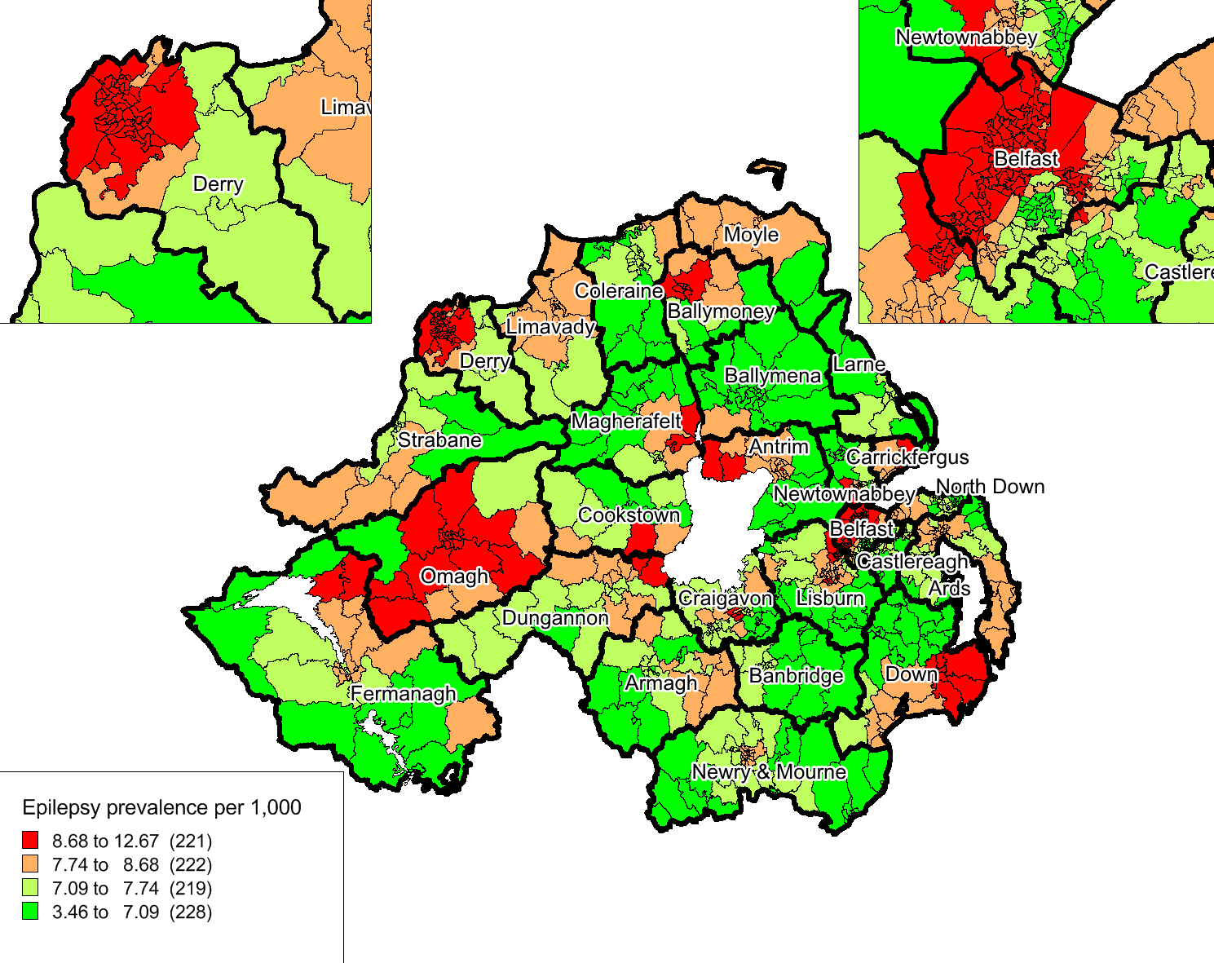

**Figure 12.4 Prevalence of Mental Health per 1,000 Population by SOA**

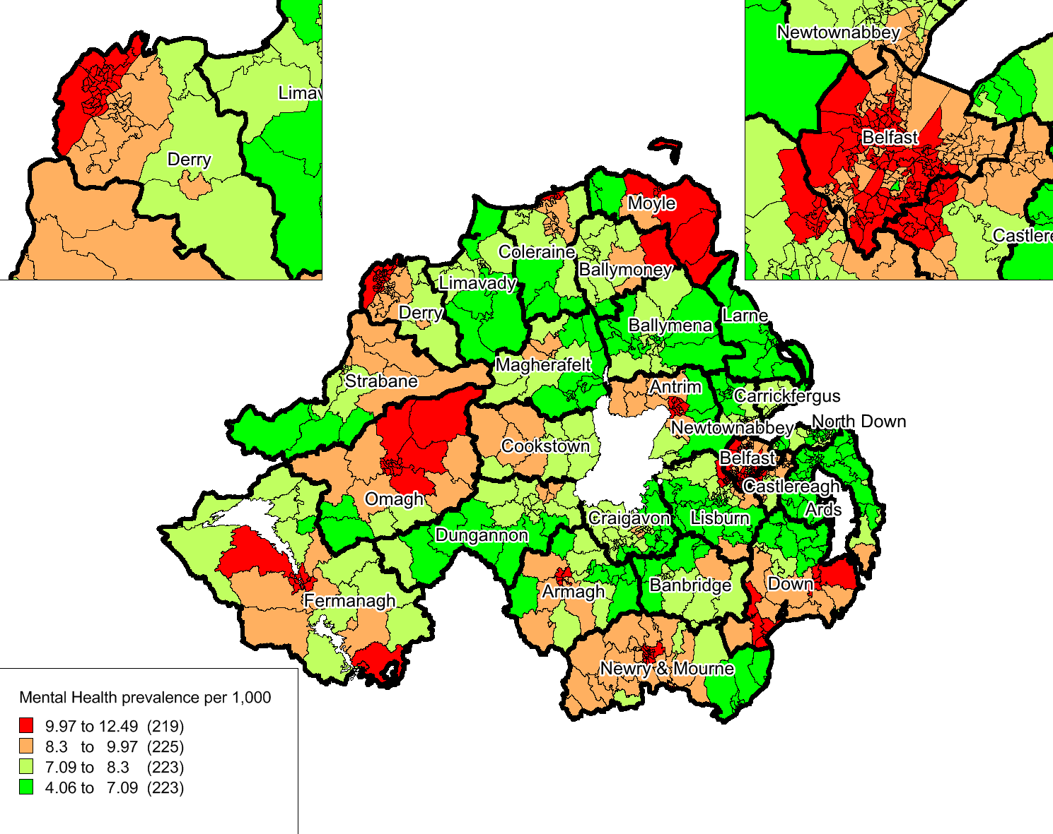

**Figure 12.5 % Unemployed Who Are Aged 16-24 by SOA**

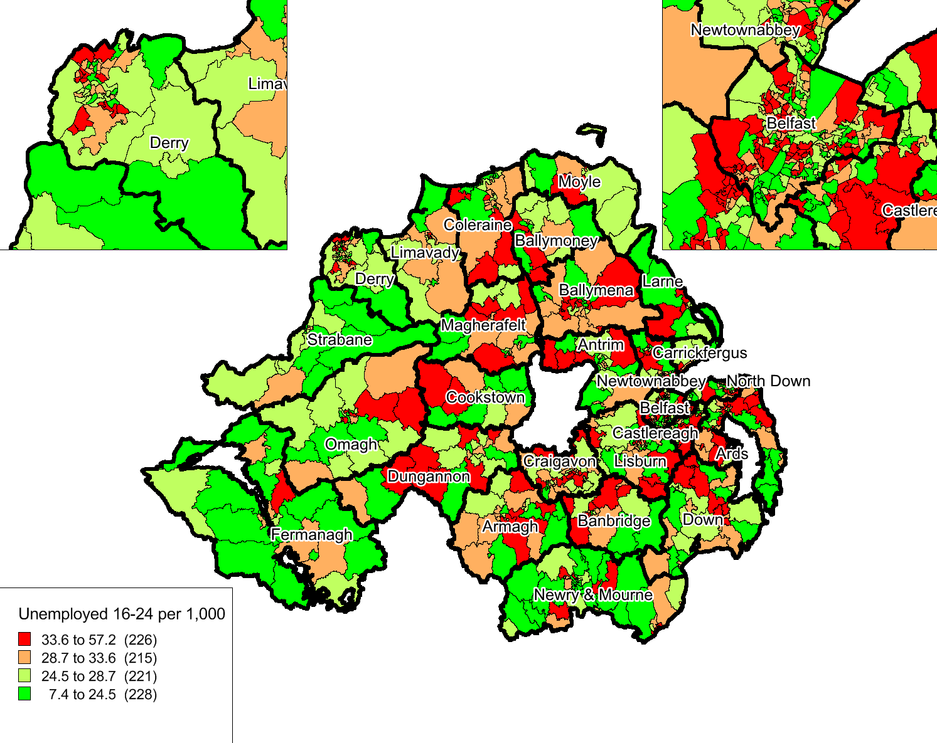

12.6The thematic maps re-enforce the LCG profiles presented in Table 12.4. The maps have been created at SOA level to prevent any masking that can occur at LCG level and LGD boundaries have been annotated. Note, LGDs are then coterminous with LCG boundaries. As before, the 4 disease prevalence variables have been age standardised and therefore there are no age effects in the results. In order to present results at SOA level, it was necessary to attribute the QOF disease prevalence data from GP practice to SOA level; the attribution process is outlined at Appendix F. The unemployment indicator was available at SOA level from the Census 2011.

12.7 The pattern across NI is very different depending on which individual needs indicator we are examining. Figures 12.1 to 12.4 clearly show the high level of disease prevalence in Belfast LGD. Figure 12.1, as well as showing the high CHD prevalence in Belfast LGD, also has a distinct pattern across central LGDs of Omagh, Cookstown, Magherafelt and into Craigavon and Banbridge areas, whereas Figure 12.2 shows a clear pattern of high diabetes prevalence across Western LGDs. Mental health prevalence is more concentrated in Western LGDs but with other pockets in Moyle, Armagh, Newry and Mourne. Figures 12.1 to 12.3 show that, in general, disease prevalence is lower in LGDs within the Southern and South Eastern LCGs; this re-affirms the resulting lower additional needs indices for these LCGs. The unemployment indicator has a less clear pattern, with higher levels occurring in more urban areas. The thematic maps provide a good visual impression of the individual indicators within the additional needs index at area level and how these then result in the overall needs index at LCG level.

**13. Application of the Full Formula at Local Commissioning Group (LCG) Level**

13.1 Table 13.1 details the effect of applying both the age-gender and additional needs weightings (that is, the effect of applying “total need”). Note that the age-gender index incorporates the adjustment for care home patients. South Eastern LCG has the highest overall total index (1.0462) followed by Northern LCG (1.0234). Belfast LCG has an index greater than the NI average and the other 2 LCGs have indices lower than the NI average. Both Belfast and Western LCGs would reduce their share in terms of their age-gender profile but both would gain in terms of additional needs. Belfast LCG’s gain in terms of need outweighs its loss due to age-gender need and Belfast LCG therefore gains in weighted population compared to the constrained registered population shares. Western LCG’s share reduces due to its young age profile and this is not offset by the gain due to additional need and it therefore experiences an overall decrease in share when the population is weighted compared to the constrained registered population. Northern and South Eastern LCGs would gain in terms of age-gender, but both reduce their share due to additional need. South Eastern LCG’s very elderly age profile sees it gain overall in share despite having the largest decrease in share due to additional need. Southern LCG is the only LCG to lose in terms of both age-gender and additional need, resulting in an overall loss when the interaction of both types of need is captured.

**Table 13.1 Effect of Age-Gender & Additional Needs Weightings 2015 at LCG Level**

|  |  |  |  |  |  |
| --- | --- | --- | --- | --- | --- |
|  | **Belfast** | **Northern** | **S Eastern** | **Southern** | **Western** |
| **Constrained Registered Population**  **% Shares** | 22.33% | 24.23% | 16.89% | 20.22% | 16.33% |
| **Age-Gender Index 2015 (incorporating the care home adjustment)**  **Age Weighted Population % Shares**  **Change in % Share (from constrained reg popn) due to Age Weighting Only** | 0.9856  22.01%  -0.32% | 1.0247  24.82%  +0.60% | 1.0766  18.19%  +1.29% | 0.9522  19.25%  -0.97% | 0.9630  15.72%  -0.60% |
| **Additional Needs Index 2015**  **Need Weighted Population % Shares**  **Change in % Share (from constrained reg popn) due to Need Weighting Only** | 1.0443  23.28%  +0.94% | 0.9983  24.14%  -0.09% | 0.9699  16.35%  -0.54% | 0.9832  19.84%  -0.38% | 1.0060  16.39%  +0.07% |
| **Total Index 2015**  **Age & Need Weighted Population % Shares**  **Change in % Share (from constrained reg popn) due to Age & Need Weighting Combined** | 1.0201  22.78%  +0.45% | 1.0234  24.79%  +0.57% | 1.0462  17.67%  +0.78% | 0.9363  18.93%  -1.29% | 0.9689  15.82%  -0.51% |

13.2 Table 13.2 compares the overall index and overall final % shares under the current formula with the overall index and % shares using the new formula. Table 13.3 compares the age index and % shares under the current formula with the new formula; Table 13.4 compares the additional needs indices under both formulae. The comparisons are made using a consistent population base, that is, the GP registered list at April 2015 constrained to the 2013 MYE.

13.3 Belfast, Northern and South Eastern LCGs continue to have an overall index higher than 1.0 with Southern and Western LCGs continuing to have overall indices less than 1.0. Southern LCG continues to see the largest change due to application of both age-gender and additional needs weightings (a decrease in share of -1.29%). South Eastern LCG now has the highest overall index with an increase in share of +0.78% due to age-gender and additional need weightings combined. In the current formula, Belfast LCG experiences the largest increase in weighted population share due to the additional needs index but now that the additional needs index under the current review is less redistributive, instead South Eastern LCG experiences the largest weighted population change due to its elderly age structure.

**Table 13.2 Comparison of New Total Index 2015 with Current Total Index 2010**

|  |  |  |  |  |  |
| --- | --- | --- | --- | --- | --- |
|  | **Belfast** | **Northern** | **S Eastern** | **Southern** | **Western** |
| **Old Total Index** | 1.0638 | 1.0022 | 1.0411 | 0.9159 | 0.9712 |
| **% Shares - current formula 2010** | 23.76% | 24.28% | 17.59% | 18.52% | 15.86% |
|  |  |  |  |  |  |
| **New Total Index** | 1.0201 | 1.0234 | 1.0462 | 0.9363 | 0.9689 |
| **% Shares - new formula 2015** | 22.78% | 24.79% | 17.67% | 18.93% | 15.82% |

**Table 13.3 Comparison of the New Age Index 2015 with the Current Age Index 2010**

|  |  |  |  |  |  |
| --- | --- | --- | --- | --- | --- |
|  | **Belfast** | **Northern** | **S Eastern** | **Southern** | **Western** |
| **Old Age-Gender Index (with care home adjustment)** | 0.9828 | 1.0267 | 1.0821 | 0.9493 | 0.9617 |
| **% Age-Weighted Shares using the current formula 2010 (includes care home adjustment)** | 21.95% | 24.87% | 18.28% | 19.20% | 15.70% |
|  |  |  |  |  |  |
| **New Age-Gender Index (with care home adjustment)** | 0.9856 | 1.0247 | 1.0766 | 0.9522 | 0.9630 |
| **% Age-Weighted Shares using the new formula 2015 (includes care home adjustment)** | 22.01% | 24.82% | 18.19% | 19.25% | 15.72% |

**Table 13.4 Comparison of the New Needs Index 2015 with the Current Needs Index 2010**

|  |  |  |  |  |  |
| --- | --- | --- | --- | --- | --- |
|  | **Belfast** | **Northern** | **S Eastern** | **Southern** | **Western** |
| **Old Additional Needs Index** | 1.1029 | 0.9746 | 0.9590 | 0.9640 | 1.0095 |
| **% Shares After Adjusting for Additional Need using the current formula 2010** | 24.53% | 23.51% | 16.13% | 19.41% | 16.41% |
|  |  |  |  |  |  |
| **New Additional Needs Index** | 1.0443 | 0.9983 | 0.9699 | 0.9832 | 1.0060 |
| **% Shares After Adjusting for Additional Need using the new formula 2015** | 23.28% | 24.14% | 16.35% | 19.84% | 16.39% |

***Redistributive Effect of the New Formula at LCG Level***

13.4 Table 13.5 details the effect of applying the new formula at LCG level compared with the formula currently in operation. The redistribution refers to moving from a crude population share (constrained registered population) to a share weighted by each individual component of age-gender and additional need separately plus the redistribution having applied both components simultaneously. Monetary swings have been shown based on applying the redistribution to an overall NI allocation of £400m (in 2014/15, the NI IPA was just over £400m).

**Table 13.5 Redistribution of Resources at LCG Level**

|  |  |  |
| --- | --- | --- |
| **Formula Component** | **New Proposed Formula** | **Old Current Formula** |
| **Age Index with Care Home Adjustment** | +/-1.89% (+/- £7.57m) | +/-2.03% (+/- £8.14m) |
| **Additional Needs Index** | +/-1.01% (+/- £4.03m) | +/-2.28% (+/- £9.13m) |
| **Total Index** | +/-1.80% (+/- £7.18m) | +/-2.17% (+/- £8.69m) |

13.5 The age index under the new formula is less redistributive; this is as expected given that the new age cost curve is less steep (see Figure 13.1). The additional needs index under the new formula is less redistributive; the range of the additional needs index across LCGs is narrower under the new formula. The new additional needs index across the 5 LCGs ranges from 0.9699 to 1.0443 (a range of 0.0744) whereas the current formula has an additional needs index ranging from 0.9590 to 1.1029 (a range of 0.1439) across the 5 LCGs.

**Figure 13.1 Comparison of Age Cost Curve NI-PU 2015 with NI-PU 2010**

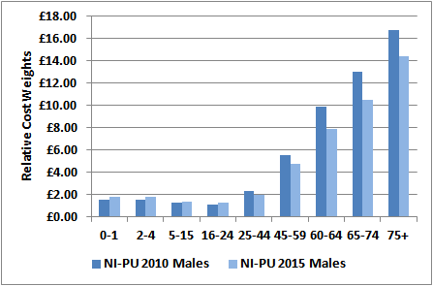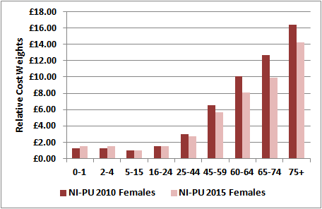

13.6The new formula can be viewed as having an overall swing of £14.36m (+/- £7.18m) between LCGs compared to a swing of £17.4m (+/- £8.69m) under the current formula; however, in each LCG, these redistributions will work in opposing directions. For example, in Belfast and Western LCGs, such deprived areas with younger populations need relatively less resources due to age factors but relatively more resources due to deprivation, morbidity and socio-economic factors. South Eastern and Northern LCGs, as more affluent areas with older populations, need relatively more resources due to age factors but relatively less due to additional need. Southern LCG is the only LCG where the redistribution does not work in opposing directions, instead, less relative resources are skewed to Southern LCG on the basis of both age factors and additional need factors.

**14. Sensitivity of the Formula to Targeting Deprivation**

14.1 One of the characteristics of an effective weighted capitation formula is to effectively channel or skew resources towards people, groups and areas in greatest need. It is important to note that any analysis examining whether the formula effectively skews resources in response to need can only focus on needs which are currently being met; this is because the formula has been developed using a utilisation-based approach and no account is taken of any differential unmet need which may exist between areas.

14.2 Sensitivity of the prescribing formula to additional needs can be masked at LCG level; this is because the different needs of affluent and deprived sub-populations which make up LCGs can, to a large extent, cancel each other out. That is why, at LCG level, it is population size which is the major determinant of need rather than socio-economic profile. The age-gender structure of the LCG population has a larger impact than additional need but is still dwarfed by population size. The differences in socio-economic conditions and deprivation between areas are much more apparent at small area level than LCG level.

14.3 Table 14.3 shows the top and bottom 10 super output areas (out of the 890 SOAs that cover Northern Ireland) ranked from highest to lowest in terms of the age-gender index, additional needs index and overall total index. This ranking is also represented geographically in Figures 14.1 to 14.3. It should be noted that, although the areas of SOAs vary significantly, they have approximately equivalent populations (a mean population of approximately 2,000 people).

14.4 The tables and maps highlight that the ranking of SOAs is very different depending on whether we are considering additional need as opposed to need arising from age-gender structure. This is as expected, as deprived areas tend to consist of relatively younger populations whereas more affluent areas tend to have more elderly populations; these are of course generalisations and there will always be deviations from this general perception. The interaction between both types of need is captured in the total needs index. Consider these examples below:

* Crumlin_1 in Belfast LGD has an elderly age profile with an age index of 1.3035 (it has the 56th highest age index) but has a high level of additional need with an index of 1.1478 (it has the 26th highest needs index) resulting in a total index of 1.5002 (ranked 7th highest in terms of total need).
* Falls_1 in Belfast LGD has a young age profile with an age index of 0.8535 (ranked 762nd highest in terms of age) but has a high additional need index of 1.1458 (it has the 31st highest needs index) resulting in a total index of 0.9806 (ranked 472th highest in terms of total need).
* Kilfennan_2 in Derry LGD has a young age profile with an age index of 0.8579 (it has the 754th highest age index) but also has a low level of additional need with an index of 0.9511 (it has the 677th highest rank in terms of additional need) resulting in a total index of 0.8181 (ranked 807th in terms of overall need).
* Crawfordsburn in North Down LGD has a very elderly age profile with an age index of 1.4201 (ranked 19th highest) but has a very low additional need index of 0.8508 (ranked 875th highest) resulting in a total needs index of 1.2114 (ranked 99th overall).

**Figure 14.1 Age-Gender Index of the New Formula by SOA**

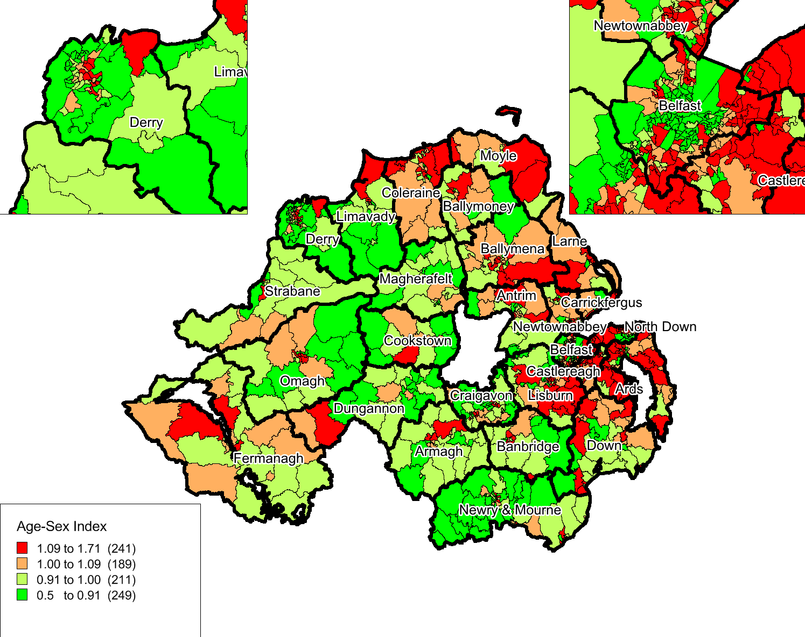

**Figure 14.2 Additional Needs Index of the New Formula by SOA**

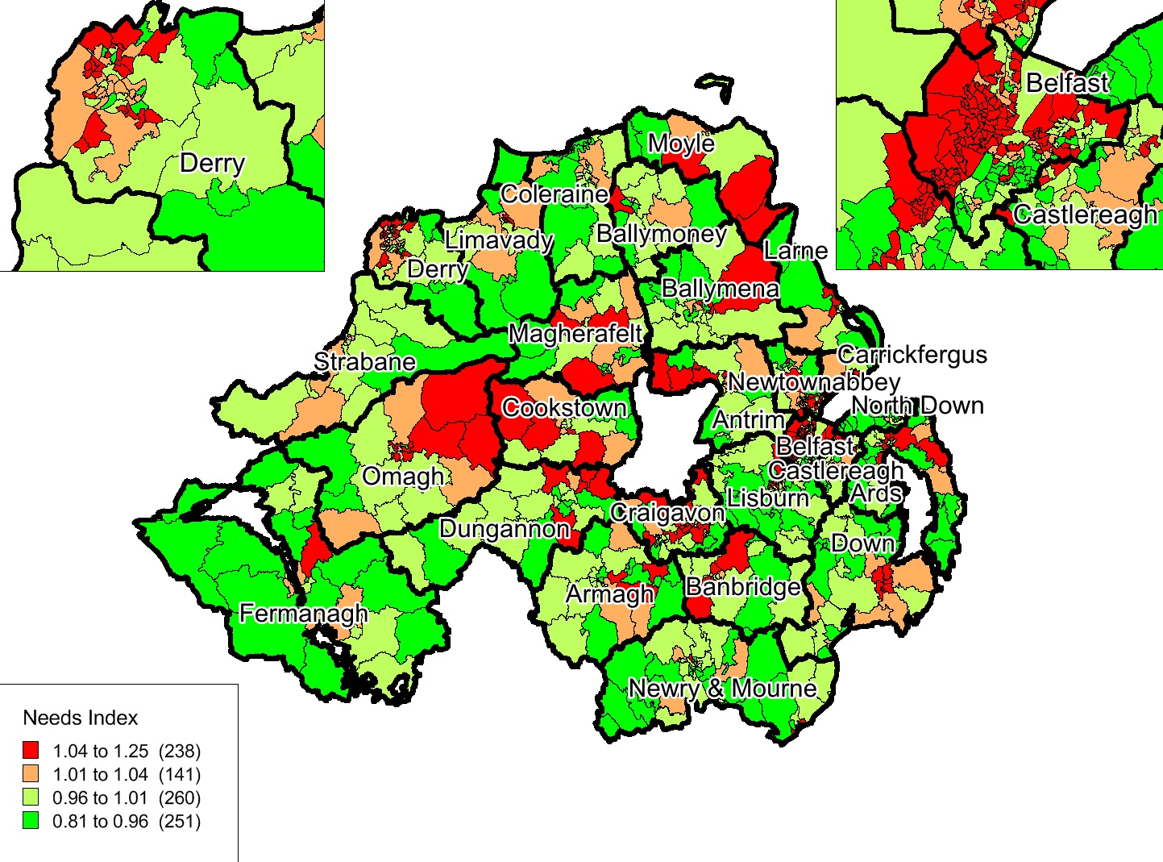

**Figure 14.3 Total Needs Index of the New Formula by SOA**

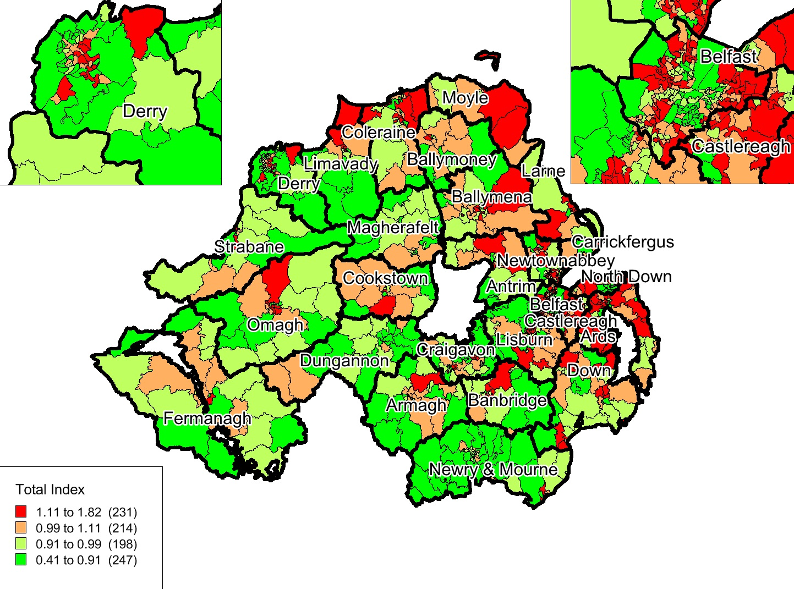

14.5 Table 14.3 and the maps have high face validity in relation to the additional needs index where the results match well with perceptions of which SOAs would be considered affluent and which would be considered deprived. Table 14.3 only shows the extreme bottom and top 10 SOAs; Table 14.1 summarises the overall picture for each LCG in terms of quintiles of deprivation derived from the additional needs index. The table details the percentage of SOAs within each LCG which fall into each deprivation quintile, 1 being the most deprived.

**Table 14.1 Profiles of LCGs in terms of SOA Additional Need Deprivation Quintiles**

|  |  |  |  |  |  |
| --- | --- | --- | --- | --- | --- |
| **LCG** | **Quintile 1** | **Quintile 2** | **Quintile 3** | **Quintile 4** | **Quintile 5** |
| **Belfast** | 42.1% | 18.0% | 12.0% | 12.6% | 15.3% |
| **Northern** | 17.1% | 23.2% | 26.3% | 14.5% | 18.9% |
| **South Eastern** | 12.2% | 15.0% | 18.3% | 21.7% | 32.8% |
| **Southern** | 10.8% | 15.3% | 21.0% | 30.6% | 22.3% |
| **Western** | 16.2% | 28.9% | 21.1% | 24.6% | 9.2% |

14.6 Table 14.1 and Figure 14.2 give a very distinct pattern arising from application of the new formula additional needs index. Southern LCG has only 26.1% of SOAs in the bottom 2 deprivation quintiles; likewise South Eastern LCG has 27.2% of SOAs in the bottom 2 most deprived quintiles. In comparison, Belfast LCG has 60.1% of its SOAs in the 2 most deprived quintiles; and 45.1% of SOAs in Western LCG. 32.8% of SOAs in South Eastern LCG fall within the least deprived quintile, compared with 15.3% of SOAs in Belfast and 9.2% of SOAs in Western LCG. Belfast LCG has only 27.9% of SOAs in the top 2 most affluent quintiles compared with Southern and South Eastern LCGs which each have over 50% of SOAs in these top 2 quintiles.

***Redistributive Effect of the New Formula at SOA Level***

14.7 Table 14.2 details the effect of applying the new formula at SOA level compared with the formula currently in operation. The redistribution refers to moving from a crude population share (SOA population based on residency of patients on NHAIS GP registered list) to a share weighted by each individual component of age-gender and additional need separately plus the redistribution having applied both components simultaneously. Monetary swings have been shown based on applying the redistribution to an overall NI allocation of £400m (in 2014/15 the NI IPA was just over £400m).

**Table 14.2 Redistribution of Resources at SOA Level**

|  |  |  |
| --- | --- | --- |
| **Formula Component** | **New Proposed Formula** | **Old Current Formula** |
| **Age Index with Care Home Adjustment** | +/-6.23% (+/- £24.9m) | +/-7.08% (+/- £28.3m) |
| **Additional Needs Index** | +/-2.82% (+/- £11.3m) | +/-6.89% (+/- £27.5m) |
| **Total Index** | +/-6.27% (+/- £25.1m) | +/-9.34% (+/- £37.4m) |

14.8 The age index under the new formula is less redistributive; this is again as expected given that the new age cost curve is less steep (see Figure 13.1). The additional needs index under the new formula is also less redistributive; the range of the additional needs index across SOAs is narrower under the new formula. The new index across the 890 SOAs ranges from 0.8116 to 1.2500 (a range of 0.4383) whereas the current formula has an additional needs index ranging from 0.3119 to 1.6491 (a range of 1.3372) across the SOAs.

**Table 14.3 Highest and Lowest 10 SOAs Ranked by (i) Age-Gender Index; (ii) Additional Needs Index and (iii) Total Needs Index (Age-Gender & Additional Needs Combined)**

|  |  |  |  |  |  |  |  |  |  |
| --- | --- | --- | --- | --- | --- | --- | --- | --- | --- |
|  | **Ranked by Age-Gender Index** | | | **Ranked by Additional Needs Index** | | | **Ranked by Total Needs Index** | | |
| **Rank** | **LGD** | **SOA** | **Index** | **LGD** | **SOA** | **Index** | **LGD** | **SOA** | **Index** |
| **1** | North Down | Churchill_1 | 1.7018 | Belfast | Shankill_1 | 1.2500 | Ballymena | Ballyloughan | 1.8131 |
| **2** | Ballymena | Ballyloughan | 1.6216 | Belfast | Whiterock_2 | 1.2313 | North Down | Churchill_1 | 1.7424 |
| **3** | Ards | Donaghadee S_2 | 1.5937 | Lisburn | Collin Glen_1 | 1.2279 | Derry | Ebrington_1 | 1.5934 |
| **4** | Lisburn | Lagan Valley_2 | 1.5691 | Newtownabbey | Cloughfern_2 | 1.2135 | Carrickfergus | Love lane | 1.5347 |
| **5** | Limavady | Magilligan | 1.5673 | Belfast | Woodvale_3 | 1.1934 | Ballymoney | Glebe | 1.5081 |
| **6** | Derry | Ebrington_1 | 1.5394 | Ards | Whitespots_2 | 1.1903 | Ards | Whitespots_2 | 1.5079 |
| **7** | North Down | Princetown | 1.5139 | Belfast | Beechmount_2 | 1.1893 | Belfast | Crumlin_1 | 1.5002 |
| **8** | Down | Donard_1 | 1.5061 | Belfast | Upper Springfield_3 | 1.1893 | Coleraine | Mount Sandel | 1.4895 |
| **9** | North Down | Groomsport | 1.4994 | Belfast | Upper Springfield_2 | 1.1818 | Limavady | Magilligan | 1.4607 |
| **10** | Belfast | Fortwilliam_1 | 1.4959 | Belfast | Shankill_2 | 1.1803 | Down | Kilmore_1 | 1.4557 |
|  |  |  |  |  |  |  |  |  |  |
| **881** | Belfast | Botanic_3 | 0.6448 | North Down | Holywood Priory | 0.8452 | Newtownabbey | Mallusk_2 | 0.6836 |
| **882** | Lisburn | Derryaghy_2 | 0.6385 | Ards | Donaghadee N_1 | 0.8448 | Belfast | Windsor_3 | 0.6721 |
| **883** | Belfast | Botanic_2 | 0.6375 | North Down | Bryansburn_2 | 0.8398 | Belfast | Botanic_3 | 0.6674 |
| **884** | Belfast | Windsor_3 | 0.6374 | Carrickfergus | Blackhead | 0.8311 | Antrim | Aldergrove_1 | 0.6615 |
| **885** | Derry | Shantallow W_3 | 0.6371 | North Down | Holywood Demesne | 0.8282 | Derry | Shantallow W_2 | 0.6416 |
| **886** | Lisburn | Collin Glen_2 | 0.6272 | Belfast | Finaghy_1 | 0.8219 | Lisburn | Derraghy_1 | 0.6402 |
| **887** | Belfast | Botanic_4 | 0.6168 | Fermanagh | Derrylin | 0.8160 | Belfast | Botanic_4 | 0.6367 |
| **888** | Belfast | Botanic_1 | 0.6040 | Lisburn | Maze_1 | 0.8145 | Belfast | Botanic_1 | 0.5960 |
| **889** | Lisburn | Derryaghy_1 | 0.5616 | Lisburn | Hillsborough_1 | 0.8143 | Belfast | Botanic_2 | 0.5599 |
| **890** | Belfast | Stranmillis_2 | 0.5081 | Belfast | Stranmillis_2 | 0.8116 | Belfast | Stranmillis_2 | 0.4135 |

***Sensitivity of the Additional Needs Weighting to Deprivation***

14.9 As a final test of the sensitivity of the additional needs index to deprivation-related need, we correlated the additional needs index at SOA level with other recognised measures of deprivation and morbidity (see Table 14.4). The correlations are moderate, which is encouraging as it demonstrates that other widely accepted indicators of deprivation and morbidity validate the ordering of SOAs in terms of their relative deprivation/affluence. It should be noted that the additional needs index is concerned with measuring need for prescribing resources which may arise from deprivation and other socio-economic factors, rather than measuring deprivation per se. The correlation coefficients are in line with these different measurements, in that we do not expect a perfect fit but at least a moderate association. To carry out SOA analysis it was also necessary to attribute 4 of the needs variables (the QOF disease prevalence variables) from GP practice to SOA; however, the measures of deprivation and morbidity are available directly at SOA level. The introduction of attribution to only one side of the correlation may have impacted on the associations.

**Table 14.4 Correlation at SOA Level of the Additional Needs Index with Deprivation & General Morbidity Measures**

|  |  |
| --- | --- |
| **Indicator** | **Correlation Coefficient** |
| Standardised Limiting Long-Term Illness1 | 0.4639 |
| SMR under 752 | 0.3183 |
| NI Multiple Deprivation Measure 20103 | 0.4224 |
| Multiple Deprivation Measure 2010 – Health Domain4 | 0.4146 |
| Multiple Deprivation Measure 2010 – Income Domain5 | 0.4016 |

Footnotes:

1. Standardised limiting long-term illness is derived from the Census 2011 question asking if an individual’s day-to-day activities are limited because of a health problem or disability which has lasted or is expected to last at least 12 months. There is a recognised association between long-term illness and deprivation.
2. Standardised Mortality Ratio (SMR) under 75; this variant of the standardised mortality ratio is widely accepted as a good proxy for morbidity.
3. The Northern Ireland Multiple Deprivation Measure (NIMDM) 2010 report was published on 26 May 2010. The NIMDM 2010 updates and replaces the Northern Ireland Multiple Deprivation Measure 2005 as the official measure of spatial deprivation in Northern Ireland. The MDM comprises the following components of deprivation: income, employment, health and disability, education, access to services, living environment and crime and disorder.
4. This domain of the MDM identifies areas with high rates of premature deaths and areas where a relatively high proportion of the population’s quality of life is impaired by poor health or who are disabled.
5. This domain of the MDM is a non-overlapping count of individuals living in households in receipt of income related benefits and tax credits.
6. **Application of the Formula at GP Practice Level**

15.1 The DHSSPS also calculates indicative prescribing amounts (IPAs) at GP practice level using the same weighted capitation formula as that applied at LCG level. The formula is less robust at GP practice level, something which we will examine in detail in this section. The Health and Social Care Board are therefore encouraged to use the GP practice IPAs as a guideline in conjunction with local knowledge when setting final GP practice allocations. Certain GP practices may have situations unique to themselves which cannot be dealt with through a capitation formula, for example, high numbers of temporary residents for GP practices in predominantly tourist locations. The HSCB may also need to deal with practice reconfigurations mid-year, for example, practice mergers or practices with rapidly growing lists due to being newly opened.

***Population Base***

15.2 The population base for setting GP practice indicative prescribing amounts is the GP registered list as recorded on the National Health Applications and Infrastructure Services (NHAIS) System. The NHAIS system also includes registration of cross border workers who are entitled to medical treatment whilst in Northern Ireland, on the same basis as residents. The latest available list at the time of calculations is obtained from the Business Services Organisation (BSO). We have already discussed the issue of list discrepancy and the method of constraining (see paragraphs 4.5 to 4.8 and Appendices A and B) when allocating prescribing resources to LCGs; this adjustment is not possible at GP practice level without knowledge of list discrepancy for each individual GP practice. That aside, these practice allocations are intended to cover costs incurred by GP practices in prescribing drugs to all patients registered with them; each GP practice should therefore receive an allocation for the proportion of patients on their registered list (adjusted for age-gender and additional need) of the overall LCG share which has already been constrained to the LCG mid-year estimate of population.

***Age-Gender Adjustment***

15.3 The construction of updated age-gender weightings (NI-PU 2015) has been fully described in section 5. These NI-PU 2015 age-gender weightings are then applied to the GP practice list populations broken down by the same age-gender groups, to produce GP practice age-weighted populations. This calculation is carried out on the 2 population subsets of those residing in care homes and those living in their own home. Having applied the NI-PU 2015 weightings to both population subsets to produce prescribing units, the prescribing units for those in care homes are then multiplied by a further 2.5 before being added to the prescribing units for those not living in care homes. Note, there is no longer an adjustment within the age weighting for temporary residents; where this is an issue for individual GP practices, the HSCB should deal with this as an off-formula adjustment.

15.4 The enhanced prescribing dataset maintained by the BSO would make it possible to update the age-gender weightings annually. However, the NI-PU 2015 age cost curve has been used within the additional needs modelling to age standardise the dependent variable; it would be incorrect to update the age-gender adjustment within the formula without recalibration of the additional needs index. Essentially, update of the age cost curve would change the coefficients of the age weightings but the additional need model has used a dependent variable standardised using specific age-gender weightings.

***Additional Needs Weighting***

15.5 The construction of needs indices is not straightforward for GP practices, where both the population and their need are defined in terms of GP registered lists. Four of the 5 needs indicators are available on a GP practice basis (CHD, diabetes, epilepsy and mental health prevalence) but the other needs indicator (% unemployed who are aged 16-24) was available on an area basis only. This variable had to be attributed from SOA to GP practice populations; the attribution process is outlined at Appendix F.

15.6 The main principle behind attribution is that each person on a GP practice list is given the indicator value of the SOA in which they reside. This is an approximation and raises the issue of ecological fallacy, that is, service users may not be typical of the area in which they live. The extent to which they are not typical is known as attribution error. Research has shown that the accuracy of attribution increases with practice list size; the error falls markedly when moving from a practice list size of 10,000 to practice groupings with combined lists of 50,000. This should be kept in mind when considering GP practice level allocations.

15.7 Generally, it is not advisable to change coefficients in a partial way without a corresponding recalibration of the full additional needs model. However, it can be possible to update individual needs variables base data, to which the weighting coefficients are applied, without re-estimating the coefficients of all the variables, if we accept the underlying relationship has not changed. At GP practice level, it is recommended that variables are re-attributed where they can be, to reflect the updated underlying population. Within the new additional needs index, the unemployment indicator is not updateable as it was derived from Census 2011 data; it should, however, be re-attributed each year using the latest NHAIS registered list. The disease prevalence variables derived from QOF could be updated using the latest 5-year average each year, assuming that these 4 diseases remain as registers within the QOF framework. If we accept that the underlying relationship between need and the variables remains the same, then the values for each GP practice (and indeed LCG) could be updated with no changes to the coefficients being applied. Should any of the base data to populate the needs indicators appear to change substantially, it is recommended that the regression model for the 2-stage additive model is re-run to check the coefficients and ensure the underlying relationship has not changed.

***Calculation of GP Practice % Shares***

15.8 Each of the adjustments generates a separate GP practice index, comparing the GP practice score on the adjustment to the NI average. The indices are then applied simultaneously to the GP practice list to give a weighted population for each practice. Fair shares can then be calculated for each practice across NI, with each practice being relative to every other practice. However, current allocation arrangements are such that the formula is first implemented at LCG level to allow for the constraining process to deal with list discrepancy and also to minimise the error that occurs with attribution as population size decreases, that is, allocations are robust at LCG level. Therefore, each GP practice instead needs to receive its fair share of its LCG allocation rather than a share of the overall NI allocation. This is achieved by applying each GP practice’s individual indices simultaneously to give a weighted population per practice. The practice’s fair share is then their relative share calculated across their respective LCG only. Each practice therefore receives their relative share of their LCG’s allocation, which has already been calculated at LCG level and taken account of list discrepancy.

***Confidence Intervals around the Additional Needs Index at GP Practice Level***

15.9 Applying a needs formula to resource allocation effectively means using expected or predicted levels of utilisation as a basis for setting budgets. However, for most individuals, the use made of health care in any given year will be determined not only by illness but also to an extent by unpredictable random incidents. As our regression modelling has shown, it is possible to identify the important explanatory variables that influence prescribing and we treat the remaining variation as inherently random. This error will increase as the population to which the weighting is applied decreases, because of the increased relative impact of random fluctuations in small populations. In aggregating small area budgets into larger populations, any such random variations tend to cancel each other out and average spending requirements can be predicted with greater confidence. The decreasing accuracy of statistically derived formulae with population size does not necessarily prevent budgets being set at smaller populations such as GP practice level, but a risk management strategy is advisable to deal with fluctuations. As the budget holder, it is the responsibility of the HSCB to effectively manage GP practice expenditure; they currently do this through such mechanisms as capping and top-slicing for expensive patients and drugs, but also through the deployment of Medicines Management Advisers who seek to influence the prescribing behaviour of GPs. The HSCB should also consider local knowledge that they have of GP practices and use this knowledge to adjust for situations that cannot be adequately dealt with via a capitation formula.

15.10 We have constructed a confidence interval (or error range) within which one can expect 95% of all results to fall. This provides a means of assessing how accurate an area/GP practice’s allocation will be. The relationship between the errors associated with the prescribing additional needs weighting and population size are given in Table 15.1. The strong relationship between the size of the confidence interval and the population is clear. The results show that the total allocation to an LCG (populations in the range of 300,000 to 450,000) could be over or under-estimated in any one year by between 1.9% and 2.3%. But note that the total allocation for an average GP Practice with a list size of 5,000 could be over or under-estimated by 17.8%; the largest GP practice could have their allocation over/under-estimated by 10.2%, with small practices being over/under-estimated by up to over 30%.

15.11 These confidence intervals are likely to overestimate the impact of variations in the use of prescribing resources because not all of the unexplained variation is completely random; the intervals are likely to be tighter than those presented in Table 15.1. However, the marked rise in the interval as population decreases cannot be ignored and therefore allocations to LCGs should be considered robust but allocations to GP practices will not be robust especially for smaller practices. It is vital, then, that the HSCB have in place risk management strategies including their current capping mechanism to deal with the uncertainty inherent in GP practice allocations.

**Table 15.1 95% Confidence Intervals Related to the Additional Needs Index**

|  |  |
| --- | --- |
| **Population Size** | **Confidence Interval (+/- %)** |
| 1,500 | 32.4% |
| 2,000 | 28.1% |
| 5,000 | 17.8% |
| 10,000 | 12.6% |
| 15,000 | 10.2% |
| 20,000 | 8.9% |
| 50,000 | 5.6% |
| 75,000 | 4.6% |
| 100,000 | 4.0% |
| 150,000 | 3.2% |
| 200,000 | 2.8% |
| 300,000 | 2.3% |
| 350,000 | 2.1% |
| 400,000 | 2.0% |
| 450,000 | 1.9% |

***Distribution of GP Practice Allocations: Current Formula versus Proposed Formula***

* 1. Tables 15.2 to 15.4 consider the pattern and distribution of GP practice indices and allocations under full formula application, based on current indices/formula and the proposed indices/formula. Table 15.2 indicates that the age-gender adjustment is less redistributive using the proposed NI-PU 2015 compared to NI-PU 2010. The old index had a larger range (0.8561) than the new index (0.8052) and also had greater variability (a standard deviation of 0.1189 compared to 0.1125). Overall, the new age index redistributes +/-4.35% of resources compared to +/-4.60% using the current NI-PU 2010; this is expected given that the new age cost curve is less steep (see again Figure 13.1).

15.13 The proposed new additional needs index is less redistributive than the current needs index; the proposed new index would redistribute +/-2.92% of resources compared to +/-3.51% under the old index. The new needs index also has less variability (standard deviation of 0.0842 compared to 0.1020). Using the new needs index, the 5th and 95th percentiles are lower and the 25th and 75th percentiles are higher than the corresponding percentiles under the old index; this indicates less redistribution under the new index. Due to both the age-gender and additional needs indices being less redistributive using the proposed new formula; the range of the total index is smaller and the measure of dispersion shows less variability and therefore there is less redistribution overall with the proposed new formula. Overall, the new formula would redistribute +/-4.34% compared to +/-4.81% under the current formula.

**Table 15.2 Distribution of Age Index: Current v Proposed Adjustment**

|  |  |  |
| --- | --- | --- |
| **Statistic** | **Current Age Index (with care home adj)** | **New Age Index (with care home adj)** |
| Minimum | 0.4537 | 0.4826 |
| Maximum | 1.3098 | 1.2877 |
| Range | 0.8561 | 0.8052 |
| Mean | 1.0037 | 1.0034 |
| 5th Percentile | 0.8200 | 0.8306 |
| 25th Percentile | 0.9275 | 0.9312 |
| Median | 0.9979 | 0.9982 |
| 75th Percentile | 1.0859 | 1.0824 |
| 95th Percentile | 1.2042 | 1.1942 |
| Standard Deviation | 0.1189 | 0.1125 |
| Redistribution | +/- 4.60% (+/- £18.4m) | +/- 4.35% (+/- £17.4m) |

**Table 15.3 Distribution of Needs Index: Current v Proposed Adjustment**

|  |  |  |
| --- | --- | --- |
| **Statistic** | **Current Needs Index (without supply)** | **New Needs Index (with supply)** |
| Minimum | 0.7632 | 0.7564 |
| Maximum | 1.3689 | 1.2937 |
| Range | 0.6057 | 0.5373 |
| Mean | 1.0067 | 1.0046 |
| 5th Percentile | 0.8888 | 0.8731 |
| 25th Percentile | 0.9410 | 0.9524 |
| Median | 0.9789 | 0.9980 |
| 75th Percentile | 1.0440 | 1.0491 |
| 95th Percentile | 1.2293 | 1.1546 |
| Standard Deviation | 0.1020 | 0.0842 |
| Redistribution | +/- 3.51% (+/- £14.0m) | +/- 2.92% (+/- £11.7m) |

**Table 15.4 Distribution of Practice Allocations: Current v Proposed Formula**

|  |  |  |
| --- | --- | --- |
| **Statistic** | **Current Total Index** | **New Total Index** |
| Minimum | 0.3473 | 0.3657 |
| Maximum | 1.5928 | 1.4851 |
| Range | 1.2456 | 1.1193 |
| Mean | 1.0106 | 1.0082 |
| 5th Percentile | 0.8181 | 0.8339 |
| 25th Percentile | 0.9145 | 0.9305 |
| Median | 1.0076 | 1.0124 |
| 75th Percentile | 1.0811 | 1.0716 |
| 95th Percentile | 1.2426 | 1.2232 |
| Standard Deviation | 0.1384 | 0.1259 |
| Redistribution | +/- 4.81% (+/- £19.2m) | +/- 4.34% (+/- £17.4m) |

**Table 15.5 Highest and Lowest 10 GP Practices Ranked by (i) Age-Gender Index; (ii) Additional Needs Index and**

**(iii) Total Needs Index (Age-Gender & Additional Needs Combined)**

|  |  |  |  |  |  |  |  |  |
| --- | --- | --- | --- | --- | --- | --- | --- | --- |
| **Ranked by Age-Gender Index** | | | **Ranked by Additional Needs Index** | | | **Ranked by Total Needs Index** | | |
| **Rank** | **LGD** | **Index** | **Rank** | **LGD** | **Index** | **Rank** | **LGD** | **Index** |
| **1** | Ards | 1.2877 | **1** | Belfast | 1.2937 | **1** | Belfast | 1.4851 |
| **2** | Ards | 1.2860 | **2** | Belfast | 1.2573 | **2** | Belfast | 1.4179 |
| **3** | Larne | 1.2669 | **3** | Belfast | 1.2389 | **3** | Belfast | 1.3621 |
| **4** | Ballymena | 1.2614 | **4** | Belfast | 1.2388 | **4** | Belfast | 1.3578 |
| **5** | Down | 1.2446 | **5** | Belfast | 1.2322 | **5** | Belfast | 1.3526 |
| **6** | Castlereagh | 1.2436 | **6** | Belfast | 1.2229 | **6** | Belfast | 1.3449 |
| **7** | Ballymena | 1.2424 | **7** | Belfast | 1.2227 | **7** | Ards | 1.3273 |
| **8** | North Down | 1.2381 | **8** | Belfast | 1.2184 | **8** | Omagh | 1.3214 |
| **9** | North Down | 1.2380 | **9** | Lisburn | 1.2175 | **9** | Belfast | 1.3175 |
| **10** | Belfast | 1.2256 | **10** | Omagh | 1.2143 | **10** | Larne | 1.3139 |
|  |  |  |  |  |  |  |  |  |
| **881** | Derry | 0.7907 | **881** | Fermanagh | 0.8471 | **881** | Newry & Mourne | 0.7831 |
| **882** | Belfast | 0.7901 | **882** | North Down | 0.8456 | **882** | Belfast | 0.7809 |
| **883** | Derry | 0.7785 | **883** | Lisburn | 0.8425 | **883** | Fermanagh | 0.7754 |
| **884** | North Down | 0.7726 | **884** | Fermanagh | 0.8409 | **884** | North Down | 0.7546 |
| **885** | Derry | 0.7671 | **885** | Lisburn | 0.8374 | **885** | Newry & Mourne | 0.7438 |
| **886** | Belfast | 0.7645 | **886** | Belfast | 0.8329 | **886** | Limavady | 0.7364 |
| **887** | Newry & Mourne | 0.7439 | **887** | Belfast | 0.8303 | **887** | Newry & Mourne | 0.7315 |
| **888** | Ballymena | 0.7291 | **888** | Larne | 0.7818 | **888** | Ballymena | 0.6714 |
| **889** | Lisburn | 0.7123 | **889** | Fermanagh | 0.7623 | **889** | Newry & Mourne | 0.6688 |
| **890** | Belfast | 0.4826 | **890** | Belfast | 0.7564 | **890** | Belfast | 0.3657 |

15.13 Table 15.5 shows the top and bottom 10 GP practices (anonymised) out of 349 GP practices in Northern Ireland, ranked from highest to lowest in terms of the age-gender index, additional needs index and overall total index. For confidentiality the GP practices have been anonymised and only the Local Government District in which they are located has been provided (provision of the SOA in which they are located would have made identification possible). The key point that stands out is that 8 of the top 10 GP practices in terms of the highest additional needs indices are all located in Belfast LCG. This is consistent and reinforces the results seen previously in the report at both LCG (see Table 12.1 where the additional needs index for Belfast LCG is 1.0443, the highest across the 5 LCGs) and SOA level (see Figure 14.2 and Table 14.1 showing Belfast LCG has the highest percentage of SOAs falling into the highest quintile of deprivation across Northern Ireland).

15.14 As a final test of the sensitivity of the additional needs index to deprivation-related need, we correlated the additional needs index at GP practice level with other recognised measures of deprivation and morbidity (see Table 15.6). The correlations are moderate, which (like the SOA testing against other measures of deprivation) is encouraging as it demonstrates that other widely accepted indicators of deprivation and morbidity validate the additional needs index at GP practice level. Again it should be noted that the additional needs index is not measuring deprivation per se but rather the need for resources that may arise from socio-economic, morbidity and deprivation factors. The correlations are higher at GP practice level than that observed at SOA level; the fact that 4 of the 5 needs indicators within the overall additional needs index were available at GP practice level (and therefore did not require attribution) likely contributes to this higher association.

**Table 15.6 Correlation at GP Practice Level of the Additional Needs Index with Deprivation & General Morbidity Measures**

|  |  |
| --- | --- |
| **Indicator** | **Correlation Coefficient** |
| Standardised Limiting Long-Term Illness | 0.6788 |
| SMR under 75 | 0.6654 |
| NI Multiple Deprivation Measure 2010 | 0.6323 |
| Multiple Deprivation Measure 2010 – Health Domain | 0.6399 |
| Multiple Deprivation Measure 2010 – Income Domain | 0.5764 |

For notes on these indicators, see Table 14.4.

1. **Equality Impact Assessment**

16.1 Section 75 of the Northern Ireland Act 1998 requires public authorities, in carrying out their functions relating to Northern Ireland, to have due regard to the need to promote equality of opportunity between:

* Persons of different religious belief, political opinion, racial group, age, marital status or sexual orientation;
* Men and women generally;
* Persons with a disability and persons without; and
* Persons with dependants and persons without.

16.2 Without prejudice to these obligations, a public authority is also required, in carrying out its functions, to have regard to the desirability of promoting good relations between persons of different religious belief, political opinion or racial group.

16.3 The purpose of this analysis is to examine the potential impact of the revised formula on the above equality categories at a Northern Ireland level, in order to ensure that it provides a fair and equitable allocation of resources across all equality categories. It should be noted that the analysis assesses the effect on each equality category as a whole. It does not assess the geographic distribution of people on the category nor the effect on pockets of a group in particular localities or small areas. Although resources for primary care prescribing are allocated at Local Commissioning group (LCG) and GP practice level, analysis was more appropriate at a smaller area level in order to better detect any differential impacts.

***Data Sources for Equality Categories***

16.4 Data was obtained at super output area (SOA) level in respect of 7 of the 9 equality groups (or suitable proxies for the group) from the Census 2011. Definitions of the equality group data are provided at Appendix M. No data was available for sexual orientation and political opinion was not available from the Census 2011. Comparison of voting patterns since the 2005 Local Government elections (the data used for the equality impact assessment in the previous 2010 Prescribing Review) suggested that there had been shifts in political opinion across Northern Ireland in the interim. Data was available from Access Research Knowledge (ARK), a joint resource and political archive between Queen’s University Belfast and the University of Ulster (<http://www.ark.ac.uk>), on the first voting preference patterns in the 2011 Assembly Elections and data has been attributed from 18 Constituencies to SOA level. A unionist/nationalist rate was calculated at constituency level and this rate applied to all the usual residents of the SOA to estimate the SOA level data needed for the equality analysis.

***Methodology for Assessing Differential Equality Impacts***

16.5 The formula consists of 3 elements: (i) the relative size of the population; (ii) the age-gender structure of the population and (iii) the relative level of additional need for prescribing resources. The age-gender structure is taken account of using an age-gender index and the additional need adjustment comprises an additional need index. The simultaneous application of these 2 indices captures “total need”. These indices were calculated at SOA level and, having assembled the equality categories data at SOA level, the separate indices for age-gender, additional need and total need were applied to each equality category to create a weighted population. Comparison of the weighted population with the crude population for each category allows a ratio or index to be calculated separately for each equality category. Figures 16.1 to 16.3 show these indices in terms of application of each element of the formula. The indices are based around Northern Ireland being 1.0. An index greater than 1.0 indicates that the formula element (age-gender, additional need or total need) is skewing resources towards that equality group; likewise an index less than 1.0 indicates that resources are being skewed away from that equality group.

***Equality Impact Assessment Results***

16.6 There are no differential impacts between males and females in terms of application of any of the formula elements; all indices are around the NI of 1.0. This result is consistent with application of the current formula; all indices were around 1.0 and so no differential impacts were observed.

16.7 The elderly are needier in terms of the age adjustment (index of 1.052); as expected, the age adjustment skews resources towards the elderly as it is designed to do. The elderly tend to live in areas with lower additional need (index of 0.995); there are no differential impacts as all the indices are around the NI of 1.0. Total need skews resources towards the elderly; this is a function of the age-gender index and is again as expected. This skewing of resources due to age was also observed in the current formula application.

16.8 As expected, single people tend to be younger (index of 0.987), with resources being skewed to people who are married or divorced/separated/widowed (although both are very close to the NI average of 1.0). These indices are simply a reflection of age structure and therefore there is no differential impact on marital status in terms of the formula age adjustment. Those married tend to live in areas with less additional need (index of 0.994), although again indices for all categories are close to 1.0. Note this differential in terms of additional need was also observed in application of the current formula but the gap has now reduced. In the current formula, married people had additional need 2.6% below the NI average, with those divorced/separated/widowed having need 4.7% above the NI average. This gap has reduced to 0.6% below and 0.3% above respectively and therefore no differential impacts occur.

16.9 Non-whites tend to be younger (index of 0.979) but there are no differences in terms of additional need; both whites and non-whites have need of the NI average level. There are no differential impacts for these equality groups, the small skew of resources to whites is simply a function of age structure. The skewing due to age was also observed in application of the current formula, however previously, non-whites had additional need 2.2% lower than the NI average; this is no longer observed. This previously small differential no longer occurs.

16.10 Those with dependent children have slightly greater need when total need is captured (index of 1.019) but this appears to be because they are slightly older (age index of 1.022). The indices in terms of additional need for both categories are very close to the NI average of 1.0. In application of the current formula, those with dependent children were slightly younger and again there was no difference between either group in terms of additional need, both having indices close to the NI average.

16.11 Those with limiting long-term illness are slightly older (index of 1.013) and live in areas with slightly greater need (index of 1.005) resulting in a total need index of 1.018. Those without a long-term illness have age, additional and total need close to the NI average of 1.0. Given that the additional needs index comprises 4 variables which are disease prevalence of long-term conditions, this skewing of resources is as expected.

16.12 In terms of political opinion, unionists tend to be older (index of 1.022) and tend to live in areas with less additional need (index of 0.992) resulting in an overall index of 1.015. Nationalists tend to be younger (index of 0.969) and have an index of close to the NI average in terms of additional need, with their total need being 2% below the NI average; this is a function of their younger age profile. It would therefore be considered that the skewing of resources due to age is justified and there are no differential impacts.

16.13 As expected, the pattern for religion follows closely that observed for political opinion. Protestants are older (index of 1.045) and live in less deprived areas (index of 0.993). Catholics are younger (index of 0.955) but with additional need close to the NI average. The age-gender indices are similar to the application of the previous formula and although the additional needs indices have changed, the gap between the 2 groups has remained at 0.5%. Again, it would be considered justified that resources are skewed to the elderly.

16.14 The above analysis suggests that the proposed new formula would not significantly redirect large amounts of resources away from the section 75 groups. The age group experiences differential impact in favour of skewing resources towards the elderly; this is as expected in a weighted capitation formula which weights elderly age groups more heavily than the younger. Where resources are skewed in some of the other equality groups, it can be concluded that this is due to the underlying age structure of the equality groups being examined, for example, those people with a long-term illness tend to be older and Catholics tend to be younger. Based on this equality impact analysis, it can be concluded that the new formula would not create any adverse impacts on any of the equality categories.

**Figure 16.1 Average Age-Gender Index for each Equality Category (NI = 1.0)**

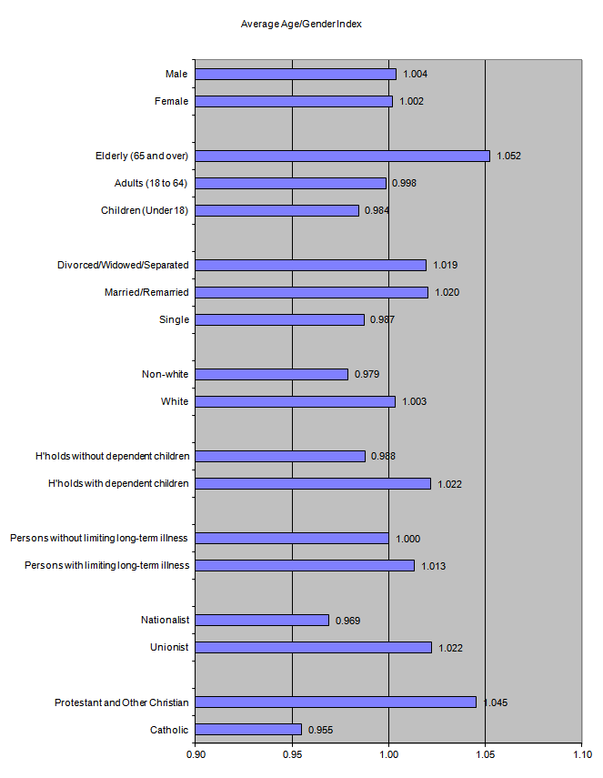

**Figure 16.2 Average Additional Needs Index for each Equality Category (NI = 1.0)**

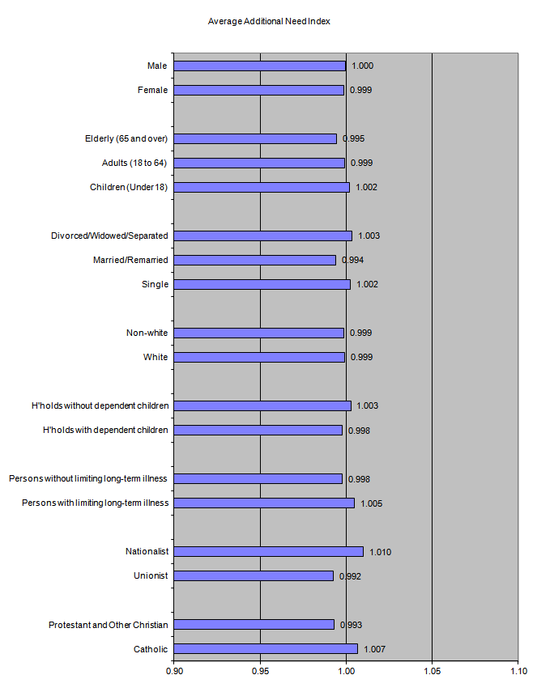

**Figure 16.3 Average Total Index (Age-Gender & Need) for each Equality Category (NI = 1.0)**

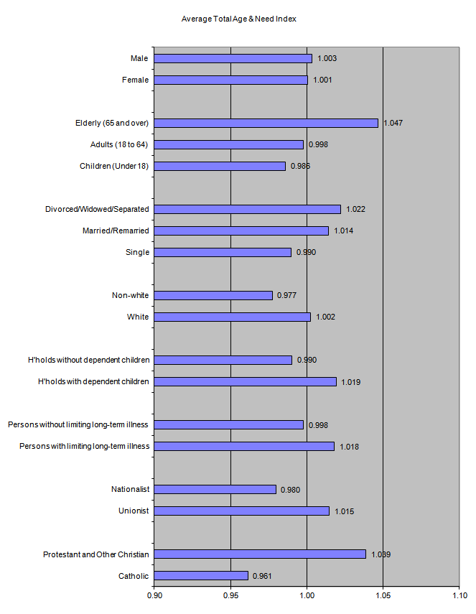

1. **Conclusions & Recommendations**

17.1 This report details a large amount of DHSSPS in-house analytical work to develop updated components of the weighted capitation formula used in allocating primary care prescribing resources to GP practices and Local Commissioning Groups (LCGs). Background information on the current formula and the rationale behind this review are presented in sections 1 to 3. The population base has been re-examined and population trend analysis has been presented (section 4). The method of constraining has been re-examined and is presented as a supplementary paper at Appendix N. An updated age cost curve has been derived using the enhanced prescribing database and associated Electronic Prescribing and Eligibility System (EPES); the results are presented in section 5.

17.2 There are differences in the age and gender of patients for whom drugs in specific therapeutic groups are usually prescribed. During the last formula review in 2010, it was highlighted that it would have been desirable to construct age weights for each therapeutic group and likewise to build additional needs models for these separate therapeutic groups. Dispensing data was not considered robust enough at that time to carry out such analysis. During this current review, we were able to construct age-gender specific weights (STAR-PU) for the 10 leading British National Formulary (BNF) chapters plus a number of specific drugs (see section 6). In developing the preferred additional needs model, separate models were constructed for specific BNF chapters (see paragraphs 11.12 to 11.13 and Table 11.5).

17.3 An adjustment has been developed and incorporated within the age-gender weighting to take account of the relative greater prescribing need of patients in care homes compared to patients living in their own homes. This work is presented in section 7. The need for such an adjustment had already been recognised by the IPA Management Group; analysis was carried out in 2012 and the IPA group endorsed the work and agreed to introduction of the adjustment for 2013/14. This review allows the adjustment to be updated but also to be formally presented and subjected to peer review and public consultation.

17.4 A comprehensive modelling exercise has been undertaken to develop an updated additional needs index; the modelling strategy has explored the development of different model approaches and different functional specifications and, using both theoretical rationale and statistical testing, has arrived at a preferred model. This is presented in sections 8 to 12.

17.5 We have assessed the robustness of the formula when applied at LCG level (see section 13) and at GP practice level (see section 15). We have also tested the sensitivity of the formula at small area level in terms of targeting deprivation (see section 14). Each component and the overall formula have been tested against NI equality legislation; analysis demonstrates that the new formula would not create any adverse impacts on any of the equality categories (see section 16).

***Peer Review Process***

17.6 A peer reviewer (Mr Michael Stevenson, Queen’s University Belfast) was appointed at the start of the process and has worked collaboratively with the DHSSPS statistical team throughout development of each component. The peer reviewer provided feedback at each key milestone and all suggestions and recommendations he made regarding statistical analysis, testing and presentation of results have been taken on board.

17.7 The peer reviewer has endorsed the updated age-gender weights, the development of STAR-PU and the development of the care home adjustment. A number of small queries raised have been resolved and any suggestions regarding presentation and commentary have been taken on board.

17.8 The peer reviewer has endorsed the view that the current needs indicators no longer reflect current levels of need (as demonstrated by replication of the current model with updated data) and supports the rationale for update. The peer reviewer has endorsed the strategy for modelling additional need and supports the rationale behind choosing the 2-stage additive model. However, in reviewing the results, the peer reviewer flagged that the Western LCG dummy was juxtaposed or in other words working side-by-side with admission rates. He pointed out that sensitivity test 7 is the evidence for this by the very fact that admission rates become non-significant when LCG dummies are excluded. The peer reviewer questioned the rationale for including LCG dummies given that Northern Ireland has one single regional Health and Social Care Board and he would have advocated dropping the LCG dummies and in turn that would exclude admission rates. However, it is known that, on the ground, there remain differences in policy and practice across the LCGs and therefore a case remains for retaining LCG dummy variables. Retention of the LCG dummies dictated that we had to deal with the admission rate juxtaposition issue by another means. Testing the exclusion of admission rates indicated that we could deal with the juxtaposition issue by excluding admission rates but still retaining LCG dummies which was considered more appropriate. The resulting model (Table 11.7) is basically the original preferred model with admission rates excluded but it still produces a well specified model that passes the RESET test. The resulting model is now very similar in terms of the standardised coefficients and the explanatory power to sensitivity test 7 (that is, the base model without LCG dummies).

***Peer Review Recommendations from 2010 Formula Review***

17.9 During the 2010 review, the peer reviewer was keen that an additional needs model be developed at small area level; the advantages and disadvantages of this level of modelling are outlined at paragraphs 10.7 to 10.11. Dispensing data was not sufficiently robust during the last review to allow this level of modelling; 2013/14 dispensing data used in this current review would be considered robust. Although a dataset of needs and supply variables was assembled at SOA level, time did not permit small area analysis in this 2015 review. As the dataset has been assembled, we will look at this in the near future rather than wait until the next full formula review, as this may help inform the additional needs modelling strategy next time.

17.10 Recommendations from the last review to develop STAR-PU and therapeutic-specific additional needs models have been implemented.

17.11 During the last review, the peer reviewer emphasised that the preferred theoretical additional needs model would have been a stratified 1-stage model. Dispensing data was not sufficiently robust to allow development of these models last time. The recommendation to develop stratified 1-stage models has been implemented in this current review (see paragraphs 11.10 to 11.11 and Tables 11.13 and 11.14). Although these and BNF specific models were developed, the preferred model was the 2-stage additive (the rationale for this decision is outlined at paragraph 11.14).

***Recommendations:***

17.12 The following recommendations relate to development of the updated formula:

* A constrained registered population should be retained as the population base for setting LCG allocations. The recognised method of constraining has been implemented throughout this report; however, an alternative method of constraining has been presented at Appendix N. The public consultation associated with this review should include discussion and debate regarding this alternative method.
* The GP practice registered list should be retained as the population base for setting GP practice allocations.
* The proposed new age cost curve NI-PU 2015 derived from 2013/14 dispensing data should be implemented. The NI-PU 2015 should also be introduced as the updated comparator prescribing measure in COMPASS reporting and any other comparative analysis.
* STAR-PU should be adopted as the prescribing measure when analysing a particular drug, BNF chapter, section or paragraph.
* The proposed new care home adjustment should be incorporated within the age weighting and implemented when setting both LCG and GP practice allocations.
* The preferred additional needs model based on a simplified 2-stage additive stepwise model specification (which has been through sensitivity testing and simplification) with sterilisation of supply variables should be implemented when setting both LCG and GP practice allocations.

17.13 The following recommendations relate to implementation of the updated formula:

* The limitations of any budgetary formula are likely to mean that there will be some variation from fair shares, even after variations in clinical practice have been accounted for. It is therefore advisable that any system for allocating to GP practices should be indicative and advisory and risk management strategies implemented to lessen some of the consequences. Top-slicing arrangements and capping mechanisms, as currently in place, are still very advisable.
* A major issue with implementation of any resource allocation formula is the pace of change in terms of moving towards 100% capitation and fair shares. The model explains x%; unless the position that 100-x is caused by GP behaviour can be defended, it is difficult to propose 100% allocation of resources using the formula. The current formula is implemented at 100%, albeit with mechanisms to try to retain budgetary control, but the Commissioner may want to re-consider this level of implementation in light of introducing a new formula. A reduced capitation level initially may allow more stability for GP practices and a phased return to 100% fair shares allow bedding-in of the new formula.

**Appendix A**

**List Discrepancy**

**Comparison of GP registered list populations, based on residency of the patients at January 2013, with the mid-year estimate of population at June 2013.**

|  |  |  |  |
| --- | --- | --- | --- |
| **LGD** | **NHAIS January 2013** | **MYE June 2013** | **List Discrepancy %** |
| **Antrim** | 54,377 | 53,978 | 0.74% |
| **Ards** | 79,121 | 78,549 | 0.73% |
| **Armagh** | 64,374 | 60,539 | 6.33% |
| **Ballymena** | 66,569 | 64,762 | 2.79% |
| **Ballymoney** | 30,997 | 31,659 | -2.09% |
| **Banbridge** | 49,163 | 48,910 | 0.52% |
| **Belfast** | 296,181 | 281,744 | 5.12% |
| **Carrickfergus** | 39,947 | 39,015 | 2.39% |
| **Castlereagh** | 68,900 | 67,883 | 4.50% |
| **Coleraine** | 58,590 | 59,043 | -0.77% |
| **Cookstown** | 38,383 | 37,552 | 2.21% |
| **Craigavon** | 98,061 | 95,479 | 2.70% |
| **Derry** | 119,515 | 109,620 | 9.03% |
| **Down** | 72,126 | 70,825 | 1.84% |
| **Dungannon** | 62,017 | 59,419 | 4.37% |
| **Fermanagh** | 62,691 | 62,738 | -0.07% |
| **Larne** | 32,589 | 32,220 | 1.15% |
| **Limavady** | 33,667 | 33,895 | -0.67% |
| **Lisburn** | 122,826 | 121,992 | 0.68% |
| **Magherafelt** | 46,074 | 45,827 | 0.54% |
| **Moyle** | 17,405 | 17,111 | 1.72% |
| **Newry & Mourne** | 110,351 | 101,813 | 8.39% |
| **Newtownabbey** | 86,615 | 85,558 | 1.24% |
| **North Down** | 80,393 | 79,425 | 1.22% |
| **Omagh** | 52,764 | 51,842 | 1.78% |
| **Strabane** | 42,870 | 40,243 | 6.53% |
| **Northern Ireland** | 1,886,566 | 1,831,641 | 3.00% |

Footnote: At January 2013, 22,430 records on NHAIS did not have a postcode and therefore the patient could not be assigned to an LGD based on residency. All patients could be assigned to an age group. This is why list discrepancy at NI level differs between the LGD and age group tables.

|  |  |  |  |
| --- | --- | --- | --- |
| **Age Group** | **NHAIS January 2013** | **MYE June 2013** | **List Discrepancy %** |
| **0-4** | 124,347 | 126,673 | -1.84% |
| **5-15** | 259,527 | 255,934 | 1.40% |
| **16-24** | 226935 | 220,816 | 2.77% |
| **25-44** | 547,106 | 491,881 | 11.23% |
| **45-59** | 378,472 | 363,398 | 4.15% |
| **60-64** | 95,666 | 93,745 | 2.05% |
| **65-74** | 154,562 | 155,358 | -0.51% |
| **75+** | 122,723 | 123,836 | -0.90% |
| **NI Total** | 1,909,338 | 1,831,641 | 4.24% |

**Appendix B**

**Constraining Procedure to Control GP Practice Registered List Populations to Match the Official Mid-Year Estimate**

B.1 There are a number of technical difficulties in constructing an appropriate population base when allocating primary care prescribing resources to local commissioning groups (LCGs). These are due to 2 factors: (i) cross boundary flow and (ii) list discrepancy.

B.2 Practice registered populations cannot be used directly, since they are distorted by variable list discrepancy, which differs in size and age, by geographical area and from practice to practice. Population estimates cannot be used solely either, due to problems with cross boundary flows; that is, patients who are resident in one LCG area but are registered with a GP practice in a different LCG.

B.3 Ideally, we require a population base which is free of the effects of list discrepancy but which still takes account of cross boundary flow. The population base for GP prescribing to LCGs is the constrained registered list. The constraining methodology takes the registered GP population as its start point and scales it back to match the resident population for an area. The constraining method does not eliminate list discrepancy entirely, but rather averages it across the area at which it is being absorbed. List discrepancy within the formula is currently absorbed at LCG level, but the constraining method takes place at LGD level; the method is more accurate the smaller the reference population to which the lists are constrained. This method means that LCGs are therefore not funded for the level of list discrepancy in their area. Note that whatever level of constraining is used, there will always be averaging. The only way to avoid this penalising effect would be to adjust each practice by its own level of list discrepancy. As this is unknown, an area-based constraining method is the only feasible option. It would not be feasible to ascertain the level of list discrepancy by GP practice, as there is no alternative data source to which to compare the GP practice lists. Even if other sources were used to identify practice list sizes and identify “ghost” patients who have died or left the practice, there will be a number of patients availing of GP services by using an address of convenience and these still place a burden on the GP practice in question.

B.4 Note that debate around the most appropriate population base (registered population versus constrained registered population) was subject to a Ministerial submission in 2002 and at that time it was proposed and approved by the then Minister to adopt the base and procedure as outlined below (that is, a constrained registered population). In coming to a recommendation regarding the most appropriate population base, the equality impact was also considered in the Ministerial submission. In this case, there are equality implications with both population options, as different categories of people within the same equality group are impacted in completely opposite ways depending on the method chosen. The use of registered lists impacts favourably on young Catholic populations and impacts adversely on Protestants and older age groups. The constrained registered population has an equal and opposite effect on these groups. The submission also noted the consistency with other allocations (hospital, community and social services) in the use of constrained registered lists; these other allocations use the mid-year estimate as their population base. The only divergence from this consistency is the General Medical Services (GMS) global sum allocation to GP practices, where national policy negotiations deemed registered lists to be used as the population base.

B.5 The current solution uses 3 separate population figures, each broken down by age and gender. The figures are:

* + The total number of patients on the National Health Applications and Infrastructure Services System (the NHAIS System, commonly known as the Exeter System) resident within each local government district (LGD) area.
  + The total number of patients on NHAIS registered with GP Practices within each LGD area.
  + The mid-year estimate of population (produced by the Northern Ireland Statistics & Research Agency, NISRA) for each LGD area plus the number of cross border workers as recorded on NHAIS.

B.6 The constraining method involves the following steps, carried out by separate age-gender groups:

* Any patient whose LGD of residence was unknown on the NHAIS system (due to missing postcodes) is redistributed amongst LGDs, in the proportion of those patients registered with GP practices in that LGD area.
* Divide the mid-year estimate of population by the NHAIS system number of resident patients in the LGD, producing a deflator to adjust for list discrepancy.
* Each list deflator is then applied to all patients who are resident in that LGD, regardless of their LGD of registration.
* The deflated figures are then added to give the total number of patients registered with GP practices in that LGD area.
* Results for all age-gender groups are then added to give the total population in each LGD area.

B.7 The illustration that follows, for simplicity, shows the constraining process taking place at LCG level. As described above, the constraining would actually take place at LGD level, with the list discrepancy being absorbed at LCG level.

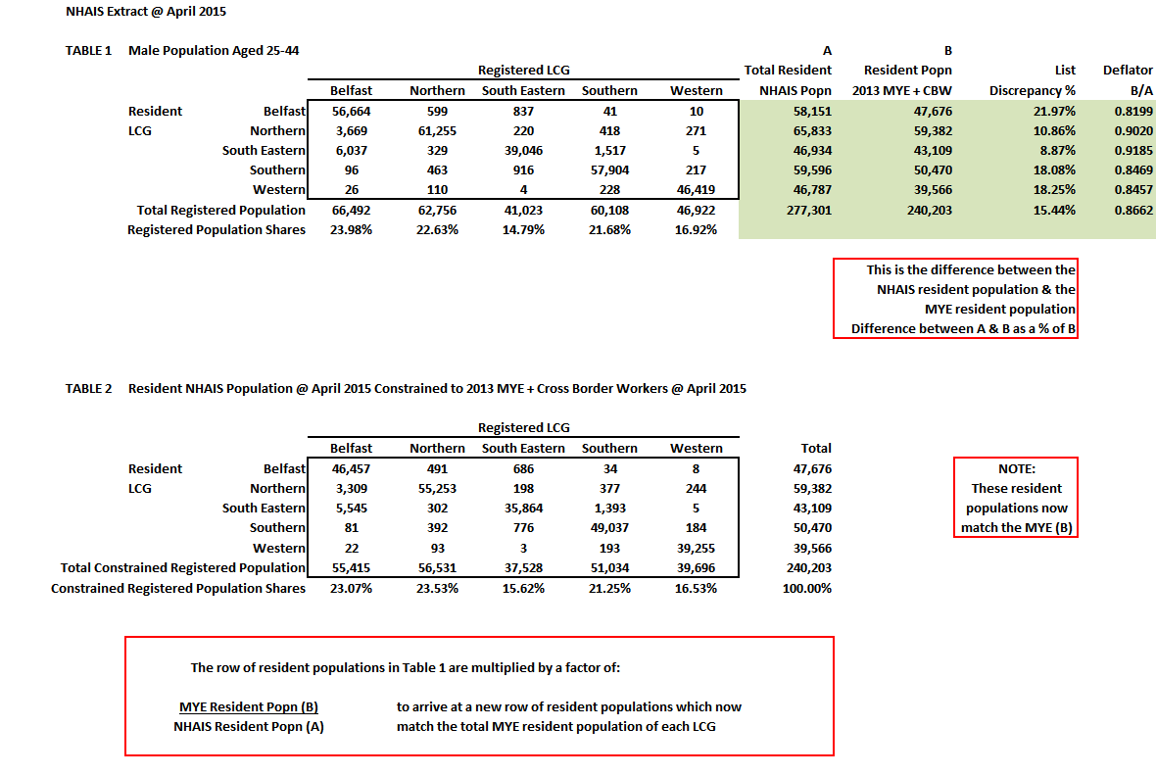

**Appendix C**

**English Relative Cost Weights (ASTRO-PU)**

C.1 The Health and Social Care Information Centre (HSCIC) in England produce prescribing relative cost weightings which are used within their resource allocation formula and are also used as a prescribing measure for better comparisons of prescribing patterns. These are referred to as Age, Sex and Temporary Resident Originated Prescribing Units (ASTRO-PU). Note that although the ASTRO name has been retained, like the NI-PU, there is actually no longer an adjustment for temporary residents within the weightings. Again due to the new GMS Contract arrangements, temporary residents attending GP practices are no longer captured and are therefore not included in funding allocations.

C.2 Although we could not make direct comparisons between NI-PU and ASTRO-PU, it was beneficial to examine the ASTRO-PU and in particular the change in weights during the last review in 2013 compared to the 2009 ASTRO-PU. Direct comparison was not possible, as the age groups differ for NI-PU and ASTRO-PU and the basis for ASTRO-PU will differ in terms of the exclusions applied in NI to ensure NI-PU weightings are appropriate for resource allocation purposes in NI.

C.3 Figure C.1 shows the change in weights between ASTRO-PU 2009 and ASTRO-PU 2013. The charts show a similar pattern, in terms of the change in the relative weights, to what has occurred in NI. Like NI, England has seen a reduction in prescribing costs in recent years.

C.4 Figure C.2 shows NI-PU 2010 and ASTRO-PU 2009 on separate charts but we can see that the pattern of weights is similar for England and NI. The steepness of the curves is very similar for all age groups up to age 64. The weights are then steeper in the older age groups for ASTRO-PU, particularly the 75+ male weighting.

C.5 Figure C.3 shows NI-PU 2015 and ASTRO-PU 2013 on separate charts. As prescribing costs have decreased in both countries, the relative cost curves are now less steep in both England and NI. This is, however, more pronounced in England, where cost weights in the older age groups have decreased by around £7-8 compared to £2-3 in NI.

C.6 Historically, both NI-PU and ASTRO-PU have been standardised; because the weightings are used in central resource allocation, they need to be standardised as a means of comparing “like with like”. The HSCIC feel that ASTRO-PU are no longer primarily used for resource allocation but are more utilised in monitoring prescribing spend; as such, the HSCIC are currently reconsidering their standardisation methodology for ASTRO-PU. Standardising the weightings potentially introduces a source of variation, with all weightings dependent on the factor by which the true weighting for the minimum cost/head is adjusted to set a weighting of 1.0.

As NI-PU weightings are still used for resource allocation purposes in NI, the recommendation in NI is to continue to standardise the NI-PU.

**Figure C.1 Comparison of ASTRO-PU 2009 v ASTRO-PU 2013**

**(a) Male Cost Weights**

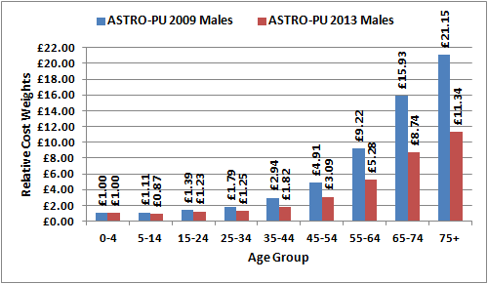

**(b) Female Cost Weights**

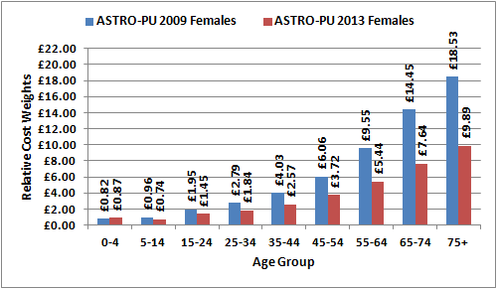

**Figure C.2 Comparison of NI-PU 2010 and ASTRO-PU 2009**

1. **NI-PU 2010**

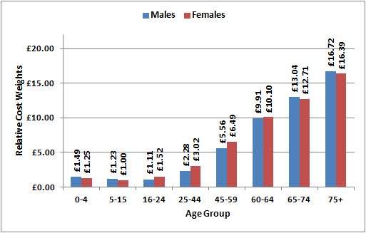

1. **ASTRO-PU 2009**

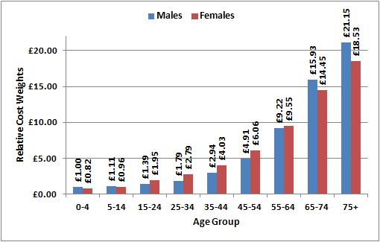

**Figure C.3 Comparison of NI-PU 2015 and ASTRO-PU 2013**

1. **NI-PU 2015**

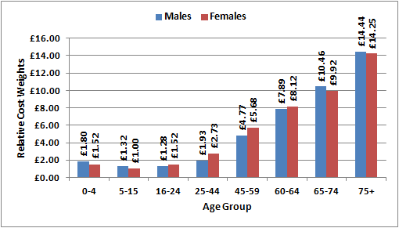

1. **ASTRO-PU 2013**

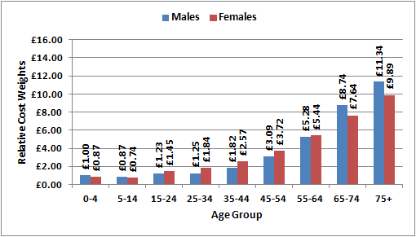

**Figure C.4 Comparison of SCOT-PU 2012 & 2014**

1. **Male Cost Weights**

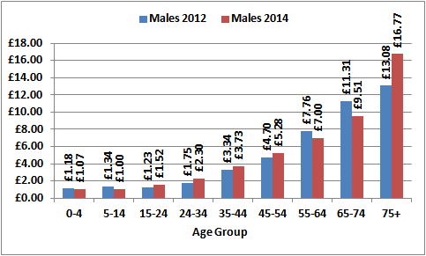

1. **Female Cost Weights**

C.7 Figure C.4 shows the change in weights between SCOT-PU 2012 and SCOT-PU 2014. Like NI, Scotland has in general seen a reduction in prescribing costs in recent years; the exception being in the males aged 75+ group, where costs have increased.

C.8 Figure C.5 shows the latest available prescribing cost weights available for Northern Ireland, Scotland and England. The Northern Ireland relative cost curve is steeper than the other countries; although prescribing costs have decreased in NI as in elsewhere, the steeper curve reflects that costs are still higher in NI. While direct comparisons are not possible due to the different age groups, the 2 oldest age groups are consistent across all 3 countries. In the 65-74 age group, NI is approximately £2 higher than England and £1 higher than Scotland. In the 75+ age group, while NI is approximately £3-£4 higher than England, Scotland now has a very low relative weight for females aged 75+, at £7 lower than NI, but their males aged 75+ increased by over £3 between 2012 and 2014, making them £2 higher than NI and £5 higher than England.

**Figure C.5 Comparison of NI-PU, SCOT-PU & ASTRO-PU (latest weights available)**

1. **NI-PU 2015**



1. **SCOT-PU 2014**
2. **ASTRO-PU 2013**



**Appendix D**

**STAR-PU Weightings for the Leading 10 Therapeutic Groups**

**Figure D.1 BNF 1 – Gastro-intestinal System (Cost Based Weights)**

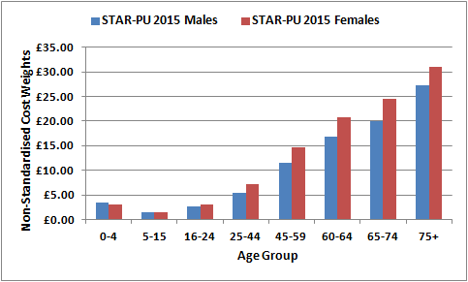

**Figure D.2 BNF 2 – Cardiovascular System (Cost Based Weights)**

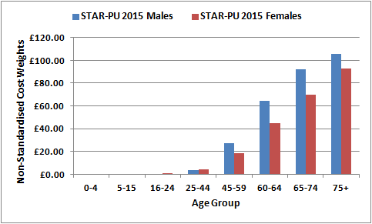

**Figure D.3 BNF 3 – Respiratory System (Cost Based Weights)**

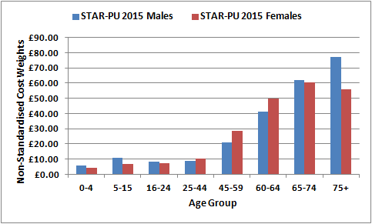

**Figure D.4 BNF 4 – Central Nervous System (Cost Based Weights)**

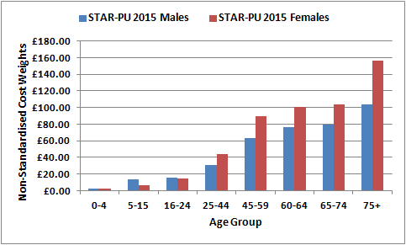

**Figure D.5 BNF 5 – Infections (Item Based Weights)**

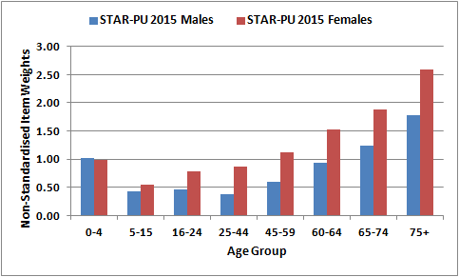

**Figure D.6 BNF 6 – Endocrine System (Cost Based Weights)**

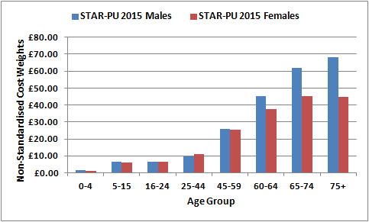

**Figure D.7 BNF 7 – Obs, Gynae & UT Disorders (Cost Based Weights)**

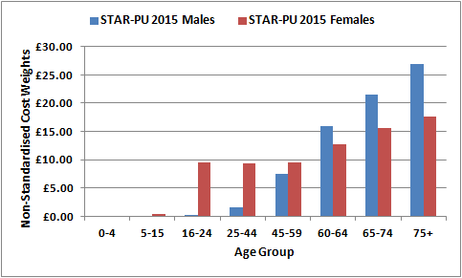

**Figure D.8 BNF 9 – Nutrition & Blood (Cost Based Weights)**

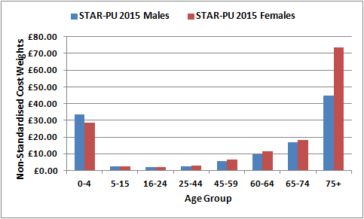

**Figure D.9 BNF 10 – Musculoskeletal & Joint Diseases (Cost Based Weights)**

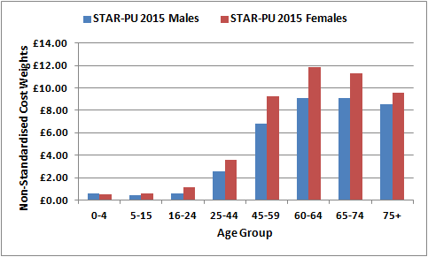

**Figure D.10 BNF 13 – Skin Diseases (Cost Based Weights)**

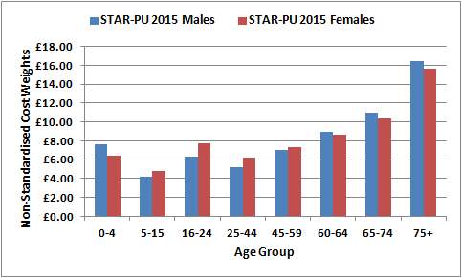

**Table D.1 STAR-PU (Cost per Head) Weightings for Specific BNF Sections & Paragraphs**

|  |  |  |  |  |  |  |
| --- | --- | --- | --- | --- | --- | --- |
| **Age Group** | **BNF 1.3**  **Ulcer Healing Drugs** | | **BNF 1.3.5**  **Proton Pump Inhibitors** | | **BNF 2.12**  **Lipid Regulating Drugs** | |
| Males | Females | Males | Females | Males | Females |
| 0-4 | £1.07 | £0.81 | £0.82 | £0.61 | £0.00 | £0.00 |
| 5-15 | £0.30 | £0.27 | £0.22 | £0.19 | £0.00 | £0.00 |
| 16-24 | £0.46 | £0.59 | £0.33 | £0.38 | £0.04 | £0.04 |
| 25-44 | £1.80 | £1.87 | £1.58 | £1.56 | £1.05 | £0.54 |
| 45-59 | £4.81 | £5.64 | £4.40 | £5.13 | £10.55 | £5.89 |
| 60-64 | £7.17 | £9.03 | £6.58 | £8.34 | £23.84 | £16.74 |
| 65-74 | £9.10 | £11.09 | £8.25 | £10.25 | £29.60 | £24.44 |
| 75+ | £10.53 | £12.06 | £9.49 | £11.07 | £24.17 | £23.23 |

|  |  |  |  |  |  |  |
| --- | --- | --- | --- | --- | --- | --- |
| **Age Group** | **BNF 2.5.5**  **Drugs Affecting the Renin Angiotensin System** | | **BNF 2.6.2**  **Calcium-Channel Blockers** | | **BNF 4.7.1 & 4.7.2**  **Analgesics** | |
| Males | Females | Males | Females | Males | Females |
| 0-4 | £0.05 | £0.05 | £0.00 | £0.00 | £1.14 | £1.07 |
| 5-15 | £0.05 | £0.04 | £0.01 | £0.01 | £0.47 | £0.55 |
| 16-24 | £0.05 | £0.02 | £0.02 | £0.04 | £0.83 | £1.23 |
| 25-44 | £0.57 | £0.39 | £0.20 | £0.19 | £5.27 | £7.68 |
| 45-59 | £4.41 | £3.53 | £1.59 | £1.31 | £16.11 | £21.53 |
| 60-64 | £9.04 | £7.60 | £4.08 | £3.45 | £21.74 | £28.82 |
| 65-74 | £11.77 | £10.98 | £6.33 | £5.97 | £22.01 | £31.80 |
| 75+ | £11.86 | £12.46 | £7.38 | £8.05 | £25.40 | £49.90 |

|  |  |  |  |  |  |  |
| --- | --- | --- | --- | --- | --- | --- |
| **Age Group** | **BNF 3.1**  **Bronchodilators** | | **BNF 3.2**  **Inhaled Corticosteroids** | | **BNF 6.1**  **Diabetes** | |
| Males | Females | Males | Females | Males | Females |
| 0-4 | £2.15 | £1.68 | £1.42 | £0.89 | £0.50 | £0.50 |
| 5-15 | £1.88 | £1.28 | £4.62 | £2.85 | £4.48 | £4.48 |
| 16-24 | £1.38 | £1.16 | £5.24 | £4.56 | £5.50 | £5.15 |
| 25-44 | £1.42 | £1.61 | £6.53 | £7.21 | £7.98 | £6.94 |
| 45-59 | £5.34 | £6.87 | £13.53 | £17.83 | £22.36 | £14.44 |
| 60-64 | £13.56 | £14.79 | £23.12 | £27.98 | £37.76 | £24.73 |
| 65-74 | £20.84 | £18.62 | £32.19 | £33.33 | £47.68 | £29.57 |
| 75+ | £26.37 | £17.08 | £38.21 | £29.96 | £42.49 | £25.71 |

|  |  |  |  |  |  |
| --- | --- | --- | --- | --- | --- |
| **Age Group** | **BNF 6.1.1 Insulin** | | **BNF6.1.2 Anti-diabetic Drugs** | |  |
| Males | Females | Males | Females |  |
| 0-4 | £0.14 | £0.18 | £0.00 | £0.00 |  |
| 5-15 | £2.08 | £2.05 | £0.02 | £0.01 |  |
| 16-24 | £3.85 | £3.21 | £0.01 | £0.04 |  |
| 25-44 | £4.66 | £3.41 | £1.11 | £0.94 |  |
| 45-59 | £8.92 | £5.70 | £9.16 | £5.59 | Source: |
| 60-64 | £13.99 | £8.85 | £17.19 | £10.70 | Derived from dispensing |
| 65-74 | £17.16 | £10.33 | £21.40 | £12.97 | Data (EPES) & GP registered |
| 75+ | £15.10 | £8.86 | £17.55 | £10.13 | Lists (NHAIS) |

**Figure D.11 BNF 1.3 – Ulcer Healing Drugs (Cost per Head)**

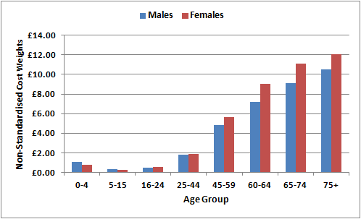

**Figure D.12 BNF 1.3.5 – Proton Pump Inhibitors (Cost per Head)**

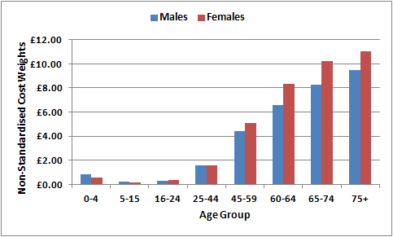

**Figure D.13 BNF 2.12 – Lipid Regulating Drugs (Cost per Head)**

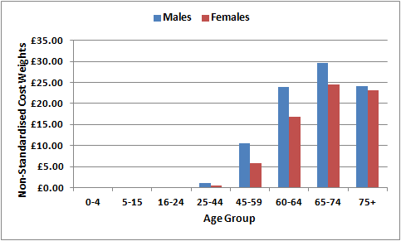

**Figure D.14 BNF 2.5.5 – Drugs Affecting the Renin Angiotensin System (Cost per Head)**

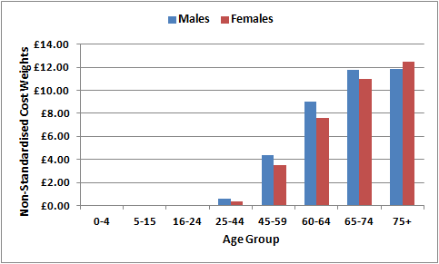

**Figure D.15 BNF 2.6.2 – Calcium-Channel Blockers (Cost per Head)**

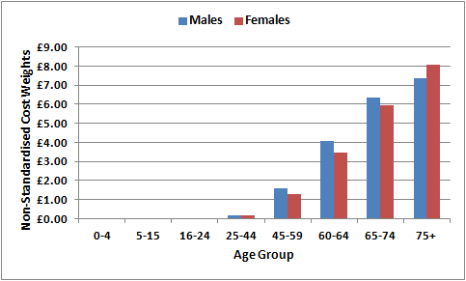

**Figure D.16 BNF 4.7.1 & 4.7.2 – Analgesics (Cost per Head)**

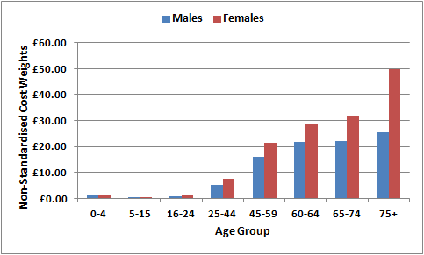

**Figure D.17 BNF 3.1 – Bronchodilators (Cost per Head)**

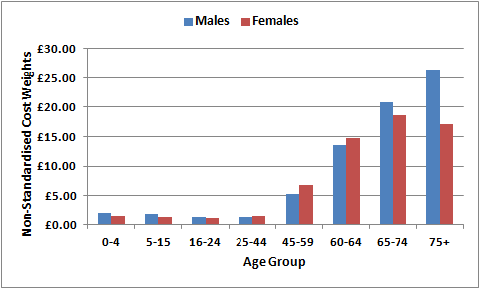

**Figure D.18 BNF 3.2 – Inhaled Corticosteroids (Cost per Head)**

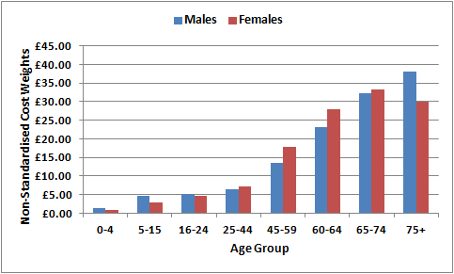

**Figure D.19 BNF 6.1 – Diabetes (Cost per Head)**

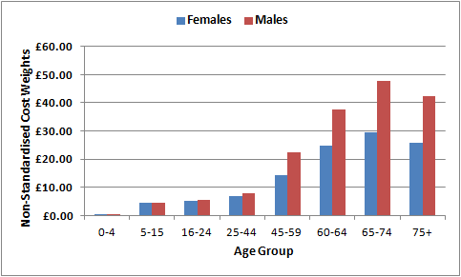

**Figure D.20 BNF 6.1.1 – Insulin (Cost per Head)**

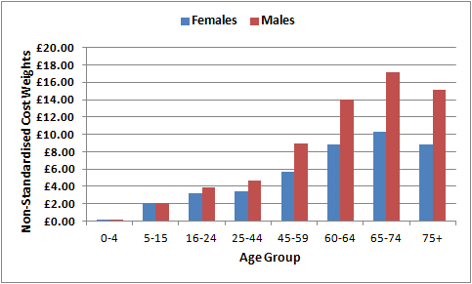

**Figure D.21 BNF 6.1.2 – Anti-diabetic Drugs (Cost per Head)**

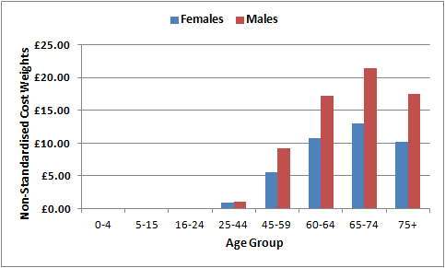

**Appendix E**

**Supplementary Analysis to Demonstrate Effect of Using NI-PU When STAR-PU More Appropriate**

E.1 This appendix considers the distribution of total prescribing compared with ‘therapeutic specific’ prescribing and the impact on Cost/PU. It sets out a worked example comparing two practices and the effects of using different population weightings. Finally, it considers the impact, at LCG level, of using different population weightings.

E.2 Tables E.1 and E.2 show the effects on two different GP practices of using weights derived from (i) ‘total prescribing’ (NI-PU as the denominator) when applied to costs for Cardiovascular BNF 2 only, compared to (ii) the effects of using the appropriate STAR-PU weights, in this case STAR-PU Cardiovascular BNF2 as the denominator, when the numerator is the cost of Cardiovascular BNF 2 only.

E.3 It is important to note that Cost/Head and Cost/PU are two different currencies and cannot be compared to each other. However, we can compare cost per head and cost per head adjusted for age and gender. Application of weightings to a practice list produces a practice weighted population. Application of the weightings to all practices produces an overall notional population, which differs from the actual population. Through a process of scaling back, known as ‘normalisation’, the weighted populations are adjusted so as to total the actual population. This creates actual populations which have been adjusted for age and gender.

**Table E.1 Practice A**

|  |  |  |
| --- | --- | --- |
|  | **Using NI-PU** | **Using STAR-PU** |
| Prescribing units | 12,097 | 66,786 |
| Age Index | 1.1490 | 1.2606 |
| Cost/PU | £9.14 | £1.66 |
| Cost/PU difference | £7.49 | |
| Cost/Head adjusted for age and gender | £39.42 | £35.93 |
| Cost/Head without adjustments | £45.29 | |

**Table E.2 Practice B**

|  |  |  |
| --- | --- | --- |
|  | **Using NI-PU** | **Using STAR-PU** |
| Prescribing units | 21,380 | 44,369 |
| Age Index | 0.4971 | 0.2050 |
| Cost/PU | £1.04 | £0.50 |
| Cost/PU difference | £0.54 | |
| Cost/Head adjusted for age and gender | £4.50 | £10.91 |
| Cost/Head without adjustments | £2.24 | |

E.4 For Practice A, applying NI-PU 2015 weightings instead of STAR-PU weightings would result in a lower Age Index and the cost per PU would be £7.49 higher using the 2015 NI-PU rather than the STAR-PU. If there was no existing STAR-PU, the cost per head would be £45.29, which is higher than the cost per head would be using NI-PU 2015 weightings.

E.5 For Practice B, applying NI-PU 2015 weightings instead of STAR-PU weightings would result in a higher Age Index. The cost per PU under NI-PU would be £0.54 higher than when using STAR-PU. In this example, in the absence of an existing STAR-PU, the cost per head without adjustments would be £2.24, which is lower than the Cost per head would be using NI-PU 2015.

E.6 These examples show that using NI-PU can result in either a lower or higher cost per head than would be achieved without adjustments. The lack of a consistent relationship further strengthens the argument for not applying NI-PU in the absence of an existing STAR-PU. It is clear from these examples that the effects of NI-PU can differ in either direction from the effects of STAR-PU and NI-PU should therefore not be used as an alternative to a STAR-PU.

**NI-PU v STAR-PU charts**

E.7 Comparison of the NI-PU 2015 chart with STAR-PU charts further highlights the differences that can exist in the relative cost weights. The examples below show how the distribution of the STAR-PU charts can differ from that of the NI-PU chart. Not surprisingly, the STAR-PU weightings differ greatly for different therapeutic groups and they also differ from the overall NI-PU weightings derived from total dispensing. In the case of these examples, applying the NI-PU 2015 weightings instead of STAR-PU weightings would lead to patients being weighted inappropriately. As such, applying the NI-PU 2015 *in the absence* of a STAR-PU would also be an incorrect use of the weightings, potentially leading to inappropriate weighting of age-gender groups.

**Figure E.1 NI-PU 2015**

E.8 The weights shown in the NI-PU 2015 chart in Figure E.1 can be interpreted in the following way: overall, a 75+ male is 14 times more expensive than a female aged 5-15. When we consider Musculoskeletal prescribing, a 75+ male is 15 times more expensive than a female aged 5-15 (Figure E.2). However, a male aged 75+ is 18 times more expensive than a female aged 5-15, when considering prescribing for Nutrition and Blood (Figure E.3), and 62 times more expensive when considering prescribing for Obs, Gynae & Urinary Tract Disorders (Figure E.4).

**Figure E.2 BNF Chapter 10 - Musculoskeletal & Joint Diseases - Cost Based Weights**

**Figure E.3 BNF Chapter 9 - Nutrition & Blood - Cost Based Weights**

**Figure E.4 BNF Chapter 7 - Obs, Gynae & Urinary Tract Disorders - Cost Based Weights**

E.9 If you were looking at Nutrition and Blood BNF prescribing, for example, you would want a PU giving greater weight to the 0-4 age group, so that when comparing areas or practices, those with a higher proportion of children are weighted accordingly. If you used NI-PU, the weighting would not be high enough for 0-4s and this would distort the results.

E.10 Further analysis was carried out to compare Cost per PU using either the NI-PU 2015 or the STAR-PU as the denominator for a subset of 20 practices, to show how the cost per PU varies using the different weightings. The findings from this are shown in Figures E.5-E.9. In each chart, the Cost per PU when using the NI-PU as the denominator is higher for each practice than the Cost per PU when the appropriate STAR-PU is used as the denominator. This lends further support to the argument against using the NI-PU to calculate Cost per PU in the absence of an existing STAR-PU, as use of the NI-PU would weight patients inappropriately.

E.11 Analysis was also carried out at LCG level, to determine how percentage shares for each LCG would vary using either NI-PU or the relevant STAR-PU. Table E.3 shows how resources are redistributed across LCGs using age gender weightings compared to crude population shares. If resources for cardiovascular medicines were being shared out, the use of NI-PU would only redistribute +/- 1.95% of resources, whereas the use of a BNF 2 STAR-PU would redistribute +/- 3.25% of resources.

**Table E.3**

|  |  |  |  |  |  |  |  |
| --- | --- | --- | --- | --- | --- | --- | --- |
| **LCG** | **Crude Popn Shares %** | **% Shares using NI-PU** | **% Shares using STAR-PU** | | | | |
| **Cardiovascular BNF 2** | **Endocrine BNF 6** | **Diabetes BNF 6.1** | **Nutrition BNF 9** | **Analgesics BNF 4.7.1 + 4.7.2** |
| Belfast | 22.42% | 22.14% | 21.74% | 21.99% | 21.97% | 22.28% | 22.28% |
| Northern | 23.62% | 24.33% | 24.82% | 24.35% | 24.30% | 24.41% | 24.36% |
| S Eastern | 17.18% | 18.42% | 19.23% | 18.45% | 18.37% | 18.52% | 18.53% |
| Southern | 19.95% | 18.93% | 18.36% | 18.92% | 18.98% | 19.04% | 18.74% |
| Western | 16.83% | 16.18% | 15.84% | 16.29% | 16.37% | 15.74% | 16.10% |
| N Ireland | 100.00% | 100.00% | 100.00% | 100.00% | 100.00% | 100.00% | 100.00% |
|  | | | | | | | |
| **Redistribution from crude population share** | | **+/- 1.95%** | **+/- 3.25%** | **+/- 2.00%** | **+/- 1.87%** | **+/- 2.14%** | **+/- 2.09%** |

E.12 When NI-PU is applied to their crude population shares, the Northern and South Eastern LCGs’ shares increase, as they have more elderly population profiles. The shares for the other three LCGs decrease when NI-PU is applied to their crude population shares, as they have younger age profiles.

E.13 When an appropriate STAR-PU is applied, the percentage shares for each LCG show the same direction of change from the crude population shares as when NI-PU is applied i.e if the % shares increase when NI-PU is applied, they also increase when the STAR-PU is applied; conversely, if the % shares decrease when NI-PU is applied, they also decrease when the appropriate STAR-PU is applied. Further, when considering BNF 2, the extent of the increase or decrease is greater for each LCG when the appropriate STAR-PU is applied than when NI-PU is applied.

E.14 Table E.4 shows how the Age Index of each LCG is affected by applying the NI-PU or the appropriate STAR-PUs. The relativity of the LCGs differs depending on the weighting being used. The range of the LCG’s Age Indices using NI-PU is 0.1235, which although similar to the 0.1257 range using the STAR-PU for Endocrine BNF6, is lower than the range of 0.1989 for Cardiovascular BNF 2. Although the LCGs tend to retain their relative positions, this order alters in the case of Nutrition and Blood BNF 9, where the Western rather than the Southern LCG has the lowest age index.

**Table E.4**

|  |  |  |  |  |  |  |
| --- | --- | --- | --- | --- | --- | --- |
| **LCG** | **Age Index using NI-PU** | **Age Index using STAR-PU** | | | | |
| **Cardiovascular BNF 2** | **Endocrine BNF 6** | **Diabetes BNF 6.1** | **Nutrition BNF 9** | **Analgesics BNF 4.7.1 + 4.7.2** |
| Belfast | 0.9874 | 0.9697 | 0.9808 | 0.9798 | 0.9937 | 0.9934 |
| Northern | 1.0302 | 1.0508 | 1.0310 | 1.0289 | 1.0338 | 1.0314 |
| S Eastern | 1.0721 | 1.1194 | 1.0740 | 1.0693 | 1.0778 | 1.0784 |
| Southern | 0.9486 | 0.9205 | 0.9483 | 0.9516 | 0.9546 | 0.9392 |
| Western | 0.9616 | 0.9415 | 0.9678 | 0.9730 | 0.9353 | 0.9567 |
| N Ireland | 1.0000 | 1.0000 | 1.0000 | 1.0000 | 1.0000 | 1.0000 |

E.15 Table E.5 compares the Cost per PU using either NI-PU or specific STAR-PU. In each instance, applying the correct STAR-PU to calculate Cost per PU produced a smaller Cost per PU than would result from using the NI-PU.

**Table E.5**

|  |  |  |  |  |  |  |  |  |  |  |
| --- | --- | --- | --- | --- | --- | --- | --- | --- | --- | --- |
| **LCG** | **Cardiovascular BNF 2** | | **Endocrine BNF 6** | | **Diabetes BNF 6.1** | | **Nutrition BNF 9** | | **Analgesics BNF 4.7.1 + 4.7.2** | |
| **£/PU NI-PU** | **£/PU STAR-PU** | **£/PU NI-PU** | **£/PU STAR-PU** | **£/PU NI-PU** | **£/PU STAR-PU** | **£/PU NI-PU** | **£/PU STAR-PU** | **£/PU NI-PU** | **£/PU STAR-PU** |
|
| **Belfast** | £4.88 | £0.99 | £4.39 | £0.97 | £3.14 | £0.98 | £2.56 | £1.04 | £3.23 | £1.16 |
| **Northern** | £5.46 | £1.06 | £4.97 | £1.09 | £3.53 | £1.09 | £2.56 | £1.04 | £2.68 | £0.96 |
| **S Eastern** | £5.05 | £0.96 | £4.76 | £1.04 | £3.31 | £1.03 | £2.48 | £1.01 | £3.04 | £1.09 |
| **Southern** | £4.90 | £1.00 | £4.53 | £0.99 | £3.13 | £0.97 | £2.50 | £1.01 | £2.64 | £0.96 |
| **Western** | £5.19 | £1.05 | £4.50 | £0.98 | £3.23 | £0.99 | £2.66 | £1.11 | £2.43 | £0.88 |
| **N Ireland** | £5.11 | £1.02 | £4.64 | £1.01 | £3.28 | £1.01 | £2.55 | £1.04 | £2.82 | £1.01 |

**Conclusions and Recommendations**

E.16 The analysis in this appendix has demonstrated the distortion in resource allocation that can occur if NI-PU is used inappropriately. The use of patients instead, while not ideal, at least treats the age/gender groups equally rather than weighting one age/gender group over another, with a weighting that may be in appropriate. It is recommended that, in the absence of an appropriate STAR-PU, the population denominator that should be used is number of patients i.e. a per head figure. When reporting the difference between per PU and per head figures, it may be best to report ‘per head’ adjusted and ‘per head’ not adjusted figures.

**Appendix F**

**Attribution Process**

F.1 Historically, it has only been possible to analyse prescribing variation by GP practice; the costs of drugs dispensed in the community were only available at GP practice level. The standard unit of analysis from the Census, the General Registrar Office, social security systems and the NI Index of Multiple Deprivation is area-based (that is, data is available at Super Output Area (SOA) level). This therefore made it necessary to create practice level variables from these area based variables, through “attributing” the characteristics of the area from which each practice list was drawn to the practice (with the exception of QOF prevalence data which is collected at general practice level). Although the Enhanced Prescribing Database now makes it feasible to analyse dispensing costs by area and this area level analysis will indeed be undertaken as part of this review, practice level analysis will also be carried out and therefore attribution is still necessary. Attribution is also necessary from practice to SOA for QOF data.

F.2 Attribution is made possible because the NHAIS System contains a unique identifier for each GP practice and the postcode of each patient’s home address, to which area of residency can be attached. The method assumes that each individual on a GP’s list is randomly selected from the area in which he/she lives. The characteristics of the area to which that person belongs are then attributed to the individual. Consider the hypothetical GP practice in the diagram below; each individual on the GP practice’s list takes on the unemployment rate for the SOA as a whole.

# SOA 2



## SOA 3

**5% unemployment**

**GP** **Practice**



GP

## SOA 1



**10% unemployment**

**40% unemployment**

Practice catchment:

F.3 Giving the practice the unemployment value for the SOA in which it is based would be inaccurate, as the practice draws patients from more than one SOA. It is more accurate to compute values based on the place of residence of the practice population. The practice unemployment rate can then be computed by calculating the population-weighted average of the SOA unemployment rates of all the patients on each GP practice’s list.

F.4 In the example above, the GP Practice unemployment rate would be:



**Summary Statistics for Needs Variables at GP Practice Level (Reduced Dataset After Dealing with Collinearity) Appendix G**

|  |  |  |  |  |  |  |  |  |  |  |  |
| --- | --- | --- | --- | --- | --- | --- | --- | --- | --- | --- | --- |
| **Variable** | **Description** | **Mean** | | **Std. Dev.** | | **Min.** | | **Median** | | **Max.** | |
| child_immu_menc | Children immunised against MenC (%) | 96.380 | | 2.063 | | 88.466 | | 96.541 | | 99.906 | |
| child_immu_mmr | Children immunised against MMR (%) | 94.545 | | 2.541 | | 86.166 | | 94.331 | | 99.630 | |
| child_immu_pert | Children immunised against Pertussis (%) | 96.147 | | 2.006 | | 87.195 | | 96.531 | | 100.026 | |
| babies | % of babies | 0.018 | | 0.002 | | 0.013 | | 0.018 | | 0.023 | |
| lbw | % of Low Birth Weight babies | 0.063 | | 0.010 | | 0.030 | | 0.064 | | 0.083 | |
| genhealth_vgood | Age Standardised General Health: Very good health | 99.844 | | 6.212 | | 81.413 | | 100.531 | | 121.751 | |
| genhealth_good | Age Standardised General Health: Good health | 99.912 | | 5.293 | | 83.978 | | 100.166 | | 111.581 | |
| admiss_rates_all | Standardised Admission Rates: All | 104.192 | | 17.404 | | 60.062 | | 101.713 | | 175.881 | |
| emerg_admiss_0_14 | Standardised Emergency Admission Rates: 0-14yrs | 27.805 | | 11.085 | | 7.513 | | 26.953 | | 93.398 | |
| emerg_admiss_65plus | Standardised Emergency Admission Rates: 65+yrs | 66.138 | | 13.072 | | 32.473 | | 65.870 | | 116.799 | |
| emerg_admiss_total | Standardised Emergency Admission Rates: Total | 181.119 | | 33.730 | | 94.696 | | 181.441 | | 351.715 | |
| llti | Age Standardised Limiting Long Term Illness | 102.507 | | 16.827 | | 64.991 | | 99.024 | | 158.086 | |
| unpaid_care_none | Provides no unpaid care | 88.20 | | 1.00 | | 85.90 | | 88.40 | | 91.40 | |
| unpaid_care_1_19 | Provides 1-19 hours unpaid care per week | 6.70 | | 0.90 | | 4.40 | | 6.50 | | 9.40 | |
| fillings_per_pat | Fillings per Registered Patient | 0.586 | | 0.064 | | 0.411 | | 0.587 | | 0.787 | |
| crowns_per_pat | Crowns per Registered Patient | 0.026 | | 0.007 | | 0.005 | | 0.026 | | 0.046 | |
| xrays_per_pat | X-Rays per Registered Patient | 0.288 | | 0.023 | | 0.206 | | 0.285 | | 0.352 | |
| births_mothers_under18_pct | % of births to mothers under 18 | 1.20 | | 0.60 | | 0.000 | | 1.20 | | 2.90 | |
| fertility_rate | Total Fertility Rate | 0.068 | | 0.009 | | 0.032 | | 0.068 | | 0.106 | |
| aa | Age Standardised Rate of Attendance Allowance | 106.527 | | 12.321 | | 65.698 | | 105.312 | | 154.359 | |
| income_dep_child | Income Deprivation Affecting Children Score | 0.278 | | 0.108 | | 0.081 | | 0.250 | | 0.625 | |
| income_dep_older | Income Deprivation Affecting Older People Score | 0.412 | | 0.116 | | 0.168 | | 0.395 | | 0.727 | |
| income_domain_score | Income Domain Score | 0.259 | | 0.095 | | 0.097 | | 0.237 | | 0.565 | |
| imd | Index of Multiple Deprivation Score | 22.321 | | 9.680 | | 6.570 | | 19.852 | | 54.748 | |
| mdm_rank | Multiple Deprivation Measure Rank | 428 | | 144 | | 102 | | 433 | | 766 | |
| health_domain | Health Domain Score | 0.052 | | 0.553 | | -1.350 | | 0.019 | | 1.709 | |
| employ_domain | Employment Domain Score (18-59/64 years) | 0.134 | | 0.039 | | 0.061 | | 0.125 | | 0.266 | |
| edu_domain | Education Domain Score | 22.080 | | 10.023 | | 4.509 | | 19.595 | | 60.592 | |
| living_domain | Living Environment Domain Score | 21.667 | | 7.551 | | 7.777 | | 19.869 | | 47.800 | |
| crime_domain | Crime Domain Score | 21.189 | | 10.935 | | 1.319 | | 19.069 | | 52.060 | |
| **Variable** | **Description** | | **Mean** | | **Std. Dev.** | | **Min.** | | **Median** | | **Max.** |
| qual_highest_1_16plus | Highest level of qualification: Level 1 qualifications: Aged 16+ years (%) | | 11.625 | | 1.242 | | 5.589 | | 11.633 | | 15.195 |
| qual_highest_2_16plus | Highest level of qualification: Level 2 qualifications: Aged 16+ years (%) | | 14.904 | | 1.193 | | 9.479 | | 14.978 | | 17.683 |
| qual_highest_appren_16plus | Highest level of qualification: Apprenticeship: Aged 16+ years (%) | | 4.269 | | 0.843 | | 1.615 | | 4.212 | | 6.789 |
| qual_highest_3_16plus | Highest level of qualification: Level 3 qualifications: Aged 16+ years (%) | | 11.983 | | 1.634 | | 9.613 | | 11.834 | | 32.762 |
| qual_highest_4plus_16plus | Highest level of qualification: Level 4 quals & above: Aged 16+ years (%) | | 22.893 | | 5.218 | | 11.935 | | 21.877 | | 49.580 |
| own_mortgage | Owner occupied: Owns with a mortgage or loan (%) | | 34.817 | | 4.862 | | 21.522 | | 34.399 | | 52.278 |
| rent_private | Rented from: Private landlord or letting agency (%) | | 13.154 | | 3.694 | | 5.646 | | 12.881 | | 38.336 |
| rent_free | Lives rent free (%) | | 2.561 | | 0.548 | | 1.200 | | 2.530 | | 4.726 |
| hh_no_cent_heat | Households: No central heating (%) | | 0.552 | | 0.201 | | 0.161 | | 0.527 | | 1.291 |
| hh_electric | Households: Electric (including storage heaters) central heating (%) | | 3.164 | | 1.680 | | 0.439 | | 3.089 | | 9.394 |
| hh_solid | Households: Solid fuel (for example wood, coal) central heating (%) | | 2.687 | | 1.143 | | 0.570 | | 2.787 | | 6.403 |
| single_16plus | Single: Aged 16+ years in households (%) | | 31.729 | | 5.130 | | 22.483 | | 31.533 | | 53.247 |
| not_coup_married_16plus | Married or in same-sex civil partnership: Aged 16+ years (%) | | 1.093 | | 0.227 | | 0.625 | | 1.056 | | 2.025 |
| widow_16plus | Widowed: Aged 16+ years in households (%) | | 6.311 | | 0.758 | | 4.439 | | 6.253 | | 8.647 |
| hh_1_person_65plus | Rate of One person household: Aged 65+ years | | 0.404 | | 0.049 | | 0.260 | | 0.407 | | 0.515 |
| dep_child_3_allages | Rate of Families in households: 3+ dependent children; all ages | | 0.075 | | 0.023 | | 0.038 | | 0.073 | | 0.143 |
| lone_parent_pct_child | % of children in lone parent households | | 0.274 | | 0.105 | | 0.112 | | 0.251 | | 0.635 |
| cob_uk | Country of birth: United Kingdom: Total (%) | | 93.297 | | 3.030 | | 82.397 | | 93.992 | | 97.930 |

|  |  |  |  |  |  |  |
| --- | --- | --- | --- | --- | --- | --- |
| **Variable** | **Description** | **Mean** | **Std. Dev.** | **Min.** | **Median** | **Max.** |
| cob_roi | Country of birth: Republic of Ireland (%) | 2.205 | 1.962 | 0.531 | 1.459 | 13.838 |
| cob_oth_eur | Country of birth: Other Europe: EU countries (%) | 2.596 | 1.870 | 0.340 | 1.845 | 11.635 |
| cob_oth_eur_non_eu | Country of birth: Other Europe: Non EU countries (%) | 0.102 | 0.053 | 0.003 | 0.093 | 0.370 |
| eth_white | Ethnic group: White (%) | 98.288 | 1.172 | 92.329 | 98.600 | 99.699 |
| eth_black | Ethnic group: Black all (%) | 0.192 | 0.201 | 0.002 | 0.144 | 1.269 |
| rel_cath | Religion: Catholic (%) | 38.770 | 10.448 | 8.413 | 39.877 | 64.487 |
| rel_oth | Religion: Other religions (%) | 0.833 | 0.345 | 0.331 | 0.782 | 3.168 |
| rel_none | Religion: No religion (%) | 10.637 | 2.518 | 5.011 | 10.124 | 21.519 |
| active_employee_pt_16_74 | Economically active: Employee: Part-time: Aged 16-74 years (%) | 13.158 | 0.941 | 7.621 | 13.230 | 15.009 |
| active_employee_ft_16_74 | Economically active: Employee: Full-time: Aged 16-74 years (%) | 35.235 | 4.511 | 24.105 | 35.506 | 44.706 |
| inactive_retired_16_74 | Economically inactive: Retired: Aged 16-74 years (%) | 12.877 | 2.075 | 6.222 | 12.608 | 19.567 |
| voluntary_16_74 | Carried out voluntary work: Aged 16-74 years (%) | 15.392 | 2.425 | 9.299 | 15.318 | 27.289 |
| unemploy_16_24 | Unemployed: Aged 16-24 years (%) | 28.996 | 2.838 | 16.259 | 29.094 | 36.306 |
| unemploy_50_74 | Unemployed: Aged 50-74 years (%) | 17.376 | 2.601 | 12.492 | 17.099 | 26.623 |
| large_employ_16_74 | NS-SeC: 1.1 Large employers, higher managerial & admin: Aged 16-74 (%) | 1.345 | 0.415 | 0.534 | 1.267 | 3.248 |
| inter_occu_16_74 | NS-SeC: 3. Intermediate occupations: Aged 16-74 years (%) | 12.351 | 2.166 | 7.789 | 12.134 | 17.732 |
| lower_super_16_74 | NS-SeC: 5. Lower supervisory & tech occupations: Aged 16-74 years (%) | 6.909 | 0.894 | 3.518 | 6.922 | 9.911 |
| semi_routine_16_74 | NS-SeC: 6. Semi-routine occupations: Aged 16-74 years (%) | 15.531 | 2.125 | 7.386 | 15.638 | 20.520 |
| routine_occu_16_74 | NS-SeC: 7. Routine occupations: Aged 16-74 years (%) | 13.633 | 2.820 | 4.743 | 14.005 | 21.005 |
| long_term_unem_16_74 | NS-SeC: L14.2 Long-term unemployed: Aged 16-74 years (%) | 2.297 | 0.709 | 1.046 | 2.121 | 4.906 |
| student_ft_16_74 | NS-SeC: Not classified: L15 Full-time students: Aged 16-74 years (%) | 9.264 | 2.567 | 6.113 | 8.932 | 40.008 |
| chd | Coronary Heart Disease - Prevalence per 1,000 Population | 40.034 | 6.396 | 19.717 | 39.497 | 64.083 |
| stia | Stroke and TIA - Prevalence per 1,000 Population | 17.808 | 3.631 | 9.018 | 17.636 | 33.602 |
| dm | Diabetes - Prevalence per 1,000 Population | 40.345 | 6.367 | 22.072 | 39.795 | 62.859 |
| ep | Epilepsy - Prevalence per 1,000 Population | 7.931 | 2.369 | 2.289 | 7.578 | 18.119 |
| hyp | Hypertension - Prevalence per 1,000 Population | 128.436 | 18.058 | 75.441 | 127.802 | 200.158 |
| ckd | Chronic Kidney Disease - Prevalence per 1,000 Population | 33.665 | 10.872 | 4.366 | 33.295 | 66.122 |
| copd | Chronic Obstructive Pulmonary Disease - Prevalence per 1,000 Popn | 18.671 | 8.747 | 4.686 | 16.377 | 68.045 |
| ast | Asthma - Prevalence per 1,000 Population | 59.256 | 12.623 | 33.734 | 57.576 | 121.041 |
| mh | Mental Health - Prevalence per 1,000 Population | 8.374 | 2.998 | 2.364 | 7.976 | 24.068 |
| cancer | Cancer - Prevalence per 1,000 Population | 15.944 | 2.856 | 7.580 | 15.881 | 25.502 |

**Correlations of the Needs Variables & the Dependent Variables (for 2-stage additive & 1-stage stratified models) – GP Practice Level Analysis**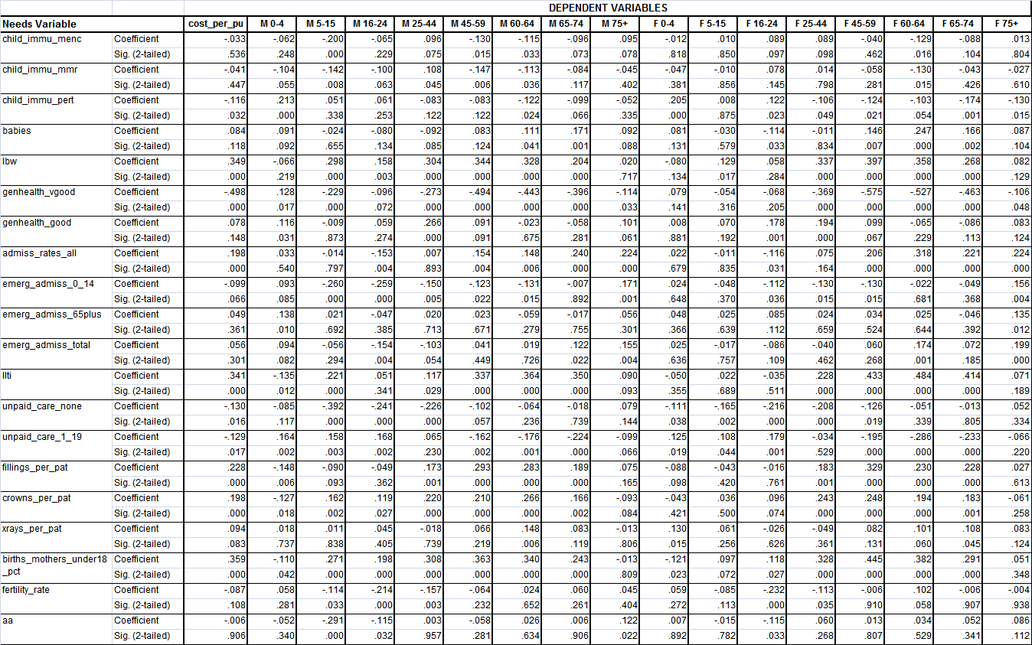

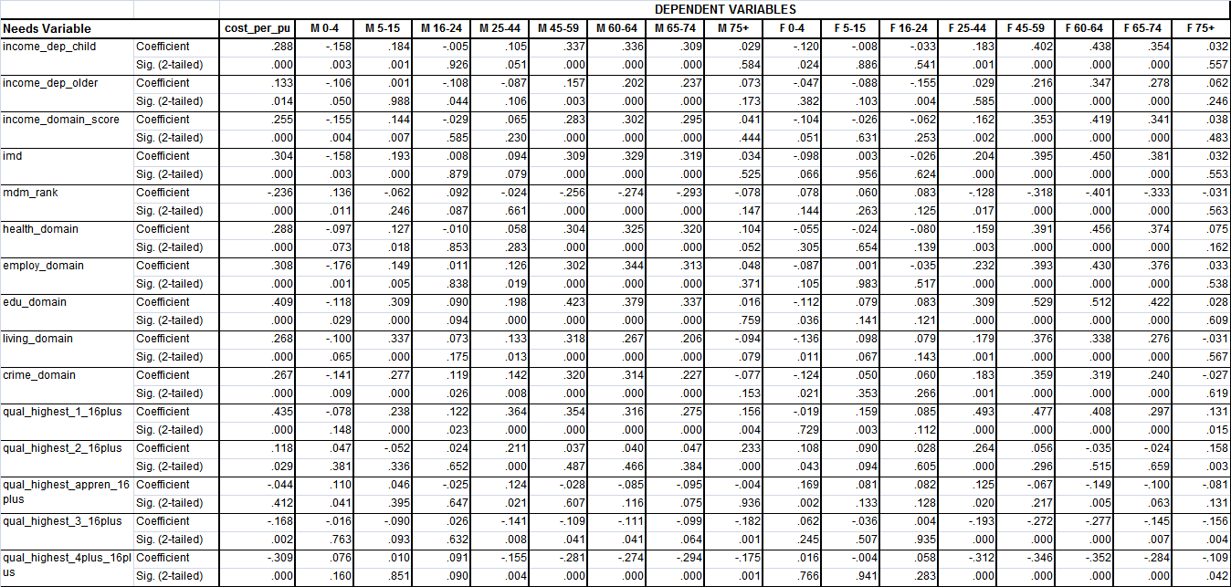

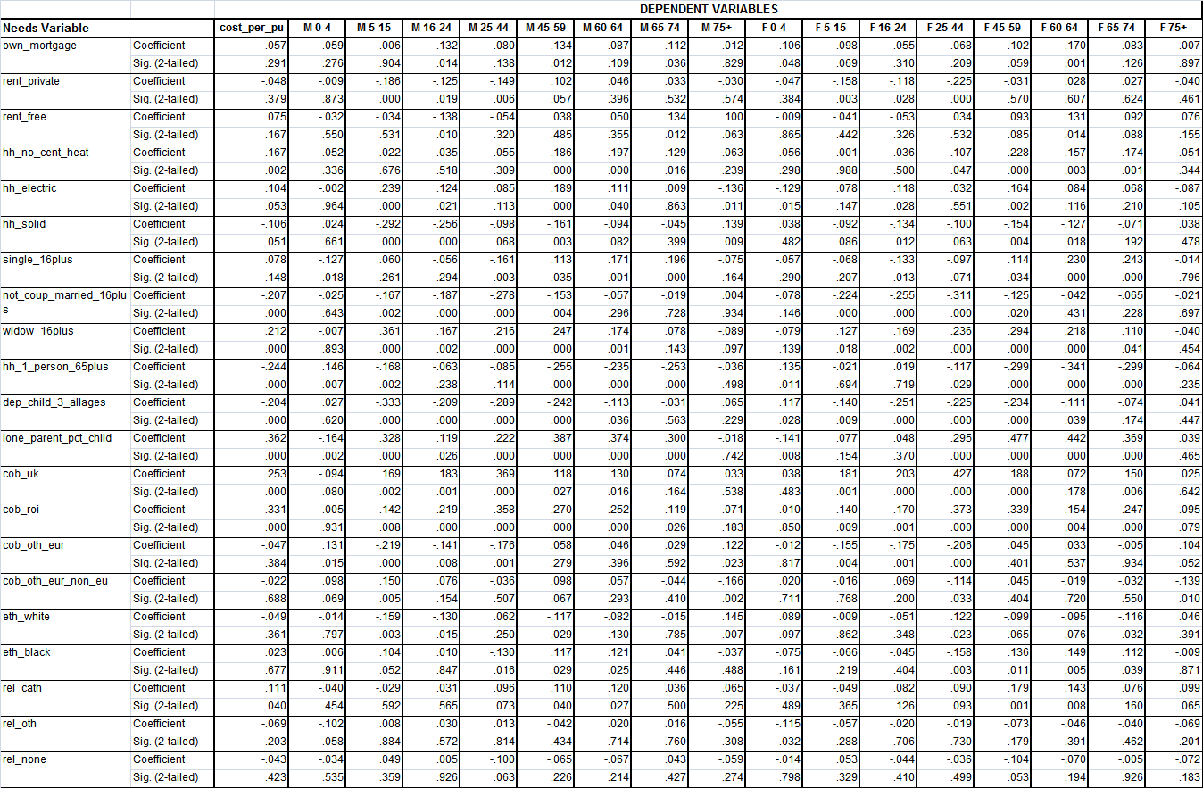

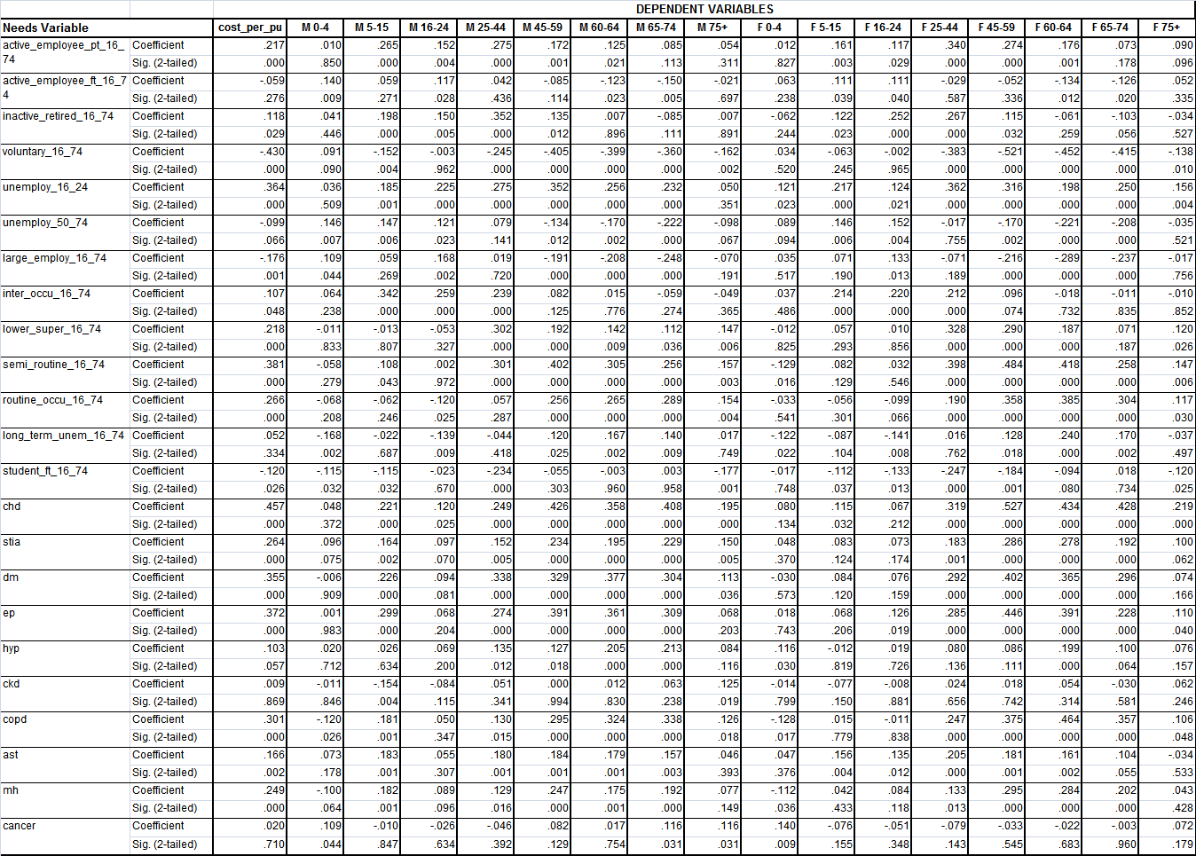

**Summary Statistics for the Supply Variables & Correlation with Dependent Variable Cost per PU**

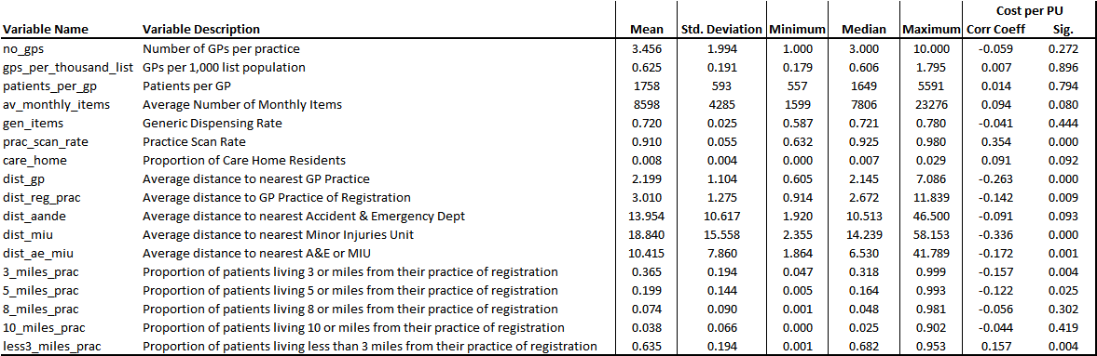

**Correlations of the Supply Variables & the Dependent Variables (1-stage stratified models) – GP Practice Level Analysis**

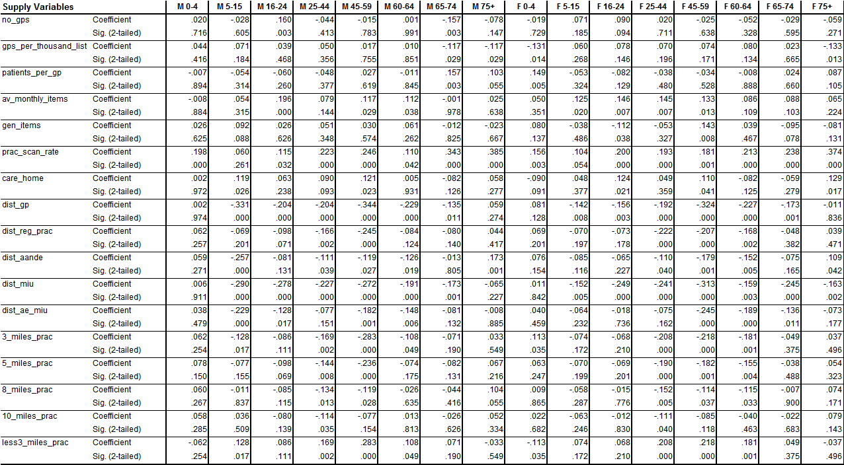

**Summary Statistics for the Dichotomous Supply Variables when the Dependent Variable = Cost per PU**

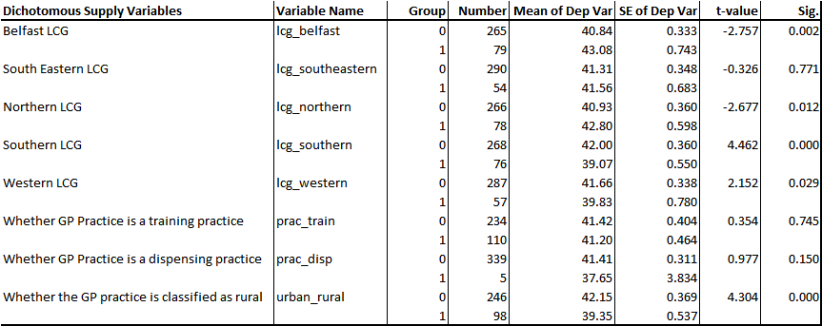

**Summary Statistics for the Dichotomous Supply Variables (when Dependent Variable = Males 0-4: dep var has been log transformed)**

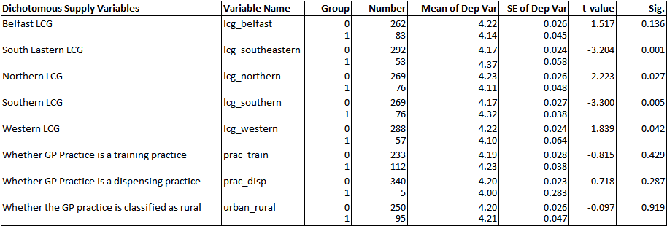

**Summary Statistics for the Dichotomous Supply Variables (when Dependent Variable = Males 5-15: dep var has been log transformed)**

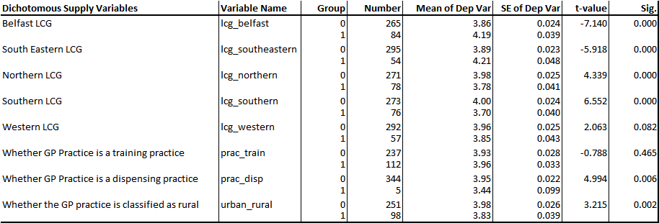

**Summary Statistics for the Dichotomous Supply Variables (when Dependent Variable = Males 16-24: dep var has been log transformed)**

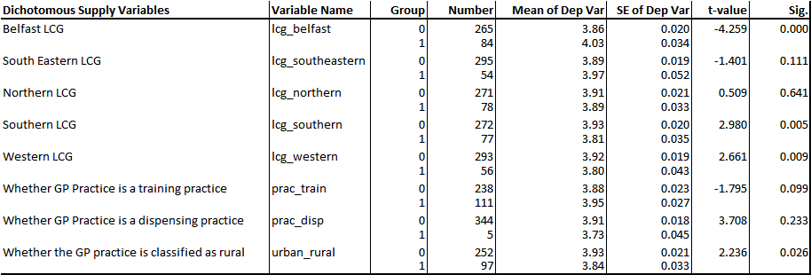

**Summary Statistics for the Dichotomous Supply Variables (when Dependent Variable = Males 25-44: dep var has not been log transformed)**

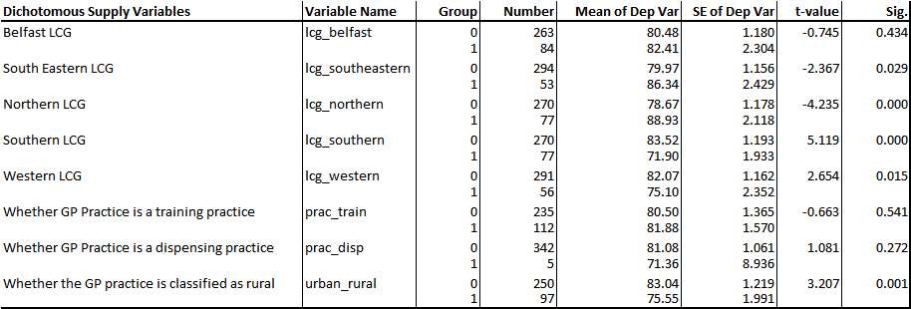

**Summary Statistics for the Dichotomous Supply Variables (when Dependent Variable = Males 45-59: dep var has been log transformed)**

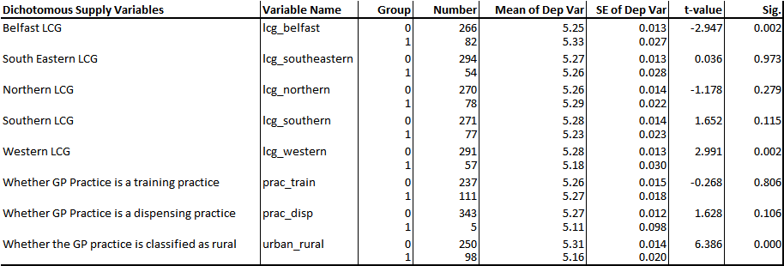

**Summary Statistics for the Dichotomous Supply Variables (when Dependent Variable = Males 60-64: dep var has not been log transformed)**

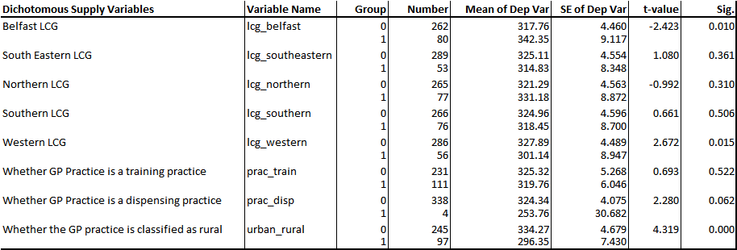

**Summary Statistics for the Dichotomous Supply Variables (when Dependent Variable = Males 65-74: dep var has not been log transformed)**

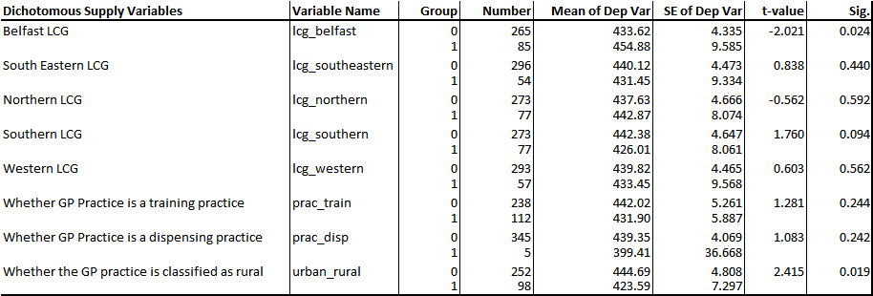

**Summary Statistics for the Dichotomous Supply Variables (when Dependent Variable = Males 75+: dep var has not been log transformed)**

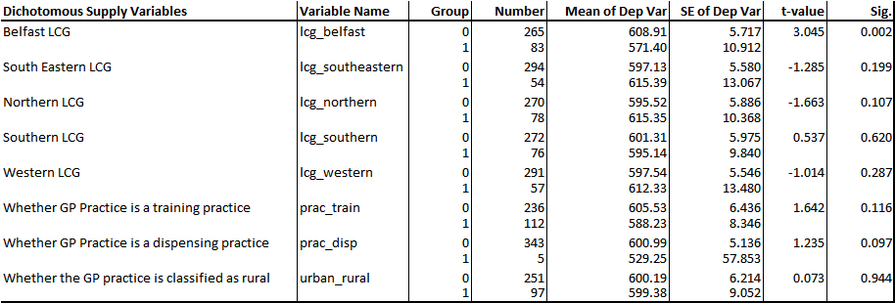

**Summary Statistics for the Dichotomous Supply Variables (when Dependent Variable = Females 0-4: dep var has been log transformed)**

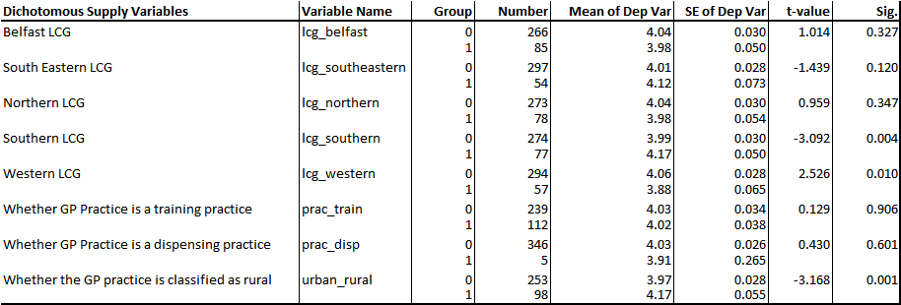

**Summary Statistics for the Dichotomous Supply Variables (when Dependent Variable = Females 5-15: dep var has been log transformed)**

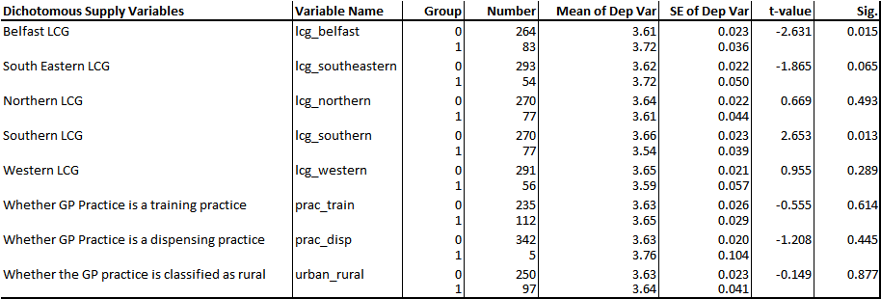

**Summary Statistics for the Dichotomous Supply Variables (when Dependent Variable = Females 16-24: dep var has been log transformed)**

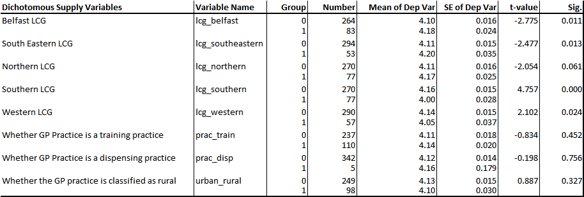

**Summary Statistics for the Dichotomous Supply Variables (when Dependent Variable = Females 25-44: dep var has not been log transformed)**

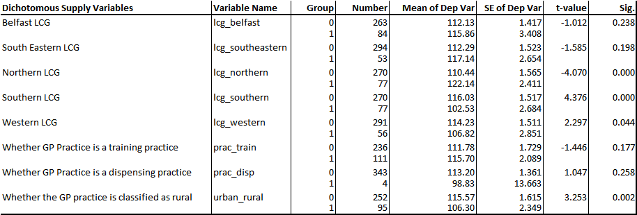

**Summary Statistics for the Dichotomous Supply Variables (when Dependent Variable = Females 45-59: dep var has not been log transformed)**

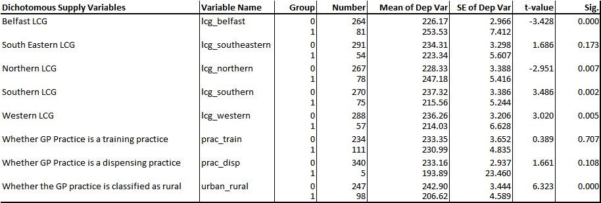

**Summary Statistics for the Dichotomous Supply Variables (when Dependent Variable = Females 60-64: dep var has been log transformed)**

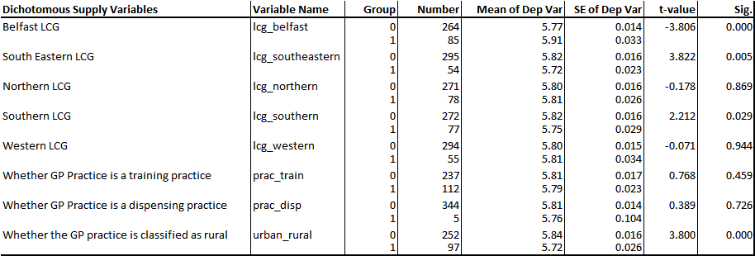

**Summary Statistics for the Dichotomous Supply Variables (when Dependent Variable = Females 65-74: dep var has not been log transformed)**

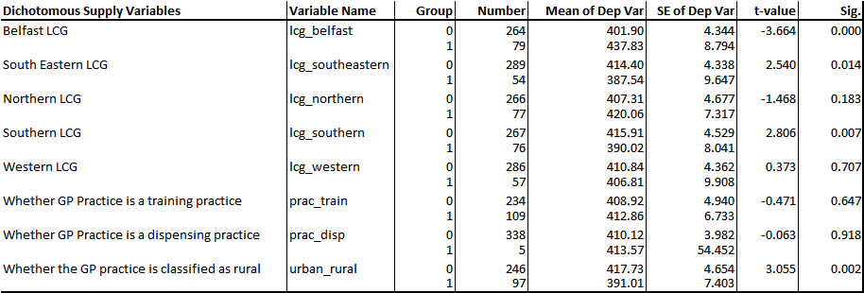

**Summary Statistics for the Dichotomous Supply Variables (when Dependent Variable = Females 75+: dep var has not been log transformed)**

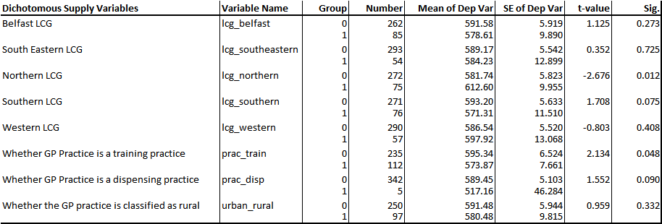

**Appendix H**

**Data Sources & Disease Prevalence Profiles Used to Age Standardise QOF Registers**

|  |  |  |
| --- | --- | --- |
| **QOF Register** | **Data Source used in 2015** | **Data Source used in 2010** |
| Asthma | 2009/10-2013/14 Hospital Admissions estimated from deaths & discharges. Defined by ICD 10 Codes J45 & J46. | Prevalence Rates per 1,000 Population 2003-2005. Sourced from PRIMIS. |
| Cancer | Cancer Incidence Rates 2009-2013. All cancers excluding non-melanoma skin cancer. Cancer Registry NI. | Cancer Incidence Rates 2002. All cancers excluding non-melanoma skin cancer. Cancer Registry NI. |
| COPD | 2009/10-2013/14 Hospital Admissions estimated from deaths & discharges. Defined by ICD 10 Codes J40-J44 + J47. | 2004/05 Hospital Admissions estimated from deaths & discharges. Defined by ICD 10 Codes J40-J44 + J47. |
| Mental Health | Costed activity data from HSC Trusts; used to derive the age cost curve for the Mental Health Programme of Care in the regional capitation formula. | Not included in 2010 Review. |
| CHD | Q-Research Age-Specific Prevalence Rates per 1,000 Population 2001-2006. | Prevalence Rates per 1,000 Population 2003-2005. Sourced from PRIMIS. |
| Stroke | Q-Research Age-Specific Prevalence Rates per 1,000 Population 2001-2006. | Prevalence Rates per 1,000 Population 2003-2005. Sourced from PRIMIS. |
| CKD | Q-Research Age-Specific Prevalence Rates per 1,000 Population 2001-2006. | Not included in 2010 Review. |
| Diabetes | Q-Research Age-Specific Prevalence Rates per 1,000 Population 2001-2006. | Not included in 2010 Review. |
| Epilepsy | Q-Research Age-Specific Prevalence Rates per 1,000 Population 2001-2006. | Not included in 2010 Review. |
| Hypertension | Q-Research Age-Specific Prevalence Rates per 1,000 Population 2001-2006. | Prevalence Rates per 1,000 Population 2003-2005. Sourced from PRIMIS. |

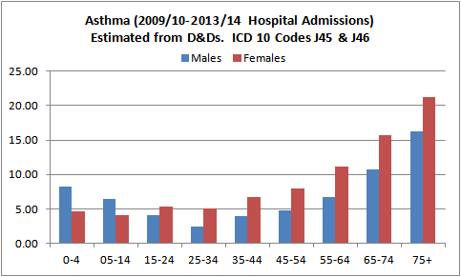

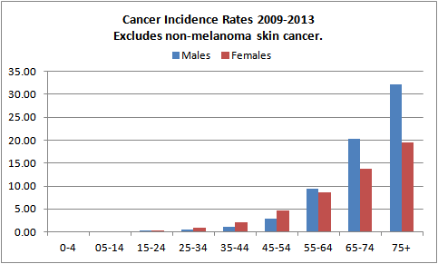

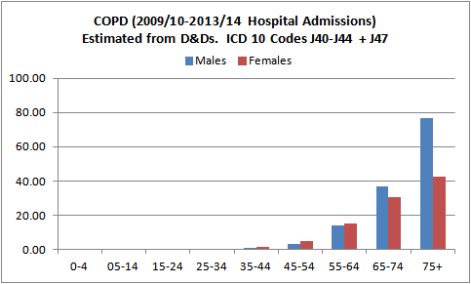

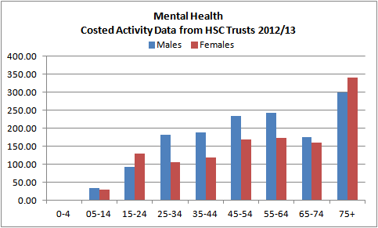

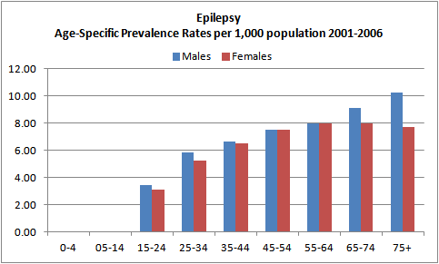

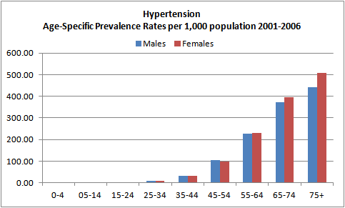

**Appendix I**

**Summary Statistics of the Dependent Variables from each Model**

**Table I.1 Cost per Prescribing Unit (weighted by practice list)**

|  |  |
| --- | --- |
|  | **Cost per PU** |
| **Mean** | 41.16 |
| **Std Dev** | 5.40 |
| **Min** | 25.87 |
| **25%** | 37.34 |
| **Median** | 41.14 |
| **75%** | 44.56 |
| **Max** | 56.39 |
| **Un-weighted Count** | 344 |

**Table I.2 Cost per Head for each Age-Gender Group (weighted by practice list)**

|  |  |  |  |  |  |  |  |  |
| --- | --- | --- | --- | --- | --- | --- | --- | --- |
|  | **M 0-4** | **M 5-15** | **M 16-24** | **M 25-44** | **M 45-59** | **M 60-64** | **M 65-74** | **M 75+** |
| **Mean** | 71.89 | 54.53 | 53.14 | 80.21 | 196.94 | 323.43 | 434.31 | 598.17 |
| **Std Dev** | 28.14 | 22.49 | 16.08 | 17.58 | 39.85 | 70.38 | 71.41 | 92.36 |
| **Min** | 19.69 | 12.56 | 18.85 | 22.63 | 94.55 | 129.17 | 244.21 | 339.98 |
| **25%** | 53.10 | 39.84 | 41.55 | 68.37 | 169.31 | 272.04 | 388.63 | 545.14 |
| **Median** | 67.40 | 48.84 | 50.08 | 78.84 | 194.34 | 319.71 | 431.30 | 596.89 |
| **75%** | 86.54 | 64.59 | 63.08 | 92.74 | 219.61 | 364.12 | 478.37 | 659.57 |
| **Max** | 215.12 | 170.29 | 127.70 | 138.74 | 341.07 | 536.41 | 634.99 | 877.10 |
| **Count** | 345 | 349 | 349 | 347 | 348 | 342 | 350 | 348 |

|  |  |  |  |  |  |  |  |  |
| --- | --- | --- | --- | --- | --- | --- | --- | --- |
|  | **F 0-4** | **F 5-15** | **F 16-24** | **F 25-44** | **F 45-59** | **F 60-64** | **F 65-74** | **F 75+** |
| **Mean** | 62.20 | 40.48 | 63.92 | 112.78 | 230.93 | 338.21 | 409.16 | 587.71 |
| **Std Dev** | 28.21 | 13.72 | 15.18 | 23.03 | 50.00 | 84.16 | 69.33 | 89.34 |
| **Min** | 9.40 | 12.36 | 28.04 | 46.99 | 68.56 | 163.41 | 240.94 | 339.55 |
| **25%** | 43.26 | 31.04 | 54.10 | 96.50 | 196.46 | 281.52 | 367.82 | 526.34 |
| **Median** | 56.95 | 37.97 | 61.49 | 113.15 | 227.36 | 332.50 | 407.30 | 585.65 |
| **75%** | 75.44 | 46.00 | 71.47 | 129.03 | 263.32 | 386.50 | 448.18 | 647.14 |
| **Max** | 194.55 | 95.91 | 126.64 | 193.88 | 386.12 | 720.70 | 630.81 | 856.81 |
| **Count** | 351 | 347 | 347 | 347 | 345 | 349 | 343 | 347 |

**Table I.3 Cost per STAR-PU (weighted by practice list)**

|  |  |  |  |  |  |  |
| --- | --- | --- | --- | --- | --- | --- |
|  | **BNF 1** | **BNF 2** | **BNF 3** | **BNF 4** | **BNF 6** | **BNF 9** |
| **Mean** | 0.996 | 0.998 | 0.973 | 0.998 | 0.998 | 1.001 |
| **Std Dev** | 0.141 | 0.154 | 0.188 | 0.202 | 0.165 | 0.202 |
| **Min** | 0.603 | 0.596 | 0.463 | 0.425 | 0.601 | 0.555 |
| **25%** | 0.909 | 0.898 | 0.845 | 0.856 | 0.880 | 0.857 |
| **Median** | 0.997 | 1.008 | 0.958 | 0.990 | 0.994 | 0.994 |
| **75%** | 1.087 | 1.091 | 1.105 | 1.126 | 1.104 | 1.122 |
| **Max** | 1.390 | 1.385 | 1.506 | 1.561 | 1.436 | 1.543 |
| **Count** | 343 | 344 | 330 | 346 | 345 | 340 |

**Table I.4 Cost per Prescribing Unit by LCG (weighted by practice list)**

|  |  |  |  |  |  |
| --- | --- | --- | --- | --- | --- |
|  | **Belfast** | **Northern** | **South Eastern** | **Southern** | **Western** |
| **Mean** | 42.20 | 42.29 | 41.11 | 39.37 | 40.47 |
| **Std Dev** | 6.60 | 4.96 | 4.96 | 4.55 | 4.96 |
| **Min** | 29.46 | 27.13 | 32.28 | 28.76 | 25.87 |
| **25%** | 36.64 | 39.45 | 37.20 | 36.04 | 38.08 |
| **Median** | 42.01 | 42.45 | 41.06 | 39.57 | 40.81 |
| **75%** | 47.63 | 45.57 | 43.50 | 42.46 | 43.92 |
| **Max** | 56.39 | 53.21 | 52.91 | 52.57 | 56.09 |
| **Count** | 79 | 78 | 54 | 76 | 57 |

**Tables I.5i – I.5xvi Cost per Head for each Age-Gender Group by LCG (weighted by practice list)**

**Table I.5i Males 0-4**

|  |  |  |  |  |  |
| --- | --- | --- | --- | --- | --- |
|  | **Belfast** | **Northern** | **South Eastern** | **Southern** | **Western** |
| **Mean** | 68.17 | 63.84 | 85.06 | 79.67 | 65.62 |
| **Std Dev** | 25.60 | 24.52 | 32.77 | 24.65 | 28.28 |
| **Min** | 27.51 | 19.69 | 28.68 | 32.10 | 19.92 |
| **25%** | 50.28 | 48.93 | 61.45 | 65.21 | 46.67 |
| **Median** | 65.54 | 58.66 | 82.77 | 76.69 | 58.28 |
| **75%** | 80.50 | 77.27 | 102.62 | 93.35 | 79.65 |
| **Max** | 156.57 | 170.51 | 215.12 | 146.67 | 206.60 |
| **Count** | 83 | 76 | 53 | 76 | 57 |

**Table I.5ii Males 5-15**

|  |  |  |  |  |  |
| --- | --- | --- | --- | --- | --- |
|  | **Belfast** | **Northern** | **South Eastern** | **Southern** | **Western** |
| **Mean** | 68.28 | 45.49 | 69.16 | 43.18 | 48.36 |
| **Std Dev** | 23.69 | 14.96 | 26.52 | 14.97 | 14.32 |
| **Min** | 29.50 | 12.56 | 37.56 | 21.48 | 27.13 |
| **25%** | 47.29 | 36.14 | 53.84 | 32.86 | 36.81 |
| **Median** | 64.74 | 42.49 | 63.50 | 40.09 | 45.93 |
| **75%** | 83.71 | 51.38 | 77.77 | 48.67 | 53.72 |
| **Max** | 136.53 | 106.45 | 170.29 | 105.31 | 106.45 |
| **Count** | 84 | 78 | 54 | 76 | 57 |

**Table I.5iii Males 16-24**

|  |  |  |  |  |  |
| --- | --- | --- | --- | --- | --- |
|  | **Belfast** | **Northern** | **South Eastern** | **Southern** | **Western** |
| **Mean** | 60.09 | 51.04 | 58.37 | 47.97 | 48.17 |
| **Std Dev** | 15.98 | 13.83 | 19.40 | 13.63 | 13.34 |
| **Min** | 22.47 | 18.85 | 21.18 | 22.37 | 18.92 |
| **25%** | 48.13 | 40.85 | 44.18 | 37.93 | 39.20 |
| **Median** | 60.06 | 49.76 | 51.32 | 46.00 | 45.91 |
| **75%** | 69.25 | 58.69 | 77.69 | 57.97 | 55.67 |
| **Max** | 127.70 | 91.22 | 111.19 | 87.30 | 83.49 |
| **Count** | 84 | 78 | 54 | 77 | 56 |

**Table I.5iv Males 25-44**

|  |  |  |  |  |  |
| --- | --- | --- | --- | --- | --- |
|  | **Belfast** | **Northern** | **South Eastern** | **Southern** | **Western** |
| **Mean** | 79.42 | 86.80 | 84.37 | 72.11 | 77.96 |
| **Std Dev** | 19.67 | 16.27 | 15.70 | 16.43 | 14.55 |
| **Min** | 22.63 | 42.18 | 55.81 | 34.43 | 33.06 |
| **25%** | 67.57 | 77.23 | 72.87 | 59.33 | 68.11 |
| **Median** | 78.21 | 83.13 | 82.00 | 71.80 | 77.17 |
| **75%** | 89.82 | 95.74 | 95.92 | 86.75 | 88.85 |
| **Max** | 134.31 | 126.13 | 138.74 | 128.59 | 119.45 |
| **Count** | 84 | 77 | 53 | 77 | 56 |

**Table I.5v Males 45-59**

|  |  |  |  |  |  |
| --- | --- | --- | --- | --- | --- |
|  | **Belfast** | **Northern** | **South Eastern** | **Southern** | **Western** |
| **Mean** | 205.72 | 199.66 | 196.00 | 190.20 | 191.06 |
| **Std Dev** | 48.86 | 34.60 | 35.90 | 37.89 | 37.23 |
| **Min** | 110.26 | 94.55 | 114.31 | 122.06 | 102.12 |
| **25%** | 167.03 | 177.68 | 166.59 | 164.52 | 169.59 |
| **Median** | 205.42 | 202.86 | 184.16 | 190.49 | 192.61 |
| **75%** | 238.67 | 222.66 | 221.48 | 206.20 | 210.42 |
| **Max** | 339.77 | 303.17 | 279.03 | 341.07 | 339.63 |
| **Count** | 82 | 78 | 54 | 77 | 57 |

**Table I.5vi Males 60-64**

|  |  |  |  |  |  |
| --- | --- | --- | --- | --- | --- |
|  | **Belfast** | **Northern** | **South Eastern** | **Southern** | **Western** |
| **Mean** | 337.69 | 325.66 | 315.70 | 321.69 | 311.96 |
| **Std Dev** | 83.28 | 71.88 | 54.58 | 71.82 | 58.02 |
| **Min** | 170.01 | 166.36 | 202.04 | 160.39 | 129.17 |
| **25%** | 265.14 | 276.03 | 273.56 | 268.11 | 265.98 |
| **Median** | 338.98 | 322.31 | 315.98 | 307.77 | 319.57 |
| **75%** | 394.25 | 370.55 | 351.10 | 371.91 | 350.99 |
| **Max** | 536.41 | 518.77 | 462.20 | 515.46 | 439.21 |
| **Count** | 80 | 77 | 53 | 76 | 56 |

**Table I.5vii Males 65-74**

|  |  |  |  |  |  |
| --- | --- | --- | --- | --- | --- |
|  | **Belfast** | **Northern** | **South Eastern** | **Southern** | **Western** |
| **Mean** | 444.91 | 436.31 | 420.79 | 428.47 | 437.72 |
| **Std Dev** | 87.49 | 67.03 | 65.57 | 65.40 | 62.64 |
| **Min** | 264.07 | 244.21 | 311.21 | 256.25 | 250.11 |
| **25%** | 393.89 | 388.92 | 387.42 | 382.82 | 404.48 |
| **Median** | 448.88 | 439.41 | 410.27 | 422.85 | 436.39 |
| **75%** | 493.44 | 478.37 | 448.50 | 471.99 | 479.62 |
| **Max** | 634.99 | 620.60 | 608.27 | 607.67 | 602.74 |
| **Count** | 85 | 77 | 54 | 77 | 57 |

**Table I.5viii Males 75+**

|  |  |  |  |  |  |
| --- | --- | --- | --- | --- | --- |
|  | **Belfast** | **Northern** | **South Eastern** | **Southern** | **Western** |
| **Mean** | 562.34 | 610.34 | 604.12 | 605.28 | 614.16 |
| **Std Dev** | 103.49 | 84.88 | 89.61 | 79.71 | 91.57 |
| **Min** | 339.98 | 441.80 | 375.05 | 433.64 | 359.96 |
| **25%** | 478.47 | 554.64 | 553.92 | 554.52 | 550.21 |
| **Median** | 584.13 | 594.55 | 602.88 | 599.47 | 606.81 |
| **75%** | 623.25 | 660.72 | 659.57 | 665.46 | 672.76 |
| **Max** | 811.44 | 822.94 | 877.10 | 773.10 | 851.52 |
| **Count** | 83 | 78 | 54 | 76 | 57 |

**Table I.5ix Females 0-4**

|  |  |  |  |  |  |
| --- | --- | --- | --- | --- | --- |
|  | **Belfast** | **Northern** | **South Eastern** | **Southern** | **Western** |
| **Mean** | 59.80 | 59.56 | 68.65 | 68.57 | 54.98 |
| **Std Dev** | 23.54 | 25.49 | 63.02 | 29.12 | 24.66 |
| **Min** | 9.40 | 15.77 | 19.49 | 25.28 | 14.68 |
| **25%** | 43.26 | 40.55 | 46.73 | 50.72 | 38.64 |
| **Median** | 55.26 | 52.55 | 62.82 | 63.60 | 47.99 |
| **75%** | 72.04 | 73.62 | 81.62 | 75.69 | 66.75 |
| **Max** | 153.53 | 125.38 | 191.65 | 194.55 | 141.05 |
| **Count** | 85 | 78 | 54 | 77 | 57 |

**Table I.5x Females 5-15**

|  |  |  |  |  |  |
| --- | --- | --- | --- | --- | --- |
|  | **Belfast** | **Northern** | **South Eastern** | **Southern** | **Western** |
| **Mean** | 43.54 | 39.51 | 44.80 | 36.37 | 38.58 |
| **Std Dev** | 13.78 | 13.70 | 13.88 | 11.65 | 13.80 |
| **Min** | 20.69 | 14.64 | 15.66 | 16.34 | 12.36 |
| **25%** | 34.51 | 28.90 | 36.74 | 27.43 | 30.63 |
| **Median** | 40.59 | 37.61 | 40.93 | 34.96 | 35.23 |
| **75%** | 50.78 | 45.57 | 51.32 | 43.12 | 44.15 |
| **Max** | 88.57 | 95.91 | 88.46 | 79.14 | 95.18 |
| **Count** | 83 | 77 | 54 | 77 | 56 |

**Table I.5xi Females 16-24**

|  |  |  |  |  |  |
| --- | --- | --- | --- | --- | --- |
|  | **Belfast** | **Northern** | **South Eastern** | **Southern** | **Western** |
| **Mean** | 66.39 | 66.95 | 69.74 | 56.64 | 59.77 |
| **Std Dev** | 13.74 | 13.80 | 17.15 | 12.59 | 15.19 |
| **Min** | 36.00 | 36.59 | 40.58 | 28.04 | 34.65 |
| **25%** | 57.55 | 56.71 | 59.81 | 47.88 | 48.16 |
| **Median** | 62.95 | 65.17 | 66.47 | 55.58 | 56.85 |
| **75%** | 76.11 | 73.58 | 80.69 | 61.28 | 66.46 |
| **Max** | 112.62 | 110.99 | 126.64 | 105.37 | 120.79 |
| **Count** | 83 | 77 | 53 | 77 | 57 |

**Table I.5xii Females 25-44**

|  |  |  |  |  |  |
| --- | --- | --- | --- | --- | --- |
|  | **Belfast** | **Northern** | **South Eastern** | **Southern** | **Western** |
| **Mean** | 111.86 | 121.06 | 116.70 | 104.22 | 109.23 |
| **Std Dev** | 28.93 | 19.90 | 17.50 | 22.31 | 18.72 |
| **Min** | 46.99 | 75.15 | 83.91 | 53.46 | 53.60 |
| **25%** | 91.93 | 105.22 | 102.62 | 85.00 | 95.05 |
| **Median** | 113.24 | 119.24 | 113.20 | 103.33 | 115.19 |
| **75%** | 130.44 | 135.25 | 129.74 | 118.71 | 123.34 |
| **Max** | 193.88 | 172.43 | 161.79 | 162.45 | 142.81 |
| **Count** | 84 | 77 | 53 | 77 | 56 |

**Table I.5xiii Females 45-59**

|  |  |  |  |  |  |
| --- | --- | --- | --- | --- | --- |
|  | **Belfast** | **Northern** | **South Eastern** | **Southern** | **Western** |
| **Mean** | 242.98 | 243.36 | 221.06 | 219.74 | 221.05 |
| **Std Dev** | 66.36 | 44.25 | 39.12 | 42.33 | 43.01 |
| **Min** | 68.56 | 133.09 | 161.11 | 103.30 | 95.32 |
| **25%** | 193.99 | 205.00 | 191.29 | 186.22 | 201.80 |
| **Median** | 255.47 | 252.40 | 217.55 | 219.63 | 215.41 |
| **75%** | 287.52 | 274.93 | 238.37 | 253.41 | 252.35 |
| **Max** | 386.12 | 373.18 | 346.32 | 324.21 | 346.99 |
| **Count** | 81 | 78 | 54 | 75 | 57 |

**Table I.5xiv Females 60-64**

|  |  |  |  |  |  |
| --- | --- | --- | --- | --- | --- |
|  | **Belfast** | **Northern** | **South Eastern** | **Southern** | **Western** |
| **Mean** | 366.65 | 335.65 | 310.86 | 328.18 | 342.84 |
| **Std Dev** | 111.81 | 69.63 | 56.20 | 81.69 | 72.76 |
| **Min** | 171.50 | 186.51 | 216.54 | 163.41 | 183.09 |
| **25%** | 285.79 | 287.47 | 260.00 | 273.23 | 282.39 |
| **Median** | 358.99 | 340.00 | 307.58 | 311.13 | 332.31 |
| **75%** | 444.15 | 380.49 | 340.61 | 375.13 | 391.26 |
| **Max** | 720.70 | 493.10 | 455.35 | 702.93 | 567.29 |
| **Count** | 85 | 78 | 54 | 77 | 55 |

**Table I.5xv Females 65-74**

|  |  |  |  |  |  |
| --- | --- | --- | --- | --- | --- |
|  | **Belfast** | **Northern** | **South Eastern** | **Southern** | **Western** |
| **Mean** | 429.40 | 415.44 | 384.25 | 394.57 | 417.50 |
| **Std Dev** | 75.27 | 62.09 | 66.26 | 65.20 | 68.08 |
| **Min** | 250.14 | 255.18 | 256.96 | 266.36 | 240.94 |
| **25%** | 386.78 | 381.90 | 354.37 | 346.67 | 388.74 |
| **Median** | 425.26 | 415.84 | 382.10 | 388.68 | 416.06 |
| **75%** | 474.43 | 455.42 | 410.81 | 440.19 | 444.55 |
| **Max** | 608.40 | 560.70 | 609.32 | 581.23 | 630.81 |
| **Count** | 79 | 77 | 54 | 76 | 57 |

**Table I.5xvi Females 75+**

|  |  |  |  |  |  |
| --- | --- | --- | --- | --- | --- |
|  | **Belfast** | **Northern** | **South Eastern** | **Southern** | **Western** |
| **Mean** | 572.47 | 609.73 | 579.89 | 579.34 | 596.07 |
| **Std Dev** | 90.88 | 79.26 | 87.76 | 94.33 | 88.83 |
| **Min** | 339.55 | 405.84 | 368.49 | 343.18 | 341.55 |
| **25%** | 510.34 | 540.87 | 509.38 | 504.82 | 550.78 |
| **Median** | 573.56 | 602.63 | 573.38 | 581.12 | 597.47 |
| **75%** | 620.26 | 675.15 | 632.88 | 654.35 | 658.90 |
| **Max** | 816.78 | 836.92 | 856.81 | 842.71 | 822.87 |
| **Count** | 85 | 75 | 54 | 76 | 57 |

**Tables I.6i – 1.6vi Cost per STAR-PU for each BNF Chapter (weighted by practice list)**

**Table I.6i BNF Chapter 1**

|  |  |  |  |  |  |
| --- | --- | --- | --- | --- | --- |
|  | **Belfast** | **Northern** | **South Eastern** | **Southern** | **Western** |
| **Mean** | 0.972 | 1.019 | 0.987 | 0.963 | 1.044 |
| **Std Dev** | 0.148 | 0.125 | 0.130 | 0.147 | 0.138 |
| **Min** | 0.633 | 0.664 | 0.710 | 0.603 | 0.684 |
| **25%** | 0.887 | 0.962 | 0.909 | 0.834 | 0.944 |
| **Median** | 0.949 | 1.025 | 0.992 | 0.954 | 1.031 |
| **75%** | 1.087 | 0.095 | 1.086 | 1.076 | 1.135 |
| **Max** | 1.390 | 1.307 | 1.318 | 1.375 | 1.345 |
| **Count** | 81 | 77 | 54 | 77 | 54 |

**Table I.6ii BNF Chapter 2**

|  |  |  |  |  |  |
| --- | --- | --- | --- | --- | --- |
|  | **Belfast** | **Northern** | **South Eastern** | **Southern** | **Western** |
| **Mean** | 0.971 | 1.047 | 0.944 | 0.985 | 1.033 |
| **Std Dev** | 0.182 | 0.155 | 0.121 | 0.141 | 0.127 |
| **Min** | 0.596 | 0.657 | 0.691 | 0.627 | 0.687 |
| **25%** | 0.863 | 0.973 | 0.835 | 0.888 | 0.960 |
| **Median** | 0.946 | 1.044 | 0.970 | 1.002 | 1.014 |
| **75%** | 1.087 | 1.144 | 1.034 | 1.086 | 1.125 |
| **Max** | 1.385 | 1.384 | 1.222 | 1.311 | 1.334 |
| **Count** | 82 | 77 | 53 | 76 | 56 |

**Table I.6iii BNF Chapter 3**

|  |  |  |  |  |  |
| --- | --- | --- | --- | --- | --- |
|  | **Belfast** | **Northern** | **South Eastern** | **Southern** | **Western** |
| **Mean** | 1.006 | 0.983 | 0.920 | 0.912 | 1.049 |
| **Std Dev** | 0.235 | 0.176 | 0.148 | 0.147 | 0.185 |
| **Min** | 0.463 | 0.544 | 0.614 | 0.584 | 0.534 |
| **25%** | 0.842 | 0.860 | 0.835 | 0.810 | 0.954 |
| **Median** | 0.982 | 0.944 | 0.921 | 0.931 | 1.023 |
| **75%** | 1.209 | 1.121 | 1.010 | 0.990 | 1.152 |
| **Max** | 1.501 | 1.405 | 1.363 | 1.217 | 1.506 |
| **Count** | 70 | 78 | 53 | 74 | 55 |

**Table I.6iv BNF Chapter 4**

|  |  |  |  |  |  |
| --- | --- | --- | --- | --- | --- |
|  | **Belfast** | **Northern** | **South Eastern** | **Southern** | **Western** |
| **Mean** | 1.085 | 1.006 | 1.040 | 0.916 | 0.933 |
| **Std Dev** | 0.232 | 0.184 | 0.171 | 0.184 | 0.172 |
| **Min** | 0.513 | 0.571 | 0.750 | 0.433 | 0.425 |
| **25%** | 0.903 | 0.893 | 0.908 | 0.797 | 0.821 |
| **Median** | 1.073 | 0.998 | 1.002 | 0.923 | 0.944 |
| **75%** | 1.254 | 1.122 | 1.135 | 1.045 | 1.030 |
| **Max** | 1.561 | 1.540 | 1.533 | 1.462 | 1.286 |
| **Count** | 82 | 78 | 54 | 76 | 56 |

**Table I.6v BNF Chapter 6**

|  |  |  |  |  |  |
| --- | --- | --- | --- | --- | --- |
|  | **Belfast** | **Northern** | **South Eastern** | **Southern** | **Western** |
| **Mean** | 0.940 | 1.070 | 1.026 | 0.978 | 0.967 |
| **Std Dev** | 0.173 | 0.153 | 0.171 | 0.136 | 0.158 |
| **Min** | 0.601 | 0.657 | 0.657 | 0.632 | 0.645 |
| **25%** | 0.810 | 0.983 | 0.902 | 0.889 | 0.841 |
| **Median** | 0.945 | 1.073 | 1.006 | 0.994 | 0.967 |
| **75%** | 1.076 | 1.156 | 1.157 | 1.047 | 1.068 |
| **Max** | 1.339 | 1.395 | 1.436 | 1.430 | 1.435 |
| **Count** | 81 | 78 | 54 | 77 | 55 |

**Table I.6vi BNF Chapter 9**

|  |  |  |  |  |  |
| --- | --- | --- | --- | --- | --- |
|  | **Belfast** | **Northern** | **South Eastern** | **Southern** | **Western** |
| **Mean** | 0.986 | 1.012 | 0.985 | 0.963 | 1.069 |
| **Std Dev** | 0.213 | 0.195 | 0.194 | 0.183 | 0.208 |
| **Min** | 0.559 | 0.692 | 0.722 | 0.555 | 0.573 |
| **25%** | 0.839 | 0.855 | 0.853 | 0.824 | 0.971 |
| **Median** | 1.012 | 0.979 | 0.950 | 0.940 | 1.053 |
| **75%** | 1.109 | 1.165 | 1.080 | 1.091 | 1.156 |
| **Max** | 1.535 | 1.543 | 1.520 | 1.447 | 1.541 |
| **Count** | 84 | 73 | 53 | 75 | 55 |

**Appendix J**

**Statistical Tests for Endogeneity**

J.1 The demand for healthcare is a complex process. Underlying socio-economic and demographic characteristics of populations give rise to health care needs, which in turn give rise to the demand for health care services. However, other socio-economic characteristics influence demand over and above those arising through health needs. The underlying need for healthcare, augmented by socio-economic characteristics, generates demand for health care. Need is not affected by either supply or demand and is therefore exogenous, that is, it is only affected by conditions outside the overall system, such as socio-economic conditions.

F.2 The local supply of health services can also influence the demand for health care. For example, when a GP refers a patient to a consultant, this decision may be influenced by expected waiting times. This may impact on the supply of prescriptions, as longer waiting times will mean longer periods of repeat prescriptions in the community; supply therefore influences utilisation. Another example could be that, as a patient’s distance to their GP surgery increases, that is, as their supply of the service is reduced, the patient’s demand or use of the service may decrease; less supply influences demand, less demand means less utilisation.

F.3 However, the adequacy of local supply in meeting demand will affect expectations and therefore future demand. Demand (and therefore utilisation) affects the future supply of health care. Within the healthcare system, there can be a feedback loop from supply to demand/utilisation. Utilisation and supply are created within the healthcare system and are termed endogenous.

NEEDS (x)

Socio-economic characteristics UTILISATION/DEMAND (U)

Mortality & Morbidity Prescribing Costs

Deprivation

HEALTH NEEDS (N) SUPPLY (S)

Health need (N) is affected by (is a function of) wider Needs (x) – this is exogenous.

F.4 For each supply variable there may be the following simultaneous relationship:

Utilisation (U) is affected by (is a function of) needs (N) and supply (S).

Supply (S) is affected by (is a function of) utilisation (U), health needs (N) and other needs (x).

F.5 If this endogeneity of supply does exist, it would be inappropriate to use ordinary least squares regression, as this would produce biased coefficients (the coefficient being the rate of change in prescribing costs given a change in the explanatory variable) which do not reflect properly the real impact that a needs variable may have on utilisation. Although in theory this system of healthcare and the feedback between utilisation and supply are expected, the first stage is to detect whether this endogeneity is indeed present and therefore a problem.

Testing for Endogeneity

U = f (N’, S)

S = f (N, U)

U = Utilisation (Prescribing Costs)

N = Additional Needs

N’ = Subset of Additional Needs

S = Supply Measures

1. Run ordinary least squares (OLS) regressions for each of the supply equations.

S1 = f (N) + e1

.

.

.

Sp = f (N) + ep

e1......ep are the residuals from each regression.

2. Take the equation from the preferred model U = f (N’, S) and add the residuals from the OLS regressions in step 1 as regressors on the right hand side of the equation. Then run an OLS regression on this new equation which includes these residuals.

3. Under the null hypothesis (H0) the supply variables are exogenous; we test the H0 by using the F-test. The equation of interest under H0 is given by:

U = f (N’, S) This is the restricted equation (R).

Under the alternative hypothesis (H1), the supply variables are endogenous; the equation of interest under the H1 is given by:

U = f (N’, S, e1.....ep) This is the unrestricted equation (UR).

4. Calculate the residual sum of squares (RSS) from the estimation of both the restricted and unrestricted equations. The test statistic is given by:

RSSR – RSSUR / (number of restrictions)

RSSUR / No of Observations – No of Regressors Unrestricted Equation

If the test statistic is greater than the critical value, then H0 is rejected, that is, the supply variables are endogenous.

**Appendix K**

**Consistency across 1-Stage Stratified models and 2-Stage Additive model**

|  |  |  |  |
| --- | --- | --- | --- |
| **Variables in 1-Stage Stratified Models** | **Number of Occurrences Across 16 Models** | **Total Models** | **Variable Occurs in 2-Stage Additive Model** |
| Asthma – Prevalence per 1,000 population | 1 female model | 1 |  |
| Epilepsy – Prevalence per 1,000 population | 3 female models & 4 male models | 7 | Yes |
| Coronary Heart Disease – Prevalence per 1,000 popn | 3 female models & 3 male models | 6 | Yes |
| COPD – Prevalence per 1,000 population | 1 female model | 1 |  |
| Mental Health – Prevalence per 1,000 population | 2 female models & 3 male models | 5 | Yes |
| Hypertension – Prevalence per 1,000 population | 1 female model & 1 male model | 2 |  |
| Stroke – Prevalence per 1,000 population | 1 male model | 1 |  |
| Diabetes – Prevalence per 1,000 population | 5 male models | 5 | Yes |
| Emergency Admissions – Total | 1 female model & 1 male model | 2 |  |
| Country of Birth : UK | 1 female model & 1 male model | 2 |  |
| Country of Birth : Other Europe | 2 female models | 2 |  |
| Country of Birth : Republic of Ireland | 3 female models | 3 |  |
| Highest Qualification Level 2 – aged 16+ | 1 female model | 1 |  |
| Children Immunised Against MMR (%) | 2 female models | 2 | Yes |
| Routine Occupations, aged 16-74 (%) | 1 female model | 1 |  |
| Index of Multiple Deprivation – Education Domain | 2 female models | 2 |  |
| Age Standardised Long-term Limiting Illness | 1 female model | 1 |  |
| Ethnic Group - White (%) | 1 female model | 1 |  |
| Admission rates - All | 2 female models | 2 | Yes |
| X-rays per patient | 1 female model | 1 |  |
| % Low Birth-Weight Babies | 2 male models | 2 | Yes |
| Rented from private landlord/letting agency (%) | 1 male model | 1 |  |
| Students - full-time, aged 16-74 (%) | 1 male model | 1 |  |
| Other Religions (%) | 1 male model | 1 |  |
| Three or more dependent children in households | 1 male model | 1 |  |
| Retired, aged 16-74 | 1 male model | 1 |  |
| Unemployed, aged 16-24 (%) | 1 male model | 1 | Yes |
| Provides 1-19 hours unpaid care per week | 1 male model | 1 |  |
|  |  |  |  |
| Married, not living in a couple, aged 16+ (%) | Does not occur in 1-stage models |  | Yes |

**Consistency across BNF models and 2-Stage Additive model**

|  |  |  |  |
| --- | --- | --- | --- |
| **Variables in BNF Models** | **Number of Occurrences Across BNF Models** | **Total Models** | **Variable Occurs in 2-Stage Additive Model** |
| Epilepsy – Prevalence per 1,000 population | 2 (BNF1 and BNF 4) | 2 | Yes |
| Coronary Heart Disease – Prevalence per 1,000 popn | 2 (BNF2 and BNF 4) | 2 | Yes |
| Mental Health – Prevalence per 1,000 population | 1( BNF 4) | 1 | Yes |
| Hypertension – Prevalence per 1,000 population | 1( BNF 2) | 1 |  |
| Stroke – Prevalence per 1,000 population | 1( BNF 6) | 1 |  |
| Diabetes – Prevalence per 1,000 population | 2 (BNF2 and BNF 6) | 2 | Yes |
| Country of Birth : UK | 2 (BNF1 and BNF 6) | 2 |  |
| Children Immunised Against MMR (%) | 1( BNF 2) | 1 | Yes |
| Age Standardised General Health - Good | 1( BNF 6) | 1 |  |
| Semi-routine Occupations, aged 16-74 (%) | 1( BNF 4) | 1 |  |
| Index of Multiple Deprivation – Health Domain | 1( BNF 9) | 1 |  |
| X-rays per registered patient | 1( BNF 9) | 1 |  |
| Economically inactive - Retired, aged 16-74 (%) | 1( BNF 2) | 1 |  |
| Unemployed Aged 50-74 (%) | 1( BNF 2) | 1 |  |
| Married aged 16+ | 1( BNF 4) | 1 |  |
| One Person Households aged 65+ (%) | 1( BNF 4) | 1 |  |
|  |  |  |  |
| Admission rates - All | Does not occur in BNF models |  | Yes |
| % Low Birth-Weight Babies | Does not occur in BNF models |  | Yes |
| Unemployed, aged 16-24 (%) | Does not occur in BNF models |  | Yes |
| Married, not living in a couple, aged 16+ (%) | Does not occur in BNF models |  | Yes |

**Explanatory Power of Models**

|  |  |  |  |  |  |  |
| --- | --- | --- | --- | --- | --- | --- |
| **Model** | **Models before Predicted List Discrepancy & before 2 SLS** | | **Models After 2 SLS (where required)** | | **Models After 2 SLS & After Substitution of Predicted List Discrepancy** | |
|  | *Males* | *Females* | *Males* | *Females* | *Males* | *Females* |
| **0-4** | 14.30% | 9.00% | - | - | 14.30% | 9.40% |
|  |  |  |  |  |  |  |
| **5-15** | 38.90% | 11.80% | - | 11.40% | 39.00% | 10.80% |
|  |  |  |  |  |  |  |
| **16-24** | 17.40% | 21.60% | - | - | 16.50% | 21.80% |
|  |  |  |  |  |  |  |
| **25-44** | 42.50% | 51.70% | - | - | 42.50% | 51.50% |
|  |  |  |  |  |  |  |
| **45-59** | 50.70% | 62.90% | - | - | 50.80% | 62.50% |
|  |  |  |  |  |  |  |
| **60-64** | 34.60% | 52.20% | - | - | 33.50% | 50.70% |
|  |  |  |  |  |  |  |
| **65-74** | 42.70% | 45.90% | - | - | 42.60% | 45.60% |
|  |  |  |  |  |  |  |
| **75+** | 32.50% | 36.80% | 16.40% | - | 17.50% | 36.80% |
|  |  |  |  |  |  |  |
| **2-Stage Additive** | 68.0% | | - | - | 68.0% | |
|  |  |  |  |  |  |  |
| **BNF 1** | 39.10% | | - | - | 38.60% | |
|  |  |  |  |  |  |  |
| **BNF 2** | 54.20% | | - | - | 54.10% | |
|  |  |  |  |  |  |  |
| **BNF 4** | 61.80% | | - | - | 61.90% | |
|  |  |  |  |  |  |  |
| **BNF 6** | 50.80% | | - | - | 50.80% | |
|  |  |  |  |  |  |  |
| **BNF 9** | 29.60% | | - | - | 29.00% | |

**Appendix L**

**Table L.1 Simplified Models of the Preferred Base Model**

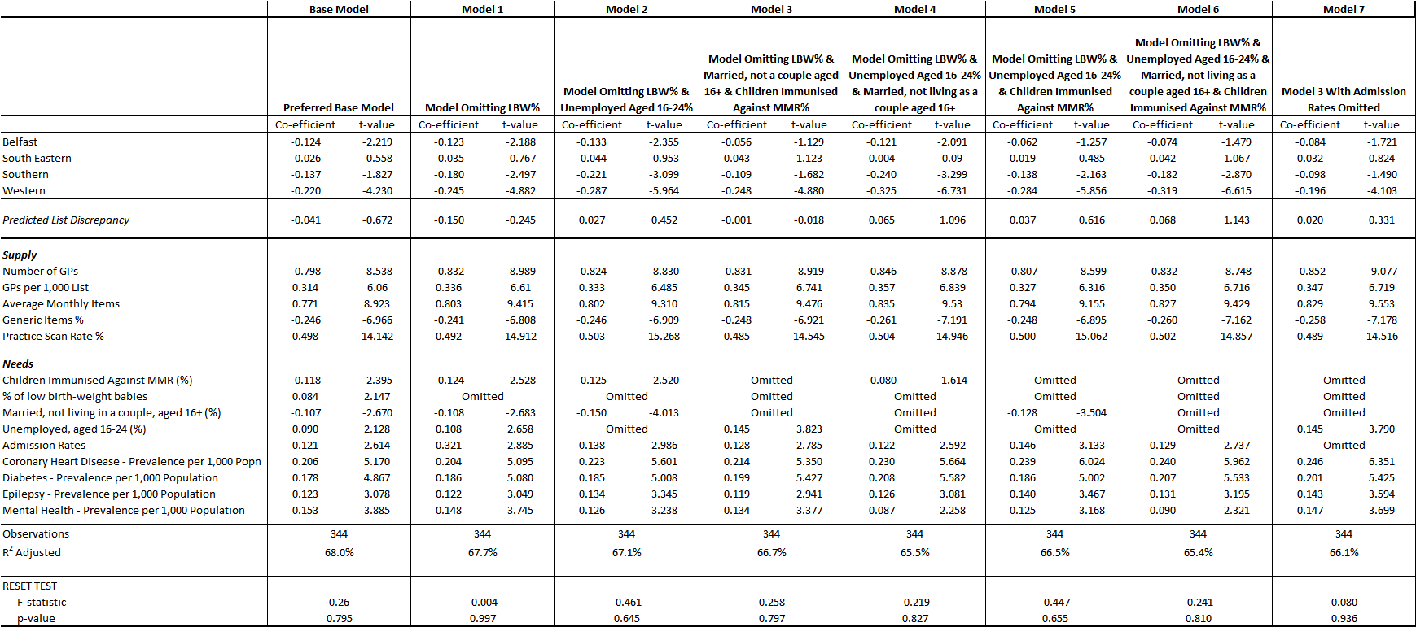

**Equality Group Data Definitions & Sources Appendix M**

|  |  |  |
| --- | --- | --- |
| **Equality Category** | **Definition** | **Source & Analysis Level** |
| Age | 1. Children defined as aged under 18 2. Adults defined as aged 18-65 3. Elderly defined as aged 65+ | Census 2011: SOA Level |
| Gender | 1. Males (ii) Females | Census 2011; SOA Level |
| Marital Status | 1. Single 2. Married/remarried including those in same-sex civil partnerships 3. Divorced/widowed/separated including relationships from same-sex civil partnerships, ie. still in legal partnership, legally dissolved partnership or surviving partner from a same-sex civil partnership. | Census 2011: SOA Level |
| Ethnic Group | 1. White 2. Non-White including Chinese, Irish Traveller, Indian, Pakistani, Bangladeshi, other Asian, Black Caribbean, Black Africa, Black Other, Mixed and Other. | Census 2011; SOA Level |
| Religion | 1. Catholic 2. Protestant and other Christian Religions   Other religions and philosophies and none are excluded from both categories. | Census 2011; SOA Level |
| Political Opinion | 1. Nationalist defined as Sinn Fein and SDLP 2. Unionist defined as DUP and UUP   Alliance and Other are excluded from both categories. | Access Research Knowledge (ARK) <http://www.ark.ac.uk>);  Constituency Level. |
| Sexual Orientation | 1. No data available. | No data available |
| Persons with/ without a Disability | 1. Persons with a disability defined as persons with a long-term health problem or disability that limits their day-to-day activities “a lot” or “a little”. 2. Persons without a disability. | Census 2011; SOA Level |
| Persons with/ without Dependants | 1. Persons with dependants defined as households with one or more dependent children 2. Persons without dependants. | Census 2011; SOA Level |

**Appendix N**

**Alternative Method to Constrain GP Registered Lists to Match Official Population Estimates**

***Background on List Discrepancy***

N.1 Central to any capitation based allocation mechanism, as its name would imply, is an accurate count of the population to which the resources are being allocated. The main capitation formula used to allocate resources for hospital, community health and personal social services is based on the resident mid-year population estimates, independently produced by the Northern Ireland Statistics and Research Agency (NISRA).

N.2 However, as individuals are free to choose their general practice without regard to administrative boundaries, resident populations are not an appropriate base for allocating prescribing resources. This is because a person may live in one local commissioning group (LCG) but be registered with a general practice in another (referred to as cross-boundary flow). At April 2015, 5.88% of patients were registered with a general practice outside the LCG in which they lived. The relevant population base, therefore, for allocating prescribing resources to each LCG is its registered population, that is, the aggregate number of persons registered with general practices that are located within its administrative boundary. The BSO maintains a single register of all persons on general practice lists within NI (known as the National Health Applications and Infrastructure Services System, NHAIS).

N.3 The use of registered populations solely as the population base suffers from the issue that the number of persons registered on general practice lists tends to exceed the official mid-year estimate count for the same area. This difference is known as list discrepancy. List discrepancy is non-uniform across Northern Ireland, varying with population size (generally it is more marked in smaller populations), population structure (highest levels exist for young adults) and geographical area (tends to be higher in urban areas and areas that form a land border with the Republic of Ireland).

N.4 There are a number of reasons why list discrepancy occurs but the 2 most significant are:

* Lists that still contain details of persons who are no longer availing of services from a practice due to death or who have moved away from the area and registered with another practice. Before the introduction of live electronic registration between practices and the BSO, there was much more of a time lag for example in registering babies or removal of those who have died. Highest levels of list discrepancy still exist for young adults as they have higher levels of population movement.
* Cross-border patients who currently live in the Republic of Ireland (ROI) and were therefore not counted in the Northern Ireland Census and subsequent MYEs (which are rolled forward from the Census) but who are availing of services from general practices in Northern Ireland by using an address of convenience. Note that cross-border workers who work in Northern Ireland but are resident in ROI hold a medical card and are entitled to the same medical care as Northern Ireland residents. As at April 2015, there were 1,921 cross-border workers registered on NHAIS. To more accurately calculate list discrepancy, the number of cross-border workers is added to the MYE to allow comparison of all official general practice registrations with the official resident population estimate.

***Options on Population Bases***

N.5 In August 2002, options for the population base in the allocation of primary care resources was referred to the then Minister for Health and Social Services and the use of constrained registered populations was endorsed. Allocating resources based simply on registered lists ignores the issue of list discrepancy and technically absorbs list discrepancy at NI level. This means that those areas with lower levels of list discrepancy will lose out as some of their “fair share” of resources will be directed elsewhere to general practices with higher list discrepancy. The plus side is that registered lists do take account of cross-boundary flow in terms of patients registered with general practices outside of the area in which they live.

N.6 Constraining the registered lists to LCG populations has the effect of absorbing the discrepancy within the LCG in which it occurs. This means that practices with low list discrepancy within an LCG would lose out to others with higher discrepancy within the same LCG, but that the LCG has not been funded for the level of discrepancy in their area. This at first is not a problem; however where list discrepancy is due to people who actually exist, whether entitled to services or not, additional demands will present on the system for which no funding will have been allocated.

N.7 It is appropriate that the impact on equality is considered in coming to a preferred method on the population base. Unfortunately, in this case this is not helpful. Previous analysis has demonstrated that there are equality implications under both options, as different categories of the same equality groups are impacted in completely opposite ways depending on which population base is chosen. The use of registered lists impacts favourably on young Catholic populations and adversely on Protestants and older groups. The constrained registered population has an equal and opposite effect on these groups.

***Ideal Population Base***

N.8 Ideally, we require a population base which is free of the effects of list discrepancy but which still takes account of cross-boundary flow. Registered lists used solely would have the list discrepancy issue and resident populations would not take account of cross-boundary flow; therefore, on balance a constrained registered list is more appropriate. The current method of constraining is outlined at Appendix B and latest figures on list discrepancy at local government district and by age group are detailed at Appendix A. Essentially, the constraining methodology takes the registered population as its start point and then scales it back so that it matches the resident population for an area. This scaling is done by individual age and gender group and by local government district; the methodology is more accurate the smaller the reference population to which the lists are constrained. It should be noted that constraining does not remove list discrepancy but merely averages its impact across the area to which the population is being constrained.

N.9 In the allocation of resources, list discrepancy would not be a problem if it was evenly spread at sub-regional level. There will always be an element of list discrepancy as people relocate or die, but in NI the issue is compounded by those using addresses of convenience and therefore Southern and Western LCGs have materially higher levels of discrepancy. It could be argued that if list discrepancy is in part due to cross-border users, then these patients represent real demand on general practice. The problem is that, quite apart from the question of whether it is right or otherwise to fund services for people who may be resident outside NI, it is however impossible to produce an accurate assessment of the total number of such “un-entitled users” as opposed to patients who have died or moved away.

N.10 If it is agreed that a constrained registered population is appropriate, this appendix considers if it is possible to penalise less those general practices that have patients on their lists using addresses of convenience especially when general practices have limited ability to control this. The discussion is therefore around an alternative method of constraining and not whether constraining should take place. Constraining is a complex process and the following section considers issues that need to be addressed when carrying out the method or developing an alternative methodology.

***Issues that Need Considered***

N.11 The effect on LCG percentage shares of using the constrained registered lists versus registered lists is shown in Table N.1 (this assumes no weighting for age-gender or additional need). Note the swings in LCG shares reflect the level of list discrepancy in these LCGs (see Table N.2). The Southern LCG is disadvantaged the most when constrained registered lists are used because it has the highest level of list discrepancy. The effect of constraining is to redistribute +/-1.03% (equivalent to +/-£4.11m when using a NI pot of £400m) of resources, that is, moving from registered % shares to constrained registered % shares.

**Table N.1 Local Commissioning Group % Shares – Comparison of Population Bases**

|  |  |  |  |  |
| --- | --- | --- | --- | --- |
| LCG | Registered Lists at April 2015 % Share | Constrained Registered Lists % Share | Difference (%) | Difference if Applied to Prescribing Resources (£) |
| Belfast | 22.38% | 22.33% | -0.05% | -£196,284 |
| South Eastern | 16.48% | 16.89% | +0.42% | +£1,668,524 |
| Northern | 23.61% | 24.23% | +0.61% | +£2,440,925 |
| Southern | 20.78% | 20.22% | -0.55% | -£2,217,345 |
| Western | 16.75% | 16.33% | -0.42% | -£1,695,820 |
| N Ireland | 100.00% | 100.00% | - | - |

Footnotes: The registered lists refer to April 2015, constrained lists refer to lists at April 2015 constrained to the 2013 mid-year estimate and the monetary figures refer to applying the % differences to a NI pot of £400m.

**Table N.2 List Discrepancy by LCG – Comparison of MYE v Patients Registered on NHAIS**

**(based on their residency)**

|  |  |  |  |  |
| --- | --- | --- | --- | --- |
| LCG | MYE 2013 (+ CBW) % Share | Residency of Registered Lists at April 2015 % Share | Difference (%) | List Discrepancy (%) |
| Belfast | 19.09% | 19.22% | +0.13% | 6.64% |
| South Eastern | 19.15% | 18.68% | -0.47% | 3.30% |
| Northern | 25.48% | 24.82% | -0.66% | 3.16% |
| Southern | 19.99% | 20.56% | +0.57% | 8.88% |
| Western | 16.29% | 16.71% | +0.42% | 8.64% |
| N Ireland | 100.00% | 100.00% | - | 5.89% |

Footnotes: The mid-year estimate refers to 2013 plus the number of cross-border workers recorded on NHAIS at April 2015. To make an accurate comparison of the registered population with the official MYE resident population, it is necessary to consider the residency of those registered on NHAIS as opposed to their registration. List discrepancy therefore refers to the comparison of the MYE versus those registered with general practices based on their postcode of residency.

N.12 During the budget setting process it is important that general practices receive an allocation for each individual registered patient on their list, as the indicative prescribing amount is intended to cover costs incurred in prescribing drugs to their registered patients. The latest available NHAIS download is therefore used in the budget setting process to ensure that general practice IPAs are based on the latest available registered list; this is usually the registered list at April of that year. There is however a time delay in the production of the official mid-year estimates in that in setting, for example, the 2015/16 IPAs, the registered lists were at 1st April 2015 but the latest available official resident population to scale this back to was the 2013 mid-year estimate at June 2013. This time lag contributes to the level of list discrepancy in each LCG. Consider Table N.3 which calculates list discrepancy by comparing the 2013 MYE with the January 2013 NHAIS; the levels are much lower than in Table N.2 where the lag between the data sources occurs.

**Table N.3 List Discrepancy without MYE Time Lag**

|  |  |
| --- | --- |
| LCG | List Discrepancy (%) |
| Belfast | 4.42% |
| South Eastern | 1.05% |
| Northern | 1.03% |
| Southern | 4.86% |
| Western | 4.41% |
| N Ireland | 3.00% |

Footnotes: List discrepancy calculated by comparing MYE 2013 with registered list

at January 2013, based on residency of registered patients.

N.13 To further complicate the issue of an accurate population base, there is cross-boundary flow between LCGs in terms of patients who register in a different LCG to the one in which they live. Table N.4 simply considers the NHAIS patients at April 2015 (i.e. there is no reference here to official mid-year estimate populations) in terms of their LCG of registration versus the LCG in which they reside. As expected, given the geography of the areas, there is much less cross-boundary flow in Southern and Western LCGs, whereas 3.16% of all patients are registered to general practices in Belfast LCG but do not live in Belfast LCG. Also, 2.20% of patients are resident in South Eastern LCG but are registered with general practices in other LCGs.

**Table N.4 Cross-Boundary Flow**

|  |  |  |  |
| --- | --- | --- | --- |
| LCG | Registered Lists % Share | Residency of Registered Lists % Share | Difference (%) |
| Belfast | 22.38% | 19.22% | -3.16% |
| South Eastern | 16.48% | 18.68% | +2.20% |
| Northern | 23.61% | 24.82% | +1.21% |
| Southern | 20.78% | 20.56% | -0.22% |
| Western | 16.75% | 16.71% | -0.04% |
| N Ireland | 100.00% | 100.00% | - |

Footnotes: Registered lists refer to patients registered on NHAIS at April 2015 according to the LCG of their general practice of registration. Residency refers to the LCG in which the registered patients on NHAIS reside.

N.14 We have therefore identified a number of issues with developing an accurate population base:

* Aim to minimise the issue of list discrepancy which is non-uniform across Northern Ireland.
* Aim to minimise the effect on LCGs impacted on more materially due to un-entitled users.
* The issue of distortion due to the time lag in production of official population estimates.
* Aim to account for cross-boundary flows where patients register with general practices outside the LCG in which they live.

***Alternative Approaches***

N.15 The current constraining method works by comparing the NHAIS registered population based on residency (we will call this A) versus the mid-year estimate plus cross border workers (we will call this B) (to create deflators) by age-gender group and local government district (LGD).

The deflator for each age-gender group for each LGD = B / A

These deflators are then applied to the LCG resident populations but this allows us to still add up LCG registered populations; these registered populations are now the sum of deflated resident populations.

N.16 Mathematically, a number of methods were tested in an attempt to distribute the list discrepancy across the LCGs so that those with lower list discrepancy would take on some of the higher list discrepancy from the other LCGs. Basically the aim was that those LCGs more affected by un-entitled users would not bear the full brunt of this but that it would be shared across all LCGs.

A number of difficulties became apparent; firstly by not being able to quantify the amount of list discrepancy attributed to the un-entitled users’ issue, it was necessary to try to average total list discrepancy from each LCG across all other LCGs. Although a method was successful in deflating the resident NHAIS populations, it did not allow us to maintain the matrix of resident v registration of patients and therefore the cross boundary flows were omitted.

Whatever method is used therefore needs to be able to deflate LCG NHAIS resident populations while retaining the structure of the LCG registered populations. The only population shares that should change within the method are the constrained registered population as we do not wish to change the size or structure of the NHAIS registered or resident population nor the size or structure of the official mid-year estimate; the only changing factor is the method of constraining.

***Suggested Proposal***

N.17 The following method allows us to deflate LCG NHAIS resident populations while retaining the structure of the LCG registered populations. We know that list discrepancy is non-uniform in terms of age-gender and geographical area, but in an attempt to distribute the list discrepancy across LCGs, this method only averages the list discrepancy by age-gender group but not local government district. This method assumes that the discrepancy is uniform across areas. Looking at the levels of list discrepancy across LGDs (see Appendix A), there is a case to argue that list discrepancy would be uniform across areas if it were not for the un-entitled user issue. We can say this because list discrepancy only varies between 1 to 3% in all LGDs, with the exception of those LGDs that have a land border with the Republic of Ireland (with the exception of Belfast and Castlereagh LGDs, this will be attributed to their urban nature). It is clear that list discrepancy would vary with age, but there is no reason why it should vary with location except for the 2 reasons already identified; urban areas and cross-border issues.

N.18 Mathematically to implement this proposal, a list deflator is only calculated for each age-gender group and not for each LGD as well. For example:

MYE + Cross-Border Workers for Males 25-44 (B) = B / A = Deflator for Age-Gender Group

Resident NHAIS Population for Males 25-44 (A)

This deflator is then applied to all LGDs within the specific age-gender group rather than calculating specific deflators for each LGD. This allows us to deal with list discrepancy as it differentially impacts on age-gender but assumes uniformity across geographical areas. This method still allows cross boundary flows to be retained as we still deflate each LGD resident NHAIS population and can subsequently sum the deflated resident populations to arrive at constrained NHAIS registered populations.

***Impact of Implementation of Proposed Alternative Constraining Methodology***

N.19 The constrained registered population shares from implementation of the alternative methodology are shown in Table N.5. In comparison to the current methodology (see Table N.1), the swings for each LCG are now much less. The alternative constraining methodology redistributes +/-0.04% or +/-£143k (that is, moving from registered % shares to constrained registered % shares).

* Belfast LCG still sees a reduction in share due to constraining, but the reduction is now 0.03% (-£112k) as opposed to -0.05% (-£196k).
* South Eastern LCG still sees an increase in share due to constraining, but the increase is less than under the current method, +0.02% (+£78k) compared to +0.42% (+£1.67m).
* Northern LCG still sees an increase in share due to constraining, but the increase is less than under the current method, +0.01% (+£51k) compared to +0.61% (+£2.44m).
* Southern LCG previously experienced a decrease in share due to constraining (-0.55%, equivalent to -£2.22m) but under the alternative method, this LCG sees a slight increase in share (+0.003%, equivalent to +£13k).
* Western LCG still sees a reduction in share due to constraining but the reduction is now much less, -0.01% or -£30k compared to -0.42% (-£1.69m).

**Table N.5 Local Commissioning Group % Shares – Comparison of Population Bases**

|  |  |  |  |  |
| --- | --- | --- | --- | --- |
| LCG | Registered Lists at April 2015 % Share | Constrained Registered Lists % Share (Alternative Method) | Difference (%) | Difference if Applied to Prescribing Resources (£) |
| Belfast | 22.38% | 22.35% | -0.03% | -£112,823 |
| South Eastern | 16.48% | 16.50% | +0.02% | +£78,112 |
| Northern | 23.61% | 23.63% | +0.01% | +£51,314 |
| Southern | 20.78% | 20.78% | 0.00% | +£13,471 |
| Western | 16.75% | 16.74% | -0.01% | -£30,075 |
| N Ireland | 100.00% | 100.00% | - | - |

Footnotes: The registered lists refer to April 2015, constrained lists refer to lists at April 2015 constrained to the 2013 mid-year estimate and the monetary figures refer to applying the % differences to a NI pot of £400m. Constraining refers to the proposed alternative methodology.

N.20 Table N.6 compares the constrained registered population shares under the current and proposed alternative methodologies. The alternative methodology effectively moves all LCGs closer to their shares from using registered lists; in essence if list discrepancy did not exist, LCGs would indeed receive their registered population shares. Resident population shares (MYEs) would never be appropriate for allocating primary care resources; general practices, and in turn their LCG of management, are concerned with the care of registered patients not residents of the area.

**Table N.6 Comparison of LCG % Shares – Current versus Alternative Methodology**

|  |  |  |  |  |  |
| --- | --- | --- | --- | --- | --- |
| LCG | Registered Lists % | Constrained Registered Lists % Share (Old Method) | Constrained Registered Lists % Share (Alternative Method) | Difference (%) | Difference if Applied to Prescribing Resources (£) |
| Belfast | 22.38% | 22.33% | 22.35% | +0.02% | +£83,462 |
| South Eastern | 16.48% | 16.89% | 16.50% | -0.40% | -£1,590,412 |
| Northern | 23.61% | 24.23% | 23.63% | -0.60% | -£2,389,611 |
| Southern | 20.78% | 20.22% | 20.78% | +0.56% | +£2,230,816 |
| Western | 16.75% | 16.33% | 16.74% | +0.42% | +£1,665,746 |
| N Ireland | 100.00% | 100.00% | 100.00% | - | - |

N.21 Table N.7 details the effect of applying the age-gender and additional needs weightings to the new population starting point, that is, the new constrained registered population having used the alternative methodology.

**Table N.7 Effect of Age-Gender & Additional Needs Weightings 2015 at LCG Level**

|  |  |  |  |  |  |
| --- | --- | --- | --- | --- | --- |
|  | **Belfast** | **Northern** | **S Eastern** | **Southern** | **Western** |
| **Constrained Registered Population**  **% Shares (Alternative Method)** | 22.35% | 23.63% | 16.50% | 20.78% | 16.74% |
| **Age-Gender Index 2015 (incorporating the care home adjustment)**  **Age Weighted Population % Shares**  **Change in % Share (from constrained reg popn) due to Age Weighting Only** | 0.9830  21.97%  -0.38% | 1.0326  24.40%  +0.77% | 1.0847  17.89%  +1.40% | 0.9453  19.64%  -1.14% | 0.9612  16.09%  -0.65% |
| **Additional Needs Index 2015**  **Need Weighted Population % Shares**  **Change in % Share (from constrained reg popn) due to Need Weighting Only** | 1.0443  23.30%  +0.94% | 0.9983  23.54%  -0.09% | 0.9699  15.97%  -0.53% | 0.9832  20.39%  -0.39% | 1.0060  16.81%  +0.07% |
| **Total Index 2015**  **Age & Need Weighted Population % Shares**  **Change in % Share (from constrained reg popn) due to Age & Need Weighting Combined** | 1.0174  22.74%  +0.39% | 1.0312  24.37%  +0.74% | 1.0540  17.39%  +0.89% | 0.9295  19.31%  -1.47% | 0.9670  16.19%  -0.55% |

N.22 Table N.8 compares the overall final fair shares for each LCG after application of the full formula, using the current and alternative constraining methodologies. A move to the alternative constraining methodology would redistribute +/-£3m (+/-0.75%) assuming a NI allocation of £400m.

**Table N.8 Comparison of Final Fair Shares by LCG**

|  |  |  |  |  |
| --- | --- | --- | --- | --- |
| LCG | Total % Fair Shares  (Current Constraining Method) | Total % Fair Shares  (Alternative Constraining Method) | % Difference | Monetary Value (£) |
| Belfast | 22.78% | 22.74% | -0.04% | -£153k |
| Northern | 24.79% | 24.37% | -0.43% | -£1.71m |
| South Eastern | 17.67% | 17.39% | -0.29% | -£1.15m |
| Southern | 18.93% | 19.31% | +0.38% | +£1.52m |
| Western | 15.82% | 16.19% | +0.37% | +£1.49m |