Review of the Northern Ireland Weighted Capitation Formula for Allocating Primary Care Prescribing Resources to LCGs and General Practices

SUMMARY REPORT
Final Summary Report for Public Consultation

March 2016
Project Support Analysis Branch
DHSSPS (NI)
Minister’s current reform proposals may mean that some organisations referred to in this document could cease to exist in the near future, with other organisations assuming responsibilities.
- Introduction
1.1 Expenditure on general practice prescribing covers the costs incurred by GPs in prescribing medication to their patients. In 2014, there were 39.7 million items dispensed in the community at a gross ingredient cost of £420 million.
1.2 A weighted capitation concept, to distribute resources on the basis of the needs of the population, was first introduced in Northern Ireland (NI) in 1998/99 through the use of Scottish age-gender weightings. Research over the next 2 years saw application of a full Northern Ireland formula in 2000/01. In 2003, the formula was subjected to an equality impact assessment, external peer review and public consultation. A full formula review was carried out in 2009/10; this updated formula was implemented with Ministerial approval in 2010/11, with the final report published in June 2010.
1.3 The current formula comprises:
- A constrained registered general practice list as the population base to take account of population size. The major determinant of an area or general practice’s level of need is the size of the population for which it is responsible.
- An age-gender adjustment (or index) to take account of needs arising from age-gender profiles which are different from the Northern Ireland average. This index also incorporates an adjustment to take account of the relative costs of those patients residing in care homes.
- An additional need adjustment to reflect the relative need for prescribing resources over and above those due to population size and age-gender profile.
1.4 The current weighted capitation formula was identified as needing a full review for a number of reasons:
- All resource allocation formulae should be reviewed regularly to ensure that the applied weightings are up-to-date and as accurate as possible in terms of reflecting current population needs. The formula was last reviewed in 2010 and review was due under the normal review process.
- Since 2011, prescribing costs in Northern Ireland have been decreasing due to a number of factors and it is therefore important that the formula used to allocate GP practice and Local Commissioning Group (LCG) resources is based on up-to-date cost information.
- NI went through a Review of Public Administration, commencing in 2002; in 2005 the Review concluded that reform was required for the administrative structures of health and social services. In April 2009, reform included the establishment of new commissioning arrangements under local commissioning groups (LCGs); it is important that the formula is robust and up-to-date under these new commissioning arrangements, particularly given the scrutiny that LCGs come under with regard to reducing prescribing spend and enabling effective prescribing.
- The need to further develop the method used to derive the age weightings, the need to devise updated age weights for specific therapeutic groups (STAR-PU) and the need to formally document the care home adjustment and subject it to peer review and public consultation.
- NI Census 2011 data had become available and so it was timely to utilise this new data. Enhanced electronic prescribing data also allows more robust modelling to be undertaken. These up-to-date enhanced data sources also allow for consideration of recommendations put forward by the peer reviewer during the last review, which were not feasible during the last review.

- Population Base
2.1 Central to any capitation based allocation mechanism is an accurate count of the population to which the resources are being allocated. Differential changes in the population will have an impact on the allocation of resources. As general practice allocations are intended to cover costs incurred by GPs in prescribing drugs to their patients, it is important that general practices receive an allocation for the proportion of patients registered with them, irrespective of whether those patients reside in that particular LCG area.
2.2 The current data source is the National Health Applications and Infrastructure Services (NHAIS) System (successor to the “Exeter” System), which is a record of everyone registered with a general practice in Northern Ireland. The NHAIS System also includes registration of cross border workers who are entitled to medical treatment whilst in NI, on the same basis as residents; that is, they receive a medical card in the same manner as NI residents.
List Discrepancy & Constraining Process
2.3 There exists a “population discrepancy” between the general practice registered list and the official mid-year estimate (MYE) of population (produced by the Northern Ireland Statistics & research Agency). The discrepancy is due in part to delays in removing patients from practice lists who no longer avail of services, e.g. due to death or having moved away and delays in registering babies. The issue in NI is further compounded by users from the Republic of Ireland (ROI) using addresses of convenience. At NI level, list discrepancy is approximately 3% (if comparing the closest lists and MYEs in terms of time period) but differs in magnitude by age and geographical area.
2.4 Given the issue of list discrepancy, it is accepted that registered practice list populations are not suitable for resource allocation purposes. It is possible, however, to carry out a controlling procedure to adjust for list discrepancy, resulting in the population base for allocations to LCGs being the constrained registered list population. The constraining methodology takes the registered GP population as its start point and scales it back to match the resident population for an area. The constraining method does not eliminate list discrepancy entirely, but rather averages it across the area at which it is being absorbed.
2.5 During development of the updated formula, discussion arose around the impact of the current constraining method on particular LCGs; namely that Southern and Western LCGs have land borders with ROI and are therefore differentially impacted by un-entitled users. An alternative method has been considered in an attempt to reduce the penalty on those practices, and subsequently LCGs, that have patients using addresses of convenience, especially when general practices have limited ability to control this. The impact of adopting the alternative methodology is documented in Appendix N; otherwise the main report and this summary retain the current methodology when presenting results. The current method has Ministerial approval and any change would require further approval.
2.6 It is recommended that regardless of the method (current or alternative); a constrained registered population should be used as the population base for setting LCG allocations. This should be the latest available list from NHAIS constrained to the latest available mid-year estimate of population adjusted for the latest available number of cross border workers as recorded on NHAIS. The latest available general practice registered list from NHAIS should be retained as the population base for setting general practice allocations.
- Age-Gender Adjustment
3.1 After population size, the next significant consideration in a resource allocation formula is to account for needs which arise from having a population age and/or gender structure which is different from the NI average. Different age-gender groups place different demands on the health service. It is logical that older age groups will require more prescribing resources than younger age groups and should therefore attract higher weightings within the formula adjustment.

3.2 The Northern Ireland Prescribing Unit (NI-PU) was first introduced in 2000/01 to account for differences in demography when distributing primary care prescribing resources. As well as an adjustment within the allocation formula, the NI-PU can be used to make comparisons more valid between general practices or between geographical areas. The NI-PU is therefore adopted within the COMPASS¹ reporting system.

3.3 The Electronic Prescribing and Eligibility System (EPES) and the associated enhanced prescribing database, maintained by the Business Services Organisation (BSO), have greatly increased the accuracy of prescribing and dispensing information. The updated age-gender weights (or cost curve) have been derived using this data source for dispensed items and the NHAIS registered population dataset.

3.4 The gross ingredient cost (costs of drugs before discount and excluding dispensing fees) of items dispensed in the community in 2013/14 (see main report for exclusions) for each age-gender group is divided by all patients registered with general practices during 2013/14 for the same age-gender groups. This creates costs per head for each age-gender group. These are then standardised around the minimum cost per head to produce relative cost weights (see Table 3.1 and Figure 3.1). The interpretation of the relative weights is that an elderly woman aged 75 and over is expected to cost just over 14 times more than a female aged 5-15.

¹ A prescribing information system developed to provide general practices with feedback on their prescribing and how they compare to their peers, both locally and regionally. Practice-specific reports provide in-depth analysis including identification of potentially high cost areas, encourage generic prescribing and discourage over-prescribing of certain medicines.
Table 3.1 Relative Age-Gender Cost Weights – NI-PU 2015
Age Group | Males | Females
0-4 | £1.80 | £1.52
5-15 | £1.32 | £1.00
16-24 | £1.28 | £1.52
25-44 | £1.93 | £2.73
45-59 | £4.77 | £5.68
60-64 | £7.89 | £8.12
65-74 | £10.46 | £9.92
75+ | £14.44 | £14.25
Source: Derived from dispensing data (EPES) & GP Registered Lists (NHAIS)

Figure 3.1 Relative Cost Weights – NI-PU 2015

Source: Derived from dispensing data (EPES) & GP Registered Lists (NHAIS)

3.5 In comparison to the weights currently in operation (NI-PU 2010), there is little change in the younger age groups (from 0 to 24), but costs per head and subsequently the relative weights have decreased in the older age groups (from age 24 upwards) and particularly in the age groups from 60+. This is in line with the trend that, despite increasing volumes of items prescribed (which reflect a steadily growing older population), prescribing costs have been decreasing in recent years. This is due to a number of factors including implementation of a Pharmaceutical Clinical Effectiveness Programme, the role of Medicines Management Advisers, the increased rate of generic prescribing/dispensing, influence of Prescribing Incentive Schemes and the introduction of a NI Formulary.
3.6 In the case of LCG allocations, the weights in Table 3.1 are applied to the constrained registered population to produce an age-gender weighted population for each LCG area. The relative effect on each LCG (the NI average being 1.0) is shown as an index around 1.0 (see Table 3.2). An LCG with an age-gender index of less than 1.0 has less need related to age-gender than the NI average, due to having a younger age profile (e.g. Western LCG). Likewise, an LCG with an index greater than 1.0 has a higher level of relative need and is most likely to have an elderly age profile (e.g. South Eastern LCG). In comparison with the population shares before adjusting for age-gender, South Eastern LCG have gained the most in age-gender weighted population share, reflecting their elderly age profile.
Table 3.2 Age-Gender Index & Age Weighted Population Shares at LCG Level at 1st April 2015
 | Belfast | Northern | S Eastern | Southern | Western
Constrained Registered Population Shares % | 22.33% | 24.23% | 16.89% | 20.22% | 16.33%
Age-Gender Index | 0.9852 | 1.0246 | 1.0703 | 0.9544 | 0.9675
% Shares After Adjusting for Age-Gender | 22.00% | 24.82% | 18.08% | 19.30% | 15.80%
Change in % Share due to Age-Gender Weighting | -0.33% | +0.59% | +1.19% | -0.92% | -0.53%

3.7 In the case of general practice allocations, the weights are applied to the registered list populations to produce an age-weighted population for each general practice.
3.8 It is recommended that the updated NI-PU 2015 be adopted as the age-gender adjustment within the Prescribing Formula for both LCG and general practice allocations from 2016/17.
STAR-PU
3.9 There are differences in the age and gender profiles of patients who are prescribed drugs in specific therapeutic groups. For example, drugs for dementia are generally prescribed for older people. STAR-PU (Specific Therapeutic Group Age-Gender Related Prescribing Unit) has been developed to allow more accurate comparisons within a specific therapeutic group by taking into account the types of people who receive that medication.
3.10 STAR-PU weightings have been developed in NI for the leading 10 therapeutic groups (which account for 94% of items dispensed and 89% of total ingredient cost in 2013/14). STAR-PU has also been developed for a number of British National Formulary (BNF) specific chapters, sections and paragraphs. The methodology is principally the same as for NI-PU, but based on costs within individual therapeutic groups rather than all prescribing and there is no standardisation (that is, no weight is adjusted to be 1.0); the weights are presented as costs per head.
3.11 Not surprisingly, the STAR-PU weightings differ greatly for different therapeutic groups, reflecting the demographics of the population being prescribed certain medicines. Table 3.3 and Figure 3.2 show the STAR-PU weightings for 2 BNF chapters (BNF Chapter 2: Cardiovascular System and BNF Chapter 4: Central Nervous System) as examples.
3.12 It is recommended that STAR-PU be adopted as the prescribing measure when analysing a particular drug, BNF chapter, section or paragraph. Note, STAR-PU is not adopted within the weighted capitation formula; STAR-PU was developed as a supplementary prescribing tool.

Table 3.3 STAR-PU Weightings for BNF Chapters 2 & 4
Age Group | BNF Chapter 2  Cardiovascular System |  | BNF Chapter 4  Central Nervous System
 | Males | Males | Females | Females
0-4 | £0.23 | £2.35 | £2.35 | £0.14
5-15 | £0.29 | £13.65 | £6.18 | £0.26
16-24 | £0.63 | £15.37 | £14.34 | £1.06
25-44 | £3.67 | £31.21 | £43.93 | £4.35
45-59 | £27.20 | £63.10 | £89.69 | £18.84
60-64 | £64.34 | £76.19 | £100.87 | £45.06
65-74 | £92.01 | £79.92 | £104.25 | £70.10
75+ | £105.72 | £103.44 | £156.03 | £92.59

Figure 3.2 (a) STAR-PU Weightings for BNF Chapter 2: Cardiovascular System
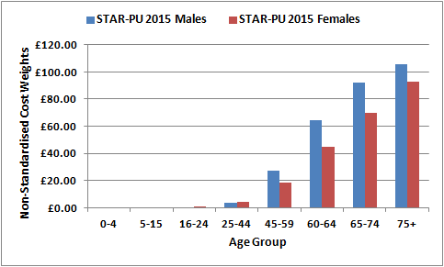

Figure 3.2 (b) STAR-PU Weightings for BNF Chapter 4: Central Nervous System
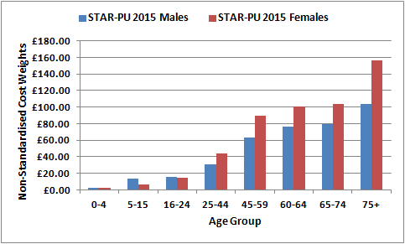

Care Home Adjustment
3.13 An adjustment has been developed and incorporated within the age-gender weighting to take account of the relative greater prescribing need of patients in care homes compared to patients living in their own homes. The analysis for this adjustment was first carried out in 2012 and presented to the IPA (Indicative Prescribing Amounts) Management Group (see Appendix A for membership), who endorsed the work and agreed to introduction of the adjustment from 2013/14. The analysis has now been updated and this is the opportunity for the adjustment to be presented formally and subjected to peer review and public consultation.
3.14 Analysis involved an examination of the age and gender distribution of the care home population in NI compared with that of the population living in the community. As expected, patients in care homes were predominantly elderly and, compared to those in the community, there were a higher percentage of females (67% of patients in care homes were females compared to 50% of the community population). The distribution of age and gender for care home patients is expected to have a large impact on volume, types of medication prescribed and subsequent prescribing costs.
3.15 Relative prescribing costs were calculated for care home patients and compared with the relative costs of those living in the community. The relative costs of those in care homes are much higher overall in each age-gender group than those living in the community. An interesting result was that unlike NI-PU, there was less association with age, rather than a steep increase in the elderly age groups, the costs tend to plateau. This suggests that age is less of a contributory factor to the costs than the fact that the patient has clinical or physical needs that require them to be in care.
Figure 3.3 Relative Prescribing Costs of Care Home Patients
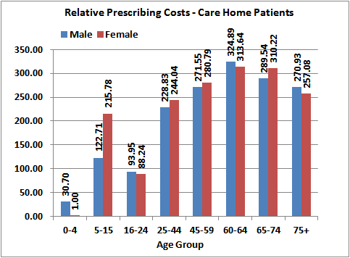
3.16 Costs per prescribing unit (having applied the NI-PU) were calculated for both care home patients and non-care home patients for each general practice. The average cost for patients in care homes was £97.62 compared to £39.91 for those living in the community; leading to a ratio of 2.45 between the 2 costs, although the distribution across all general practices ranges from less than 1.0 to 6.97 (see Figure 3.4). Given the distribution, it is recommended that the weights for patients in care homes be 2.5 times the value of the patients living in their own homes.
Figure 3.4 Distribution of Cost Ratios Across General Practices
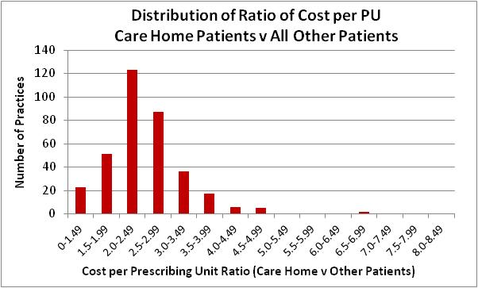
3.17 To allow for care home weightings within the allocation process for both LCGs and general practices, it is recommended that the following procedure is followed:
Calculate the number of NI-PUs for the patients in care homes and then multiply this number by 2.5 before adding to the remaining NI-PUs for the practice (that is, NI-PUs for the non-care home patients).
3.18 The effect of the care home adjustment at LCG level is shown in Table 3.4. South Eastern LCG experiences the largest increase in share from application of the adjustment; this is expected given South Eastern LCG’s more elderly age structure. Likewise, Southern and Western LCGs see a reduction in share when the adjustment is applied; this reflects their younger age profiles.
Table 3.4 Impact of Care Home Adjustment at LCG Level
 | Belfast | Northern | S Eastern | Southern | Western
% Shares After Adjusting for Age-Gender Only | 22.00% | 24.82% | 18.08% | 19.30% | 15.80%
% Shares After Adjusting for Age-Gender & Incorporation of Care Home Adjustment | 22.01% | 24.82% | 18.19% | 19.25% | 15.72%
Change in % Share due to Care Home Weighting | +0.01% | 0.00% | +0.11% | -0.05% | -0.08%

3.19 It is recommended that the care home adjustment is incorporated within the age-gender weighting in setting both LCG and general practice allocations.

- Additional Needs Adjustment
4.1 After adjusting for the age and gender structure of the population (including the care home population), the second weighted capitation adjustment is that required to reflect the relative need for prescribing resources over and above those needs due to population size and age-gender profile. This allows for two populations of similar size and demographic structure but which due to morbidity and socio-economic circumstances have additional need for prescribing resources.
4.2 The aim of the additional needs modelling is to relate prescribing utilisation to population needs, measured using a range of morbidity, health, deprivation and socio-economic factors. Prescribing utilisation is measured in the form of costs per head adjusted to take account of age. Utilisation of health care resources does not only depend on patient need and demand; supply or availability of resources also has an influence. Supply was measured in the form of general practice characteristics and access to healthcare facilities in terms of distance.
4.3 Replication of the current additional needs model with updated data provided evidence that the current formula no longer reflects current need and would lead to inaccurate allocations. Before embarking on the statistical modelling, a strategy was agreed with the peer reviewer in terms of the preferred functional form that the model should take and the preferred approach to relating age needs and additional needs. It was agreed that a 2-stage additive model, 1-stage stratified models and BNF-specific models would be tested. The 2-stage approach adjusts for differences in the age-gender structure of the population using the age-gender cost curve, so that in the second stage the utilisation data are standardised to control for the effect of age and gender. The 1-stage stratified model stratifies the utilisation cost data into age-gender groups and requires a separate regression model to be estimated for each. The BNF-specific models stratify the utilisation cost data into therapeutic groups and require a separate regression model for each BNF chapter.
4.4 Extensive statistical modelling resulted in a preferred model which was subjected to various testing to ensure the underlying assumptions of statistical modelling had not been violated. There was clear rationale for choosing the 2-stage additive model, which was then subjected to sensitivity analysis to test the robustness of the preferred model. Sensitivity testing allowed a number of needs variables to be removed from the model without adversely impacting on either the explanatory power or specification of the model. Sensitivity analysis also highlighted that an indicator within the model measuring admission rates to hospital was the result of differing policies across the Health and Social Care Trusts and not a legitimate needs driver; this indicator was also removed resulting in a robust model with good specification.
4.5 The modelling exercise determined which indicators provided the most accurate approximation of need for prescribing resources; the indicators were as follows:
- Prevalence of coronary heart disease per 1,000 population;
- Prevalence of diabetes per 1,000 population;
- Prevalence of epilepsy per 1,000 population;

- Prevalence of mental health per 1,000 population; and
- Percentage of those unemployed who are aged 16-24.
4.6 The role of supply in modelling need for prescribing resources was examined in detail. Utilisation of prescribing resources does not depend only on patient need and demand; in addition the supply of services can also influence demand. The modelling aims to explain only utilisation that is a response to need and not that created due to extra supply. The aim should be isolating the effect of the legitimate needs drivers and for resources to be allocated on the basis of legitimate need only. To do so for allocation purposes, the supply variables are retained in the model but sterilised, that is, they are fixed at the average value for NI.
4.7 The needs indicators were combined into an additional needs index and the index was applied to the age-weighted population to produce an age-need weighted population for each LCG or practice. The relative effect on each LCG (the NI average being 1.0) is shown as an index around 1.0 (Table 4.1). An LCG with an additional needs index of less than 1.0 is deemed to have less than the NI average demand placed on its prescribing resources due to additional need (e.g. South Eastern LCG). It can be seen that, overall, Belfast LCG has the highest additional needs index (1.0443) followed by Western LCG (1.0060); the other 3 LCGs have additional needs indices below the NI average.
Table 4.1 New Additional Needs Index 2015 & Need Weighted Population Shares at LCG Level at 1st April 2015
 | Belfast | Northern | S Eastern | Southern | Western
Constrained Registered Population Shares % | 22.33% | 24.23% | 16.89% | 20.22% | 16.33%
New Additional Needs Index | 1.0443 | 0.9983 | 0.9699 | 0.9832 | 1.0060
% Shares After Adjusting for Additional Need | 23.28% | 24.14% | 16.35% | 19.84% | 16.39%
Change in % Share due to Additional Need Weighting | +0.94% | -0.09% | -0.54% | -0.38% | +0.07%

4.8 Detailed analysis of the individual indicators was carried out to explore the plausibility of the resultant LCG needs weightings (see Table 4.2). Belfast LCG has indices for all 5 needs indicators greater than the NI average of 1.0 and for 4 of the variables, Belfast has the highest index; this leads to Belfast LCG having the highest additional needs index overall. Western LCG has greater than the NI average for 4 of the 5 variables, the highest index for diabetes prevalence and the second highest index for 3 of the other variables. Intuitively it is expected that South Eastern LCG would have the lowest additional need and this is indeed borne out with South Eastern LCG having the lowest indices for 3 indicators. The profiles of the LCGs in terms of the individual indicators lead to the overall plausible results in terms of the additional needs index.

Table 4.2 LCG Profiles (variables expressed as ratios around the NI Average of 1.0)
Needs Variable | Belfast | Northern | S Eastern | Southern | Western
CHD Prevalence | 1.0470 | 1.0027 | 0.9340 | 1.0038 | 1.0053
Diabetes Prevalence | 1.0256 | 1.0219 | 0.9411 | 0.9713 | 1.0328
Epilepsy Prevalence | 1.1238 | 0.9309 | 0.9624 | 0.9320 | 1.0508
Mental Health Prevalence | 1.1970 | 0.9160 | 0.8598 | 0.9222 | 1.0873
% Unemployed Aged 16-24 | 1.0375 | 1.0116 | 1.0266 | 0.9819 | 0.9472
Note: The disease prevalence variables have been age standardised.
4.9 Table 4.3 shows the effect at LCG level of applying both the age-gender and additional needs weightings, that is, the effect of simultaneously applying “total need”. Note the age-gender index incorporates the adjustment for care home patients. It can be seen that certain LCGs gain population share due to the age-gender weighting (e.g. South Eastern LCG) but reduce share to additional need. The situation is reversed in e.g. Belfast LCG where there is more than the NI average additional need but less need due to the younger age profile. Southern LCG is the only LCG to have less than the NI average need in terms of both age-gender and additional need.
Table 4.3 Effect of Age-Gender & Additional Needs Weightings 2015 at LCG Level
 | Belfast | Northern | S Eastern | Southern | Western
Constrained Registered Population  % Shares | 22.33% | 24.23% | 16.89% | 20.22% | 16.33%
Age-Gender Index 2015 (incorporating care home adjustment)  Age Weighted Population % Shares  Change in % Share (from constrained reg popn) due to Age Weighting Only | 0.9856  22.01%  -0.32% | 1.0247  24.82%  +0.60% | 1.0766  18.19%  +1.29% | 0.9522  19.25%  -0.97% | 0.9630  15.72%  -0.60%
Additional Needs Index 2015  Need Weighted Population % Shares  Change in % Share (from constrained reg popn) due to Need Weighting Only | 1.0443  23.28%  +0.94% | 0.9983  24.14%  -0.09% | 0.9699  16.35%  -0.54% | 0.9832  19.84%  -0.38% | 1.0060  16.39%  +0.07%
Total Index 2015  Age & Need Weighted Population % Shares  Change in % Share (from constrained reg popn) due to Age & Need Weighting Combined | 1.0201  22.78%  +0.45% | 1.0234  24.79%  +0.57% | 1.0462  17.67%  +0.78% | 0.9363  18.93%  -1.29% | 0.9689  15.82%  -0.51%

- Sensitivity of the Formula to targeting Deprivation
5.1 One of the characteristics of an effective weighted capitation formula is to channel or skew resources towards people, groups and areas in greatest need. Sensitivity can be masked at LCG level; the different needs of affluent and deprived sub-populations which make up an LCG area can, to a large extent, cancel each other out. At LCG level, population size is the major determinant of need rather than socio-economic profile. The differences in socio-economic circumstances and deprivation are more apparent at small area level; analysis has therefore been carried out at Super Output Area (SOA) level to demonstrate the targeting of the formula.

5.2 The maps below demonstrate that the ranking of small areas is very different depending on whether additional need or need arising from age-gender structure is considered (Figures 5.1 & 5.2). This is as expected, given that deprived areas tend to consist of relatively younger populations whereas more affluent areas tend to have more elderly populations; these are of course generalisations and there will always be deviations from this general perception. The interaction between both types of need is captured in the total needs index (Figure 5.3).

Figure 5.1 Age-Gender Index of the New Formula by SOA
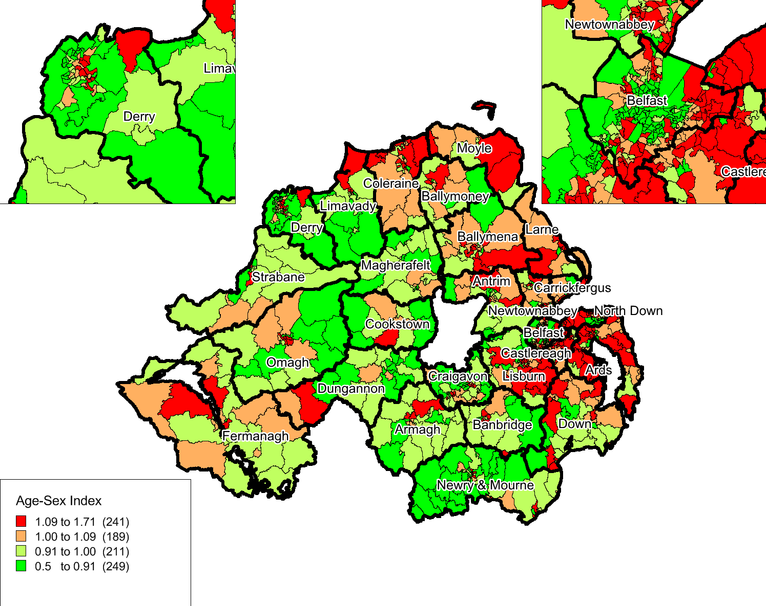

Figure 5.2 Additional Needs Index of the New Formula by SOA
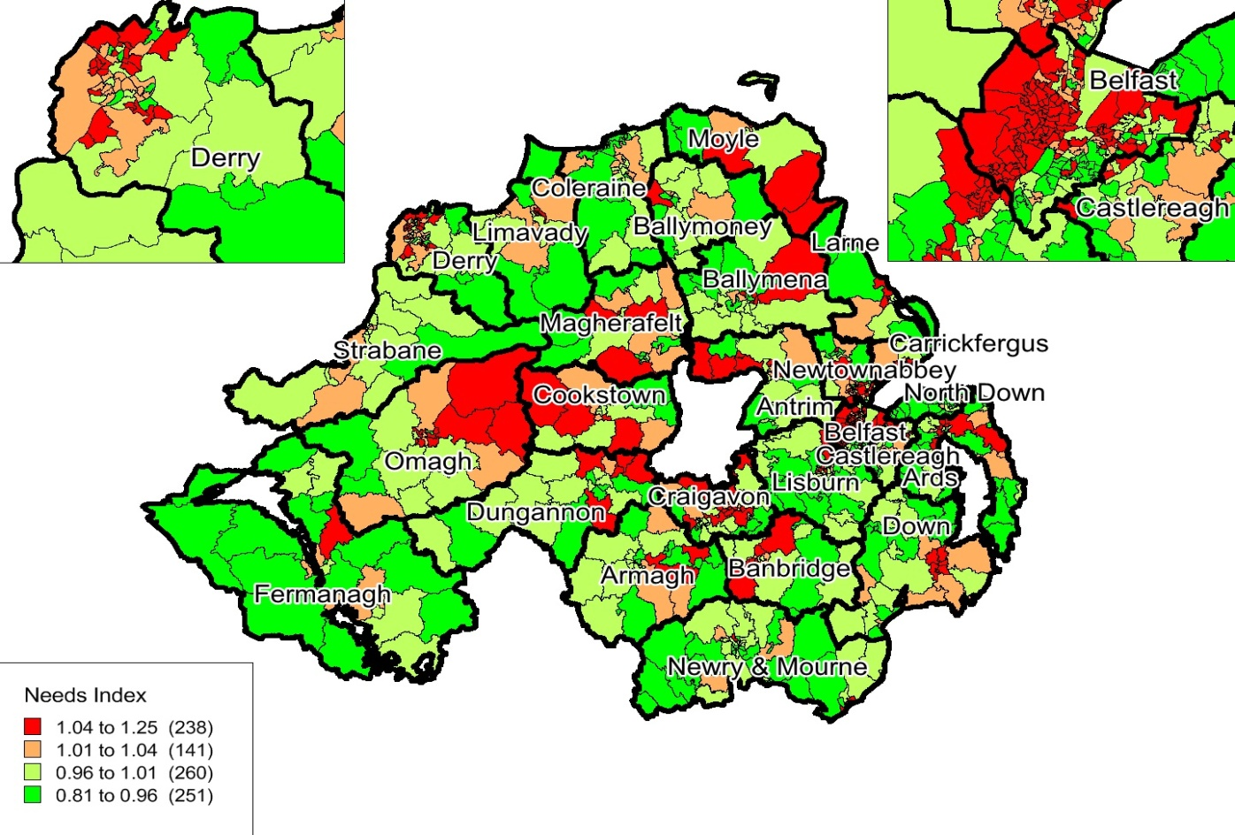
Figure 5.3 Total Needs Index of the New Formula by SOA
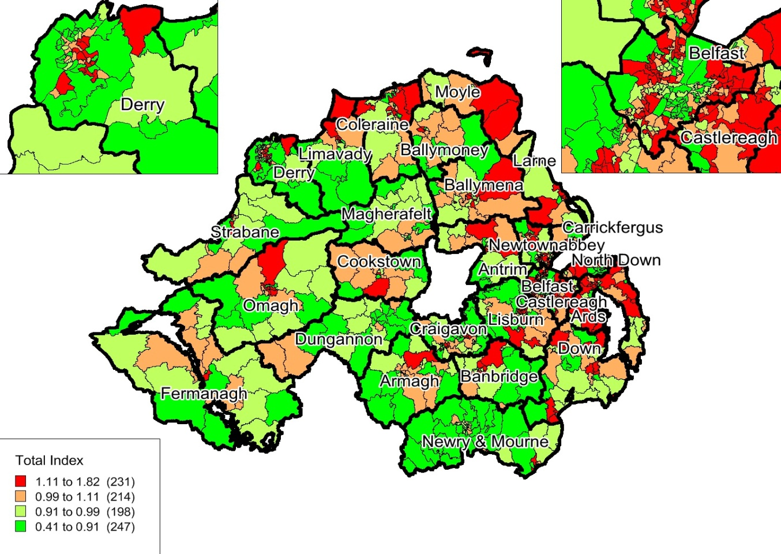

6. Equality Implications
6.1 Section 75 of the Northern Ireland Act 1998 requires public authorities, in carrying out their functions, to have due regard to the need to promote equality of opportunity between:
- Persons of different religious belief, political opinion, racial group, age, marital status or sexual orientation;
- Men and women generally;
- Persons with a disability and persons without; and
- Persons with dependants and persons without.
An additional objective is to have regard to the desirability of promoting good relations between persons of different religious belief, political opinion or racial group.
6.2 Analysis was undertaken to examine the potential impact of the proposed new formula on the above equality categories at a Northern Ireland level. It is important to note that the analysis assesses the effect on each equality category as a whole; it does not assess geographic distribution of people in each category or effects on pockets of certain groups in particular areas. In order to better detect any differential impacts, analysis was carried out at small area level. Data was obtained for 7 of the 9 equality groups at Super Output Area (SOA) level. However, data was not available on sexual orientation. Data on voting patterns was only available at constituency level and were therefore attributed to SOA level.
6.3 Using the formula weightings, separate indices were created for age-gender, additional need and total need and applied to each equality category to create a weighted population. Comparison of the weighted population with crude population allowed a ratio to be calculated for each equality category, based around NI being 1.0. An index greater than 1.0 indicated skewing of resources towards that equality group, likewise an index less than 1.0 suggests skewing of resources away from that category.
6.4 The analysis demonstrated that the new formula would not create any adverse impacts on any of the equality groups and that it would not significantly redirect resources away from the section 75 groups. Where there are differential impacts in favour of skewing resources, e.g. towards the elderly, this is expected in a weighted capitation formula which weights elderly age groups more heavily than younger groups. Where resources are skewed it can be concluded that this is always due to the underlying age structure of the equality group rather than due to any differential skewing. For example, those with a long-term illness tend to be older and so their underlying older age profile results in skewing; likewise Catholics tend to be younger and so resources will be skewed away from them as a group.

7. Re-distributional Impact of Moving from the Current Formula to the Updated Formula
7.1 The impact of the proposed new formula at LCG level is shown in Table 7.1; this compares the 100% capitation fair shares under the current formula with 100% fair shares under the proposed new formula. Overall, there is a redistributive effect of +/-1.01% at LCG level of moving from the previous to the new formula. The previous formula redistributed +/-2.17% of resources from a crude population to that weighted for age-gender and need; the updated formula would redistribute +/-1.80% based on the new weightings compared to a crude population.
Table 7.1 Comparison of 100% Fair Shares: Current versus Proposed Formula
LCG | 100% Shares  Current Formula | 100% Shares  Proposed Formula | Redistribution  +/- %
Belfast | 23.76% | 22.78% | -0.98%
Northern | 24.28% | 24.79% | +0.51%
South Eastern | 17.59% | 17.67% | +0.09%
Southern | 18.52% | 18.93% | +0.41%
Western | 15.86% | 15.82% | -0.04%
N Ireland | 100.00% | 100.00% | +/- 1.01%

7.2 Likewise at general practice level, the proposed new formula would be less redistributive than the current formula. Overall, the new formula would redistribute +/-4.34% compared to +/-4.81% under the current formula; this refers to moving from a crude population to that weighted for age-gender and additional need. The new age cost curve is less steep, that is, the weights are lower in the older age groups than in the current age weighting and therefore this element of the formula at both LCG and general practice level will be less redistributive. Likewise the new additional needs index comprises individual indicators which are more similar across LCGs (and general practices) than the variables that comprised the current additional needs model.
8. Conclusions & Recommendations
8.1 Extensive analytical work has been undertaken to develop updated components of the weighted capitation formula for allocating prescribing resources to LCGs and general practices. Of note is the updated age cost curve with the incorporation of an adjustment for care home patients. Therapeutic specific age weights have been developed which will allow much more accurate prescribing comparisons within therapeutic groups; this will be especially useful within COMPASS Reporting. A comprehensive modelling exercise has been undertaken to develop the updated additional needs index; this has used the most up-to-date cost, needs and supply data available at the time of modelling. Robustness of the formula has been tested at both LCG and general practice level. The formula has also been tested in terms of sensitivity to targeting deprivation. Each component of the formula has been tested against NI equality legislation and analysis demonstrated that the new formula would not create any adverse impacts on any of the equality categories.

8.2 All research and analysis has been subjected to external scrutiny by an independent peer reviewer; this collaborative process ensured that the theoretical rationale and statistical model building was as comprehensive and extensive as possible. All suggestions and recommendations made by the peer reviewer regarding statistical analysis, testing and presentation of results have been taken on board. The peer reviewer has endorsed all updated components.
Recommendations:
8.3 It is recommended that the weighted capitation formula should continue to be used to allocate prescribing resources to LCGs and should be used as an indicative tool in subsequently informing allocations to general practices. The following specific recommendations relate to development of the updated formula:
- A constrained registered population should be retained as the population base for setting LCG allocations. The recognised method of constraining has been implemented throughout this research; however, an alternative method of constraining has been presented. The consultation associated with this review should include discussion and debate regarding this alternative method.

- The GP practice registered list should be retained as the population base for setting GP practice allocations.

- The proposed new age cost curve NI-PU 2015 derived from 2013/14 dispensing data should be implemented. The NI-PU 2015 should also be introduced as the updated comparator prescribing measure in COMPASS reporting and any other comparative analysis.

- STAR-PU should be adopted as the prescribing measure when analysing a particular drug, BNF chapter, section or paragraph.

- The proposed new care home adjustment should be incorporated within the age weighting and implemented when setting both LCG and GP practice allocations.

- The preferred additional needs model based on a simplified 2-stage additive stepwise model specification (which has been through sensitivity testing and simplification) with sterilisation of supply variables should be implemented when setting both LCG and GP practice allocations.
8.4 The following recommendations relate to implementation of the updated formula:
- The limitations of any budgetary formula are likely to mean that there will be some variation from fair shares, even after variations in clinical practice have been accounted for. It is therefore advisable that any system for allocating to GP practices should be indicative and advisory and risk management strategies implemented to lessen some of the consequences. Top-slicing arrangements and capping mechanisms, as currently in place, are still very advisable.

- A major issue with implementation of any resource allocation formula is the pace of change in terms of moving towards 100% capitation and fair shares. The model explains x%; unless a position that 100-x is caused by GP behaviour can be defended, it is difficult to propose 100% allocation of resources using the formula. The current formula is implemented at 100%, albeit with mechanisms to try to retain budgetary control, but the Commissioner may want to re-consider this level of implementation in light of introducing a new formula. A reduced capitation level initially may allow more stability for GP practices and a phased return to 100% fair shares allow bedding-in of the new formula.
Targeted Consultation & Way Forward
8.5 This formula development work is being subjected to a targeted consultation exercise. The full report and summary are available on the DHSSPS website as an e-consultation accompanied by a consultation response questionnaire, contact details and instructions on ways to respond. Following consideration of the consultation responses, Ministerial approval will be sought on implementation of the updated formula for 2016/17.

Appendix A
Membership of the Indicative Prescribing Amounts (IPA) Management Group
Kathryn Turner (Chair) Pharmacy & Medicines Management, HSCB
Beverley Martin Pharmacy & Medicines Management, HSCB
Brendan Doherty Pharmacy & Medicines Management, HSCB
Emma Quinn Pharmacy & Medicines Management, HSCB
Debbie McGivern Pharmacy & Medicines Management, HSCB
Dr James Bissett General Practitioner, South Eastern LCG
Dr Joe Kuricose General Practitioner, Northern LCG
Paul Cavanagh Assistant Director of Commissioning, Western LCG
Dr Michael Steele Prescribing Lead & General Practitioner, South Eastern LCG
Dean Robertson Finance, HSCB
Penny Murray Statistician, Information & Analysis, DHSSPS
Jacqueline Sheridan Business Services Organisation

