**Department of Health (NI)**

**Review of Imaging Services**

**Workforce Issues Arising from the Review of Imaging Services**



**Final Draft**

**October 2017**

**Authors: C Donnelly, P Barbour**

**HE1/16/84817**

**Updated 25/10/2017**

**Table of Contents**

|  |  |  |
| --- | --- | --- |
|  |  | **Page No** |
| **1.** | **Context and Background** | *3 – 4* |
| **2.** | **Imaging Workforce in Northern Ireland** | *5 – 6* |
| **3.** | **Radiologist Workforce** | *7 - 11* |
| **4.** | **Radiographer Workforce** | *12 - 17* |
| **5.** | **Paediatric Radiology Workforce** | *18 – 19* |
| **6.** | **Interventional Radiology Workforce** | *20 – 21* |
| **7.** | **Cardiac Imaging Workforce** | *22 – 23* |
| **8.** | **Obstetric Imaging Workforce** | *24* |
| **9.** | **Medical Physics Workforce** | *25 - 27* |
| **10.** | **Education and Training** | *28* |
| **11.** | **Conclusion and Recommendations** | *29 - 30* |
| **12.** | **Appendices:**  **Appendix 1 Terms of Reference and membership**  **Appendix 2 Radiography Data Collection 2014** | *31 - 32*  *33 – 35* |

**1.0 Context and Background**

1.1 In March 2011, the Regulation and Quality Improvement Authority (RQIA) completed its Phase 1 report following their investigation into the handling and reporting of radiological requests in all Health and Social Care (HSC) Trusts in Northern Ireland (NI). Recommendation 1 of the Phase 1 Report outlined:

***“DHSSPS should develop a strategy for the future provision of imaging services in Northern Ireland which incorporates a new workforce plan for radiology”.***

1.2 In the second half of 2012, the Minister approved the establishment of a Review of Imaging Services with associated Terms of Reference (ToR). In June 2013, DHSSPS (now DoH (NI)) undertook a scoping exercise with colleagues across the HSC to determine how best the review might be progressed.

1.4 It was recognised that the imaging review needed to be strategically considered alongside the evolving policy, financial and strategic position in the HSC. The aim of the review is to develop recommendations for service development and configuration which will form the basis of a 10-year strategy for imaging services in NI.

1.5 The Review would consider the full spectrum of imaging services provided by Health and Social Care, including radiological imaging, ultrasound imaging and nuclear medicine and established a number of clinically-led Workstreams to take forward the substantive work in each of the core areas. They would be underpinned by Workstreams to consider over-arching themes such as Workforce, Information and Communications Technology (ICT) and Capital Equipment.

1.6 A Workforce Workstream was established in July 2014 and its Terms of Reference are attached in **Appendix 1**.

1.7 The Clinical Workstreams have now completed an analysis of their respective areas. This paper aims to consider the pervading workforce issues which have been highlighted by them, to inform development of a detailed workforce plan for imaging services in NI.

1.8 This paper also provides an overview of the imaging workforce at November 2014 based on a data collation exercise carried out at that time. It endeavours to provide high level observations and presents initial conclusions which may be reasonably drawn from the data in order to inform decisions on workforce needs and requirements over the next 10 years. It also considers the key factors influencing the future needs of the imaging workforce and gives an assessment of the current workforce supply along with contributing factors where it is under challenge or pressure and makes initial recommendations as to what action is needed to address these.

1.9 The data collection exercise on imaging staff was undertaken in November 2014. It gathered information on the radiologist and radiographer staffing position at that point in time. This information was held until the Clinical Workstreams finished their reports and service models developed.

1.10 Now that this work is complete, consideration has begun on the workforce information identified by the Workstreams. It should be noted that there will have been staff movement in all imaging areas, but it does present a baseline position from which it is reasonable to move forward.

1.11 Health and Wellbeing 2026 – Delivering Together listed the development of a Health and Social Care Workforce Strategy as part of the wider transformation programme for health and social care. The strategy, which is now at an advanced stage, provides the road map for the health and social care workforce over the next nine years. The workforce issues identified in the Review of Imaging Services including training, workforce planning and skill mix, will be fully considered in the implementation of the workforce strategy.

**2.0 Imaging Workforce in Northern Ireland**

2.1 The imaging workforce is both the most important and most valuable asset of the service. Within radiology departments, it includes Radiologists (who are medically qualified), Radiographers, Assistant Radiography Practitioners, Nurses and Radiology Support Staff. In different settings, it includes staff such as other medical specialists, medical physicists, clinical technologists, vascular technologists and clinical physiologists who provide specialist support and advice. General support is provided by porters and administrative staff.

2.2 The promotion and enhancement of skill mix opportunities within clinical teams in radiology services is key to ensuring imaging services are responsive to the needs of the service and to provide resilience for the future. In light of the significant challenges with recruitment of consultant medical staff, advanced practitioners have a key role to play to safely and appropriately undertake clinical work such as reporting and / investigations to allow consultant expertise to be directed to tasks which only they can do.

2.3 In the period 2010-2015, the NI population increased at a rate of 3% per annum. At the same time, diagnostic imaging activity increased by approximately 8-12% depending on modality. Therefore, the rate of increase in imaging activity exceeded the rate of the population increase, suggesting that other drivers also contribute to growth in demand for diagnostic services, including:

* An ageing population in which the incidence of cancer and chronic disease are increasing.
* The expansion of existing screening programmes, many of which rely on imaging.
* National strategies for stroke, heart disease and trauma that all rely heavily on imaging.
* New technologies such as hybrid-imaging, e.g. single-photon emission computed tomography (SPECT) and positron emission tomography-computed tomography (PETCT) require a workforce with the skills associated with radiography and nuclear medicine.

2.4 Although we cannot be certain if demand will continue to grow at its historic level, it is realistic to conclude that demand will outstrip the rate of increase of the population in the next five to ten years. **This is the activity context against which the future workforce supply should be assessed** and it will present predictable and major implications for the provision of imaging services in the future.

2.5 The needs of the imaging workforce must be considered holistically in order to ensure that services are provided in a way that enhances the skills and contributions of both the medical and non-medical teams. The papers produced by the clinically led Workstreams have outlined the various frameworks and structures within which imaging teams currently operate, which collectively inform an overarching assessment of the key issues, challenges and opportunities for the imaging workforce.

**3.0 Radiologist Workforce**

3.1 As in the rest of the United Kingdom (UK), there is a shortage of radiologists in NI. A number of vacancy stocktakes were undertaken during the period of the review and vacancy rates fluctuated as follows:

* August 2014, there were 21.70 whole time equivalent (wte) funded vacant posts.
* April 2015, there were 18.00 wte funded vacant posts vacancies.
* October 2015 there were 42.00 wte funded vacancies.

3.2 The most recent position at November 2016 is 37.53 wte funded vacant consultant radiologist posts in NI. This is outlined as follows:



3.2 Some of these vacancies, particularly in key modalities, have been advertised on multiple occasions without suitable applicants. Where a successful appointment has been made, it was not necessarily aligned to the Trusts with the greatest recruitment challenges, thus perpetuating and increasing regional variation. Further growth in demand for imaging and imminent retirements indicates that the gap will continue to grow in the next few years. This is already presenting challenges not just for the general radiology workload, but for sub-specialist areas such as breast radiology, and will continue to do so for the foreseeable future.

3.3 In June 2012, the Royal College of Radiologists (RCR) presented a paper outlining the case for an increase in the clinical radiology workforce in the UK in light of the role of imaging in modern healthcare and to illustrate how the clinical radiologist is a vital part of the majority of patient’s diagnostic pathways[1]. The paper refers to the UK as having a lower than average rate of the use of imaging, which is reflected in the low numbers of clinical radiologists per head of population compared with its European counterparts. The UK has approximately 4.8 consultants per 100,000 population which ranks in the bottom three compared with other European countries, and whilst the NI position is slightly higher, the collective UK rate is the European outlier. As indicated in Paper 1 of the Radiology Workstream, the NI imaging rate is lower than the UK average, indicating that there will be continued and sustained demand for services.

3.4 Until March 2015, there were 37 places on the radiologist training scheme; a number which had not increased for 10 years despite sustained increases in imaging demand and activity.

3.5 For the reasons detailed in the Clinical Workstream reports, it was accepted that an immediate increase in the number of trainee radiologists was required and this was the highest priority of the three early recommendations made by the Radiology Workstream in Paper 1. A key recommendation in the draft Strategic Framework has indicated the need for incremental increases up to a total of 54 radiology trainees. To date good progress has been made in growing the Radiology training programme. Two additional training places were added in 2015, a further three in 2016 and another 4 in 2017 intake, bringing the total places in the programme to 46.

3.6 In light of the issues highlighted in the Clinical Workstream reports, it is of fundamental importance that the imaging workforce optimises the skills of its consultant staff as well as the skill mix of radiography and other professional / technical staff. In addition to the increases required in training places to create the radiologists of the future, retention of consultants in post and recruitment from outside the region are important issues in the short term.

3.7 Addressing the challenges in imaging services is complex and no single measure will be sufficient to close the gap that exists. Therefore, in addition to increasing the training scheme, further initiatives are required to increase the complement of radiologists. Work has already commenced on the following:

* An international recruitment drive commenced in Autumn 2016 in an effort to attract and recruit radiologists to NI. There were two strands to this programme:
  + An exercise exclusively for radiology in Pakistan. Interviews for potential candidates were held in December 2016. Seventy seven applications were received, twenty two met the criteria for interview, ten were found suitable and conditional job offers made. Steps to finalise the recruitment process are underway.
  + A wider international recruitment programme in the Middle East, India and Europe for a range of medical specialties for varying grades of medical staff.
* Proactive encouragement of the recently retired radiologist workforce to continue to work on a sessional basis. HSC Human Resources Directors have advised they are content to take staff back who had retired once other avenues to fill vacancies had been exhausted. They also agreed it would be helpful if the partial retirement policy was brought in as soon as possible, as this would allow older consultants to work on rather than having to retire.
* Regional networks to utilise skills of the current workforce. A pilot for plain film reporting was undertaken in June 2016 which tested the model of consultants across the region working as a collaborative network, to report plain film examinations that would otherwise have been reported by the Independent Sector. The pilot requires regional approval to address HR/Financial issues raised regarding a payment per item approach prior to roll out.
* Optimisation of skill mix opportunities within the radiography workforce through implementation of the Four Tier career pathway structure, advanced training opportunities within NI, funding for backfill and career development opportunities.
* Optimisation of radiologists in training to report examinations when clinically appropriate and safe to do so.
* Optimisation of the reporting environment, including enhancement of home reporting arrangements.

3.8 The need for radiologists with specific special experience is a current challenge for imaging services, particularly in paediatric, breast and interventional radiology. There is a need for explicit guidance on the core competencies expected to be undertaken by consultant radiologists, in order to further and better understand and quantify gaps in the general and specialist workforce and to inform development of safe and effective pathways and models where lack of expertise is available. This may necessitate change in the current configuration or location of some existing services and there will be a need for strong, effective leadership to drive this important work. In addition, there will be a corresponding impact on other acute services and these must be collectively considered as part of service remodelling.

3.9 A fully trained radiologist combines the attributes of having a minimum of five years undergraduate medical training plus two years Foundation Training, in addition to the five years of in-depth specialist radiological training, ensuring that they are ideally prepared to provide expert analysis of imaging examinations. However, with the increase in demand for key modalities such as magnetic resonance imaging (MRI), computed tomography (CT) and non-obstetric ultrasound, and a lack of available radiologists, it is increasingly important to ensure that consultant expertise is directed to those clinical areas which only they can do.

3.10 Utilising the skills of all members of the imaging team is essential, and as such, accessing the skills of advanced practitioner radiographers to undertake functions such as performance of advanced techniques and selected reporting is being supported where it is clinically safe and appropriate to do so. However, developments in advanced practice, particularly radiographer reporting, should be cognisant of the ramifications on radiologist training, particularly in plain film and ultrasound.

3.11 Similarly, increases in imaging staffing and infrastructure have a direct impact on medical physics, non-radiology imaging, nursing, administrative and clerical staff. For these reasons, a holistic approach to workforce planning for diagnostic imaging must be undertaken, with consideration of all relevant components of this complex service to ensure it is effectively resourced.

**Conclusion/Recommendation**

3.12 Efforts to close the vacancy gaps must continue as part of a regional workforce planning programme. Particular attention is needed to address gaps in specialist and sub-modalities. This will require collaboration across a range of agencies and willingness to test and implement new ways of working that may challenge traditional practice.

3.13 Regional Human Resources and Finance processes are required to facilitate across Trust working. More flexibility in across Trust employment is needed to support consultant radiologists to work regionally, addressing gaps in reporting and specialist examinations which is output rather than time based.

**4.0 Radiographer Workforce**

4.1 The Society and College of Radiographers (SCoR) and the RCR believe that appropriately constructed skill mix initiatives will benefit patients and their care by ensuring scarce workforce resource is appropriately focussed.

4.2 In November 2014, a stocktake of the radiographer workforce was undertaken, which aimed to profile the demographic and skill base of the NI workforce to inform the Imaging Review. It provides a useful baseline position. Data in respect of radiographer staffing from the five Trusts’ was collated into a single database to create a baseline workforce profile. In relation to ultrasound, the data collation did not separate obstetric from non-obstetric ultrasound, so information is presented in its entirety. However, the landscape has changed and while it remains a useful baseline, the exercise is currently being refreshed to develop a more detailed position for radiography in NI.

4.3 The Clinical Workstreams provided useful overviews of radiography workforce related issues, challenges and opportunities. These demonstrated that skill mix and role development within imaging departments in NI has tended to be pragmatic, opportunistic and driven by local champions. This has resulted in enhanced provision of service, maximising skill mix and harnessing radiography skills, but at a local and not regional level.

4.4 Radiographer role extension at Trust level has developed without necessarily assuring the transferability at regional level of the extended roles and skills, or equality of opportunity. This readiness and willingness to embrace advanced practice roles within radiography has led to an inequity of opportunity for career progression within the profession, as evidenced by the variation across the five Trust areas.

4.5 This paper takes the opportunity to review the 2014 raw data underpinning these wider issues and considers opportunities for improvement. The key elements from the data collation are attached in Appendix 2.

4.6 In relation to radiographer staffing levels, the main observations were:

* Approximately 600 funded wte radiographers.
* Approximately 17 wte funded vacant posts.
* Almost 90% of the workforce are female, which presents direct implications for backfill / cover during periods of maternity leave etc. As training opportunities for career progression are limited within NI, uptake is further compromised.
* The significant majority of staff are on permanent contracts.
* Around 67% of staff were aged under 40 years;
  + 9% were aged 55yrs and over; and
  + 18% were aged 50 and over.
* This indicates imminent challenges with respect to succession planning over the next 5-10 years, particularly for those highly experienced specialist radiographers.

4.7 With respect to the banding for practising radiographers, the profile indicated that:

* 175 wte posts are Band 5 (29%).
* 240 wte posts are Band 6 (40%).
* 163 wte posts are Band 7 (27%).
* 20 wte posts are Band 8A (3%).
* 0 wte posts at Band 8B (0%).

4.8 There has been a recent development in respect of Band 8B Consultant Radiographers with an appointment in the Western HSC Trust within breast services. This is very much welcomed, but further sustained development is required to ensure that practicing radiographers have the potential to progress to this level across diagnostic imaging services.

4.9 Detailed analysis was provided in Paper 3 of the Adult Radiology Workstream on the potential for plain film reporting by advanced practitioners and what would be required in order to deliver against the Scottish Benchmark of 20-40% of plain films reported by radiographers.

4.10 In NI there are approximately 1.1 million plain film x-rays per annum. If the Scottish Benchmarks were applied, it would indicate that in the region of 220,000 to 440,000 films could be reported by advanced practice radiographers per annum.

4.11 NI is considerably behind the rest of the UK in the number of reporting radiographers, although progress has been made here over the last number of years and there are plans in place to further increase this. There have been a number of challenges to extending the skill base of reporting radiographers, including:

* Need for support and mentorship from radiologists, which has been difficult as they are also under significant pressure.
* Lack of local education and training course in NI. Staff must travel to England to complete the relevant study / courses. These courses are expensive and AHP training budgets are insufficient to accommodate the level of training required.
* Lack of backfill to support staff to train and practice due to operational requirements of general radiography.

4.12 There are approximately 18 wte staff trained to report plain films, although not all of these are in practice. This needs to be secured in the first instance. In addition, a further 24 wte posts would be required to achieve 40% of plain films reported by radiographers, bringing the total to 42 wte.

4.13 The provision of additional radiographer capacity will require commitment to support investment for training and backfill costs, as well as commitment from within Trusts to support and encourage this approach.

4.14 When prioritising extended practice roles within a particular area, cognisance needs to be given to the impact on other clinical areas. For example, an increased demand for reporting radiographers may result in a deficit in CT training numbers. To fully maximise the skill currently available within the radiography workforce across NI will require an increase in Band 5 radiographers to backfill the release of staff. This should be co-ordinated regionally and will require engagement with the regional recruitment process.

4.15 In addition to plain film, breast screening, fluoroscopy and ultrasound reporting, there is also scope for advanced practitioner radiographers to be developed in the areas of MRI, CT and Nuclear Medicine reporting. As the remit of the Imaging Review is to consider the needs of the NI Imaging Service in 10 years’ time, it is reasonable to consider the potential for use of advanced practice radiographers in these areas, as is currently the practice in the other UK regions.

4.16 Although plain film reporting will be the priority for role extension within NI for advance practice radiography, the impact of radiographer reporting within other modalities should not be underestimated. Radiographer reporting in CT, MRI and Nuclear Medicine will make significant gains in workforce flexibility and improve patient pathways throughout NI. We also need to recognise the current role of radiography reporting within modalities such as breast, ultrasound and fluoroscopy. We need to investigate how these reporting skills can be progressed in order to meet clinical demand.

4.17 The role of Assistant Practitioners within radiography departments cannot be underestimated. As part of their duties, they perform limited clinical imaging examinations under the supervision of registered radiographers. The range of examinations varies in accordance with locally identified service needs. Regionally, assistant practitioners are currently undertaking plain film examinations, including mammograms, and assist with meeting the demand created by increased theatre sessions. General education requirements are provided by the National Vocational Qualification (NVQ) Level 3 in Health. However, additional education related to the safe use of ionising radiation is required to enable Assistant Practitioners to perform identified imaging examinations to a high standard of radiography of the upper and lower limbs etc. This is provided in a college of further education / university and takes up to 18 months.

4.18 A sustainable and trained workforce is essential to deliver modern healthcare and the Four Tier career pathway structure is the ideal model for the profession. A 4th tier would see consultant radiographers in post and would provide a focus for regional development, training and oversight of up skilling radiographers for extended roles. There is a clear absence of research in radiography and a radiographer-driven service improvement and a focussed approach by a motivated consultant radiographer workforce would support this development. The 2014 workforce census identified approximately 86 consultant radiographer posts in the UK. None of these were for diagnostic imaging services in NI.

4.19 Sufficient numbers of diagnostic radiographers must be provided to deliver new services, including sufficient capacity to allow higher level training.

4.20 Strong clinical leadership is needed to enable diagnostic leaders to challenge the status quo and to response creatively and flexibly to the future diagnostic imaging agenda.

4.21 A flexible and responsive workforce is needed to drive up quality and improve productivity, with transferrable skills and competences. This will ensure that all skills are utilised effectively and efficiently across services for the benefit of the patient.

4.22 Skill mix developments, whether in reporting or specialist practice, need to be set within a coherent strategic vision for the clinical imaging service across NI. A clear understanding of the deployment, education and training of practitioners at all levels, together with the associated resource implications, is needed.

4.23 This requires a “whole system” review of evolving service needs and planning for succession as individuals move to new or other roles. Clearly, significant backfill is required to ensure that the skills of specialist staff can be optimised and address gaps in key modalities. This must be built around a team approach to service delivery and communication. Addressing the gap for radiography will enable service needs to be met more rapidly whilst additional radiology trainees are progressing. Given the rapid increase in demand for imaging, which is not expected to slow down or disappear, the service could fall further behind if the radiography workforce is not utilised effectively with assistant practitioner support, as rapidly as possible.

4.24 Agreements and local policies promoting skill mix developments must identify the legal and ethical framework within which practice will operate. Professional relationships, lines of accountability and transparent systems for delegation, transference and referral should be identified. Explicit, documented detail of extended roles and responsibilities will be required for each service.

**Conclusion/Recommendation**

4.25 HSC Trusts should put in place necessary arrangements to ensure that there is a clear understanding of the deployment, education and training of radiographers at all levels.

**5.0 Paediatric Radiology Workforce**

5.1 The table below shows the number of clinical radiologists with a sub-specialty interest in paediatrics across HSC Trusts. It is important to emphasise however that it is only staff in the Royal Belfast Hospital for Sick Children (RBHSC) who will work exclusively in paediatric radiology. Therefore, each of these 13 District General Hospital posts will spend a significant proportion of their time in adult practice.

|  |  |  |  |  |  |  |
| --- | --- | --- | --- | --- | --- | --- |
| **Radiologists with an interest in Paediatrics / HSC Trust** | | | | | |  |
|  | **BHSCT** | **SEHSCT** | **SHSCT** | **NHSCT** | **WHSCT** | **Total** |
| **Funded Staffing Level (FSL)** | **4.9** | **3.0** | **4.0** | **2.0** | **4.0** | **17.9** |
| **Staff in post (SIP)** | **3.9** | **3.0** | **4.0** | **1.0** | **4.0** | **15.9** |
| **Vacant** | **1** | **0** | **0** | **1.0** | **0** | **2.0** |

5.2 The key recommendation arising from the Paediatric Workstream was centred around the establishment of a hub and spoke model of care. The workforce implications associated with this and the wider provision of paediatric radiology services are as follows.

* Future “joint appointments” of consultant paediatric radiologists should be managed within the hub and spoke model.
* Any further commissioned paediatric posts and services must reflect the demands any new consultant will make upon imaging, from requesting examinations to clinical care in multidisciplinary teams.
* There should be recognition of staff training requirements and increased multidisciplinary teams within consultant job plans.
* There should be an immediate increase in the number of NI radiology trainees.
* Middle grade pre-fellowship radiology trainees should rotate through the RBHSC to increase exposure to and experience of paediatric radiology.
* Promotion of the extended role of the radiographer regarding reporting of paediatric extremity radiographs, (some) paediatric ultrasound exams and the performance of micturating cystourethrogram (MCUG) examinations.

**6.0 Interventional Radiology Workforce**

* 1. The workforce position as set out in the Interventional Radiology (IR) Paper section 1 demonstrates that in IR, as elsewhere, there remain longstanding difficulties in recruiting and retaining consultants. The paper discusses at length the challenges currently facing the workforce.
  2. The Workstream recognizes the potential to expand the role of radiographic and nursing staff in IR and the resultant impact on patient care. This supports a regional hub and spoke IR service being developed in NI with central units integrating with peripheral lists.
  3. The key workforce elements pertaining to IR are as follows:
* A regional workforce plan should be developed for IR services, which matches consultant post expansion to recruitment of additional radiographer, nursing and clerical staff to manage the services.
* The workforce plan should ensure that the standards set out in the joint RCR/Royal College of Nursing (Guidelines for Nursing Care in IR, 2nd edition 2014) are implemented in NI, including potential models for extended practice.

6.4 Cognisance should be given to development of an extended role for registered nurses and healthcare support workers within an IR setting. Any role extension should only be done following stabilisation of the current IR workforce.

6.5 Training must be encouraged, supported and formalised. The potential for industry support should be considered.

6.6 IR nurses who provide anaesthetic nurse support to anaesthetics should be suitably trained practitioners who have completed a post registration course in anaesthetic nursing, as recommended by the Royal College of Anaesthetists (RCA).

6.7 IR nurses who administer pre-prescribed conscious sedation and analgesics to patients should have a sound knowledge in life support and resuscitation training. All nurses carrying out this activity should ideally be Immediate Life Support (ILS) trained or Advanced Life Support (ALS) trained. These courses are accessible through the HSC Clinical Education Centre.

6.8 The Imaging Review recommends that the IR service on the Royal Victoria Hospital and Belfast City Hospital sites may benefit from the placement of nursing students from the universities, which could increase recognition of this area as a specialism and potential place of employment.

6.9 A clear, senior, professional lead for IR nursing must be identified and available to these nursing staff.

**7.0 Cardiac Imaging Workforce**

* 1. The Cardiology Workstream paper examines the current situation in NI of cardiac imaging, explores the capacity and demands on the system and scopes out possible future trends in imaging, technology and usage.
  2. The British Cardiac Society workforce annual report indicates that there were 41 consultant cardiologists (39.2 wte) in NI at end of 2013. Consultant expertise in cardiac imaging generally in NI has generally come from this cardiology pool but in fact several subspecialties may be trained in cardiovascular imaging, as detailed below.

|  |  |
| --- | --- |
| Echocardiography | Cardiology |
| Nuclear cardiology | Cardiology  Nuclear medicine  Nuclear medicine radiology |
| Cardiac CT: | Cardiology  Radiology |
| Cardiac MRI: | Cardiology  Radiology |

* 1. Demand capacity analysis to be used to inform the numbers of specialty trainees required and funding secured for additional trainee posts.
  2. Cardiology medical staff training should encourage trainees to gain experience of functional imaging techniques.
  3. Serious shortages are predicted nationally in Cardiac Physiology staff, with particular impact expected in echocardiography. DoH (NI) provided additional investment in supporting core placements for 20 Cardiac Physiology undergraduate students per year to preserve the continued operation of the local pre-registration programme provided by Ulster University.
  4. Funding and service delivery pressures exacerbate the lack of training opportunities to develop the postgraduate workforce into the senior echo-cardiographers of the future. Urgent discussion with all stakeholders is needed, and recommendations of the NHS England review in this area should be considered for applicability to NI.

**8.0 Obstetric Imaging Workforce**

* 1. The Obstetric Imaging Workstream has recommended that a service model for obstetric imaging should be developed to inform the overall workforce plan for Imaging Services. The plan should consider the following:
* Specialist training within ‘core – groups’ e.g. dating scans / third trimester growth/assessment scans.
* Regional approach to the standard of practice, training and support of staff.
* Regional uniformity in the quality and provision of obstetric imaging services.
* Regional referral pathways for foetal medicine, foetal cardiac and paediatric renal services.
* Agreeing competencies required for doctors and midwives performing obstetric ultrasound.
* Updating of technology.
  1. **Medical Physics Workforce**
  2. As outlined in the Medical Physics Workstream paper, the Regional Medical Physics Service (RMPS) provides scientific and technical support services to medical imaging across the HSC Trusts. These services include specialist advisory roles, scientific and technical services, patient scanning in Nuclear Medicine and management of the Cyclotron and Regional Radiopharmacy facility.
  3. Medical Physics services play an important role in assisting imaging services meet legislative requirements, practice standards and guidelines, and help assure the quality and safety of imaging equipment and procedures. The extent and resource required to deliver these services is heavily dependent upon a number of factors including the size and complexity of the installed user equipment base, the complexity of diagnostic procedures delivered using the associated equipment and the encompassing legislative requirements.
  4. Medical Physics staff fall into two main professional categories namely, Clinical Scientists and Clinical Technologists. Clinical Scientists undertake specialist advisory roles and provide scientific support. Clinical Technologists provide routine and as required, more complex technical services.
  5. Baseline staffing figures as of January 2015 indicated that there were approximately 18 wte Clinical Scientist posts (including 2 vacancies) and approximately 18 wte Clinical Technologist posts (including 1 vacancy) and 2 wte Nursing supporting imaging.
  6. RMPS developed a Workforce Plan for the period 2011-2016 the objectives of which were:
     + to ensure the continuity and future delivery of Medical Physics services to HSC bodies;
     + to ensure a suitably trained and qualified workforce is enabled to exploit and respond to changes in medical technology for the benefit of the population of NI; and
     + to ensure the optimum number and skill mix of staff to meet the challenges and deliver medical physics services.
  7. This Workforce Plan identified an increasing gap between the staff resource available to RMPS and that required to provide and develop the service to meet the increasing demand for imaging services. The increased demand had arisen mainly from the significant increases in the medical imaging equipment base and the increasing technical complexity of the equipment and procedures carried out.
  8. In 2016 the RMPS workforce plan was updated to cover the period 2016-2019. This foresaw that additional workforce would be required over that period in response to projected developments and gaps in existing services. These developments include:
     + The increasing expansion in the number and complexity of the imaging equipment base including closing the existing gaps in service provision.
     + A revision and updating of the legislation applicable to the use of ionising radiation based on a revised European Directive which is due to be implemented into UK law by February 2018. Among other things the new directive puts a greater emphasis on the role of the Medical Physics Expert (MPE). Application of European Commission guidance, designed to support the implementation of the Directive, on MPE staffing levels indicates that there is a significant local shortfall in the relevant Medical Physics specialities.
     + The need to put in place a regional scientific support and quality assurance service for the ultrasound imaging devices in clinical use in NI.
     + Positron emission tomography (PET) / Radioisotope developments such as the proposal for a second PETCT scanner to meet the: (1) Increasing demand for oncology related scanning; and (2) expansion of PETCT scanning into other specialities (e.g. Cardiology) in line with published national guidance. Capital funding for a 2nd PETCT scanner has been made available via a charitable donation and the Belfast HSC Trust is currently completing a revenue business case for submission to the Health and Social Care Board for consideration.
  9. The estimated additional workforce requirements to meet these developments is 8.5 wte Clinical Scientists and 12.5 wte Clinical Technologists and 1 Specialist Nurse.
  10. Although the existing RMPS Workforce Plan only projects developments up to 2019 it is expected that the demand for Medical Physics services will continue to grow beyond this at least in line with the increasing demand for imaging services and the changes in imaging technology.
  11. In order to maintain and develop the service to meet the needs of Imaging Services it is essential that workforce planning recommendations for Medical Physics staffing are implemented and an approach to commissioning its services is developed which is responsive to changes in demand.
  12. Due to the well-recognised shortage of individuals with the required expertise in this specialist area, the staffing and filling of posts in Medical Physics has traditionally been difficult. The Modernising Scientific Careers (MSC) initiative describes training and career pathways for healthcare science staff (including both Clinical Scientists and Technologists). Included in this are higher training and career development pathways (e.g. Higher Specialist Scientist Training, Accredited Expert Scientific Practice). To ensure future sustainability of Medical Physics services it is essential that a regional approach to the commissioning of Medical Physics trainees (scientists and practitioners/technologists) is put in place

**10. Education and Training**

10.1 In order to meet clinical service need and ensure that clinical practice is safe and evidence based, the radiography profession sets annual priorities for regionally agreed post-graduate training requirements.

10.2 At present radiographers can only access post-graduate training outside NI. To sustain a cost effective model of post-graduate training and ongoing refresher training, efforts to explore NI based training are needed. Training outside NI is expensive (due partly to the travel and accommodation costs) and prohibits access to training for staff unable to travel due to other commitments.

10.3 According to the SCoR, if recruitment into academia does not improve, continued training of diagnostic radiographers could be at risk. Therefore, it is important to ensure that the necessary numbers of academic staff are available in the future.

10.4 Whilst Education and Training has been identified as a workforce issue during this process, the issues mentioned above will require further investigation and consideration of what processes are best for our workforce in order to meet the future needs of staff. This will involve exploring the possibility of providing the specialist post graduate training locally within NI as an alternative. However, without sufficient robust information no recommendation can be offered at this stage.

**11. Conclusions and Recommendations**

11.1 The review has identified significant workforce deficits in the imaging-focused elements of the medical, nursing and allied health professions workforce, which will need to be addressed if we are to improve the quality of services and outcomes for patients. DoH (NI) has already taken steps to address these gaps. Between 2015 and 2017, DoH (NI) expanded the annual number of medical radiology trainees from 37 to 46. As there is a 5-7 year training period, these posts will not come into the system in the short – medium term. It has been crucial to begin to increase the number of training places, but a sustained programme of further increases is required to ensure that sufficient numbers of radiologist posts can be developed to meet demand.

11.2 A full robust workforce plan needs to be developed to address the deficits across the entire imaging workforce as highlighted in the three key recommendations below. This work need to be carried out in a timely manner.

**Recommendations**

**Recommendation 1:** A full robust workforce plan to be developed on a ‘Programme of Care’ approach to encompass the various professions and skill mix in order to address the three key workforce recommendations that have emerged.

**Recommendation 2: Radiology -** It is recommended that the HSC takes urgent action to address vacant positions in the radiology workforce to include:

**2 (a)** further increases in the total number of regional training places to 54 by 2020;

**2 (b)** international recruitment campaigns aimed at filling at least 15 clinical radiology posts over the next four years; and

**2 (c)** HSC to develop local and regional workforce retention strategies to promote and facilitate recently retired radiologists continuing to work on a reduced basis following their retirement.

**Recommendation 3: Radiographer -** HSC Trusts to put in place necessary arrangements to ensure that there is a clear understanding of the deployment, education and training of radiographers at all levels to include:

**3 (a)** A structured career progression pathway for radiographers across HSC, supported by specialist training in specific areas and at all levels to promote and optimise skill mix opportunities within imaging teams; and

**3 (b)** Building on the progress made with fluoroscopy and ultrasound reporting, the HSC plan should include working towards ensuring that between 20 – 40% of plain film examinations are reported by radiographers by 2020.

**Recommendation 4: Physiologists/Medical Physics -** To put in place the necessary training and workforce planning mechanisms to ensure that sufficient numbers of cardiac physiologists and medical physics staff are available to meet the needs of service with respect to functional imaging techniques and medical physics support for imaging services including ultrasound.

**12. Appendices**

**Appendix 1**

**Finalised Nov 2014**

**DH1/14/1146**

**Review of Imaging Services Workforce Planning Workstream**

**Terms of Reference**

* To make recommendations regarding the workforce needs of future service models having regard to:
* extant professional, clinical and Departmental guidance;
* clinical roles and limits of professional competence;
* building effective working relationships between imaging services and the wider clinical community;
* ensuring region wide service resilience with appropriate escalation arrangements.
* To make workforce projections ensuring that the data is quantitative as well as qualitative and there is an evidence base to support recommendations.
* To make recommendations regarding the most efficient and effective use of available resources (including maximising opportunities for skills-mix).
* The list of professions/grades within the scope of this Workstream are:
  + Radiography staff and radiography assistant staff;
  + Radiology consultant, non-consultant and trainee medical staff; and
  + Medical physics staff

**Review of Imaging Services Workforce Planning Workstream: Membership**

Peter Barbour (Chair) Department of Health (NI)

Hazel Winning Department of Health (NI)

Catherine Donnelly Department of Health (NI)

Alison Dunwoody Department of Health (NI)

Clare McMurray Department of Health (NI)

Eddie O’Neill Health and Social Care Board

Maria Wright Health and Social Care Board

Gillian Rankin Public Health Agency

Muhammad Sartaj Public Health Agency

Jenny Keane Public Health Agency

Canice McGivern Medical Physics Agency

Adam Workman Medical Physics Agency

Anton Collins Belfast HSC Trust

**Appendix 2**

**Radiography Data Collection 2014**

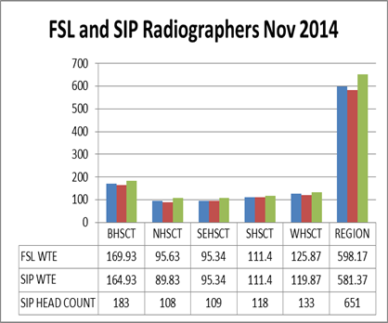 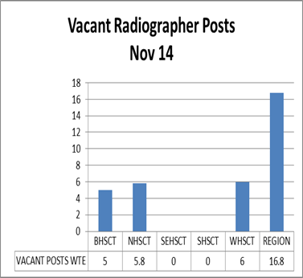

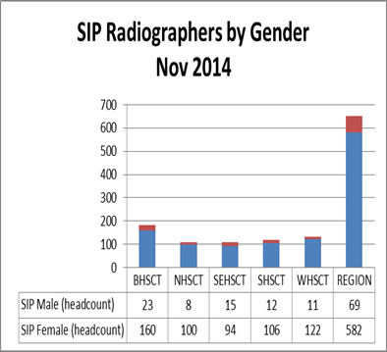 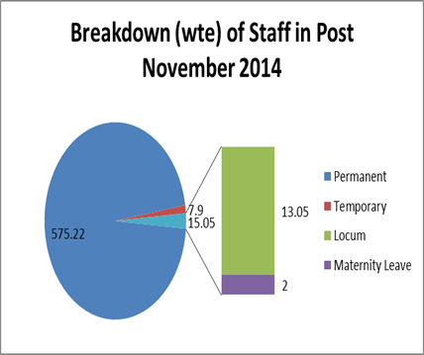

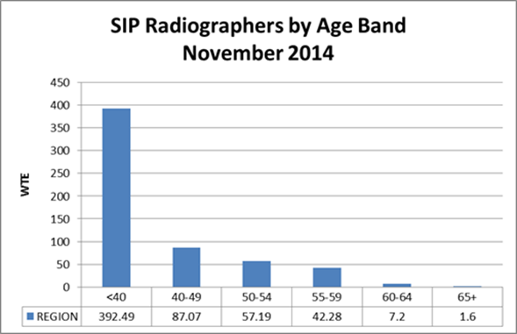

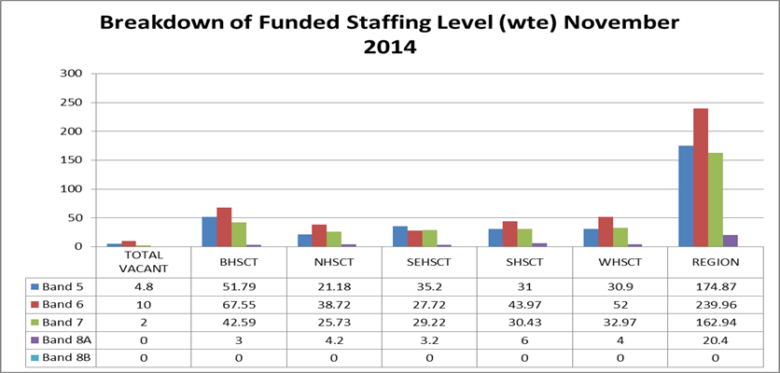

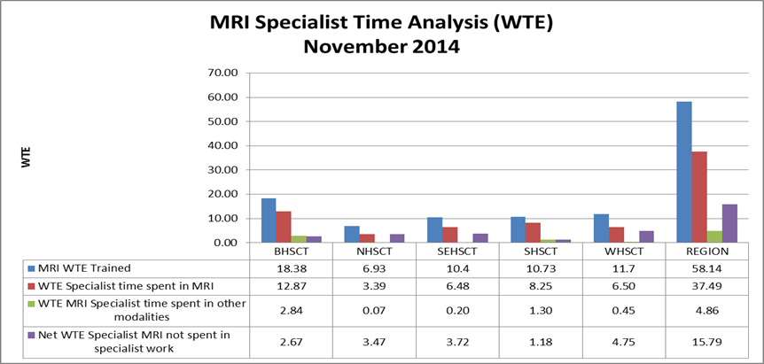

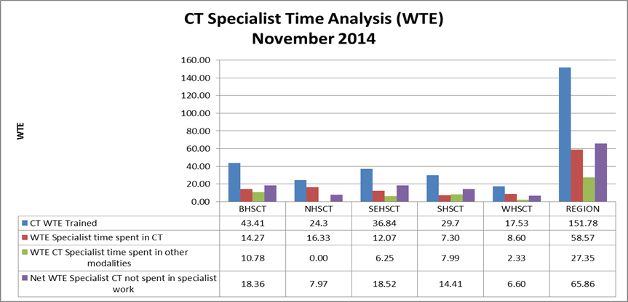

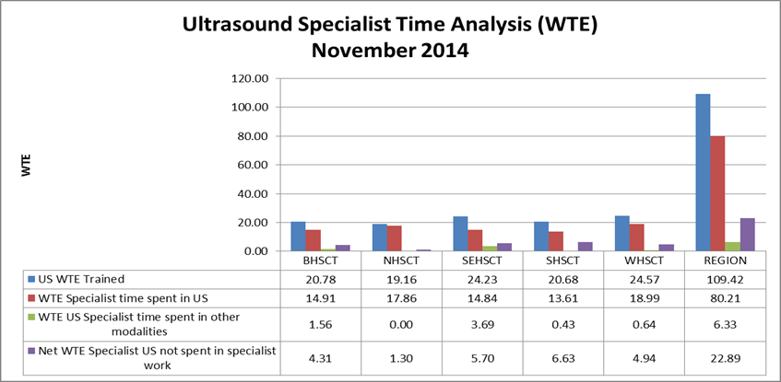

1. “Investing in the Clinical Radiology Workforce – The Quality and Efficiency Case” RCR June 2012