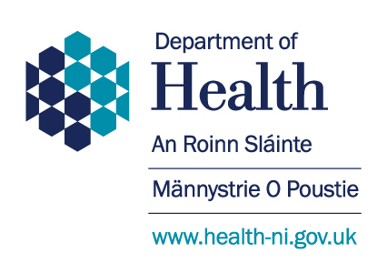

The Rural Needs Act (NI) 2016

Rural Needs Impact Assessment Template
(April 2018)

SECTION 1 - Defining the activity subject to Section 1(1) of the Rural Needs Act (NI) 2016

1A. Name of Public Authority - Department of Health

1B. Please provide the official title/ description of the Strategy, Policy, Plan or Public Service document or initiative:

TITLE: Reshaping Breast Assessment Services - Proposals for the Future Model of Breast Assessment Services for the Population of Northern Ireland

Currently in Northern Ireland, symptomatic breast assessment services (breast symptoms which may or may not be suggestive of cancer) are provided by all five Health and Social Care Trusts. Screening breast assessment services, for women with a positive screening test, are provided by four Trusts; Belfast Trust provides the screening service for women resident in both the Belfast and South Eastern Trust areas.

The national standards relating to waiting times to be seen at breast assessment clinics state that:
- Patients referred with signs or symptoms of suspected breast cancer (red flag referrals) should be seen within 14 days;
- Patients referred with signs or symptoms not suggestive of cancer (routine referrals) should be seen within 9 weeks; and
- Women who require follow up of a screening mammography (screening referrals) should be seen within 3 weeks.

Over recent years, there have been a number of growing pressures and challenges facing breast assessment services across Northern Ireland, which can compromise the ability to provide timely care, consistent with the above standards.

The consultation document reflects the work and recommendations of the Breast Assessment Project Board (“the Project Board”) which was established by the Health and Social Care Board (HSCB) and Public Health Agency (PHA) in 2017 to consider future service model options in light of ongoing capacity constraints and projected increases in demand.

The consultation document includes four recommendations for service reconfiguration; these are:

Recommendation 1: A regional Breast Assessment Network will be established by December 2019 to oversee implementation and ongoing delivery of the future model of Breast Assessment Services, to include all Trusts, commissioners and services working together to shape and support service provision for the population of Northern Ireland.

Recommendation 2: Breast assessment Services for the population of Northern Ireland will be provided in no more than three locations by December 2020.

Recommendation 3: The three breast assessment locations will comprise:

- Altnagelvin Area Hospital;
- Antrim Area Hospital; and
- Greater Belfast (likely to be the Ulster Hospital subject to the development of appropriate patient pathways).
Recommendation 4: Patient referrals to Breast Assessment Services in Northern Ireland will be managed through a central booking system by March 2020.

1C. Please indicate which category the activity specified in Section 1B above relates to -

Developing a: | Strategy |  | Policy |  | Plan
Adopting a: | Strategy |  | Policy |  | Plan
Implementing a: | Strategy |  | Policy |  | Plan
Revising a: | Strategy |  | Policy |  | Plan
Designing a Public Service |  | X
Delivering a Public Service

1D. Please provide the aims and/or objectives of the Strategy, Policy, Plan or Public Service:

Aim:

There is a Ministerial target that all patients referred with signs or symptoms of suspected breast cancer (red flag referrals) should be seen within 14 days.

Pressures on waiting lists for red flag referrals have continued to mount, with unacceptable impacts on the length of time patients have had to wait for their assessment. In one month in 2016, performance in one Trust area fell to 7% of red flag referrals seen within 14 days.

the aim of this plan is to secure a breast assessment service model which will provide a high quality, safe, sustainable, accessible and timely service.

1E. Which definition of ‘rural’ is the Public Authority using in respect of the Policy, Strategy, Plan or Public Service?:

Population Settlements of less than 5,000 (Default definition)
X
Other Definition (Provide details and the rationale below)
The default definition cited above (Population Settlements of less than 5,000) is not useful in differentiating impacts in respect of this policy. People living in both large and small settlements would be similarly impacted by changes in the location of breast assessment services.

The following alternative definition, as suggested by DAERA, is proposed:

“Populations outside of a 30 minute drive time of Derry/Londonderry or Belfast”.

This definition is better able to distinguish between those who will be most impacted by additional travel times caused by proposed changes to services. It should be noted that the service under consideration is not provided within rural communities but provided inside a hospital environment. The benefits of enhancing these services would be experienced by both urban and rural dwellers.

A definition of ‘rural’ is not applicable

SECTION 2 – Understanding the impact of the Policy, Strategy, Plan or Public Service

Yes | X | No
2A. Is the Policy, Strategy Plan or Public Service likely to impact on people in rural areas?

Please explain:

Any revision to the current configuration of breast assessment services will impact all service users, irrespective of their geographical location.

The following issues have been identified:

Negative Impacts

Travel Time: The reconfiguration of breast assessment services from five to three locations may result in increased travel times for people in order to access more timely assessment.

As breast assessment services are predominantly used by women and it is women who are more likely to have caring responsibilities, extended travel times may be problematic.

Older service users may rely more on public transport and access to suitable transport and changes in travel time could impact older people living in rural locations.

In view of the proposed future service locations, changes in travel time could also have more of an impact on service users in the Southern Trust area, which in 2011 had the second largest population of all five Trusts, and had a younger population profile than other areas of NI but is projected to see the greatest increase in the proportion of residents aged over 65.

Staff may also impacted by a change in their location of work.

Financial Impact: Service users may face additional costs as a result of increased travel times to the assessment clinics.

Staff may also incur additional costs as a result of travel or car parking charges.

Follow Up Treatment: Patients who are diagnosed with breast cancer may require further specialist treatment which could include surgery, chemotherapy or radiotherapy. Currently there are no proposals to change the location of where breast surgery and oncology services are delivered and these will continue to be provided in all present locations.

In practice this could mean that if a service user travels to a breast assessment clinic outside their Trust area of residence and they are diagnosed with breast cancer, their breast treatment may be delivered at a unit closer to their home in their Trust area. Whilst this would reduce the impact of changes in travelling times during the treatment phase, this could potentially impact on continuity of care.

Positive Impact
It is hoped that as well as promoting timeliness of access for service users, the proposed future model of breast assessment services should support service sustainability and team resilience and therefore potentially have a positive impact on staff.

If the response is NO after entering explanation GO TO Section 3

2B. If the Policy, Strategy, Plan or Public Service is likely to impact on people in rural areas differently from people in urban areas, please explain how it will impact people in rural areas differently:
The key impact that differentially affects rural dwellers is likely to relate to travel times for individuals needing to attend a breast assessment clinics.

A greater number of sites providing breast assessment services would result in a lower number of people experiencing longer journey times. This must however be balanced against the risk of delayed diagnosis if services are not sustainable and also the risk of a postcode lottery whereby patients in areas where services are vulnerable wait longer for assessment than patients in areas where services are more sustainable.

2C. Please indicate the rural policy areas the Policy, Strategy, Plan or Public Service is likely to impact on (see list at note 1):

The key policy area affected is Health and Social Care Services for those in rural areas, namely access to breast assessment clinics.

SECTION 3 – Identifying the Social and Economic Needs of Persons in Rural Areas

3A. Has the Public Authority taken steps to identify the social and economic needs of people in rural areas that are relevant to the Policy, Strategy, Plan or Public Service?
X
Yes
No Please explain:

The HSC completed extensive service user and public engagement in 2017 which included:

- Service user questionnaires distributed to a sample of 100 service users who had attended breast assessment clinics in March/April;
- Project Board members from the Health and social Care Board met with community and voluntary sector meetings in July;
- Focus groups in August with patients who had a confirmed diagnosis of cancer; and
- A series of public meetings facilitated by Local Commissioning Groups (LCGs) in July and August.

If the response is NO please explain above and GO TO Section 4

3B. Please indicate which methods or information sources were used to identify the social and economic needs of people in rural areas (see note 2 for examples) and provide details including relevant dates, names of organisations, titles of publications, website references, details of surveys or consultations undertaken etc.:
Note 2
Examples of methods or information sources used (relates to question 3B):

- Consultation with Rural Stakeholders |  | - Published Statistics
- Consultation with Other Organisations |  | - Research Papers
- Surveys or Questionnaires |  | - Other Publications
- Other Methods or Information Sources (include details)

1. Public Meetings

In August 2017, a number of the LCG public meetings were held in locations more than 30 minutes from Londonderry or Belfast including Ballynahinch, Omagh and Armagh (Annex 1 contains details of the location and date of the public meetings) .

2. Published Papers:

  - Health inequalities report published by DoH
  - DAERA statistics paper of rural needs (see Annex 1 and Annex 2).
  - Extracted Information from NINIS.

- Research:

Analysis conducted by the HSCB using a geographical information system software package (MapInfo Pro) to examine travel time for various configurations for a future service model.

3C. Please provide details of the social and economic needs of people in rural areas which have been identified:

Using the prescribed definitions of ‘Social and Economic need’ listed within guidance provided; two areas are identified in relation to ‘Health and Social Care needs’ and ‘economic needs.’

“A need can be considered as something that is essential to achieve a standard of living comparable to the population in general.”

Although the recommendations, may to an extent negatively impact on certain groups, the proposed future model of breast assessment services will apply equally to both rural and urban communities.

Health and Social Care needs

- The primary Health and Social Care ‘need’ of rural dwellers is identified as availability of timely access and the provision of high quality care.

- We considered an economic ‘need’ may relate to the additional cost of travel to attend a breast assessment service clinic in another Trust. This would include the possibility of additional travel costs to a breast assessment service clinic for follow up appointments.

- There may be a potential economic impact on staff who live in rural areas. Staff impacted may work in locations that currently provide breast assessment services but may not in the future. A change in work location could result in longer travel times, expenses incurred as a result of travel or car parking charges, and family life routines. These situations would be carefully addressed locally by employers with actions to take consideration of any work related travel costs and consideration of redeployment options. The impact on staff is however likely to be relatively modest, with two of the sites that will cease providing breast assessment being located in the Greater Belfast area.

SECTION 4 – Considering the Social and Economic Needs of Persons in Rural Areas

4A. Please provide details of the issues considered in relation to the social and economic needs of people in rural areas identified by the Public Authority:

Consideration of the impacts and needs requires us to appropriately balance issues of population travel times, provision of high quality timely care, accessibility and the sustainability of services.

The Patient Focus Groups generated feedback on travel distance and time to assessment clinics; this varied with each Trust location as noted in the table below.

Venue | Patient Travel Distance | Patient Travel time
Omagh | 3-37 miles | 5-75 minutes
Craigavon | 2-20 miles | 3-25 minutes
Antrim | 0 | 0
Londonderry | 3-15 miles | 3-40 minutes
Belfast | 3-20 miles | 15-60 minutes
Newtownards | 5-12 miles | 10-20 minutes

The furthest travel distance and time was in the Western Trust. All patients travelled by car to their assessment clinic.

Patients were asked how far they would be willing to travel if it meant that they would be seen more quickly; the summary is shown in the table below.

Venue | Patient Travel Time/Distance
Omagh | Any number of miles or time to travel
Craigavon | 1 hour maximum (irrespective of number of miles)
Londonderry | Any number of miles, however, would prefer < 1 hour travel time
Belfast | Any number of miles or time to travel
Ards | 1 hour maximum journey time (irrespective of distance)

There was a variation in the maximum travel time patients would be willing to agree to if travelling further for future Breast Assessment services. The speed of access to assessment for half of all of the patients attending focus groups was more important than journey time. The patients felt that they would travel to any location to have rapid assessment.

The remaining half of the focus groups attendees felt that there needed to be an upper limit of travel time. This was due to the length of time spent in the appointment, with a long drive on either side, adding to the stress.

There were also concerns raised for those who would not have a carer/partner to drive them to and from their appointment.

There were a number of caveats mentioned by patients for travelling a further distance. These included:
- Car parking adjacent to Breast Assessment clinic and dedicated for use by those attending the clinic
- Good road infrastructure
- Accessible public transport links (if 1 hour maximum travel time, then public transport should be accessible within this timeframe)
- Access to food and drink
- Continuity of care provided by breast care nurse, irrespective of where assessment clinic is and where treatment will be provided.
Patients mentioned that they would be happier to travel a further distance than their local hospital, if the roads were accessible and good. The dedicated car parking for those receiving radiation at the Belfast City Hospital and the excellent rail link there, were both mentioned as vital for patient experience and could be modelled for all Breast Assessment services.

On reviewing the travel time information, the Project Board recognised that any consolidation of breast assessment services would inevitably result in some people having a longer travel time to reach clinics.

Detailed travel time analysis showed that:

- No provision in the Greater Belfast area would result in more patients travelling beyond 30 minutes; with a Belfast location, 5 out of 10 patients would be within 30 minutes of travel time in comparison to 4 out of 10 patients if there was no Belfast location; and

- Potential options that excluded the West (Altnagelvin) resulted in more patients travelling up to 90 minutes and beyond; with an Altnagelvin location, 9 out of 10 patients would be within 90 minutes of travel time in comparison to 8 out of 10 patients if there was no Altnagelvin location.

Rural Isolation

There is also an established role for the community and voluntary sector in providing support for service users who may, subsequent to attendance at a clinic, receive a diagnosis of breast cancer.

SECTION 5 – Influencing the Policy, Strategy, Plan or Public Service

5A. Has the development, adoption, implementation or revision of the Policy, Strategy or Plan, or the design or delivery of the Public Service, been influenced by the rural needs identified?
X
Yes
No Please explain:

Recommendations to reshape the breast assessment services across Northern Ireland will apply to all individuals needing to attend a breast assessment clinic, irrespective of their geographical location whether that be in an urban or rural setting.

During the development of the recommendations, the focus has been to ensure better outcomes for both rural and urban dwellers.

As travel time was a specific issue raised by stakeholders including those participating in the Patient focus Groups, the Project Board gave due consideration to this matter in relation to the different configurations for a future service model. The Project Board was of the view that a modest increase in travel times was acceptable if it meant more timely access to care. This view was also echoed by patients as noted above.

It was also recognised that given the geography of the West and associated travel times, it would be reasonable to provide a location for a breast assessment service in the Western Trust area. The Project Board also agreed that there should be a breast assessment location in the Greater Belfast area.

SECTION 6 – Documenting and Recording

6A. I confirm that details of the Rural Needs Impact Assessment will be recorded on the Public Authority’s Annual Monitoring Return and the RNIA Template retained by the Public Authority (please check box) |  | X

Rural Needs Impact Assessment undertaken by: | Julie Houston
Position / Grade: | Deputy Principal
Division/Branch: | HSRD
Signature: | Julie Houston
Date: | 22/03/19
Rural Needs Impact Assessment approved by: | Alastair Campbell
Position / Grade: | Grade 5
Division / Branch: | HSRD
Signature: | Alastair Campbell
Date: | 25/03/19

Note 1
Rural Policy Areas (relates to question 2C):
- Rural Businesses  - Rural Tourism  - Rural Housing  - Jobs or Employment in Rural Areas  - Education or Training in Rural Areas  - Broadband or Mobile Communications in Rural Areas | - Transport Services or Infrastructure in Rural Areas  - Health or Social Care Services in Rural Areas  - Poverty in Rural Areas  - Deprivation in Rural Areas  - Rural Crime or Community Safety  - Rural Development  - Other (Please specify)
Note 2
Examples of methods or information sources used (relates to question 3B):

- Consultation with Rural Stakeholders |  | - Published Statistics
- Consultation with Other Organisations |  | - Research Papers
- Surveys or Questionnaires |  | - Other Publications
- Other Methods or Information Sources (include details)

Annex 1

DAERA Infographic - Rural Statistics

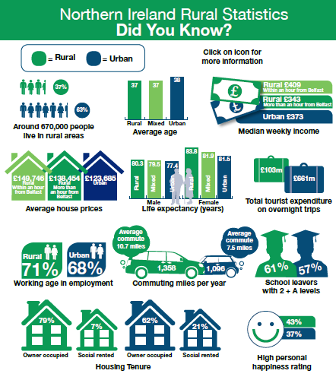

Annex 2

Most Deprived Rural Super Output Areas Within Northern Ireland – Northern Ireland Multiple Deprivation Measures 2017
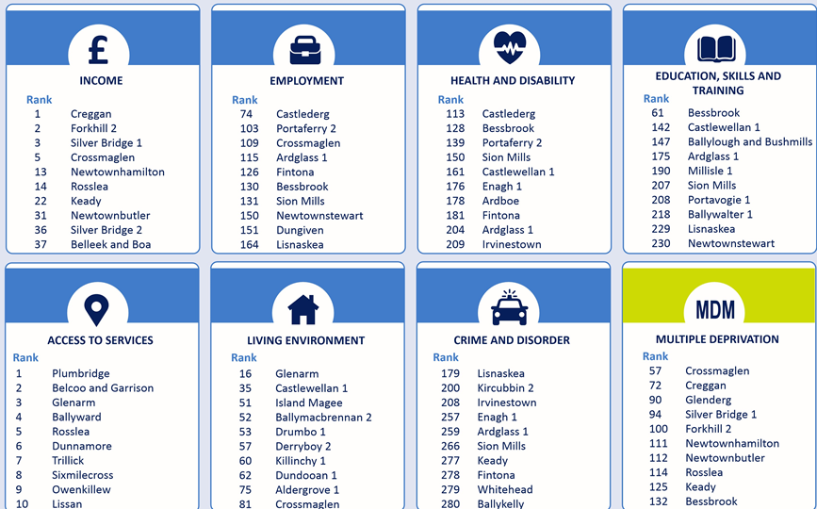

If a definition of ‘rural’ is not applicable, the policy is unlikely to fall under the scope of the Act and you should be able to screen out at this stage
http://www.health-ni.gov.uk/topics/dhssps-statistics-and-research/health-inequalities-statistics
http://www.ninis2.nisra.gov.uk/public/Home.aspx
https://www.daera-ni.gov.uk/sites/default/files/publications/daera/Rural-Urban%20Infographic_0.pdf
https://www.daera-ni.gov.uk/publications/rural-deprivation-infographic

