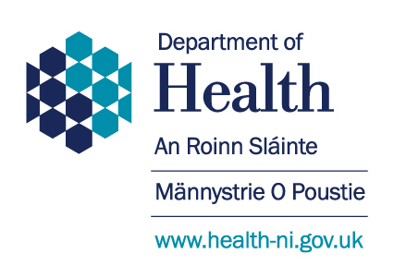

Mental Health Strategy 2021-2031

Children and Young People Consultation Response Form

If you would like to share your views on our ideas for a ten year plan for mental health in Northern Ireland, you can use this form. You can either print it out and post it to us, or send it by email.

Please send us your response by 5pm on 26 March 2021.

**E-mail:** [**mentalhealthstrategy@health-ni.gov.uk**](mailto:mentalhealthstrategy@health-ni.gov.uk)

**Post:**

Department of Health

Adult Mental Health Unit

Room D4.26

Castle Buildings

Stormont

Belfast

BT4 3SQ

|  |  |
| --- | --- |
| **If you would like to be kept updated, please give us your email address.** | |
| Email address |  |
|  | |
| **Tell us what you think…** | |
|  | |
| Are we doing the right things? | |
| Is there something else you think we should be doing? | |
| Of all the things we are going to do – which are the most important? | |

**Thank you for sharing your views!**