 | 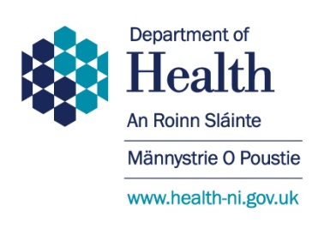
Dear Consultee |  | Room D3  Castle Buildings  Stormont  Belfast  BT4 3SQ  Tel: 028 9052 0537  Email: equality@health-ni.gov.uk  Date: 13 January 2017

CONSULTATION ON DEPARTMENT OF HEALTH EQUALITY SCHEME

The Minister has today launched a public consultation on the Department’s draft Equality Scheme.

Following the Departments Act (NI) 2016 and the renaming and restructuring of Departments, it is necessary to update the Department of Health’s Equality Scheme and confirm continued compliance with the two statutory duties, to have due regard to the need to promote equality of opportunity and promoting good relations, under Section 75 of the Northern Ireland Act 1998.

The Department has taken this opportunity to review the Equality Scheme as a whole and is proposing some changes to the current Scheme, particularly in respect of section 4 on ‘Screening’.

The consultation documents have been placed on the Departmental website at https://www.health-ni.gov.uk/consultations and we would welcome comments. A questionnaire pro-forma has been provided.

Completed questionnaires should be returned by post or e-mail to:-
Equality and Human Rights Unit
Department of Health
Room D3
Castle Buildings
Stormont Estate
BELFAST
BT4 3SQ

E-mail: equality@health-ni.gov.uk

A hard copy of the consultation document, or a copy in a different format, can be provided on request by e-mailing, as above, or telephoning 028 9052 0537.

The consultation will close on 10 April 2017. Responses received after this date will only be considered in exceptional circumstances and with prior agreement from the Department.

Yours faithfully

Judith Tener
Equality and Human Rights Unit

