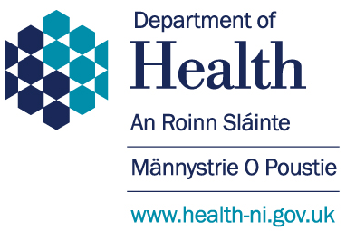
We must improve the care for people who have had a stroke

At the moment in Northern Ireland not everyone gets the same support, some people don’t have access to important treatments or specialist staff in their local hospitals, some people do not get to the right place soon enough to have the treatments that could help.

We need your views to help us make changes in the best way.

What is a stroke?

A stroke happens when blood supply to part of the brain is interrupted,

There are two main types of stroke
- The blood supply is blocked, usually caused by a clot or narrowing of an artery which carries blood to the brain. These are sometimes called Ischaemic strokes and they are the most common.
- A blood vessel supplying the brain bursts, this stops fresh blood reaching the brain and damages the affected area. These are called Haemorrhagic strokes.

What is the impact of stroke?

Stroke is the single largest cause of adult disability in the UK, the fourth largest cause of death.

2/3 of those who survive stroke have a life changing disability which can affect their movement, communication, their thinking, or mood.

Some people have the symptoms of a stroke but these disappear within 24 hours. This is called a Transient Ischaemic Attack (TIA). These people must go to a specialist clinic for treatment to try to prevent a full stroke from happening. We have plans to improve this service too so there is support across 7 days each week.

In Northern Ireland about 2,800 people have a stroke each year
…and there are about 36,000 people living with the effects of a stroke

More people will have strokes in the future as Northern Ireland has a growing older population (3/4 of people who have a stroke are over the age of 65)

What does Health and Social Care need to do?

We want to stop people having a stroke in the first place so we need to share information about how to reduce the risk of having one, and how to watch for and respond to the signs of a stroke.

Then we need to get people the right care in the right place at the right time. We want to reduce the number of people who die from a stroke, and we want to reduce the damage to their brain.

Then we need people to have good support and therapy in hospital and after they leave so that they will make the best recovery possible.
We can learn from what we know about our current services, from research and from other people

There is plenty evidence about what works best, how to save people’s lives, how to help them recover better, and which staff are needed to do this. We can use the evidence to make sure that people get the best care, and that this happens regardless of where they live in Northern Ireland.

There are some new treatments such as thrombolysis and thrombectomy which work to remove a clot, they need to be given by staff with specialist skills and must be given very soon after the stroke. We need to plan our new services to get people quickly to the place where the staff has the right skills and equipment to support them, and we need to help people get home from hospital safely, as soon as possible and into support for having rehabilitation services if appropriate.

We must make some changes. We will need to have fewer centres for stroke care – this will help us develop specialist centres to provide the best treatments, and make sure these are available when people need it. Staff here will see more people who have just had a stroke; they can learn and maintain specialist skills for stroke care and rehabilitation. However it is not good if there are too many people taken to one hospital, the staff and services will not be able to cope.

Some areas in the UK (London and Greater Manchester) have already changed to this new way of working, with a wide range of benefits – fewer people die after their stroke, and people are less disabled. We want these benefits for people in Northern Ireland too.

We need to plan for --

A few highly specialist stroke units (Hyper Acute Stroke Units - HASUs) for all Northern Ireland. People go here immediately when they have had a stroke and may travel past their local hospital to get there. We need to plan to get people to these centres as quickly as possible.

Acute stroke units (ASU). People will be moved to these units, usually after the first few days. There will be fewer of these than at the moment, but the staff will all be experts in ongoing stroke care.

Rehabilitation. When people leave hospital, if necessary they will continue their rehabilitation under the guidance of Community Therapists nearer to where they live.

The changes will happen over the next 2 years so we have time to plan and make changes properly and considering the current stroke services.

None of the changes are about saving money. All the options will cost more than at the moment but they will give a better service for people after stroke.

There are 6 options for how we could do this in Northern Ireland; we need your help to decide which people would prefer.

We have summarised the options, however, there is a lot more information on our website –
www.health-ni.gov.uk/consultations/reshaping-stroke-care

Option A  5 Highly Specialist Units  Royal Victoria Hospital, Craigavon, Altnagelvin, Antrim, South West Acute Hospital.  5 acute stroke units  These would be in different wards in the same hospitals |  |  | 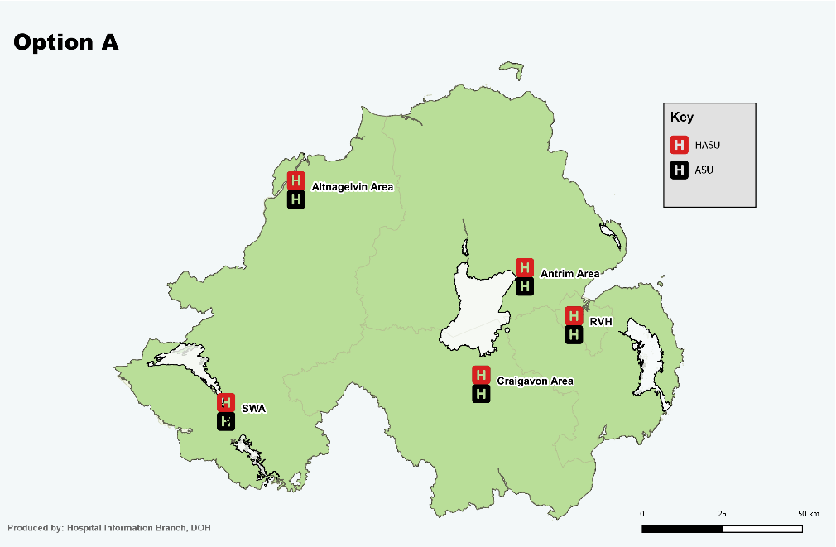
Travel time |  | 99% people live within 1 hour of a Highly Specialist Unit
Things to consider |  | There will not be enough patients in 4 of the hospitals to develop high levels of skill in some treatments
Option B  4 Highly specialist units  Royal Victoria Hospital, Altnagelvin, Craigavon and Antrim Hospitals.  4 acute stroke units  These would be in different wards in the same hospitals with a possible fifth acute stroke unit in the Ulster Hospital |  |  | 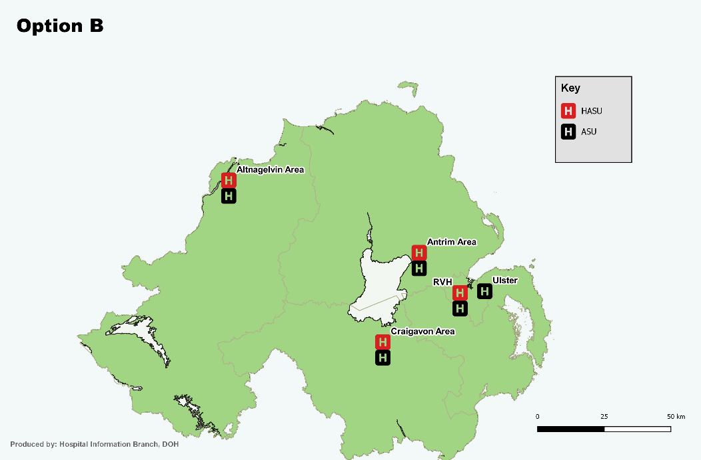
Travel time | 94% people live within 1 hour of a Highly Specialist Unit
Things to consider | There will not be enough patients in 2 of the hospitals to develop high levels of skill in some treatments
Option C  4 Highly specialist units  Royal Victoria Hospital, Craigavon, Altnagelvin, South West Acute Hospital  4 acute stroke units  Royal Victoria Hospital Craigavon, Altnagelvin, South West Acute Hospital and a possible fifth acute stroke unit at the Ulster hospital |  |  | 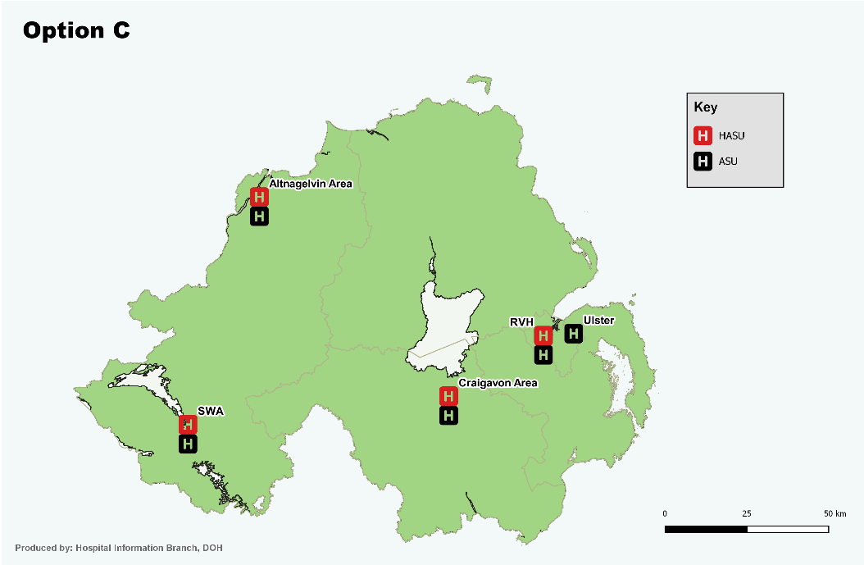
Travel time | 98% people live within 1 hour of a Highly Specialist Unit
Things to consider | There will not be enough patients in 3 of the hospitals to develop high levels of skill in some treatments
Option D  Stage 1 4 Highly specialist units  Royal Victoria Hospital, Craigavon, Altnagelvin, Antrim  Stage 2 3 Highly specialist units  Close the Antrim specialist unit  4 acute Stroke units Royal Victoria Hospital, Craigavon, Antrim Altnagelvin, and a possible fifth acute stroke unit at the Ulster hospital |  |  | Make changes in 2 stages - 4 specialist units and then close 1  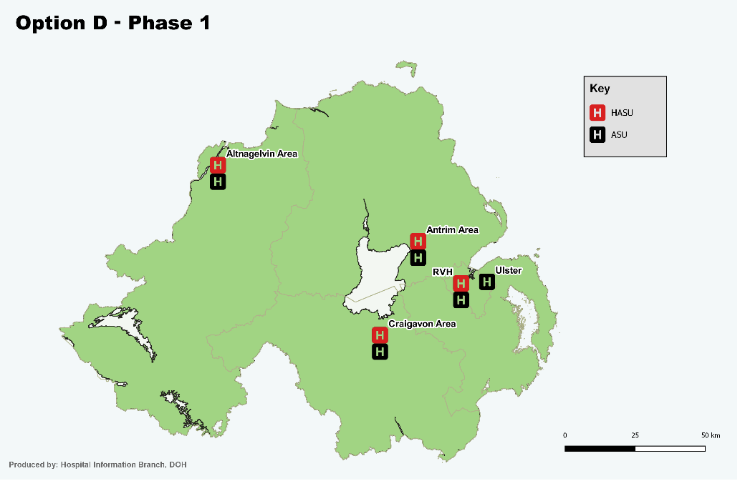  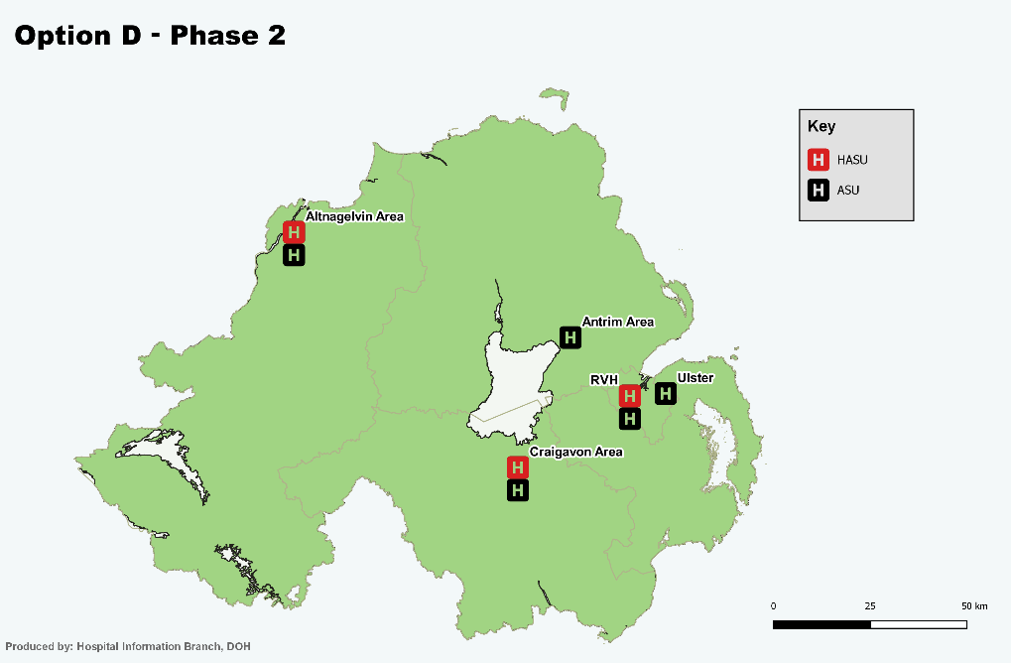
Travel time | 94% people live within 1 hour of a Highly Specialist Unit  - (93% when there are 3 Highly Specialist Units)
Things to consider | This would allow time to develop the service for more patients at the Royal Victoria Hospital, and making sure that people have good services while this happens.  Then, after Antrim closes, there will be more patients going to Altnagelvin which will help the staff there to develop their specialist skills
Option E  Stage 1 4 Highly specialist units  Royal Victoria Hospital, Craigavon, Altnagelvin, South West Acute Hospital.  Stage 2 3 specialist units Close the unit in the South West Acute Hospital  4 acute Stroke Units  Royal Victoria Hospital, Craigavon, Altnagelvin, Antrim and a possible fifth acute stroke unit at the Ulster hospital |  |  | Make changes in 2 stages - 4 specialist units, then close 1  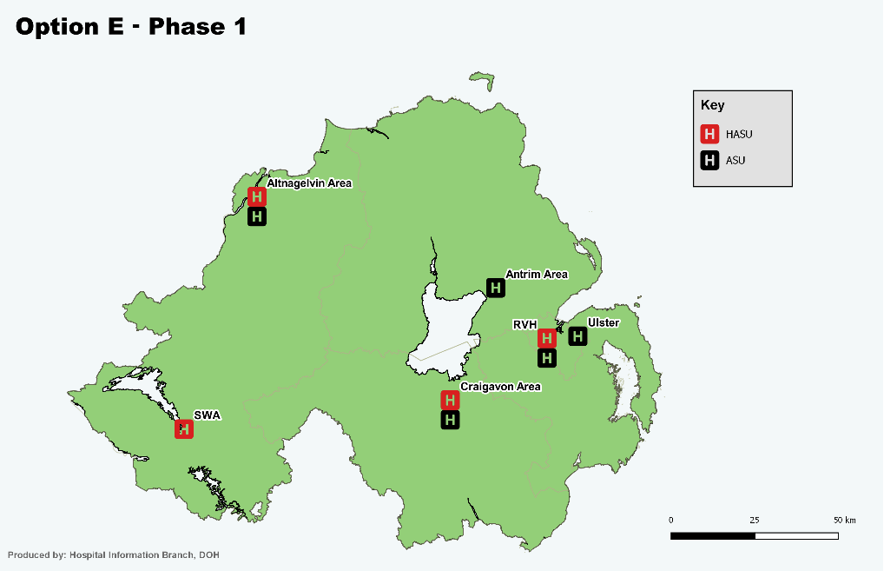  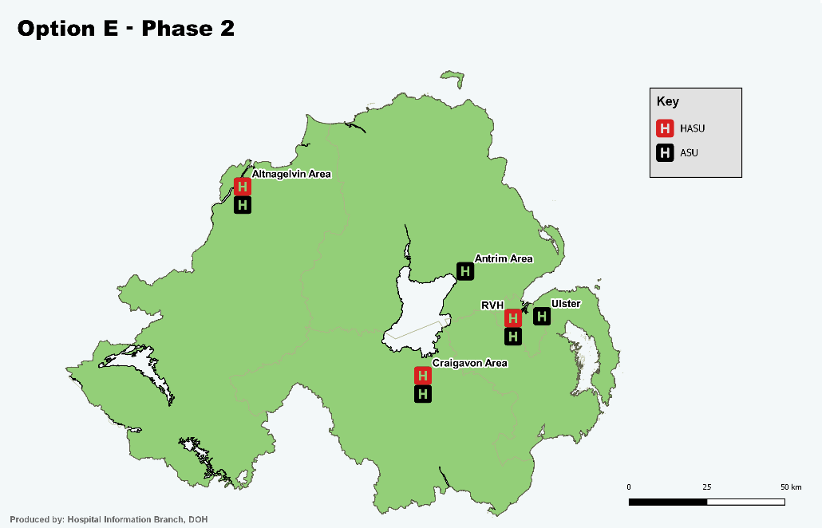
Travel time | 98% people live within 1 hour of one of the 4 Highly Specialist Units  93% with 3 Highly Specialist Units  The maximum travel time goes up from 75 to 106 minutes.  An air ambulance could help reduce this travel time for those people who have the longest travel time.
Things to consider | None of the 4 sites has the numbers of patients within the guidelines -3 are too low and Royal Victoria Hospital is too high.  Having 3 Specialist units increases admissions to good levels in Craigavon  There is no extra time to support the Royal Victoria Hospital to cope with more patients
Option F  3 Highly specialist units, Royal Victoria Hospital, Craigavon, Altnagelvin  4 Acute Stroke Units  Royal Victoria Hospital, Craigavon, Altnagelvin, Antrim and a possible fifth acute stroke unit at the Ulster hospital. |  |  | 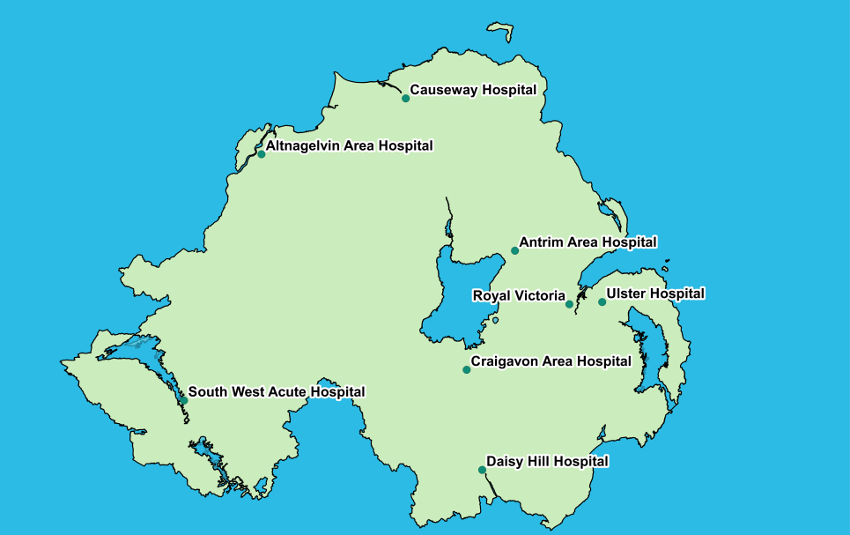  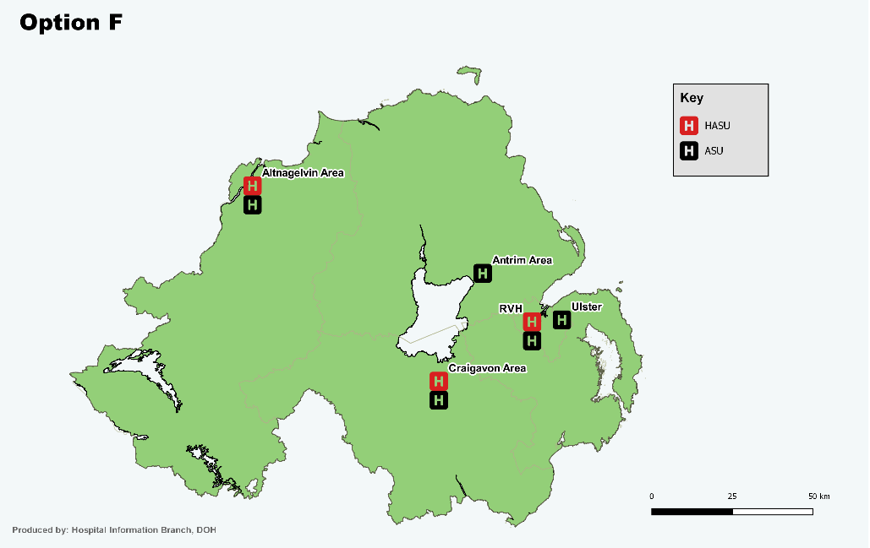
Travel time | 93% people live within 1 hour of one of the Highly Specialist Units . enable  The maximum travel time is 2 hours.  An air ambulance could help reduce this travel time for those people who have the longest travel time.
Things to consider | 2 of the specialist hospitals have numbers of patients just outside the guidelines.  This is the best option for maintaining a sustainable service on the Altnagelvin site.  The Royal Victoria Hospital will need more beds and staff to cope. This option can only go ahead if it is possible to provide extra capacity on the Royal Victoria site.
Which of the 6 options do you like best?
A B C D E F

Tell us if you have any other ideas for how we could make the changes?

Thank you for helping, your views will make a difference to what we decide to do.
If you want to keep in touch or follow progress there is information on www.health-ni.gov.uk/consultations/reshaping-stroke-care

